MINISTRY OF Education and science of ukraine
Zaporozhye National Technical University

S.V. Loskutov, S.P. Lushchin

Short course of lectures of general physics

For students studying physics on English and foreign students also
Semester III

2010

Short course of lectures of general physics. For students studying physics on English and foreign students also. Semester III / S.V. Loskutov, S.P. Lushchin. – Zaporozhye: ZNTU, 2010.- 102 p.
№ 791 від 21.04.2010

Compilers:
S.V. Loskutov, professor, doctor of sciences (physics and mathematics);
S.P. Lushchin, docent, candidate of sciences (physics and mathematics).

Reviewer:
G.V. Kornich, professor, doctor of sciences (physics and mathematics).

Language editing: A.N. Kostenko, candidate of sciences (philology).

Approved

by physics department,
protocol № 5
dated 23.03.2010

It is recommended for publishing by scholastic methodical division as synopsis of lecture of general physics at meeting of English department, protocol № 8 dated 21.04.2010.

The authors shall be grateful to the readers who point out errors and omissions which, inspite of all care, might have been there.

Contents
Lecture 1. Crystal Lattices ……………………………………………….. 5
Introduction ………………………… ….…………………..……………. 5

Crystal Lattice …………………………………………………………………… 7
The Types of the Connection Atoms in Crystals.…………………………10
Ions crystal ………………………………………………………………. 10
Atoms crystals ……………………………………………………………11
Metallic crystals …………………………………………………………..11
Van-der-Vaals connection ………………………………………………..12
Experimental methods of determination of crystal structure …………….13
Deformation …………………………………………………………….. 14
Lecture 2. Heat Properties of Solids ……………………………………...16
Dulong and Ptee law .……...…………………….………………………. 17

Phonons ………….…………………………………………………. ….. 18
Theory of Debye ……………….………………………………...…. 19
Heat Conductivity ………………….………….….………………………20
Heat Expansion ………………………………………………………….. 21
Lecture 3. Elements of Physical Static’s ………………….…………….. 22
The Function of Probability ……………………………………….…..… 22
Statistics of Maxwell-Bolzmann ……………….…….…………………..22
Phase Space. Function of Distribution ………………………………….. 23
Quantum Statistics of Fermi-Dirak and Boze-Einstein ….……………… 24
Energetic Distribution of Electrons in Metals. Fermi’s Energy ………… 25
Internal Energy and Heat Capacitance of Electron Gas ………………… 26
Lecture 4. Band Sructure of Solids .……………………………………... 28
Metals, Insulators, Semiconductors ……………………….……….……. 28
Band Theory of Semicinductors …………………………………...…… 29
Effective mass of electron …….…………….….………………………. 30
Intrinsic Semiconductors ……………….….………….....……………….32
Extrinsic Semiconductors ….……………………………………………. 33
P-n juction ………………………………………………………………. 33

Lecture 5. Physical Fundamentals of Electric Properties of Solids ……. 35
Theory of Free Electrons in Metals …………………………………....... 35
Wiedemann - Franz Law ……………………..…………………………. 37
Fermi’s Energy of Electrons in Metals ………………………….….…… 37
Superconductivity ……………………………………………………….. 40
Emission of electrons …………………………………………………….42
Work function …………………………………………………………… 42
Contact potentional difference. Metal-metal contact …………………… 43
Lecture 6. The Magnetic Field in Materials ……………….…….…. 44
Diamagnetic, Paramagnetic and Ferromagnetic Materials ……...….44
Magnetic moments of atom ………………………………………………48
Atom in magnetic field …………………………………………………………..50
Hall’s effect ………………………………………………………………51
Lecture 7. Semiconductor Photoconductivity ………………………….. 53
Absorption, Spontaneous and Induced Radiation ….……….................... 54
Laser ………….….……………………………………………………… 56
Lecture 8. Quantum Physics …………….…………………….………… 58
Thomson and Rutherford Model of Atom …………….…….………….. 58
Atomic spectra …………………….……………………………………. 59
Bohr’s Theory …………………………….…………………….…......... 61
Bohr’s Theory of Hydrogen Atom and its Spectrum .……………………62
Franck’s & Hertz Experiments ……………………………...…...……… 64

Duality of Particles and Waves ………………………………………….. 66
Uncertainty Principle ……………………………………………………. 67

Lecture 9. Wave Function ………………………………………………. 69
Schrodinger Equation ……………………………………….……….…. 70
Motion of a Free Particle and its Energetic Spectrum ………………….. 70
Motion of a Space Limited Particle …………….……………………….. 71
Tunneling Through a Barrier. Tunnel Effect ……………………………. 74
Hydrogen Atom in Quantum Mechanics …………………………………76
Quantum Numbers ………………………………………………………. 77

Pauli's Principle …………………………………………………………. 80
Structure of Electron Shells in Mendeleyev Periodic System ……………80

Types of Wave Functions ……………………………………………….. 81
Lecture 10. Element of Nuclear Physics ……………………………….. 84
Atomic Nucleus ………………… …… …………… ………..………… 84
Nuclear Forces …………… ………… ………..………………………... 86
Radioactivity ………..……………………………..…………………….. 87
Radioactive Decay Law …………………………………………………. 88
Nuclear Reactions ……………………………………………………….. 90
Nuclear Fission Reaction …………………………………………………90
Chain Fission Reaction ………………………………………………….. 91
Nuclear Reactor …………………………………………………………. 92
Nuclear Fusion ……………………………………………………………93
Elementary Particles …………………………………………………….. 94
Lecture 1. Crystal Lattices

Introduction

Crystals are formed from atoms, sometimes in simple and sometimes in complicated ways. Many crystals built up of ions bearing positive and negative charges: rock salt is composed of Na+ and Cl- ions, fig.1.1.
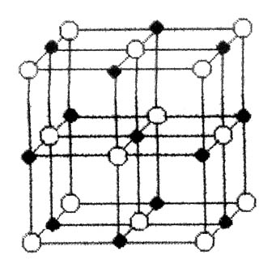
Figure 1.1

Crystals of the alkali metals are made up of small positive ion cores immersed in a negatively charged sea of conduction electrons, fig.1.2. Some crystals are made up of neutral atoms having slightly overlapping electron clouds forming electron bridges or covalent bands between neighbouring atoms.
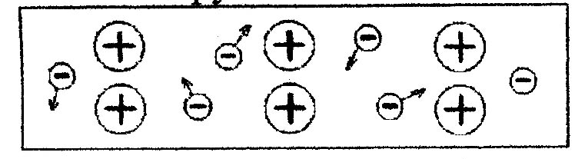
Figure 1.2

The differences among these varieties of crystalline binding forces are closely connected with differences in the mechanical, electrical and magnetic properties of crystals. In all crystals the actual interaction which causes the binding is almost entirely the ordinary Coulomb electrostatic interaction between charges - the attraction between the negative charges of the electrons and the positive charges of the nuclei. The differences in the types of crystalline binding thus are not differences in the nature of the interaction, but are qualitative differences in the distribution of electronic charge. One of the questions in the physics solid state is "Where are the nuclei and the electrons in the solid?" This problem is called the determination of the structure of the solid.
All atoms are constructed of various elementary particles. And complete descriptions of a solid would simultaneously specify the condition of all these particles. However, such a description is unnecessarily complex for most purposes. An approximation sufficiently accurate for the study of the geometrical arrangement of entire atoms in crystals is to suppose the atoms to be round, hard balls. These balls rest against each other in various geometrical arrangement, each solid having its own mode of atom placement.
The solids of primary interest for us have an arrangement of atoms in which the atoms are arranged on some regular repetition pattern in three dimensions. Such solids are called crystals, and the arrangement of atoms is termed the crystal structure, fig.1.3. The internal regularity of atom placement in solids often leads to symmetry of their external shapes.
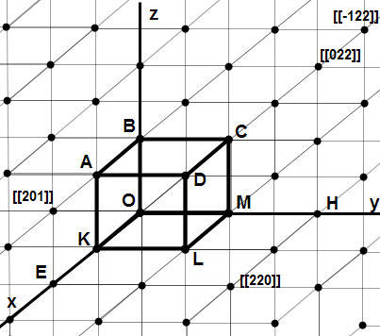
Figure 1.3

Suppose that there are some atoms in the neighbourhood of origin O. The transitional invariance insists that there must be exactly similar atoms, placed similarly about each lattice site.
It is obvious that we can define the physical arrangement of the whole crystal if we specify the content of a single unit cell for example, the parallelepiped subtended by the basic vectors
${\vec{r}}_{m,n,p}=m{\vec{a}}_{1}+n{\vec{a}}_{2}+p{\vec{a}}_{3}$, (1.1)
where m, n, p – indexes.
The whole crystal is made up of endless repetitions of this object stacked like bricks in a wall. Suppose that there is some central symmetry about some point in the structure. This would be a convenient point to choose as the centre of a cell, itself with central symmetry. One can do this systematically by constructing a Wigner-Seitz cell, that is, by drawing the perpendicular bisector planes of the translation vectors from the chosen centre to the nearest equivalent lattice sites. The volume inside all the bisector planes is obviously a unit cell - it is the region, whose elements lie nearer to the chosen centre that to any other lattice site.
The unit cell can contain one or more atoms. Naturally, if it contains only one atom, we put that on the lattice site, and say that we have a Bravais lattice. If there are several atoms per unit cell, then we have a lattice with a basis.
Structures are classified according to their symmetry properties, such as invariance under rotation about an axis, reflection in a plane.

Crystal Lattice

Between atoms exist the forces of the interaction. Figure 1.4 shows the dependence of the interaction energy and forces with respect to distance between them.
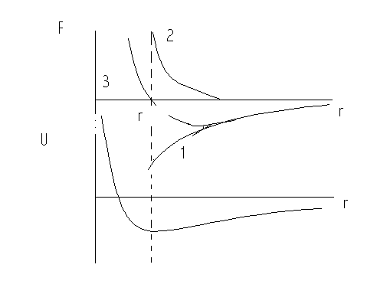
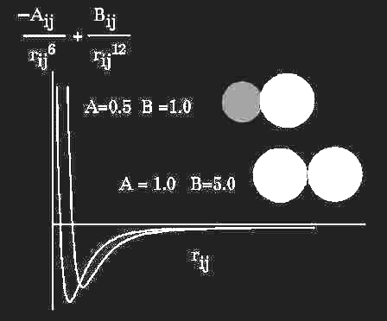

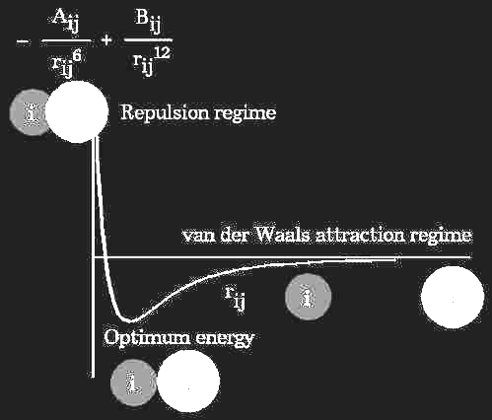
Figure 1.4

Curve 1: when r > r0 , between the atoms there are the forces of the attraction.
Curve 2: when r < r0 , between the atoms act the repellent forces.
Curve 3: when r = r0, then Falt = Frep, and so the energy of the interaction reach minimum -Umin how it shows "b".
It means, that the atoms in crystal lattice must be in equilibrium state, when r tends to r0.
Then we may make the conclusion that atoms must be constructed in the strict order under influence the forces of the interaction. In result it formed a body with regularity or periodically structure. For describing crystal structure we use the idea of the crystal lattice.
The crystallisation process of a substance occurs due to the forces of attraction acting between its particles. At small distances they disappear and the forces of repulsion appear, preventing the further binding of particles. These forces strive to arrange the particles of substance as closer to each other as possible. In the first approximation we may compare molecules with solid particles, in particular, with balls of definite radius which may be brought only into contact by the forces of attraction.
When ball-type particles are packed tightly, each of them is surrounded by a certain number of adjoining (neighbouring) particles arranged at equal distances from the first. This number is called a co-ordination number with values 12, 8, 6, 4 and 2.
The orderly distribution of particles within the volume of a crystal forms the so-called space crystal lattice. Geometrically the entire pattern of a lattice can be obtained if we draw three systems of planes, intersecting between themselves at angles end. The planes in each system are parallel to each other and are spaced at equal distances a, b and c.
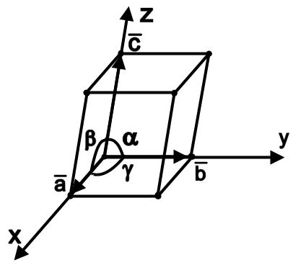
Figure 1.5

These planes divide the crystal by unit cells, constituting kind of bricks of which the whole crystal is built. Depending on the ratio between the cell ribs a, b and c, as well as the angles α, β and γ we distinguish seven crystallographic systems:
1) a = b = c; α = β = γ = 90 - cubic system;
2) a = b = c; α = β = 90 , γ = 120 - hexagonal system;
3) a = b = c; α = β = γ = 90 - tetragonal system;
4) a = b = c; α = β = γ = 90 - trigonal system;
5) a =b = c; α = β = 90 - monoclinic system;
6) a = b = c; α = β = γ = 90 - triclinic system;
7) a = b = c; р = с = g = 90 - rhombohedral system.

For description crystal structure we must determine the coordination number. It is the number of the nearest neighbours. And also the interatomic distance is the shortest distance between two atoms in a crystal.
Points of intersection of the planes forming a space crystal lattice are called points of this lattice.
There are following groups of lattices:
- Atomic lattices - in the points of these lattices there are neutral atoms of a given substance. (A diamond crystal consist of neutral atoms of carbon).
- Molecular lattices whose points contain neutral molecules of substance. These are ice crystals, CO2.
- Ion lattices with electrically charged particles – ions in its points. In lattices of type NaCl the neighboring ions have opposite signs (Na+ and Cl-) and they are attracted to each other, thus ensuring the solidity of a crystal;
4. Metal lattices consisting of positively charged ions of metal, held together by an “atmosphere” of free elections. These elections and positive metal ions bind each other. The elections cannot leave the metal owing to the attraction to the positively charged metal atoms.

The Types of the Connection Atoms in Crystals.
Ions crystal

Between metals and halogens the connection realize in following way. At the first, electrons of metal transit to halogen atom. The charge of metal atom is positive and the halogens atom charge is negative. Then these atoms connected how charge particles to conformity with Coulomb law. The energy of the attraction is
$U_{\text{att}}=−\frac{e^{2}}{4{\text{πε}}_{0}r}$. (1.2)
The energy of the repelling is
$U_{\text{rep}}=\frac{B}{r^{n}}$, (1.3)
where B, n are constants. The complete energy of the interaction is
$U_{\text{int}}=\frac{B}{r^{n}}−\frac{e^{2}}{4{\text{πε}}_{0}r}$. (1.4)
In the equilibrium state
$\frac{\text{dU}}{\text{dr}}=0$. (1.5)
Then
$r_{0}=\left(\frac{4{\text{πε}}_{0}\text{nB}}{e^{2}}\right)$, (1.6)
and
$U=−U_{\text{con}}=−\frac{e^{2}}{4{\text{πε}}_{0}r_{0}}\left(1−\frac{1}{n}\right)$. (1.7)
For the energy of crystal lattice, building from N pair atoms
$U_{\text{lat}}=−\text{NA}\frac{e^{2}}{4{\text{πε}}_{0}r_{0}}\left(1−\frac{1}{n}\right)$, (1.8)
where A is Madelung constant.
Atoms crystals

When two atoms draw near with each other, then it electrons can to belong differences nuclei.
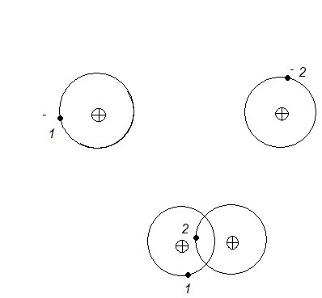
Figure 1.6

In result two atoms formed a new state in which the electrons belong two nuclei at the same time (simultaneously) or become socialization.

Metallic crystals

In the atoms of metals external valent electrons have a weak bond with nuclei. When the crystal lattice formed then external valent electrons are socializate. In result a new type of the bond arise.

Van-der-Vaals connection

It is the most common type of the connection between atoms and molecules. This connection consists of dispersive, orientational, inductive interactions.
Dispersive interaction. At the simple of He. When the atoms draw closer to one another, then they polarize how it shows Fig.1.7.

a b
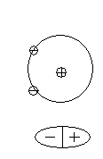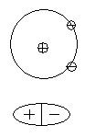
Instantaneous Instantaneous
dipoles dipoles
(attraction) (repulsive)
Figure 1.7

Energy of the system in the case (a) is less then in (b). Because, between atoms there are the forces of the attraction. Energy of the interaction is
$U_{\text{dis}}=−\frac{3}{4}\frac{α^{2}I}{r^{6}}$, (1.9)
where α is polarizability; I is energy of excitement; r is the distance between atoms.
Orientational interaction
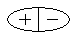
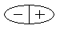
Figure 1.8
For the polar molecules electrostatic interaction regulate molecules arrangement how it shows in Fig. 1.8. After that the energy of the system decrease. In result between molecules there are forces of the attraction. They energy is
$U_{\text{or}}=\frac{μ^{4}}{\text{24}π^{2}ε_{0^{2}}\text{kT}}\frac{1}{r^{6}}$. (1.10)

Inductive interaction

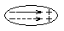
Figure 1.9

For the polar molecules with high polarizability may arise a new dipole. In this case the energy of the attraction is
$U_{\text{ind}}=\frac{{\text{αμ}}^{2}}{{bπ}^{2}ε_{0^{2}}}\frac{1}{r^{4}}$. (1.11)

Experimental methods of determination of crystal structure

For determination of crystal structure used X-rays, because the length of X-ray is comparable with the distance between atoms. If the electromagnetic waves fall on the isolated atom it begin to oscillate. By these the atom radiate electromagnetic wave with frequency equal of the frequency falling wave.
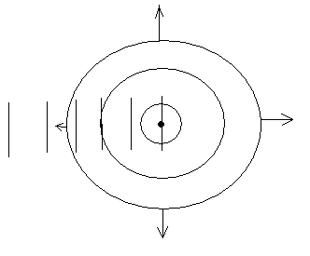

Falling wave
wave dispersion

Figure 1.10

When electromagnetic waves fall on the row of the atoms, then every atom begins to oscillate. In result the effect of the X-ray diffraction arises.
Brag forms the condition of the diffraction for real crystal lattices:
$nλ=2d\text{sin}θ$, (1.12)
where n is whole number; λ is length of wave; d is distance between nearest atom planes; Ө is angle of fall falling normal wave of wave reflection Bragg’s law atomic planes.
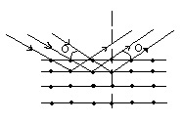
Figure 1.11

The easiest way to approach the optical problem of X-ray diffraction is to consider the X-ray waves as being reflected by sheets of atoms in the crystal. When a beam of monochromatic X-rays strikes a crystal, the wave scattered by the atoms combine with reflected wave. If the path difference for waves reflected by successive sheet is a whole number of wavelengths, the wave trains will combine to produce a strong reflected beam. In more formal geometric terms, if the spacing between the reflecting planes is d and the angle of the incident X-ray beam is θ, the path difference for waves reflected by successive planes is 2dsinθ, hence the condition for diffraction is formula (1.12).

Deformation

An important property of bodies is their elasticity which appears an a results of deformation of these bodies caused by external forces. The principal types of deformations are: longitudinal (linear), manifold (volumetric) tension and compression, shear and twist. If the external force discontinues its action and the deformed body restores its initial form and dimensions, this deformation is called elastic. If a body has weak elastic properties it is called plastic bodies.
Elasticity and plasticity depend on temperature. Plastic bodies at normal temperature become elastic at low temperature and elastic bodies become plastic at high temperature.
Elasticity and plasticity of solids are of great complexity. First, under the action of external forces the deformation of the crystal lattice occurs, i.e.,a change in the distances between particles. Owing to this, elastic forces are evoked which act against the external forces. Besides, as a results of deformation of polycrystalline body the shift (twist) of some grains with respect to each other is possible, and in this case the external forces develop on the boundaries between these grains. If such a body undergroes numerous deformations then a partial pulverization of it grains may occur and consequently a change of its elastic properties will take place.

Lecture 2. Heat Properties of Solids

Heat capacity, heat conductivity and heat expansion are classified as heat properties. Atoms in solids oscillate nearby equilibrium positions. Along a solid different waves are running continuously. These waves possessed different characteristics. An atom displacement is described by the equation
$U={\text{Ae}}^{i(ωt−\frac{2π}{λ}x)}$, $U={\text{Ae}}^{i(ωt−\text{kx})}$. (2.1)

Thus a wave is characterized by an amplitude A; a wave length λ; a frequency ν or an angular frequency ω; a velocity υ and a wave vector k. It is directed along the wave motion and is equal to $\left|\vec{k}\right|=\frac{2π}{λ}$.
Frequencies in solids are the order of 1014 rad/s and amplitudes are the order of 10-11m. The point is that there are a lot of lengths of waves inside the same solid body. However a minimum wave length exists due the discreet structure of a solid.
(2.2)
$λ=\frac{1}{n}2l$ , (2.3)
where $n=\frac{l}{a}$. (2.4)
$λ=\frac{1}{1}2l$, (2.5)
$λ=\frac{1}{2}2l$ (2.6)
$λ=\frac{1}{3}2l$ (2.7)
$λ_{\text{min}}=\frac{1}{\frac{l}{a}}2l=2a\text{.}$ (2.8)
Thus $λ_{\text{min}}=2a$ and a maximum frequency corresponded to it:
$λ_{\text{min}}⋅υ_{\text{max}}=υ⇒ν_{\text{max}}=\frac{υ}{2a}$. (2.9)
The waves having $ν<ν_{\text{max}}$cannot exist in the crystal lattice.
$ν_{\text{max}}≡ν_{D}$. (2.10)
The totality of vibrations in solids forms so called spectrums of normal vibrations. This spectrum is given by
$\text{dg}=g(ω)dω=\frac{3V}{2π^{2}υ^{3}}ω^{2}dω$ or $g(ν)$, (2.11)
where V is the volume and υ is the sound velocity in a solid. The meaning of $g(ω)dω$ is a number of frequencies ranged within $[ω,ω+dω]\text{.}$The total number of frequencies
$\int_{0}^{ω}{g(ω)dω=3N,}$ (2.12)
where N is number of atoms.

Dulong and Ptee law

All particles forming a crystal, continue to participate in thermal motion performing vibrations about their position of equilibrium – the points of space lattice. If the energy is divided equally 1/2kT between each degree of freedom, then the specific heat of one kg-atom of a crystal substance at constant volume may be defined by the formula
$C_{v}=N_{0}\frac{i}{2}k=\frac{i}{2}R$. (2.13)
Measurements showed that the kg-atom specific heat of numerous elements at usual temperatures is close to 3R. It is the Dulong and Ptee law.
Owing to orderly arrangement of particles in the crystal space lattice, the crystals are considered to be anisotropy bodies. Their physical properties are different in various directions. All properties of the substance which depend on the distances between the particles will be different.
Thermal expansion of crystal bodies at heating occurs due to an increase of the amplitude of vibration of the particles. At small distances act the rapidly increasing forces of repulsion, whereas at large distances act the slowly decreasing forces of attraction. The thermal expansion of crystal bodies is connected with the asymmetry of interacting forces with respect to the position of equilibrium.
This expansion increases with the decrease of the distance between the particles in the given direction. Hence, the coefficient of linear expansion equals
$\frac{Δl}{l}=α⋅ΔT;α=\frac{Δl}{lΔt}$, (2.14)
where Δl is the change of length l of a crystal in a given direction when the temperature changes by ΔT. In crystal α has different values in various directions and, therefore, the coefficient of volume expansion β has to be defined separately
$\frac{ΔV}{V}=β⋅ΔT;β=\frac{ΔV}{VΔT}$, (2.15)
where ΔV is the change in volume V of a given crystal during variation of its temperature by ΔT. For isotropic bodies
$β=3α$ , (2.16)
thermal conductivity of crystals is explained by the fact that the increase in amplitude of vibration of particles in a given place, owing to the interacting forces, is transmitted to the neighboring particles. It leads us to conclude that owing to bonds between particles, the thermal energy tends to a uniform distribution through the volume of the crystal. The coefficient of thermal conductivity k, which defines the amount of heat dQ, passing through the area S for the time dt
$\text{dQ}=k\frac{\text{dT}}{\text{dt}}\text{Sdt}$. (2.17)
In metallic bodies the heat is transferred not only by vibrations of atoms but also by the election gas which participates in the thermal conductivity of metals.

Phonons

On the other hand we know that oscillations and particles correspond to each other. Thus every wave in crystal lattice may be regarded as a particle (the duality principle)
$E=hν$ (2.18)
This quantum of normal oscillations in crystal is called a phonons. The velocity of phonons is equal to the velocity of a sound. One may confirm that phonons form a phonon gas. Normal vibrations as well as phonons are responsible for heat properties of a solid.

Theory of Debye

By definition
$C=\frac{\text{dU}}{\text{dT}}$, $\left[C_{V}≈C_{p}\right]$ (for solids) (2.19)
According to numerous experiments C is related to temperature. Classical physics can not explain these results. According to classical physics
$U=U_{\text{pot}}+E_{\text{kin}}=\frac{3}{2}\text{RT}+\frac{3}{2}\text{RT}=\text{RT}$(for mole). (2.20)
Thus
$C=3R$. (2.21)
According to Debye’s theory the heat energy is spent a generation of normal vibrations. The more temperature the more energy of oscillations and thus the more ν. Energy: ${\text{hv}}_{D}=kθ$(per one degree of freedom),
then $θ=\frac{{\text{hv}}_{D}}{k}$ . (2.22)

Element | $θ_{D}$, K
Fe  Cu  Pb  Be  Al | 467  339  95  1160  418

We should know that if a T>$θ_{D}$ the high frequencies are generated. If T>$θ_{D}$ only the lowest low frequencies are generated. Debye calculated C(T) and results of calculations were find to correspond to experiments.
Energy of lattice = energy of a phonon × number of phonons × probability function.

$U=\int_{0}^{ω_{D}}{ℏω⋅g(ω)ω⋅f(E)=}\int_{0}^{ω_{D}}{ℏω⋅\frac{3V}{2π^{2}υ^{3}}ω^{2}dω⋅\frac{dω}{e^{\frac{E−E_{F}}{\text{KT}}}−1}}$,
$U=\frac{3ℏV}{2π^{2}υ^{3}}\int_{0}^{ω_{D}}{\frac{ω^{3}dω}{e^{\frac{ℏω}{\text{KT}}}−1}}$. (2.23)
Further $\frac{ℏλ}{\text{KT}}=x$ and so on. Solutions are the following:
- High temperatures, T$θ_{D}$, U~T and since $C=\frac{\text{dU}}{\text{dT}}$, C=const=3R.
- Low temperatures, T<$θ_{D}$, $U\text{\sim }T^{4}$ and $C\text{\sim }T^{3}$.
Very important conclusion. The absolute zero is unachievable. It is impossible to achieve the absolute 0. Really, if C=0, this means, that dU=0 and further cooling is impossible.

Heat Conductivity

A heat flux across a solid is given by
$I_{Q}=−χ⋅\frac{\text{dT}}{\text{dx}}\text{.}$ (2.24)
In general case the heat conductivity coefficient may be expressed as
$χ=χ_{\text{phonons}}+χ_{\text{electrons}}$. (2.25)
The heat conductivity of insulators is due to phonons exclusively. In this case $χ$ can be described quite like an ideal gas
$χ_{\text{phonons}}=\frac{1}{3}\bar{λ}\bar{υ}\text{Cn}\text{.}$ (2.26)
$[m⋅\frac{m}{s}⋅\frac{I}{K}⋅\frac{1}{m^{3}}]=[\frac{I}{m⋅s⋅K}]\text{.}$

At first concentration of phonons increases. Later phonons collide each other and scatter. It results in a drop of$χ$.
The heat conductivity of metals is due to electrons.

Heat Expansion

All solids expand if their temperature is increased. The heat expansion is increased by α. Value of α is so-called coefficient of expansion. By definition:
$α=\frac{1}{l}⋅\frac{\text{dl}}{\text{dT}}=\frac{1}{r_{0}}⋅\frac{\text{dr}}{\text{dT}}\text{.}$ (2.27)
$\left[α\right]=[\frac{1}{m}⋅\frac{m}{K}]=K^{−1}\text{.}$
Metal | $α$, K-1
Cu  Al  Au | 1,610-5  2,310-5  1,410-5

The physical nature of the heat expansion is connected with peculiarities of atomic interactions. An atom oscillates and interatomic distance is changed.

Lecture 3. Elements of Physical Static’s

A statistical method is used in order to describe an energetical state of particles. It is convenient to introduce so called total statistical function of distribution. It is denoted N(E)dE. This product means simply the number of particles which are possessed energy from E to E+dE:
${αN}_{[E,E+\text{dE}]}=N(E)\text{dE}$ (3.1)
In its turn
$N(\text{dW})\text{dE}=g(dτ)\text{dEf}(E)$ (3.2)
where g(E)dE is the number of states in the interval [E, E+dE]; f(E) is a function of probability. The last value determines the probability of having the energy E really. The function (E)dE is given by
$g(E)\text{dE}=\frac{2πV}{h^{3}}(2m)^{3/2}E^{1/2}\text{dE}\text{.}$ (3.3)
$$N_{[O,E]}=\int{g(E)}\text{dE}=\frac{2πV}{h^{3}}(2m)^{3/2}\int{E^{1/2}α}=\frac{4}{3}\frac{{πV}^{0}}{h^{3}}(2m)^{3/2}E^{3/2}\text{.}$$

The Function of Probability

There are three types of statistic. One of them is classic and two others are quantum:
- Statistics of Maxwell-Bolzmann.
- Statistics of Fermi-Dirak.
- Statistics of Bose-Einstein.

Statistics of Maxwell-Bolzmann

Let N denotes a number of particles. Z denotes a possible number of states. According to the M-B statistics all particles obey the laws of classical physics, N<<Z
$f(E)={\text{Ae}}^{−\frac{E}{\text{kT}}}$; (3.4)
particles are not different in among them; they don’t obey the Pauli’s principle. The gas molecules are an example of a totality that obeys this statistics.

Phase Space. Function of Distribution

Quantum statistics is a part of statistic physics which deals with systems that contain huge number of particles described by laws of quantum mechanics.
Quantum statistics is based on the principle of nondifferentiation of identical particles: we cannot experimentally distinguish two identical particles. Identical particles have the same physical properties, for example electron mass, charge, spin are the same. The main problem of quantum statistics is to determine the function of distribution of system particles by physical parameters such as coordinates, impulses, energies and calculate the average values of these parameters. Let’s consider the system of N particles. In order to describe this system the six-dimensional space is used with coordinate axis x, y, z,$p_{x},p_{y,}p_{z}$. It is called the phase space. According to the uncertainty principle the elementary cell $dτ$corresponds to the state of a particle:
$dτ={\text{dxdydzdp}}_{x}{\text{dp}}_{y}{\text{dp}}_{z}$.
The volume of this elementary cell isn’t less than$ℏ^{3}$:
$dτ≥ℏ^{3}$.
Probability of system state $\text{dW}$may be expressed by the function of distribution f:
$\text{dW}=f\left(x,y,z,p_{x},p_{y},p_{z}\right)dτ=\text{fd}τ$.
Thus, the function of distribution is probability density of a system state:
$f=\frac{\text{dW}}{dτ}$.
The function of probability satisfies the normalization condition:
$\int_{−∞}^{∞}{\text{fd}τ}=1$.
With the help of the function of distribution we can determine the average values of system parameters.

Quantum Statistics of Fermi-Dirak and Boze-Einstein

If the particles obey the principle of Pauli, the quantum statistics of Fermi-Dirak is used
$f_{F−D}=\frac{1}{e^{\frac{E−μ}{\text{kT}}}+1}$.
The function of distribution f shows the mean number of particles in quantum state with energy E; $μ$is the chemical potential; k is the Bolzman’s constant; T is the temperature.
The chemical potential is
$μ=\frac{U−\text{TS}+\text{PV}}{N}$,
where U is the internal system energy, S is the entropy, T is the temperature, P is the pressure, V is the volume, N is the number of particles in system.
The chemical potential is the work that is required to increase the number of system particles per unit at given conditions.
The graph of the Fermi-Dirak function of distribution is shown in Fig.3.1.
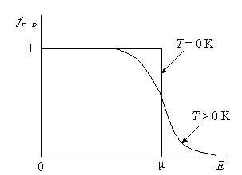
Figure 3.1

You can see that at T=0 K
$\begin{aligned}\left\{f_{F−D}=1,E<μ | \right.\end{aligned}$.
If particles aren’t subordinated to Pauli’s principle the Boze-Einstein function of distribution is used to describe its ideal gas.
$f_{B−E}=\frac{1}{e^{\frac{E−μ}{\text{kT}}}−1}$.
These particles are called Boze-particles or bozons and its ideal gas is boze-gas. Bozons are collectivists, because in a quantum state can be more than one particle.

Energetic Distribution of Electrons in Metals. Fermi’s Energy

We can consider electrons in metals as ideal gas that is governed by the Fermi-Dirak function of distribution:
$f_{F−D}=\frac{1}{e^{\frac{E−μ}{\text{kT}}}+1}$.
You can see that all quantum states with energy $E<μ$ are filled at T = 0 K, but if $E>μ$ they are free (Fig.3.1). Chemical potential $μ$ is the maximum energy of electrons in metal at T = 0 K. This energy is called Fermi’s energy:
$E_{F}=μ$.
The highest energetic level that corresponds to Fermi’s energy is called Fermi’s level. If T > 0 K the function of distribution $f_{F−D}$ is changed in $μ$-region. It can be explained by the transition of some electrons to the states of $E>μ$by the heat motion. The distribution of electrons with respect to energies is expressed in Fig.3.2.
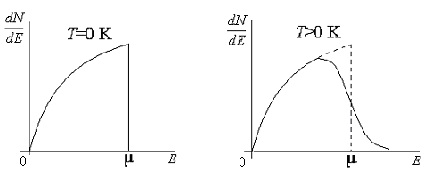
Figure 3.2

$\frac{\text{dN}}{\text{dE}}=\frac{4π{\left(2m\right)}^{\frac{3}{2}}}{h^{3}}⋅\frac{E^{\frac{1}{2}}}{e^{\frac{E−μ}{\text{kT}}}+1}$.
The energy of Fermi may be expressed as:
$E_{F}=\frac{h^{2}}{8m}{\left(\frac{3n}{π}\right)}^{\frac{2}{3}}$,
where $n=\frac{N}{V}$ is the concentration of electrons.
The relationship of energy of electron gas with temperature T may be expressed by the graph which is shown in Fig.3.3. Temperature $T_{0}$ is called degeneracy temperature.

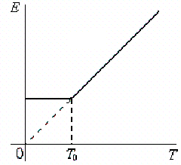
Figure 3.3

Internal Energy and Heat Capacitance of Electron Gas

Internal energy of electron gas is determined by average energy of electrons and their number:
$U=\bar{E}⋅N$,
where N is the number of electrons; $\bar{E}$ is the average energy of electron. Internal energy of one mole of electron gas is
$U_{m}=\bar{E}⋅N_{A}$,
$U_{m}=\frac{3}{5}E_{F}⋅N_{A}$.
Molar heat capacity of electron gas is
$C_{V}={\left(\frac{∂U_{m}}{∂T}\right)}_{V}$.
If $V=\text{const}$, $n=\frac{N}{V}=\text{const}$, $E_{F}=\text{const}$,
$C_{V}=\frac{3}{5}N_{A}E_{F}⋅\frac{5}{6}{\left(\frac{πk}{E_{F}}\right)}^{2}T=\frac{π^{2}R}{2}⋅\frac{\text{kT}}{E_{F}}$,
$C_{V}^{\text{cl}}=\frac{3}{2}R$,
$\frac{C_{V}}{C_{V}^{\text{cl}}}=\frac{π^{2}}{3}⋅\frac{\text{kT}}{E_{F}}≈0,\text{01}$.
The heat capacity of electron gas is less than heat capacity of crystal lattice. It is connected with the fact that only a little number of free electrons is subjected to thermal excitement, i.e. only those electrons energy of which is near the range of Fermi’s level. Fermi’s energy depends upon the temperature too:
$μ=μ_{0}\left[1−\frac{π^{2}}{\text{12}}{\left(\frac{\text{kT}}{μ_{0}}\right)}^{2}\right]$.

Lecture 4. Band STRUCTURE of Solids
Metals, Insulators, Semiconductors

Valency electrons interact with periodic field of a crystal lattice. This interaction results in some features of an electron behavior and of electric resistance.
Let us consider a formation of a crystal from separate atoms. As we know an energetical spectrum of an atom is discrete, Fig.4.1. If atoms approach closer to form the crystal lattice, the energy of electrons must be changed. Pauli’s principle is the reason of this. It doesn’t allow electrons to have the same energy. That is why the bands of electron energies are formed. This formation of bands is shown in the figure 4.1. In reality the number of electrons is the order of 6,02×1023$\frac{1}{\text{mole}}$. Thus in fact a distance between neighboring levels is very small. The point is that so called allowed energetic bands (shaded) are separated by forbidden energetic bands. Different solids are characterized by different arrangement of allowed and forbidden bands. the example is the forbidden band width [Eg]=[eV]. There are three main bands. If a potential difference is applied the energy of electrons can be rised and a current flows. For example Na 1s22s22p63s1. Insulators. Eg is the order of 36 eV. Electrons cannot overcome the forbidden bands. That is why insulators do not conduct the electric current. Under the action of the electric field the electron moves over to the adjacent energy levels. But it is possible only if the adjacent levels are free semiconductors. The band structure is the same, but Eg is less, the order of 1 eV. If a semiconductor is stimulated by the external factors, electrons can overcome the forbidden zone. The ways of stimulation (excitation) are heating, lightening or acting by X-rays.
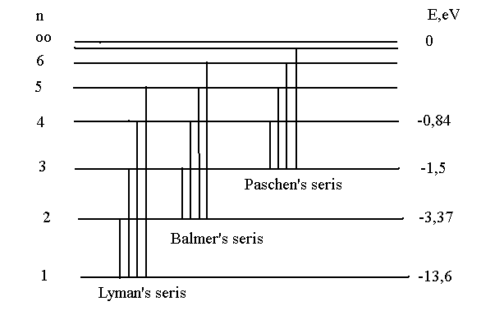
Figure 4.1

Band Theory of Semicinductors

Figure 4.2 shows a diagram of energy levels of an isolated atom. An assential property of the atomic wave function is its sharp dependence on the distance as $\vec{r}$exceeds a certain value it decreases exponentially.

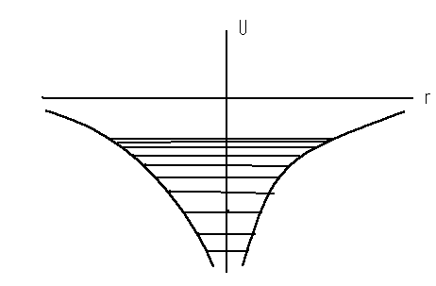
Figure 4.2

Suppose the crystal is “elongated” so that atoms cease to interact. In this case the periodic potential field of the crystal is made up of the potential fields of isolated atoms periodically repeated, and therefore
$U(r)=\sum_{n}{U(\vec{r}−\vec{n})}$, (4.1)
where translation vector is
$\vec{n}=n_{1}{\vec{a}}_{1}+n_{2}\vec{a}+n_{3}{\vec{a}}_{3}$. (4.2)
As long as atoms are attracted U(r) will be negative. When as a result of a very strong contraction of the crystal the atoms will begin to be repell, U(r) will turn positive.
Electron may, with some probability, be located near any atom. Two atoms may exchange electrons. The exchange takes place mainly between nearest atoms. Of the crystal takes place by way of a chain of nearest neighbor exchanges. In other words, electrons are not localized near individual atoms but move “freely” through the crystal jumping from one atom to another by the exchange process.
As the atoms are brought together energy levels are lowered by the amount c and split into a band of a definite width.
Energy depends quasicontinuosly on the wave vector k and changes from E min to E max
$\begin{aligned}E_{\text{min}}=E_{a}+c+6\left|A\right| \\ E_{\text{max}}=E_{a}+c−6\left|A\right|\end{aligned}$. (4.3)
Thus, as a result of atomic interaction the energy level of an isolated atom Ea drops by the amount c and splits into a band 12|A| wide. Energy bands are separated by forbidden energy intervals – forbidden bands, the energy band width depend on the exchange energy value A. But the exchange energy itself is dependent on the area overlapping of the wave functions: the more the atomic wave functions overlap, the greater will the exchange energy be. It follows from here that energy levels corresponding to inner electron shells do not split so intensely as those of the outer shells since the inner shell electrons are localized in smaller areas of space.

Effective mass of electron

The most important concept to describe the motion of electrons in solids is the effective mass m* concept.
The energy E of the electron and its wave function may be found from the equation
$\left[−\frac{ℏ^{2}}{2m}Δ+U(\vec{r})\right]Ψ(\vec{r})=EΨ(\vec{r})$. (4.4)
It can be said of the potential energy U(r) that in a crystal it should be a periodic function of the coordinates.
The solution of Schrödinger equation for the electron in a periodic feed $U(\vec{r}+\vec{n})=U(\vec{r})$ should be of the form
$Ψ(\vec{r})=e^{\text{ikr}}ϕ_{r}(\vec{r})$. (4.5)
Electron energy is a function of the wave vector
or $\begin{aligned}E=E(\vec{k}) \\ E=E(\vec{P})\end{aligned}$. (4.6)
The non-periodic part of the potential field $ΔU(\vec{r})$changes the quasimomentum. This means that any deviation from the ideal lattice field cause changes in the quasimomentum P and consequently, any defects in the ideal lattice occasion the scattering of electron waves. Such deviations of U(r) from periodicity are caused by thermal vibrations and lattice imperfections. Electron scattering on these defects is the physical reason for electric conductivity being finite. If an external force field U(r) is applied to the ideal crystal, the quasimomentum will change only under the influence of external force Fa; the momentum, on the other hand, changes under the combined influence of external Fa internal ${\vec{F}}_{i}=−ΔU(\vec{r})$forces
$\frac{d\vec{P}}{\text{dt}}=\vec{F}+{\vec{F}}_{a}$. (4.7)
Now the equation for constant – energy surface assumes the form
$E(\vec{k})=E({\vec{k}}_{0})+\frac{1}{2}\sum_{i=1}^{3}{\frac{d^{2}E}{{\text{dk}}_{i^{2}}}⋅(k_{i}−k_{0i})^{2}=\text{const}=E}$. (4.8)
It is expand E(k) around one of the extremal point k0. The expression for energy in terms of the reciprocal effective mass tensor may be written in the form
$E(\vec{P})=E_{0}+\frac{1}{2m^{x}}(\vec{P}−{\vec{P}}_{0})^{2}$, (4.9)
which looks like the expression for kinetic energy of a free particle having the momentum P-P0.
Introduce a tensor reciprocal to the reciprocal effective mass tensor
${\left[m^{x−1}\right]}^{−1}=m^{}$. (4.10)
We will term it the effective mass tensor. Quasimomentum changes under the action of an external field Fa which results from any disturbance of the periodical field. The point in k (or P) space representing the state will move in compliance with the equation
$\frac{d\vec{P}}{\text{dt}}={\vec{F}}_{a}$. (4.11)
As soon as the particle begins to move in the quasimomentum space, it will shift from one energy surface to another. In other words, external force F_{a} changes not only the quasimomentum but the particle energy, as well. We may write
$\frac{1}{m∗}=\frac{d^{2}E}{{\text{dp}}^{2}}\frac{1}{ℏ^{2}}\frac{d^{2}E}{{\text{dk}}^{2}}$. (4.12)
For example for $a^{x}$ takes the form
$a^{x}=\frac{1}{m_{\text{xx}}}F_{x}+\frac{1}{m_{\text{xy}}}F_{y}+\frac{1}{m_{\text{xz}}}F_{z}$. (4.13)
The acceleration will be collinear to the force only when the force is directed along one of the ellipsoid axes.
$a_{j}=\frac{F_{j}}{m_{j}}$, (4.14)
secondly, only the external force F_{a} imparts acceleration to the electron; internal forces F_{i} cannot impart any acceleration to the electron. Thirdly, the effective mass m* is not the normal mass serves as a dynamical characteristic of the electron that determines its reaction to external forces. This means that though the electron is not accelerated by the lattice field, the latter influences the charges in its motion under external forces. In other words, in the presence of external forces the lattice field manifests itself in that the dynamic properties of the election are no longer determined by its mass, but by its effective mass. When the election is in the vicinity of an energy maximum its effective mass is negative, and its acceleration $\vec{a}$ is directed against the external force F_{a}
$\vec{a}=−\frac{\vec{F}}{}$. (4.15)
If, on the other hand, the electron is near an energy minimum, then m*>0 and the acceleration is in the direction of the force.

Intrinsic Semiconductors

Intrinsic semiconductors do not contain impurities. They have a crystal lattice of diamond. They are Si and Ge. As electrons carry negative, so called holes carry the positive charge: $q_{e}=−e;q_{p}\text{=+}e$. The number of electrons and holes are equal. The generation of conduction electrons and holes in an intrinsic semiconductor takes place. Conductivity
$σ=\left|e\right|(n\frac{υ_{n}}{E}+p\frac{υ_{p}}{E})$, (4.16)
where n and p are the concentrations of electrons and holes respectively. $ρ=\frac{1}{σ}$ is related to T
$σ\text{\sim }f(E)=\frac{1}{e^{\frac{E_{g}}{2\text{kT}}}+1}≈e^{\frac{E_{g}}{2\text{kT}}}$. (4.17)
The more is $σ$, the less is $ρ$
$ρ={\text{Ae}}^{\frac{E_{g}}{2\text{kT}}}\text{=>}\text{ln}ρ=\text{ln}A+\frac{E_{g}}{2\text{kT}}\text{.}$ (4.18)

Extrinsic Semiconductors

An important feature of semiconductors is the noticeable dependence of their conductivity on impurities. An insignificant amount of impurity sharply increases the conductivity of semiconductors. For example one atom of boron B per 105 atoms of Si decreases ρ in 10000 times. The atoms of impurity can be ionized. Some atoms tend to give electron (donors) and other atoms prefer to take an electron (acceptors). We should distinguish between semiconductors of n- and p-type. Let us consider atoms of As5 in Si4 as type donor impurity. The electron leaves atom of As5 and roves inside the lattice. Atom As+ is immobile. If an external voltage is applied semiconductor conducts electric current. Electrons are called main carriers of charge. Now let’s consider atom of BIII in SiIV. Boron’s atom takes one electron of two in fact. A hole is a broken binding. This broken binding can rove in the crystal.

P-n juction

Let us consider a contact between an electron and a hole type of the same semiconductor. The electrone concentration inside the n-type semiconductor is much more than inside the p-type. This results in a diffusion flux across the boundary between semiconductors. As some electrons left n-p boundary a positive uncompensated charge rises. Similar holes will go over to n-region charging the p-region negatively. As the result a double layer of charge originates and the process stops. So called potential barrier arises. Concentration of electrons an p-region is given by
$n=n_{0}e^{−\frac{{qϕ}_{0}}{\text{kT}}};$ (4.19)
I_{diffusion} + I_{drift}= 0 .
Currents are compensated each other. Thus equilibrium is achieved little by little. Now let us put a voltage to the semiconductor pair. Let us assume that the minus electrode is connected with n-type and plus is connected with p-type. The positive pole of a generator may be connected to either n on p. One can see that field that is applied helps main carriers to conduct the electricity. One can speak of the external field decreasing the potential barrier between semiconductors. The resistance decreases and the current intensity increases. The concentration of electrons in p - semiconductor may be expressed as
$n=n_{0}e^{−\frac{{qϕ}_{0}−\text{qU}}{\text{kT}}}=n_{0}e^{−\frac{{qϕ}_{0}}{\text{kT}}}e^{\frac{\text{qU}}{\text{kT}}}$. (4.20)
This concentration extremely increases with U. In the second case the external electric field hinders motion of major carriers and prevents the resistance increases. The concentration of electrons in this case is
$n=n_{0}e^{−\frac{{qϕ}_{0}+\text{qU}}{\text{kT}}}=n_{0}e^{−\frac{{qϕ}_{0}}{\text{kT}}}e^{\frac{\text{qU}}{\text{kT}}}$. (4.21)
This is so called reverse direction of the voltage. Such properties of p-n junction may be used in order to rectify a current. The dependence of the current I on the externally applied potential U is the voltage – ampere characteristic. The equation of the voltage – ampere characteristics may be expressed as
$I=I_{\text{dr}}(e^{±\frac{\text{qU}}{\text{kT}}}−1)\text{.}$ (4.22)

Lecture 5. Physical Fundamentals of Electric Properties of Solids

Theory of Free Electrons in Metals

Electrical properties are characterized by the specific resistivity $ρ$ or by the specific conductivity. All solids can be classified proceed $ρ$ values in the following way.

Substance | $$ρ,Ω×m$$
Metals  Semiconductors  Dielectric Insulators | $${\text{10}}^{−8}$$  $${\text{10}}^{−4}\text{.}\text{.}\text{.}{\text{10}}^{9}$$  $${\text{10}}^{\text{12}}\text{.}\text{.}\text{.}{\text{10}}^{\text{20}}$$

Metals and semiconductors differ ones another by dependence $ρ$(T). In metals the valence electrons do not belong individual atoms. They are free to move about within the lattice. These free delocalized electrons form so called electronic gas. In the absence of an external electric field electrons move completely chaotic. Average speed v for copper is equal to 1,6106 m/s. The electrons collide constantly with the ionic cores and change their velocity in quantity and in direction. The behavior of electrons in metals is like behavior of gas molecules. Thus laws of molecular physics can be used during considering of electrical conductivity.
When an electric field is applied to a metal, electrons modify their random motion in such a way that they drift slowly with an average speed $υ_{\text{dr}}$.
$υ_{\text{dr}}=\frac{λ}{τ}$. (5.1)
Here$λ$is a mean free path of electrons between collisions, $τ$- time between collisions. As $s\bar{λ}$is a volume; $\text{ns \{}\bar{λ}$is a number of electrons within this volume; $\text{ens \{}\bar{λ}$is the charge of electrons, then
$I=\frac{e⋅n⋅s⋅\bar{λ}}{τ}=\text{ens}υ_{\text{dr}}\text{.}$ (5.2)
Current density is
$j=\frac{I}{S};$ (5.3)
$[\frac{c}{m^{3}}\frac{m}{s}]=[\frac{c}{{\text{sm}}^{2}}]=[\frac{A}{m^{2}}]$;
$j=\text{en}υ_{\text{dr}}$. (5.4)
The unit of current density is $\frac{A}{m^{2}}$. According to the Newton’s Second law
$m\vec{a}=e\vec{E}−δm{\vec{υ}}_{\text{dr}}$, (5.5)
$δ=\frac{1}{τ}$, (5.6)
$m\vec{a}=e\vec{E}−\frac{1}{τ}m{\vec{υ}}_{\text{dr}}$, (5.7)
$[\frac{1}{s}⋅\text{kg}⋅\frac{m}{s}]=[N]$
$m\vec{a}=e\vec{E}−m\frac{{\vec{υ}}_{\text{dr}}}{τ}\text{.}$ (5.8)
If $\vec{a}=0$
$m\vec{a}=δmυ_{\text{dr}}$, (5.9)
$υ_{\text{dr}}=\frac{\text{eE}}{δm}=\frac{τ\text{eE}}{m}\text{.}$ (5.10)
Substituting (5.10) to (5.4) we obtain
$j=\frac{{\text{ne}}^{2}τ}{m}E,$ (5.11)
or
$j=\frac{{\text{ne}}^{2}λ}{{mυ}_{\text{dr}}}E$. (5.12)
$\vec{j}=σ\vec{E};\vec{j}=\frac{\vec{E}}{ρ}\text{.}$ (5.13)
This is Ohm’s law in differential form. Specific resistivity is
$ρ=\frac{{mυ}_{\text{dr}}}{{\text{ne}}^{2}λ};$ (5.14)

Wiedemann - Franz Law

There is connection of heat conductivity and electric conductivity in metals. This law is concerned to metals. The following conclusions may be deducted from the free electrons theory: the ratio of the thermal conductivity is the same for all the metals and proportional to the absolute temperature. We have obtained
$σ=\frac{{\text{ne}}^{2}\vec{λ}}{{mυ}_{\text{dr}}}\text{.}$ (5.15)
Proceeding from the gas theory for electrons
$χ=\frac{1}{3}υ_{\text{dr}}⋅\bar{λ}⋅n⋅C_{V}\text{.}$ (5.16)
$\frac{χ}{σ}=\frac{\frac{1}{3}υ_{\text{dr}}⋅\vec{λ}⋅n⋅C_{V}⋅{mυ}_{\text{dr}}}{n⋅e^{2}⋅\vec{λ}}=\frac{1}{3}{mυ}_{\text{dr}}^{2}⋅\frac{C_{V}}{e^{2}}=\frac{2}{3}\frac{{mυ}^{2_{\text{dr}}}}{2}\frac{C_{V}}{e^{2}}=\frac{2}{3}⋅\frac{3}{2}\text{kT}⋅\frac{\frac{3}{2}k}{e^{2}}=\frac{3}{2}(\frac{k}{e})^{2}T$ (5.18)
Consequently the more is the electric conductivity the more is thermal conductivity. The reason is heat and charge are being carried by electrons.
The Wiedemann–Franz law states that the ratio of the electronic contribution to the thermal conductivity and the electrical conductivity of a metal is proportional to the temperature.
The Wiedemann–Franz law is generally valid for high temperatures and for low (i.e a few kelvins) temperatures, but may not hold at intermediate temperatures.

Fermi’s Energy of Electrons in Metals

Our aim is to calculate the energy of electrons in metals. As far as we know electronic gas is described by statics of Fermi – Dirac, $E_{F}\text{>>}\text{kT}$.
$g(E)\text{dE}=\frac{2πV}{h^{3}}(2m)^{3/2}E^{1/2}\text{dE}\text{.}$ (5.17)
Spins are directly oppositely. The number of electrons may be expressed as
$N=2\int_{0}^{E_{F}}{g(E)\text{dE}}=\frac{4πV}{h^{3}}(2m)^{3/2}2\int_{0}^{E_{F}}{E^{1/2}\text{dE}=\frac{8πV}{3h^{3}}}(2m)^{3/2}E_{\text{Ep}}^{3/2}\text{.}$(5.18)
Since $n=\frac{N}{V}$,
$n=\frac{8π}{3h^{3}}(2m)^{3/2}E_{F}^{3/2}\text{=>}[E_{F}^{3/2}]^{2/3}=[\frac{3h^{3}}{8π(2m)^{3/2}}n]^{2/3}\text{.}$ (5.19)
Let us raise product to power 3/2
$E_{F}=\frac{h^{2}}{8m}(\frac{3n}{π})^{3/2}$ (5.20)
Let’s calculate Fermi’s Energy for Cu
$μ\frac{\text{kg}}{\text{mole}}$ corresponded to $N_{a}\frac{\text{molecules}(\text{atoms})}{\text{mole}}$
m kg corresponded to N atoms
$N=\frac{m}{μ}N_{a}$ . (5.21)
Dividing by volume, we obtain
$n=\frac{N}{V}=\frac{m}{V}\frac{N_{a}}{μ}$, (5.22)
$$n=\text{8900}\frac{6,\text{02}×{\text{10}}^{\text{23}}}{\text{14}×{\text{10}}^{−3}}=8,\text{37}×{\text{10}}^{\text{28}}m^{−3}\text{.}$$
$$E_{F}=\frac{(6,\text{62}×{\text{10}}^{−\text{34}})}{8×9,\text{11}×{\text{10}}^{−\text{31}}}(\frac{3×8,\text{37}×{\text{10}}^{\text{28}}}{π})^{2/3}=1,1×{\text{10}}^{−\text{18}}I\text{.}$$
At 1000 K kT=1,38×10-20I. EF>>kT
$\text{kT}≈E_{F}\text{=>}T=\frac{1,1×{\text{10}}^{−\text{18}}}{1,\text{38}×{\text{10}}^{−\text{23}}}=\text{79700}K$.

Superconductivity

Since a crystal always has a considerable number of imperfections, it will usually possess a residual resistance, which is reached at a temperature of several degrees Kelvin, i.e, below this point the resistance does not decrease with temperature.
There exist the metals which behavior quite differently. At definite temperatures close to absolute zero, such metals completely lose their electrical resistance, when an electric current is induced in such a superconductor, the current will flow in the circuit for days.
Superconducting materials include, in addition to pure metals, numerous alloys of such nonsuperconducting metals. The disappearance of electrical resistance at temperature Tκ is not the only peculiarity of superconductors.
Another mark of a superconductor is its characteristic behavior in a magnetic field: a magnetic field penetrates such a conductor to a depth of only about 1 Ǻ. The magnetic field inside a superconductor equals zero. However, this is true only as long as the applied external field does not exceed a certain critical value H_{c}. When this value is exceeded, the superconducting state disappears - the magnetic field penetrates the material and electrical resistance is restored.
Electrical resistance is due to the scattering of electrons by the thermal waves of atoms in crystal lattice. These thermal waves exist, as we know, because of the presence of a zero energy, even at absolute zero. It would seem, there fore, that electrical resistance should not disappear no matter how mach the temperature is decreased.
This problem was not solved until 1937 when it was proved by means of quantum mechanics that electrons in a thin energy layer next to a Fermi surface are able to become «paired» thanks to interaction with the thermal vibrations of a crystal lattice.
It transpired that at low temperatures it is advantageous from the energy viewpoint for two electrons of equal spin magnitude but opposite spin direction to become «united». The calculations indicate that the wave functions of these electrons extend over a large distance ~(10÷4) cm.
There fore, the formed pairs should not be viewed as peculiar «molecules», since the bond is implemented over a large distance by means of thermal waves. It follows from the theory that all electrons pairs are identical in the sense that they have the same total momentum. «Matter» consisting of such electron pairs possesses superconduction properties. The formation of electron pairs does not eliminate the thermal scattering of electrons.
Superconduction occurs because the scattering of the electrons of a pair ceases to effect the current strength. Thermal scattering can only break up one or another pair or from a new pair from separate electrons, but the magnitude of the current is determined by the total momentum of the electrons, wich remains unchanged.
The phenomenon called superconductivity was discovered by Kammerlingh Ohnes in the Netherlands in 1911. He studied mercury and found that in space of about 0.05 K at 4.2 K the resistance drops abruptly up to zero practically. The resistance of materials in the superconducting state seems to be zero; in any case ρ_{sup}< (10÷18) Ω·m (compare ρ_{cu}=1.7×10⁻⁸ Ω×m). A current once established in a closed circuit persists circulates for months and years. T_{c} = 4.2 K for mercury is called the critical temperature. A magnetic field can not penetrate in a superconductor. In other words the semiconductor is an ideal diamagnetic. The state of superconductivity can be destroyed:
- if the temperature increases above over T_{c}, (T>T_{c});
- if the magnetic field is applied, (B>B_{c});
- if the critical current flows, (I>I_{c}).
$B_{c}=B_{0}[1−\frac{T}{T_{c}}]\text{.}$ (5.23)
The more B_{c} the less T_{c}. There are ~25 superconductive metals and some compositions.

Material | Tc, K | Hc, A/m
Hg | 4,2 | -
Al | 1,2 | -
Sn | 3,7 | 8000
Pb | 7,2 | 64000
Nb3Sn | 18,0 | -
Nb3Ge | 23,2 | 200×105
$$\begin{aligned}\left\{\text{La-Ba-Cu-O} | \right.\end{aligned}$$ | 40 | -
 | 100 | -
The physical nature of superconductivity contains in the following. At T<Tc some electrons forming pairs. It’s a quantum effect. The charge of carriers e0=2e. The binding energy E =3,5 kTc. A distance between electrons is the order of 10-6m, it is more than a distance between atoms. The motion of electron pairs and phonons is coordinated with each other. That is why electrons carrying charge do not scatter by heat oscillations.

Emission of electrons

Electrons in a conduction band behave like an electron gas. The surface of a solid acts as the «walls» of the vessel in which this gas is located. To leave the bound of this surface, an electron must surmount a potential barrier the height of which is designated by ε at absolute zero. Electrons have a limitins energy W – Fermi energy is the energy of electrons which at absolute zero are located at the highest level. Thus, in order for an electron to surmount the potential barrier, it is not necessary to impart to it an energy ε; it is sufficient to give it an additional energy
A= ε – W. (5.24)

Work function

The work must be expended to transport an electron from a solid into vacuum. Assume the energy origin to be the energy of an electron immobile in relation to the body and placed in vacuum at an infinite distance from the body. In this case total energy of electrons at rest inside the body will be negative. The kinetic energy of the electrons at the bottom of the conduction band is zero, and its total energy, from the stand point of classical physics, is potential.
Let the position of the bottom of the conduction band Ec in the “absolute” energy scale defined above be – W(W>0), W is equal to the work must be performed to transport an electron resting inside the solid into vacuum without imparting kinetic energy to it. W is termed true work function.
The energy level above Ec and up to the Fermi level are practically all occupied electrons. Electrons with a negative total energy cannot leave the metal. But some of the electrons have a positive total energy and they can leave the metal.
Calculate the number of electrons capable of negotiating a rectangular potential barrier of the height W and leaving the metal. To this end the kinetic energy of the electron determined by its velocity Vx should be no less than the height of the potential barrier
$\frac{m^{}υ_{x^{2}}}{2}≥W;\frac{m^{}υ_{x^{2}}}{2}+E_{c}=E≥0$, (5.25)
it will be assumed that all the electrons that have left the metal are trapped by some external field and are unable to return into the metal.
This assumption makes it easy to write an expression for the density of current flowing from the vacuum to the metal
$γ_{x}=e\int_{υ_{x\text{min}}}^{∞}{\int{υ_{x}2\frac{m^{x}}{h^{3}}e^{−\frac{E−F}{\text{kT}}}{dυ}_{x}{dυ}_{y}{dυ}_{z}}}$ (5.26)
or $γ_{x}=\frac{4π{\text{em}}^{}k^{2}T^{2}}{h^{3}}e^{\frac{F}{\text{kT}}}={\text{AT}}^{2}e^{\frac{F}{\text{kT}}}$
$A=\frac{4π{\text{em}}^{}k^{2}}{h^{3}}=\text{120}\left(\frac{m^{}}{m}\right)\frac{A}{{\text{cm}}^{2}k^{2}}$ , (5.27)
denote the distance from the energy origin to the Fermi level F by Φ, i.e. put
$F=−Φ\left(Φ≥0\right)$. (5.28)
Then jx will be equal to $j_{x}={\text{AT}}^{2}e^{−\frac{Φ}{\text{kT}}}$ Richardson’s formula. Φ is termed thermodynamically electron work function of the metal. Numerically is equal to the work which should be performed an electron occupying the Femi level from the metal.
Indeed, the metal having lost some of its electrons becomes positively charged. The electric field established thereby retains the electrons and returns them to the metal.
A schematic diagram of energy levels in a metal and a semiconductor, fig.5.1. The energy of an electron at rest in vacuum is taken as the energy origin.
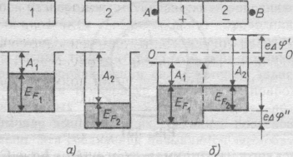
Figure 5.1

Contact potentional difference. Metal-metal contact

Should the materials be brought into contact they would start exchanging electrons. Particles go over from a subsystem with a higher Fermi level to a subsystem with a lower Fermi level. The variation of the system thermodynamic potentional Φ is
$dΦ\text{==}F_{1}{\text{dN}}_{1}+F_{2}{\text{dN}}_{2}$. (5.29)
Directional particle flow continues until owing to certain physical processes connected with the flow, the chemical potentionals become equal.
When two bodies are brought into contact, a directional particle flow from the body with the smaller work function to the body with the greater work function is initiated. The Fermi levels of both bodies become equal
F1=F2.. (5.30)
Since the bodies become charged, a potential difference and an electric field is established between them. In a metal the electric field is localized in thin layer the thickness of which is much less than the lattice constant.
A potential difference φ termed external contact potential difference should exist between any two points on the outside surface of the metals. The value of this contact potential difference may be obtained with the help of simple reasoning: the energy levels in two points rise and drop, so that their displacement becomes equal to the difference of the respective work function, therefore
${eϕ}_{\text{21}}=V_{\text{12}}=Φ_{1}−Φ_{2}$. (5.31)

Lecture 6. The Magnetic Field in Materials
Diamagnetic, Paramagnetic and Ferromagnetic Materials

Moving charges exist in the atoms of material. A magnetic field acts on these charges with the Lorenz force. The influence of a magnetic field on a body is defined by the nature of the motion of such charges, their velocity, the shape and position of the trajectory they describe inside the body.
All materials have magnetic properties; such properties are discovered by placing the body in a magnetic field. The following phenomena are observed:
- The magnetic field acts on the body with some forces. In nonhomogeneous field some bodies move in the direction of increasing field intensity, i.e., are attracted by the field. They are paramagnetics. Other bodies are moved in the direction of decreasing field intensity, i. e., are repelled by the field. They are diamagnetics.
- The field may magnetize the substance, so that the body obtains its own magnetic field wich superposed itself on the basic field. This magnetic field opposes the external field in diamagnetics and has the same direction as external field in paramagnetics.
If the material is placed inside a long, uniformly wound solenoid, so that no field, for practical purposes, exists outside the body. In such cases the magnetic vector B inside the medium consists of the vector B₀ of the external magnetizing field, and the vector B₁ possessed by the material itself when it is magnetized
B= B₀+B₁ , (6.1)
B₁ depends on the magnetic properties of the medium only.
The quantity χ is called the magnetic susceptibility and is an important magnetic characteristic of a substance. Thus the relative magnetic permeability of a medium is connected to the magnetic susceptibility by the relation
μ =1+ χ , (6.2)
where χ is negative for diamagnetics, χ<0 , μ<1, and the vector В₁ is in the opposite direction to the vector B₀, where χ is positive for paramagnetics,
χ > 0, μ > 1 and the vector B₁ is in the same direction as B₀.
The magnetization of a material is measured by the magnetic moment I per unit volume of the material; it is the total magnetic moment of all the molecules, atoms and electrons in this volume. The vector I is connected with the intensity H₁ and induction B₁ of the proper magnetic field of the material.
Let us assume that the magnetization of a materials fixed by uniform position of the electron orbits in atoms with respect to the direction of the external field. Divide the interior of the substance into cylindrical volumes of base S, equal to the area of the orbits, and length L, wich contains a large number n of such orbits. The vector I is called the intensity of magnetization or the magnetization of the material. The magnetic induction vector of the proper magnetic field of the material B₁ according to
B₁= χ B₀ . (6.3)
On the other hand
${\vec{B}}^{1}=μ_{0}\vec{H}=μ_{0}\vec{Ι}$ (6.4)
and
${\vec{B}}_{0}=μ_{0}\vec{H}$. (6.5)
So that the magnetization vector may be written in a form showing its dependents on the intensity $\vec{H}$ of the external magnetization field:
$\vec{Ι}=$ χ $\vec{H}$. (6.6)
As a consequence, the substance is placed in an external magnetic field H (x,y,z) the induction inside it
$\vec{B}={\vec{B}}_{0}+{\vec{B}}^{1}=μ_{0}\vec{H}+μ_{0}\vec{Ι}=μ_{0}(\vec{H}+\vec{Ι})$. (6.7)
Ferromagnetic materials, wich are paramagnetics with very large values of χ and $μ$, have important scientific and industrial applications:
Iron $μ=5,\text{000}−\text{15},\text{000}$;
Nickel $μ≈\text{300}$ ;
Cobalt $μ≈\text{180}$ .
Thus, the value of the proper magnetic field vector ${\vec{B}}^{1}$ is very much larger than the value of external magnetization field vector ${\vec{B}}_{0}$ for such materials (the directions of $\vec{B}$ and ${\vec{B}}_{0}$are the same).
Conclusions:
- diamagnetism is a property of all bodies as the magnetic field acts on electron orbits in the atoms and molecules of the material;
- any change in the velocity of the electrons in their orbits is accompanied by the appearance of a magnetic field which is directed against the external field and weakens it (Lenz’s Law); thus, every material opposes the setting up of a magnetic field inside it;
- the diamagnetic effect is not connected with any ordering of the positions of the electron orbits, so that the diamagnetic susceptibility χ does not depend on the temperature;
- a material is diamagnetic if its atoms and molecules do not possess their magnetic moments; then demagnetization is the only relation of the material to the action of an external magnetic field. The magnetization of paramagnetics and ferromagnetics is heaped by the uniform distribution of their elementary magnets.
Materials which atoms and molecules, in the absence of an external field, have some magnetic moment p (they contain an odd number of electrons) have paramagnetic properties. Thermal motion makes the orientation of the magnetic moments completely random, so that the total projection of the vectors p on some direction is zero in the absence of a magnetic field. When a field is switched on the projection of p on the field direction is no longer zero so that the material is magnetized.
The magnetization of ferromagnetics is not governed by the orientation of the electron orbits in the field but by the orientation of the proper magnetic moment (the spin) of these electrons. Einstein-de Haas conducted experiment where a small ferromagnetic rod hanging from a thread of quartz was placed inside a solenoid through which a varying current flowed.
Every crystal has a large number of areas which are magnetized to saturation in one of their directions of easiest magnetization. Such regions of «spontaneous» (occurring by themselves) magnetization are called domains. The total magnetic moment of all the domains is zero in the absence of a field, which corresponds to the stable state of the crystal.
When an external magnetic field is switched on, couples act on the electrons and orient them in the field. As the external field intensity is increased the relatively easy process of rotating the vectors p₀ between the domains starts. This leads to an increase in size of those domains whose magnetization vector is inclined at a small angle to the external field, at the expense of those domains angle is large. Thus the domain structure of the material is continuously ruptured until the crystal is finally magnetized in one direction only.
The investigation of the dependence of magnetization on temperature leads to the following result. As the temperature increases some electrons, on account of their thermal motion turn over to their antiparallel states. The number of such electron transitions increases as the temperature rises, especially sharply near the Curie temperature, at the number of parallel and antiparallel spins becomes equal and the spontaneous magnetization of the domains disappears. Above the Curie temperature T_{c}, when the ferromagnetic material becomes a paramagnetic. The susceptibility depends on the absolute temperature according to Curie – Weiss Law
χ $=\frac{C}{T−T_{e}}$ , (6.8)
where C is const. The Curie temperature of some materials:
Iron - 768 $C$ Nickel - 358 $C$ Cobalt - 1120 $C$
Magnetic hysteresis is observed during magnetization. The magnetization changes one dependence of B on H, to another dependence during demagnetization. By increasing the intensity of external field from H = 0 to some fixed value, we may change the bodies magnetization to the value corresponding. By decreasing H the induction B decreases for H = 0 there is a residual magnetism. To completely demagnetize the body it is essential to apply a reverse filed H_{k}, this intensity is called the coercive force and is a characteristiс of the magnetic properties of the body. As the field is in the revers directions, the magnetization occurs. The area of the hysteresis loop in the scale of the drawing denotes the work done by the external field during one magnetization of the body. The work done in overcoming the forces tending to hold the «domains» in some fixed orientation.
This work is transformed into heat energy. This work is small for «soft» ferromagnetics. «Hard» ferromagnetic have a large value of coercive force.

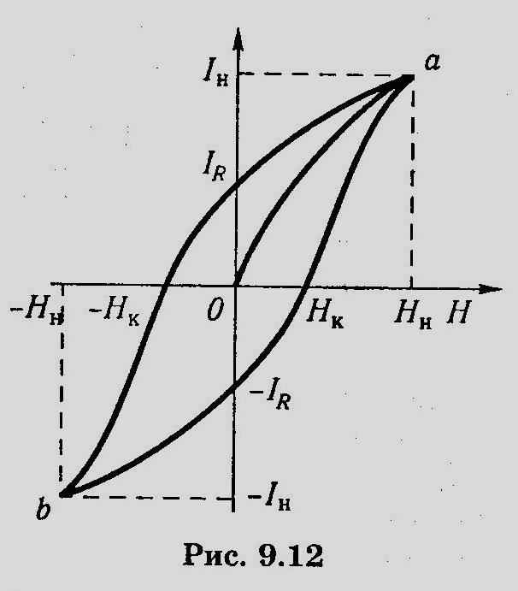
Figure 6.1

Magnetic moments of atom

According the idea of Ampere, moving electrons in the atoms and molecules creates microcurrents in material
$I=eν=e⋅\frac{υ}{2πr}$, (6.9)
where ν - frequency of electron rotation; υ - velocity of electron; r -radius of orbit. Microcurrent has a orbital magnetic moment:
$\vec{P_{m}}=\text{IS}\vec{n}$. (6.10)
Module of ${\vec{P}}_{m}$ is
$P_{m}=\text{IS}=eνS=e⋅\frac{υ}{2πR}⋅{πr}^{2}=\frac{1}{2}eυr$, (6.11)

where S is area of electron orbit. Direction of ${\vec{P}}_{m}$ is the same as the direction of vector magnetic induction in the centre of circular current. This direction is determined according to the right – hand screw rule.
Electron possess the orbital mechanical moment
${\vec{L}}_{e}=m\left[\vec{r},\vec{v}\right]$. (6.12)
Module of ${\vec{L}}_{e}$ is
$L_{e}=mυr=2mνS$, (6.13)
where $υ=2\text{πν}r$ , $S={πr}^{2}$.
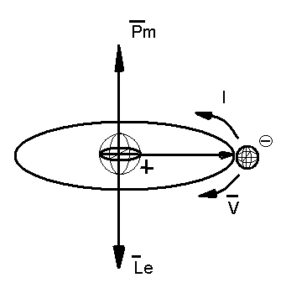
Figure 6.2

Direction of ${\vec{L}}_{e}$ is opposite to vector${\vec{P}}_{m}$. From comparison formula for ${\vec{P}}_{m}$ and L_{e} we obtain
$\frac{P_{m}}{L_{e}}=\frac{e}{2m}$, (6.14)

${\vec{P}}_{m}=−\frac{e}{2m}{\vec{L}}_{e}=g{\vec{L}}_{e}$, (6.15)
where
$g=−\frac{e}{2m}$ (6.16)
- giromagnetic ratio of orbital moments. In 1915 Einstein and Haaz found that the experimental value g is in twice more than theoretical., i.e. $−\frac{e}{m}$. This fact (connected) explained that electron has own mehanical moment of impulse Les. It is called spin. Spin is the one of characteristics of electron as mass and charge. The own magnetic moment corresponds to spin
$L_{\text{es}}=\frac{\sqrt{3}}{2}⋅\frac{h}{2π}$, (6.17)

where h – Planck’s constant. Then
, (6.18)
where $μ_{b}=\frac{h}{4π}⋅\frac{e}{m}$ is magneton of Bohr. In magnetic field spin has only two orientations.The are only two values projections of spin on the direction vector of magnetic induction$\vec{B}$.
$P_{{\text{ms}}_{B}}=±\frac{e\bar{h}}{2m}=±μB$. (6.19)
There are three reasons of magnetic moments of atoms:
- motion of electrons in electronic shells;
- spin of electrons;
- magnetic moment of nuclei.
Magnetic moment of atom more less then magnetic moment of electrons.

Atom in magnetic field

All bodies placed in a magnetic field possess a magnetic moment. Acting a magnetic field on the orbital moving electrons in atoms is the reason of magnetization.
In the absence of an external magnetic field the microcurrents are oriented chaotically. Under the action of a magnetic field the magnetic moments of atoms become oriented along the field. The rotating moment acts on the moving electron in magnetic field
$\vec{M}=\left[{\vec{p}}_{m,}\vec{B}\right]=\left[g{\vec{l}}_{e}\vec{B}\right]=\left[−g\vec{B}{\vec{l}}_{e}\right]$. (6.20)
According to basic law of rotational motion dynamic
$\frac{d{\vec{l}}_{e}}{\text{dt}}=\left[−g\vec{B}{\vec{l}}_{e}\right]$ ; $\frac{d{\vec{p}}_{m}}{\text{dt}}=\left[−g\vec{B}{\vec{p}}_{m}\right]$. (6.21)

Vector $−g\vec{B}$ is oriented along $\vec{B}$
. (6.22)
Velocity of electron is $\vec{v}=\frac{d\vec{r}}{\text{dt}}=\left[\vec{ω},\vec{r}\right]$.
From comparison of these equations we obtain, that
. (6.23)
Vectors ${\vec{l}}_{e}$ and ${\vec{p}}_{m}$ rotate by acting of magnetic field. In this case vectos ${\vec{l}}_{e}$ and ${\vec{p}}_{m}$ describe so axis with $\vec{B}$ circular cone surfaces.
That motion is called precession of Larmor. The theorem of Larmor takes place: the precession of orbit and vector ${\vec{p}}_{m}$ with angular velocity $ω_{L}$ around axis that pass throught atom nuclei and parallel to vector magnetic induction $\vec{B}$, is only one result of magnetic field influence on the orbit of electron in atom.
Hall’s effect

Hall’s effect was discovered by American scientist E. Hall in 1870. Hall’s effect is the existence of e.m.f. in metal or semiconductor specimen with electric current, which is situated in external magnetic field. Let’s consider specimen in external magnetic field (Fig. 6.3).
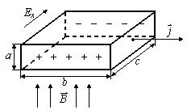
Figure 6.3

Lorentz's force is acting upon a positive charge in the magnetic field. The direction of this force is determined by the rule of left hand. As a result on the lateral planes of the specimen electromotive force of Hall arises.
Accumulation of charges will exist until formation of field intensity Ex which equalizes Lorentz's force and as a result stationary distribution of charges in the polar direction will occur. In this case
${\text{qE}}_{x}=q\frac{Δϕ}{c}$ , (6.24)
$q\frac{Δϕ}{c}=qυB$, (6.25)
$Δϕ=υ\text{Bc}$. (6.26)
Let’s determine velocity $υ$
$I=\text{jS}=\text{nq}υS$ $(S=a⋅c)$, (6.27)
$υ=\frac{I}{\text{nqac}}$. (6.28)
Then
$Δϕ=\frac{I}{\text{nqa}}B=\frac{1}{\text{nq}}⋅\frac{\text{IB}}{a}=R\frac{\text{IB}}{a}$, (6.29)
where $R=\frac{1}{\text{na}}$ is Hall constant.
By measuring R we can determine concentration of the current carriers in the conductor and assume the nature of conductance, as the sign of Hall’s constant coincides with that of current carriers charge.
Hall’s effect has very wide practical applications: devices to measure of currents of high frequency, constant and variable magnetic fields etc.

Lecture 7. Photoconductivity OF Semiconductor`S

Semiconductor photoconductivity arises under the action of electromagnetic radiation. Photoconductivity is a result of internal photoeffect. The internal photoconductivity occurs if the energy of a photon is more than a width of a forbidden zone
$hν≥{ΔE}_{g}$. (7.1)
In this case electrons pass from valence zone to conduction one (Fig. 7.1)
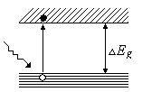
Figure 7.1

In extrinsic semiconductors the impurity photoconductivity arises if the energy of a photon is more than the activation energy of impurity
$hν≥E_{a}$. (7.2)
In n-type semiconductor electrons pass from donor levels to conduction zone. In p-type semiconductor electrons pass from valence zone to acceptor level (Fig. 7.2)
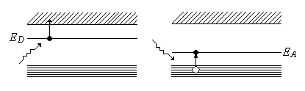
Figure 7.2

One can see that activation energy of the impurity photoconductivity is less than activation energy of an intrinsic photoconductivity. Cutoff wavelength can be determined from the following conditions
$λ_{0}=\frac{\text{ch}}{{ΔE}_{g}}$ for intrinsic semiconductors;
$λ_{0}=\frac{\text{ch}}{{ΔE}_{a}}$ for extrinsic semiconductors.
The cutoff wavelength of the intrinsic semiconductor lies in the visible region and the extrinsic semiconductors lies in infrared region. Fig.7.3 represents the relationship of photoconductivity γ and absorptive factor $α$ with respect to electromagnetic radiation wavelength.
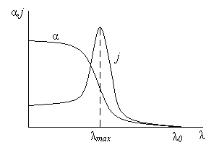
Figure 7.3

If $λ>λ_{0}$than the photoconductivity doesn’t exist. The decrease in photoconductivity when $λ<λ_{\text{max}}$ is related to big velocity of recombination charges and big absorption in the surface layer of semiconductor.
Semiconductor photoconductivity is widely used in engineering. Photocells with internal photoeffect are called photoresitors. The PbS, Cds, PbSe and other semiconductors are the based materials of photoresistors.

Absorption, Spontaneous and Induced Radiation

Under the action of external radiation atom may transfer from E1 energy state to E2 energy state. It is corresponds to the absorption (Fig.7.4).
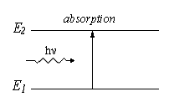
Figure 7.4

Atom may transfer spontaneously without any external effect from excited state with E2 energy to the state with E1 energy. During this process spontaneous radiation occurs (Fig.7.5).
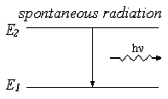
Figure 7.5

In 1916 A. Einstein stated that besides absorption and spontaneous radiation the third type of action called induced transition must exist. If an atom being in excited state is influenced by external radiation with frequency, which satisfies $hν=E_{2}−E_{1}$, then there exists induced transition to the E1 state with the same energy of photon’s radiation $hν=E_{2}−E_{1}$ (Fig.7.6).
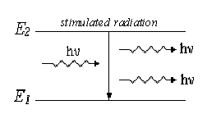
Figure 7.6

Einstein and Dirack showed that induced radiation is identical to initial radiation. Thus, they are coherent with respect to each other. This peculiarity of induced radiation is the base for the work of amplifiers and generators of light being called lasers.
It is necessary to create unequal state of the system, where the number of excited atoms will be more than the number of atoms in the base state to amplify the initial radiation. Such state is called the state of population inversion. The process of creation of such a state is called pumping. Pumping can be realized optically, electrically and by other methods.
In the medium of population inversion, being called active, falling beam of light will be amplified. As Bouger’s Law
$I=I_{0}e^{−αx}$, (7.3)
coefficient α changes its sign on the opposite one. For the first time soviet physicist V. Fabricant in 1940 showed that such medium can occur. He discovered induced radiation of mercury vapors excited in electrical discharge. This resulted in the creation of quantum electronics.

Laser

In 1953 Basov, Prohorov (Soviet physicists) and independently from them Townes (American physicist) created first molecular generators called lasers which worked in the range of centimeter waves. In 1960 Meiman (USA) created analogical device working in the optical range (Light Amplification by Simulated Emission of Radiation) – laser or optical quantum generator.
There are solids, gas, semiconductor and liquid lasers accordingly to the type of medium. Laser consists of: active medium, system of pumping, optical resonator. The scheme of laser is shown in Fig. 7.7.
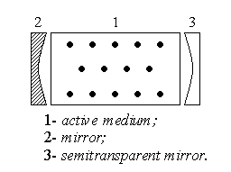
Figure 7.7

The active medium amplifies light. System of pumping realizes transition of medium to the state with population inversion. For the selection of direction of laser radiation optical resonator is used. For example, a pair of parallel mirrors facing each other being on the common optical axis between which optical medium exists. One of the mirrors is semitransparent through which numerically amplified flux of photons laser radiation escapes. Let us consider the work of He-Ne laser (Fig.7.8).
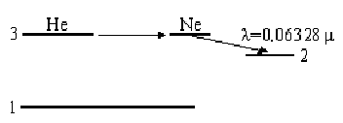
Figure 7.8

Population of inversion of levels is realized trough electrical discharge: electrons formed in discharge excite atoms of He at collision that transfer to the state 3.
At the collisions of excited He atoms with Ne atoms excitation of them occurs and they pass to higher level situated near respective He level. Passing of Ne atoms from the high level 3 to the lower level 2 causes laser radiation of λ = 0,6328 μ. Laser radiation is characterized by
- high time and space coherence;
- rigid monochromatic ($\text{Δλ}<{\text{10}}^{−\text{11}}m$);
- the high power of radiation;
- very small angular discrepancy of the beam.
The use of laser is very wide: machining of materials, research of plasma, in the measuring devices, in medicine.

Lecture 8. Quantum Physics

Quantum mechanics study microscopic particles: electrons, protons, photons, atoms and so on. It deals with their energy and laws of their motion. This branch of physics has two peculiarities:
1) objects of atomic physics cannot be observed with the aid of human sense organs. Moreover, an investigation of object changes its state;
2) laws of atomic physics are not obvious. These laws don’t have analogies with human experience and they seem to be contradictive to common sense.
Thus concepts and laws of atomic physics are concepts and laws of another strange world.
Atoms are small with comparison to the light wavelength. The dimensions of atom are the order of ~ 10⁻¹⁰ m and atom consists of positive nucleus and negative electron shells. The dimensions of nucleus are the order of ~ 10⁻¹⁴ m. Charge of an atom is zero. Energy in microscopic world is measured in electronvolts
1 eV$=1\text{.}6⋅{\text{10}}^{−\text{19}}J$.
Other constants are the following:
mass of electron $m_{e}=9\text{.}\text{11}⋅{\text{10}}^{−\text{31}}$kg ;
charge of electron $q_{e}=−1\text{.}6⋅{\text{10}}^{−\text{19}}$C;
charge of proton $q_{p}\text{=+}1\text{.}6⋅{\text{10}}^{−\text{19}}$C.
We should know that results of quantum physics are of great importance. The laws of this science are fundamentals for new useful materials and new energy sources.

Thomson and Rutherford Model of Atom

In 1903 the British physicist John Thomson suggested the model of atom on the bases of experimental data. According to the Thomson model, atom consists of positive and negative charges distributed in sphere of radius ~${\text{10}}^{−\text{10}}m$. The sum of positive and negative charges is equal to zero and the atom is generally neutral.
In 1911 the British physicist E. Rutherford irradiated thin gold foil by α-particles (Fig.8.1). α-particles are nucleus of 2He₄ atoms. Their charge is +2 electron units.
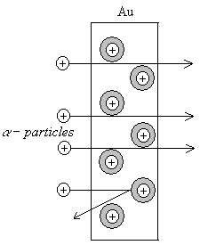
Figure 8.1

Practically all the α-particles penetrate the foil free. Only 0.01 % of general number was scattered back. Rutherford conclusion was that an atom is almost empty. Mass of atom is concentrated inside its nucleus. Radius of nucleus $r_{n}=$10⁻¹⁴ m is much less than radius of atom $r_{a}=$10⁻¹⁰ m.
Rutherford concluded that the electrons are moving around nucleus like planets do around the sun. It was so called the planetary model of the atom. The planetary atom model developed by Rutherford gave a good explanation to these experiments and it enabled to determine the nucleus charge. It was established that the positive nucleus charge is equal to atomic number Z of an element in Mendeleev’s periodic table. The number of electrons inside an atom is equal to Z too. However, the Rutherford model is connected with insoluble contradictions. According to the laws of classical physics every electric charge rotating on trajectory, i.e. moving with acceleration must emit electromagnetic waves continuously. On account of that the energy of electron must be decreased and the electron must approach the nucleus. At last the electron must fall on the nucleus. Atom must be destroyed but we know that the atoms are stable indeed.

Atomic spectra

Gas atoms being stimulated with an electric discharge radiate the so called line spectrum. Atomic hydrogen spectra is shown in Fig 8.2.
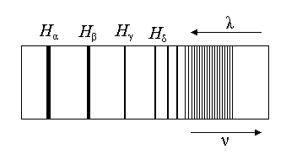
Figure 8.2

The atomic spectra have special features. Every chemical element has its own location of lines. Any line corresponds to definite wavelength. The more is the temperature, the more is an intensity of lines. However, its location and wavelengths remains unchanged if the temperature rises. These features cannot be explained by the classical physics laws because electrons are moving around nucleus and it must emit electromagnetic waves of continuous wavelengths.
In 1885 the physicist Balmer found an empirical formula which describes the spectrum lines of hydrogen in the visible region.
$\frac{1}{λ}=R^{'}\left(\frac{1}{2^{2}}−\frac{1}{n^{2}}\right),$ $n=3,4,5$…, (8.1)
where $λ$ is the wavelength of spectral lines,
$R^{'}=1\text{.}\text{097}⋅{\text{10}}^{7}m^{\text{-1}}$ is the Rydberg constant.
These spectrum lines in visible region is called Balmer series.
As $ν=\frac{c}{λ}$, then
$ν=R\left(\frac{1}{2^{2}}−\frac{1}{n^{2}}\right)$, (8.2)
where $R=R^{'}c=3\text{.}\text{29}⋅{\text{10}}^{\text{15}}s^{−1}$ is called Rydberg’s constant too.
Later the spectral line series was discovered in the ultraviolet and infrared regions. They are described by the similar formulas. In ultraviolet region the Lyman series is observed:
$ν=R\left(\frac{1}{1^{2}}−\frac{1}{n^{2}}\right)$ n = 2,3,4… (8.3)
In infrared region several series are observed:
the Paschen series
$ν=R\left(\frac{1}{3^{2}}−\frac{1}{n^{2}}\right)$ n=4,5,6…, (8.4)
the Bracket series
$ν=R\left(\frac{1}{4^{2}}−\frac{1}{n^{2}}\right)$ n= 5,6,7…, (8.5)
the Pfunda series
$ν=R\left(\frac{1}{5^{2}}−\frac{1}{n^{2}}\right)$ n = 6,7,8…, (8.6)
the Hemphry series
$ν=R\left(\frac{1}{6^{2}}−\frac{1}{n^{2}}\right)$ n = 7,8,9… (8.7)
The general Balmer formula for any spectrum series of hydrogen atom may be expressed as
$ν=R\left(\frac{1}{m^{2}}−\frac{1}{n^{2}}\right)$, (8.8)
where m = 1,2,3…, it determines the series; n = m+1, m+2…, it determines the given lines in series.

Bohr’s Theory

An explanation of spectral lines and Rutherford experiments with planetary model of atom was given by the theory of Bohr in 1913.
Bohr formulated three postulates:
1) There exists the stationary states of an atom in which an atom doesn’t emit electromagnetic waves.
2) The electron being at the stationary state and moving along circular orbit has quantized angular momentum (the moment of impulse):
$L=mυr=nℏ$, (n = 1,2,3,…). (8.9)
3) Transition of atom from one stationary state to another one is accompanied by the emission or absorption of one photon with energy that equals to the energy difference of these two stationary states
$hv=E_{n}−E_{m}$. (8.10)

Bohr’s Theory of Hydrogen Atom and its Spectrum

The hydrogen atom is a system that consists of one electron and one proton, between which there is an electric attraction. The hydrogen – like atom consists of nucleus which carries the charge of +Ze and one electron, which has got the charge -e. The Newton’s second law in this case is
$\frac{{\text{Ze}}^{2}}{4{\text{πε}}_{0}r_{n^{2}}}=\frac{{mυ}^{2}}{r_{n}}$. (8.11)
According to Bohr’s second postulate
${mυr}_{n}=nℏ$. (8.12)
Solving the set of these equations
$\begin{aligned}\left\{\frac{{\text{Ze}}^{2}}{4{\text{πε}}_{0}r_{n^{2}}}=\frac{{mυ}^{2}}{r_{n}} | \right.\end{aligned}$ (8.13)
we obtain the radius of electron orbits
$r_{n}=\frac{4{\text{πε}}_{0}ℏ^{2}}{{\text{Zme}}^{2}}n^{2}$ , n = 1,2,3… (8.14)
The radius of the first electron orbit (n = 1) is
$r_{1}=0\text{.}\text{53}⋅{\text{10}}^{−\text{10}}$m.
The total energy of hydrogen atom is the sum of potential energy of the interaction between electron and the nucleus and kinetic energy of electron movement
$E=E_{p}+E_{k}$, (8.15)
$E_{p}=−\int_{∞}^{r_{n}}{\text{Fdr}}=\int_{∞}^{r_{n}}{\frac{1}{4{\text{πε}}_{0}}\frac{{\text{Ze}}^{2}}{r^{2}}\text{dr}=−\frac{{\text{Ze}}^{2}}{4{\text{πε}}_{0}r_{n}}}$. (8.16)
Thus
$E=\frac{{mυ}^{2}}{2}−\frac{{\text{Ze}}^{2}}{4{\text{πε}}_{0}r_{n}}$. (8.17)
Substituting the r_{n} we obtain
$E=−\frac{1}{n^{2}}⋅\frac{Z^{2}{\text{me}}^{4}}{8h^{2}ε_{0^{2}}}$, n = 1,2,3… (8.18)
The state with n = 1 is called the basic state. If n > 1 it is called an excited state. Fig.8.3 illustrated the possible allowed orbits of the hydrogen atom originated from formula (8.19)
$E\text{\sim }\frac{1}{n^{2}}$. (8.19)

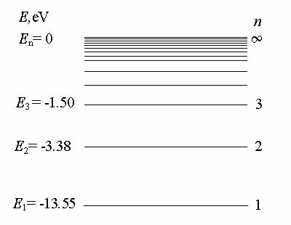
Figure 8.3

According to the Bohr’s third postulate
$$hν=E_{n}−E_{m}=−\frac{{\text{me}}^{4}}{8h^{2}ε_{0^{2}}}\left(\frac{1}{m^{2}}−\frac{1}{n^{2}}\right)⇒$$
$ν=\frac{{\text{me}}^{4}}{8h^{3}ε_{0^{2}}}\left(\frac{1}{m^{2}}−\frac{1}{n^{2}}\right)=R\left(\frac{1}{m^{2}}−\frac{1}{n^{2}}\right)$, (8.20)
where
$R=\frac{{\text{me}}^{4}}{8h^{3}ε_{0^{2}}}$. (8.21)
This theoretical value of R coincides with experimental one that confirms Bohr’s theory to be true.
An atom can be stimulated for example with an electric discharge. Due to this process energy of an electron increases according to the equation. However excited state is unstable. Thus an atom makes a transition from one state En to a state with lower energy E_{m} ,(n > m). Electromagnetic waves radiate and according to the law of energy conservation we obtain
$hv=E_{n}−E_{m}$. (8.22)
Thus the spectrum of hydrogen consists of series of lines (three of which are shown in Fig.8.4) and is described by the general Balmer’s formula
$ν=R\left(\frac{1}{m^{2}}−\frac{1}{n^{2}}\right)$. (8.23)
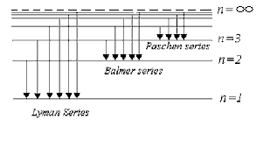
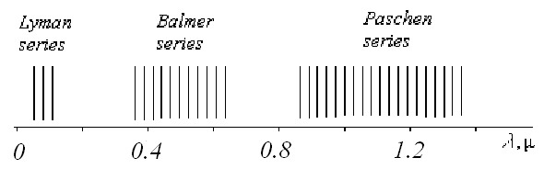
Figure 8.4

Franck’s & Hertz Experiments

German physicists D. Franck and J. Hertz studied scattering of electrons by atoms of mercury. Electrons were accelerated by high voltage inside a tube filled with a mercury vapor. The higher was the voltage, the higher current through the tube was expected. The scheme of experimental installation is shown in Fig.8.5.
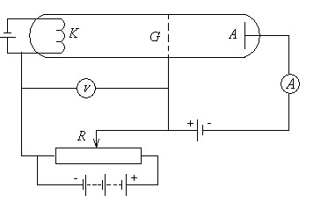
Figure 8.5

A grid is meant to catch weak electrons because it carries a small potential ($0\text{.}5$V). The electrons that are emitted by a cathode are accelerated by electric field and passing through the grid reach anode and produce a current. The electrons that pass the grid with low velocities come back and don’t reach the anode. It was discovered that the current raised gradually but dropped sharply at 4.9 V. A further increase in voltage results in repeated rise of current but a new sharp drop was observed at 9.8 V( Fig.8.6).
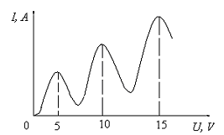
Figure 8.6

These results can be explained by following: electrons collide with mercury atoms. A sharp drop of current at $4\text{.}9$V means that electrons undergo inelastic collisions with atoms mercury. As a result they loose their energy and cannot reach anode. It is of vital importance that a mercury atom can take a definite energy only namely 4.9 eV, 9.8 eV ...
Thus it was found that transmission of energy from an electron to atom is possible only from one stationary state into another one. Energy is transferred by portions. Transition of excited mercury atom to base state is accompanied by emission of light quant of frequency
$ν=\frac{ΔE}{h}$.
As $ΔE=4\text{.}\text{86}$eV, then
$\frac{c}{ν}=\frac{c⋅h}{ΔE}=0,\text{2537}$$μ$.
This wavelength corresponds to ultraviolet line of mercury spectrum. These experiments of Franck and Hertz confirmes the Bohr’s theory.

Duality of Particles and Waves

French physicist Louis De Broglie assumed firstly (1924) that any moving particle as well as any body that is moving has wave properties. The wavelength of a particle is given by De Broglie formula
$λ=\frac{h}{p}=\frac{h}{mυ}$, (8.24)
where $h=6\text{.}\text{62}⋅{\text{10}}^{−\text{34}}J⋅s$ is Planck’s constant, m is the mass of a particle, $υ$ is the velocity of a particle. Thus, we should take into account that any moving particle may be considered as a wave.
The formula (8.24) can be deduced easily for a photon. In this case impulse is
$p=\frac{hν}{c}$, (8.25)
as $ν=\frac{c}{λ}$,
then $λ=\frac{h}{p}=\frac{h}{mυ}$. (8.26)
Let’s calculate wavelength $λ$ for a ball and for an electron accelerated by 100 kV
$λ_{\text{ball}}=\frac{6\text{.}\text{62}⋅{\text{10}}^{−\text{34}}}{1\text{.}5⋅\text{10}}=4\text{.}4⋅{\text{10}}^{−\text{55}}$m,
$λ_{\text{electron}}=\frac{6\text{.}\text{62}⋅{\text{10}}^{−\text{34}}}{9\text{.}\text{11}⋅{\text{10}}^{−\text{31}}⋅1\text{.}\text{28}⋅1\text{.}\text{87}⋅{\text{10}}^{8}}=3\text{.}\text{04}⋅{\text{10}}^{−\text{12}}$m.
We can measure only lengths $l>{\text{10}}^{−\text{18}}m$. Thus, $λ_{e}$can be measured. Electron beams are used in engineering for example in electron microscope.
In 1927 American physicists Davisson and Germer discovered that the flux of electrons displayed properties of waves. The behavior of electron flux is absolutely like that of X-rays. The diffraction maxima correspond equation
$2d⋅\text{sin}θ=nλ$. (8.27)
The reflected beam may be considered by assumption that the electron beam has a wavelength.

Uncertainty Principle

In classical physics coordinates $x,y,z$ and impulse $\vec{p}$ were introduced for the purpose to characterize the motion of ordinary bodies. The definite values of accuracy $Δx,Δy,Δz$ and$Δp$, are understood. In this case we consider that the error of determination will be decreased little by little because of using instruments. Thus according to classical physics $Δx$ and $Δp$ may be as small as possible
$Δx→0,Δp→0$.
Quite another situation occurs in quantum physics. German physicist Werner Heisenberg introduced in 1927 the so called uncertainty principle. It states that the product of the measurement error of a coordinate by the measurement error of an impulse along these coordinate cannot be less than Plank’s constant:
$\begin{aligned}\left\{Δx⋅{Δp}_{x}≥ℏ | \right.\left\{Δy⋅{Δp}_{y}≥ℏ | \right.\end{aligned}$. (8.28)
On the basis of this principle the coordinate of a particle and its impulse cannot be measured exactly simultaneously. Actually, if
$Δx→0$, $Δp→∞$
and contrary if
$Δp→0,$ $Δx→∞$.
One of the conclusions of uncertainty principle states: there is no trajectory of an electron inside atom. The quantum theory leads also to the relation of uncertainties of energy and time
, (8.29)
where $Δt$ is the time of receiving energy $ΔE$ by the particle.
The uncertainty principle is the proof for stability of atoms. Let's assume that an electron approaches nucleus, then$Δx→0$. Accordingly, ${Δp}_{x}→∞$, thus the velocity and the energy of electron increases. As a result electron moves away nucleus and atom is in a stable state.

Lecture 9. Wave Function

Let’s remember how location of a material point was determined in classical physics. It was determined by means of three $x,y,z$ coordinates. According to the uncertainty principle the precise determination of coordinates is impossible as the concept of trajectory has no any physical sense.
The wave function $ψ$ is introduced in quantum mechanics to characterize the microparticle state. The wave function is a completely quantum characteristic of a state of microparticle. The wave function is a complex value that is determined at all points of space at any moment of time:
Ψ = Ψ(x,y,z,t). (9.1)
The physical sense of $ψ$ is determined as follows: square of the wave function multiplied by an element of volume dV is proportional to the probability of a particle being inside volume dV. This may be expressed as:
$ω (x,t)=Ψ(x,t)⋅Ψ^{}(x,t)\text{dV}$, (9.2)
where $Ψ^{}$is the complex conjugated function. Thus wave function $ψ$ has no physical meaning itself, the physical meaning has value$ψ^{2}$. The quantity $ψ^{2}\text{dV}$doesn’t tell us, where the particle is. It tells us where the particle is likely to be.
The equation of the wave function is similar to the equation of wave, because of duality a particle is a wave at the same time. Let’s see the formula of the electric intensity vector connected with an electromagnetic wave
$E=E_{0}⋅e^{i\left(ωt−\text{kx}\right)}$, (9.3)
where $k=\frac{\text{2π}}{λ}$.
Like this the wave function may be expressed as
$ψ=ψ_{0}⋅e^{i\left(ωt−\text{kx}\right)}$. (9.4)
The conjugated expression is
$ψ^{}=ψ_{0}⋅e^{−i\left(ωt−\text{kx}\right)}$, (9.5)
where $ψ_{0}$ is called the module of the wave function. The $ψ$ function must satisfy the normalization condition
$\int_{−∞}^{∞}{ψ⋅ψ^{}\text{dV}=1}$. (9.6)
The last equation means that the particle exists for sure somewhere, i.e. the particle will necessarily be detected somewhere. This condition confirms that the particle objective exists in space and time.

Schrodinger Equation

In classical physics the motion of a body is described by Newton's laws. Microparticles possess wave properties and for description of their motion another equation is needed. This equation was founded in 1926 by the Austrian physicist Schrodinger and is named after him. In case when microparticle moves along the x-axis the equation of Schrodinger looks like:
$\frac{ℏ^{2}}{2m}⋅\frac{∂^{2}ψ}{∂x^{2}}=Uψ−Eψ$, (9.7)
where E is total energy of a particle; U is potential energy; $ℏ$is Plank's constant; m is mass of the particle. The stationary Schrodinger equation is
$Δψ+\frac{2m}{ℏ^{2}}\left(E−U\right)ψ=0$. (9.8)
The common equation of Schrodinger is
$−\frac{ℏ^{2}}{2m}⋅Δψ+Uψ=iℏ\frac{∂ψ}{∂t}$. (9.9)

Motion of a Free Particle and its Energetic Spectrum

A particle is called free if its motion isn't limited in space and if its potential energy doesn't depend upon coordinates. In this case
$U\left(x\right)=0$. (9.10)
Consequently,
$Δψ+\frac{2\text{mE}}{ℏ^{2}}ψ=0$, (9.11)
$\frac{2\text{mE}}{ℏ^{2}}=k^{2}$, (9.12)
$Δψ+k^{2}ψ=0$. (9.13)
The solution of this differential equation is
$ψ={\text{Ae}}^{\text{ikx}}+{\text{Be}}^{−\text{ikx}}$, (9.14)
where A and B are constants; k is a wave number. In the Fig.9.1 the energy of the free particle
$E=\frac{ℏ^{2}}{2m}k^{2}$ (9.15)
is plotted against the wave vector
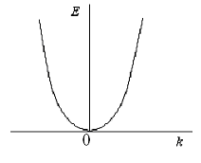
Figure 9.1

The total solution of Schrodinger equation is
$ψ\left(x,t\right)=ψ\left(x\right)⋅e^{−i\frac{E}{ℏ}t}={\text{Ae}}^{i\left(\text{kx}−\frac{E}{ℏ}t\right)}+{\text{Be}}^{−i\left(\text{kx}+\frac{E}{ℏ}t\right)}$, (9.16)
as
$\frac{E}{ℏ}=ω$,
$ψ\left(x,t\right)={\text{Ae}}^{i\left(\text{kx}+ωt\right)}+{\text{Be}}^{−i\left(\text{kx}+ωt\right)}$. (9.17)
Thus, there are three conclusions, connected with a motion of free particle:
- energy is directly proportional to k2;
- energy is expressed like in classical physics;
- location of the particle along all the x-axis has an equal probability.
In other words, neither energy nor the location is limited. Energetic spectrum of free particle is continuous.

Motion of a Space Limited Particle

The potential energy of a space limited particle is:
$U(x)=\begin{aligned}\left\{∞,x<0 | \right.\left\{0,0≤x≤l | \right.\end{aligned}$. (9.18)
The dependence of a particle‘s potential energy on its coordinates is called potential square well. A motion of a particle in potential square well is limited in space (Fig.9.2). Particle cannot leave Ol segment. It may move only inside this segment. This problem is called the problem of potential square well. Along Ol the potential energy of the particle is the same and is equal to zero.
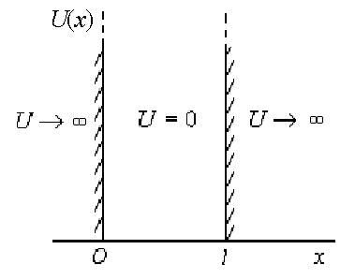
Figure 9.2

There are the boundary conditions. According to the both problems conditions, the particle doesn't penetrate through the well walls and wave function is $ψ(x)=0$ over the limits of square well. The problem under consideration is a model. The point is that a motion of an electron inside atom is space limited. An electron cannot leave an atom, because it is attracted by nucleus. The Schrodinger equation in this case is
$\frac{∂^{2}ψ}{∂x^{2}}+\frac{2m}{ℏ^{2}}\left(E−U\right)ψ=0$, (9.19)
the boundary conditions:
$ψ\left(0\right)=ψ\left(l\right)=0$. (9.20)
Along the Ol segment the Schrodinger equation is
$\frac{∂^{2}ψ}{∂x^{2}}+\frac{2m}{ℏ^{2}}Eψ=0$, (9.21)
$\frac{∂^{2}ψ}{∂x^{2}}+k^{2}ψ=0$. (9.22)
The total solution of this equation is
$ψ\left(x\right)=A\text{sin}\text{kx}+B\text{cos}\text{kx}$, (9.23)
The first boundary condition is
$ψ\left(0\right)=0⇒B=0$, (9.24)
$ψ\left(x\right)=A\text{sin}\text{kx}$. (9.25)
The second boundary condition is
$ψ\left(l\right)=0$,
$ψ\left(l\right)=A\text{sin}\text{kl}=0$,
$\text{kl}=nπ,$,
$k=\frac{nπ}{l}⇒E=\frac{ℏ^{2}k^{2}}{2m}=\frac{π^{2}ℏ^{2}}{2{\text{ml}}^{2}}⋅n^{2}$, (n = 1,2,3…).
The A constant may be determined with the help of normalization condition
$\int_{0}^{l}{A^{2}{\text{sin}}^{2}}\frac{nπ}{l}\text{xdx}=1$, (9.26)
$A=\sqrt{\frac{2}{l}}$.
Consequently,
$ψ_{n}\left(x\right)=\sqrt{\frac{2}{l}}\text{sin}\frac{nπ}{l}x,$$(n=1,2,3,\text{.}\text{.}\text{.})$. (9.27)
The graph of this function is represents Fig.9.3.
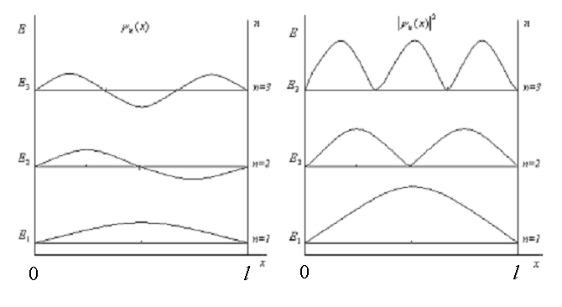
Figure 9.3

The particle cannot be at any point of Ol segment with equal probability. If n = 1, the probability which discovers the particle is the most possible in half of segment Ol. At x = 0 and x = l, this probability is equal to zero. It is surprising that if n = 2, this probability equals zero at x = l/2 and it is the largest at x = l /4 and x = 3l/4 and so on.
The behavior of the particle looks like a system of standing waves because the particle possesses wave properties. Let's consider the energy of a particle. The energy cannot be equal to zero and can be changed by portions only
$E_{1}=\frac{π^{2}ℏ^{2}}{2{\text{ml}}^{2}}⋅1^{2}$; $E_{2}=\frac{π^{2}ℏ^{2}}{2{\text{ml}}^{2}}⋅2^{2}$ ; $E_{3}=\frac{π^{2}ℏ^{2}}{2{\text{ml}}^{2}}⋅3^{2}$;… (9.28)

In other words the energy is quantized. Energy spectrum of a particle is discrete. If the dimensions of potential square well are large, the spectrum is practically transformed into a continuous one.

Tunneling Through a Barrier. Tunnel Effect

Let’s consider the rectangular potential barrier with its width of l and height of U (Fig.9.4):
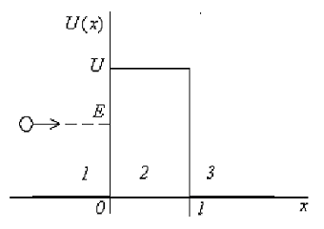
Figure 9.4

In this case
$U(x)=\begin{aligned}\left\{0,x<0 | \right.\left\{U,0≤x≤l | \right.\end{aligned}$.
Classical particle with energy $E<U$ wouldn’t pass this potential barrier. But quantum mechanics gives other result for microparticles. Schrodinger equation in this case may be expressed as:
$\frac{∂^{2}ψ}{∂x^{2}}+k^{2}ψ=0$, (9.29)
where
$k_{{1,3}^{2}}=\frac{2\text{mE}}{ℏ^{2}}$ for region 1,3
$k_{2^{2}}=\frac{2m\left(E−U\right)}{ℏ^{2}}$ for region 2.
The solution of Schrodinger equation for different regions is
$ψ_{1}\left(x\right)=A_{1}e^{{\text{ik}}_{1}x}+B_{1}e^{−{\text{ik}}_{1}x}$,
$ψ_{2}\left(x\right)=A_{2}e^{{\text{ik}}_{2}x}+B_{2}e^{−{\text{ik}}_{2}x}$,
$ψ_{3}\left(x\right)=A_{3}e^{{\text{ik}}_{3}x}+B_{3}e^{−{\text{ik}}_{3}x}$.
The total wave function is:
Ψ1$\left(x,t\right)=ψ_{1}\left(x\right)⋅e^{−i\frac{E}{ℏ}t}=A_{1}e^{i\left(k_{1}x−ωt\right)}+B_{1}e^{−i\left(k_{1}x+ωt\right)}$, (9.30)
Ψ2$\left(x,t\right)=ψ_{2}\left(x\right)⋅e^{−i\frac{E}{ℏ}t}=A_{2}e^{i\left(k_{2}x−ωt\right)}+B_{2}e^{−i\left(k_{2}x+ωt\right)}$,
Ψ3$\left(x,t\right)=ψ_{3}\left(x\right)⋅e^{−i\frac{E}{ℏ}t}=A_{3}e^{i\left(k_{3}x−ωt\right)}+B_{3}e^{−i\left(k_{3}x+ωt\right)}$,
$k_{3}=k_{1}$.
These equations are the result of superposition of two waves that are spreading in opposite directions. The graph of this wave function in different regions is showed in Fig.9.5.
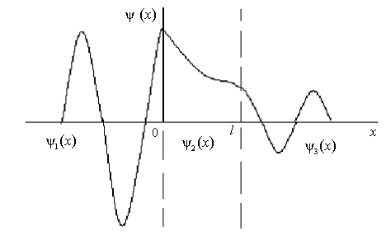
Figure 9.5

If energy of microparticle$E<U$, then there is a probability of passing through the potential barrier. The phenomenon of passing microparticle through the potential barrier is called the tunnel effect. Calculations prove that this probability may be expressed as:
$ω=\text{exp}\left[−\frac{2l}{ℏ}\sqrt{2m(U−E)}\right]$. (9.31)
Electron field emission from metals, the transmission of electrons in the contact layer of boundary of two semiconductors, α-radioactivity and other phenomenon are explained by the tunnel effect.

Hydrogen Atom in Quantum Mechanics

The force of electron interaction with nucleus is given by
$F=\frac{1}{4{\text{πε}}_{0}}⋅\frac{{\text{Ze}}^{2}}{r^{2}}$, (9.32)
The potential energy
$\text{dU}=−\text{Fdr}$,
$\text{dU}=\frac{1}{4{\text{πε}}_{0}}⋅\frac{{\text{Ze}}^{2}}{r^{2}}\text{dr}$,
$U=\int_{∞}^{r}{\frac{1}{4{\text{πε}}_{0}}⋅\frac{{\text{Ze}}^{2}}{r^{2}}\text{dr}}=−\frac{{\text{Ze}}^{2}}{4{\text{πε}}_{0}r}$.
Schrodinger equation may be expressed as
$Δψ+\frac{2m}{ℏ^{2}}\left(E+\frac{{\text{Ze}}^{2}}{4{\text{πε}}_{0}r}\right)ψ=0$. (9.33)
Total energy of the electron is expressed as:
$E_{n}=−\frac{Z^{2}{\text{me}}^{4}}{8h^{2}ε_{0^{2}}}⋅\frac{1}{n^{2}}$ $\left(n=1,2,3,\text{.}\text{.}\text{.}\right)$, (9.34)
where n is the main quantum number. The state with n = 1 is called the base state of an electron. If n > 1, there are so called excited states.
The formula 9.34 gives directly the energy values of the allowed stationary states (Fig.9.6). The upper level when $n=∞$corresponds to a state at which electron is completely removed from the atom (i.e. E = 0,$r=∞$).
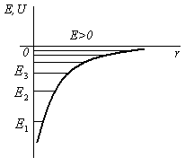
Figure 9.6

Quantum Numbers

Any problem of quantum physics comes to a solution of Schrodinger equation. It appears that these equations have simple solutions (wave functions) that contain four parameters. They are called quantum numbers and are denoted as n, l, ml, ms.
Thus quantum numbers are parameters that are related to state of an electron in atom. These parameters are included in solution of Schrodinger’s equation. There are four quantum numbers.
Main quantum number n defines an energy of an electron. It determines the energy levels. In other words the electron energy depends mainly upon this number
$E_{n}=−\frac{{\text{me}}^{4}Z^{2}}{8ε_{0}^{2}h^{2}}⋅\frac{1}{n^{2}}$, (9.35)
where n can only be equal to integer from one to infinity: $n=1,2,3\text{.}\text{.}\text{.}$
Orbital quantum number l determines angular moment of impulse L of an electron
$L=ℏ\sqrt{l(l+1)}$, (9.36)
where L is the moment of impulse.
Thus, l concerns so called angular motion of the electron. The point is that L can be changed by discrete portions only. This is the difference between classical and quantum physics. Value of l can be equal to $0,1,2,\text{.}\text{.}\text{.},\left(n−1\right),\text{.}\text{.}\text{.}$ Thus, l is an integer from 0 up to $n−1$. Numerical values of l are denoted by letters as follows table 9.1.

Table 9.1
N | l | Notations
1 | 0 | s
2 | 0, 1 | s, p
3 | 0, 1, 2 | s, p, d
4 | 0, 1, 2, 3 | s, p, d, f

An electron may be denoted as 1s, 2s, 2p, 3s, 3p, 3d...
The third quantum number ml is called magnetic quantum number. It determines the projection of an electron angular moment of impulse vector into direction of the external magnetic field

$L_{z}=ℏ⋅m_{l}$. (9.37)
The vector Lz is quantized. Magnetic quantum number ml possesses integer values from zero to $±l$
$m_{l}=0,±1,±2\text{.}\text{.}\text{.}±l$. (9.38)
There are 2l+1 values of ml (Fig.9.7).
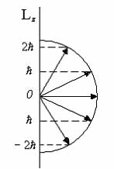
Figure 9.7

Thus magnetic quantum number ml determines the orientation of the electron orbit in such a manner that Lz is a quantized value.
If the atom is placed in an external magnetic field new energy levels occur and the splitting of spectral lines in atom spectrum is observed. The level with main quantum number n is splitted into 2l+1 sublevels. This phenomenon was discovered by Holland physicist P. Zeeman in 1896. It is called the Zeeman’s effect. In 1922 German physicists Stern & Gerlach discovered that hydrogen atoms in s-state are split into two parts by effect of non-homogenous magnetic field. In this state L = 0 and magnetic moment of atom is equal to zero too. Magnetic field doesn't influence on hydrogen atom in this state. But use of high-resolution optical spectrometers indicated that emission lines of hydrogen have two very closely spaced lines.
To describe correctly the electron orbit the concept of the electron spin quantum number is required. One can say it is the electron own moment of impulse. Its value is equal to
$L_{s}=ℏ\sqrt{s\left(s+1\right)}$, (9.39)
where s is the spin quantum number ($s=\frac{1}{2}$). The projection of $L_{s}$in the direction of external magnetic field is quantized
$L_{\text{sz}}=ℏm_{s}$, (9.40)
where $m_{s}=±\frac{1}{2}$ is called magnetic spin quantum number.

Pauli's Principle

This principle is of great importance. It states that any atom system cannot have even two electrons with identical four quantum numbers. In other words it states that all electrons in atom system are different. If an electron has got a given set of quantum numbers then another electron must have other set of quantum numbers.
Proceeding the Pauli's principle let's calculate how many electrons can have the same main quantum numbers n. As ml can have 2l+1 different values and taking into account that ms= ±1/2 we obtain that common quantity of electrons is 2(2l+1). Total number of electrons equals
$Z=\sum_{l=0}^{n−1}{2\left(2l+1\right)=2n^{2}}$. (9.41)
The community of electrons with the same n value is called electron shell, which is divided into subshells corresponding to l value, table 9.2.

Table 9.2
N | Shell | Z=2n2
1 | K | 2
2 | L | 8
3 | M | 18
4 | N | 32

Structure of Electron Shells in Mendeleyev Periodic System

Mendeleev’s periodic system of elements is based on the Pauli’s principle. In 1869 Russian chemist D. Mendeleyev arranged the chemical elements in periods in such a manner that their properties are repeated periodically when the atomic mass of elements increases. On the base of Pauli’s principle we plot the following table:

Table 9.3
n | 1 | 2 |  | 3 |  |  | 4
Shell’s  symbol | K | L |  | M |  |  | N
Max.number of electrons in shells | 2 | 8 |  | 18 |  |  | 32
l | 0 | 0 | 1 | 0 | 1 | 2 | 0 | 1 | 2 | 3
Subshell’s  symbol | 1s | 2s | 2p | 3s | 3p | 3d | 4s | 4p | 4d | 4f
Max.number of electrons in subshells | 2 | 2 | 6 | 2 | 6 | 10 | 2 | 6 | 10 | 14

Let’s consider the structure of electron shells of some atoms:
$H$: the single electron in atom H is in state of 1s1 (n = 1, l = 0, ml= 0, ms= 1/2). In all s-shells there are only two electrons. That's why hydrogen takes part in chemical reactions. Its valency is equal to unit. Hydrogen needs just one more electron.
$\text{He}$: 1s2 (n = 1, l = 0, ml = 0, ms= ±1/2). The s-shell is filled up completely.
$\text{Li}$: 1s22s1. Li is active and tends to give its electron to other elements.
$\text{Be}$: 1s22s2. Its valence is two.
$B$: 1s22s22p1
$C$: 1s22s22p2.
$N$: $1s^{2}2s^{2}2p^{3}$, and so on.

Types of Wave Functions

Type of a wave function is related to the set of quantum numbers. We should know that a change of quantum number results in a change of electron distribution in space. Thus $dω=$$ψ^{2}$dV depends upon coordinates and upon quantum numbers. In the Fig. 9.8 $ψ^{2}$ presents 1s and 2s electrons.
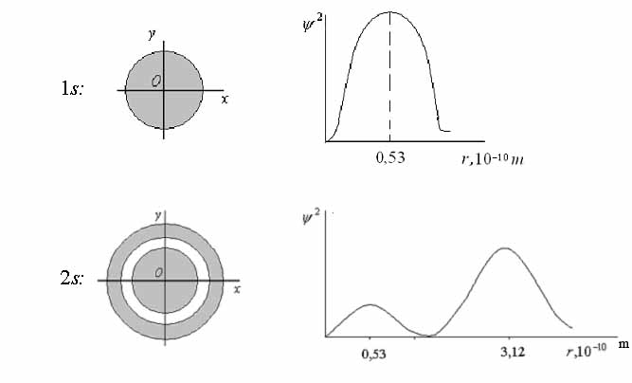
Figure 9.8

A single electron forms ψ2 as if it is a cloud. The most probable location of an electron is at $r_{0}=0\text{.}\text{53}⋅{\text{10}}^{−\text{10}}m$. It is the so called Bohr’s radius. But even inside a sphere at radius of $r_{0}$ the electron location isn't uniform.
2s electron has got ψ2(r) with two maximums. In other states, say in p-and d-states, the distribution of electron cloud density is not already spherical (Fig.9.9).
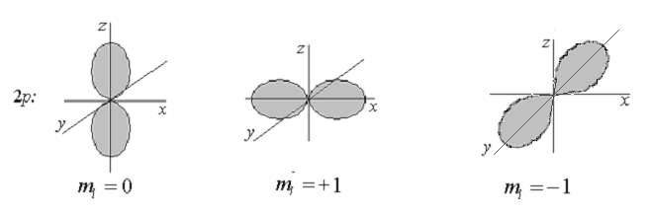
Figure 9.9

The main conclusion is the following: if the set of quantum numbers is changing then electron distribution in space and wave function are changing as well.
Lecture 10. Elements of Nuclear Physics
Atomic Nucleus

The atomic nucleus of any chemical element consists of protons and neutrons. Soviet physicist D. Ivanenko suggested proton-neutron model in 1932.
Mass of proton is $m_{p}=\text{1836}\text{.}2⋅m_{e}=1\text{.}\text{67267}⋅{\text{10}}^{−\text{27}}\text{kg}$.
Mass of neutron is $m=\text{1838}\text{.}7⋅m_{e}=1\text{.}\text{67492}⋅{\text{10}}^{−\text{27}}$kg, where $m_{e}=9\text{.}\text{11}⋅{\text{10}}^{−\text{31}}$ kg is mass of electron. Protons and neutrons are called nucleons or heavy particles. A proton has an electric charge $q_{p}\text{=+}e\text{=+}1\text{.}6⋅{\text{10}}^{−\text{19}}C$. A neutron is a particle which has no charge $q_{n}=0$C.
The number of protons Z inside nucleus is equal to the atomic number of element in the periodic table. The total electric charge of nucleus equals $+\text{Ze}$.
Sum of protons and neutrons in a nucleus is called the mass number
$A=Z+N$, (10.1)
where Z is number of protons, N is number of neutrons. A given nucleus is represented by its chemical symbol X with Z and A as subscript and superscript respectively ${}_{Z}^{A}{}X$. For example
${}_{\text{92}}^{\text{235}}{}U⇔\begin{matrix}A=\text{235} \\ Z=\text{92}\end{matrix},N=\text{143}$.
Nucleons are bound together inside the nucleus by special forces called nuclear forces.
Chemical elements which differ in mass numbers but have the same charge of atomic nucleus and occupy an identical place in Mendeleyev periodic table are called isotopes. Hydrogen has got 3 isotopes: ${}_{1}^{1}{}H$- hydrogen, ${}_{1}^{2}{}H$- deuterium, ${}_{1}^{3}{}H$- tritium.
Majority of elements are the isotopic mixture. Physical properties of isotopes are different. Slow neutrons are captured by nuclei of ${}_{\text{92}}^{\text{235}}{}U$,
and as a result of this nuclei disintegrate. Nuclei ${}_{\text{92}}^{\text{237}}{}U$ hasn’t got such a property either, the latter can be got from natural sources.
The atomic unit of mass is used to measure the atom and nucleons masses. $\text{1a}\text{.}u\text{.}m\text{.}=\frac{1}{\text{12}}$ of $C$ atoms mass. 1 a.u.m.= $1\text{.}\text{66}⋅{\text{10}}^{−\text{27}}$kg.
According to the Einstein’s equation one atomic unit of mass corresponds to the energy
$E={\text{mc}}^{2}=1\text{.}\text{66}⋅{\text{10}}^{−\text{27}}{\left(3⋅{\text{10}}^{8}\right)}^{2}=1\text{.}\text{4922}⋅{\text{10}}^{−\text{10}}J=\text{931}\text{.}5 \text{MeV}$.

Binding Energy and Mass Defect

The nucleus is a very strong structure. The nucleons, i.e. protons and neutrons, are strongly bonded to each other in nucleus by means of strong attracting forces that are called nuclear forces. Binding energy of nucleus is equal to the energy needed to destroy these nucleus into its nucleons and obtain protons and neutrons without kinetic energy. Measurements of masses discovered that the mass of the nucleus is always less than the total mass of free nucleons
$m_{\text{nucleus}}<{\text{Zm}}_{p}+{\text{Nm}}_{n}$. (10.2)
The difference in masses$Δm$ is called the defect in mass
$Δm=\left({\text{Zm}}_{p}+{\text{Nm}}_{n}\right)−m_{\text{nucleus}}$. (10.3)
According to the Einstein’s equation$E={\text{mc}}^{2}$ this mass defect is equal to binding energy
$E_{\text{binding}}=\left[\left({\text{Zm}}_{p}+{\text{Nm}}_{n}\right)−m_{\text{nucleus}}\right]c^{2}$. (10.4)
Binding energy is a very big value. According to the calculations $E_{\text{binding}}≈8 \text{MeV/nucleons}$.
The important characteristic is specific bounding energy of nucleus. It is an average binding energy per nucleon for stable nucleus:
$E_{s\text{.}b\text{.}e}=\frac{E_{\text{binding}}}{A}$. (10.5)
Fig. 10.1 shows the relationship between $E_{s\text{.}b\text{.}e}$ and mass number
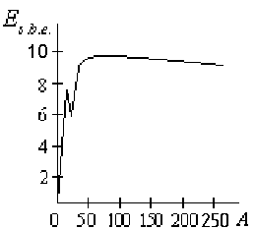
Figure 10.1

We can see that $E_{s\text{.}b\text{.}e}$ grows rapidly for a light nuclear and reaches the level of about 8 MeV/nucleon for nuclei with mass numbers of A > 50. Then $E_{s\text{.}b\text{.}e}$ decreases slowly that is related to growth in the number of protons in nucleus and repelling forces of Coulomb that increase.

Nuclear Forces

Extremely strong attracting forces binding nucleons together exist inside a nucleus. They act over the distance that is less than ${\text{10}}^{−\text{15}}$m and are of sufficient magnitude to overcome electrostatic repulsion between protons being about 100 times stronger. These forces are called nuclear forces. There are some features of nuclear forces.
- Nuclear forces are so called short-range forces occurring at distances of ${\text{10}}^{−\text{15}}$m order and sharply decreasing with distance growth.
- The nuclear forces are independent of electric charge. They don’t depend upon particles charge. Hence, the nuclear forces act between neutron and proton, two protons or two neutrons.
- The nuclear forces are saturated. Nucleon interacts only with limited number of nearest nucleons and specific binding energy of nucleons is the same if the number of nucleons increases.
- The nuclear forces depend upon the orientation of nucleons spins.
- The nuclear forces are not central. They act between nucleons along the line that doesn’t connect nucleons centers.
No good theory of nuclear forces has as yet been created. In 1934 Russian physicist I. Tamm supposed that nuclear forces are due to an exchange between nucleons by virtual particles. In 1935 Japan physicist H. Yukawa postulates that the nuclear interaction was due to exchange of a particle between nucleons, having the mass 200÷300 times more than electrons mass and having the energy of about 130 MeV. This particle was called meson. It was later found in cosmic rays and was called π-meson.
There are neutral and charged π-mesons: $π^{0}{\text{,π}}^{−}{\text{,π}}^{+}$. The charge of π-meson equals the electron charge. Charged π-mesons posses mass of $\text{273}⋅m_{e}$(140 MeV). The neutral π-meson posses the mass of $\text{264}⋅m_{e}$(135 MeV). π-mesons spin equals zero. π-mesons are unstable particles. The time of exchange for the π-meson is about 10⁻²³ s.
The interactions between nucleons seem to correspond to equations:
$\begin{aligned}p⇔n+π^{+} \\ n⇔p+π^{−} \\ p⇔p+π^{0} \\ n⇔n+π^{0}\end{aligned}$.

Radioactivity

A spontaneous transformation of unstable nuclei into nuclei of another element which is accompanied by the emission of some particles is called radioactivity.
There exists natural radioactivity associated with existence of unstable isotopes in nature and artificial radioactivity that exist as the result of nuclear reactions.
For the first time French physicist A. Becquerel discovered radioactivity in 1896. He studied the fluorescence of uranium salts and found that they emit rays of unknown nature that acts on the photographic plate, penetrate through thin layers of substances.
Later in 1898 Pierre and Marie Curie discovered that other heavy elements are radioactive: thorium, actinium, radium and polonium.
Radiation comprises three constituens: α - decay; β - decay; γ - radiation.
α - decay process accompanied with the emittance of α-particles. α-particles are deflected by electric and magnetic fields, are easily absorbed by thin layers of substance and have little penetrability. α-particles carry the charge of +2e and represent nuclei of helium atoms ${}_{2}^{4}{}$He.
β - decay process accompanied with the emittance of β-particles that are deflected by electric and magnetic field, possess a higher penetrability than α-particles and carry a negative charge – e. β-particles represent a flux of fast electrons. Thus β - decay is the electron emission from the nucleus.
γ - radiation isn’t deflected by electric and magnetic fields and posses a very high penetrability. γ - radiation represents a flux of photons with very short waves of $λ<{\text{10}}^{−\text{10}}m$.

Radioactive Decay Law

The activity of a given radioactive substance decreases with time and the quantity of radioactive atoms decreases. A certain part of radioactive atoms dN disintegrates during time dt
$\text{dN}=−λ\text{Ndt}$, (10.6)
where λ is decay constant, $\left[λ\right]=s^{−1}$.
Decay constant λ is equal to the relative decrease in the number of radioactive atoms per unit time or the probability of atom decay per unit of time
$λ=−\frac{\text{dN}}{\text{Ndt}}$. (10.7)
Integrating this equation we obtain the law of radioactive decay
$N=N_{0}e^{−λt}$, (10.8)
where N0 is the number of atoms at initial time t = 0; N is the number of atoms remained after time t. Fig. 10.2 represents this exponential function.
Time $T_{12}$ is the time during which the initial number of radioactive atoms decreases twofold. $T_{12}$ is called the half-life.
As
$\frac{N_{0}}{2}=N_{0}e^{−{λT}_{12}}$ , (10.9)
then
$T_{12}=\frac{\text{ln}2}{λ}=\frac{0,\text{693}}{λ}$. (10.10)

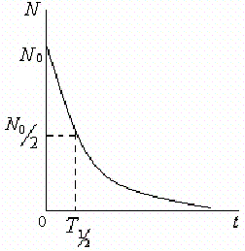
Figure 10.2

Activity of radioactive element A is the number of atoms that disintegrate in one second
$A=\left|\frac{\text{dN}}{\text{dt}}\right|=λN$,
$A=\frac{N\text{ln}2}{T_{12}}$.
The unit of radioactivity A is a becquerel (Bq). This is such activity when one disintegration per second occurs. Non-system unit of curie (Ci) is used also:
$1\text{Ci}=3\text{.}7⋅{\text{10}}^{\text{10}}\text{Bq}$.
Radioactive decay process submitted the displacement laws that on the basis of laws of conservation of matter and electric charge permit to establish the mass number and charge of nucleus of a new element which is produced from α - or β - decay
α: ${}_{Z}^{A}{}X→{}_{Z−2}^{A−4}{}Y+{}_{2}^{4}{}\text{He}$,
β: ${}_{Z}^{A}{}X→{}_{Z+1}^{A}{}Y+{}_{−1}^{0}{}e$.

Nuclear Reactions

All processes that happen with participation of nuclear forces and are the result of nuclear interactions are called nuclear reactions. Nuclear reactions are usually realized through bombarding nuclei with particles.
For the first time Rutherford performed artificial nuclear reaction in 1919
${}_{7}^{\text{14}}{}N+{}_{2}^{4}{}\text{He}→{}_{8}^{\text{17}}{}O+{}_{1}^{1}{}H$.
Other nuclear reactions are expressed by the equations
${}_{3}^{7}{}\text{Li}+{}_{1}^{1}{}H→{}_{\text{14}}^{\text{30}}{}\text{Si}+{}_{2}^{4}{}\text{He}$,
${}_{\text{13}}^{\text{27}}{}\text{Al}+{}_{2}^{4}{}\text{He}→{}_{\text{14}}^{\text{30}}{}\text{Si}+{}_{1}^{1}{}H$.
The general scheme of nuclear reaction is
$X+a→Y+b$, (10.11)
where X and Y are the initial and final nuclei, a and b are bombarding and emissive particles.
It is interesting that ancient alchemists were right. It is possible to turn elements into gold. The following reaction proves this fact:
${}_{\text{80}}^{\text{200}}{}\text{Hg}+{}_{1}^{1}{}p→{}_{\text{79}}^{\text{197}}{}\text{Au}+{}_{2}^{4}{}\text{He}$.
Unfortunately the real process is expected to be very expensive. And such production of gold would be a dead loss. The basic physical laws are observed during nuclear reactions: specifically law of the energy conservation and law of the charge conservation. Energy that is released at any nuclear transformation is called nuclear energy.

Nuclear Fission Reaction

Nuclear fission reaction proceeds when a heavy nucleus under the action of neutrons is divided into two lighter nuclei with emission of secondary neutrons.
German scientists O. Hahn and F. Strassmann discovered nuclear fission reaction in 1938. They found that an uranium nucleus is divided into two almost equal fragments of Ba and La during collisions with a neutron. Fission reaction is accompanied by the release of a large quantity of energy of 200 MeV order per nucleus. As a result 2÷3 secondary neutrons are liberated during one act of nuclear fission. The mass numbers of fragments lie within the limits from 79 to 165. There are several variants of fission reactions of uranium. For example
${}_{\text{92}}^{\text{235}}{}U+{}_{0}^{1}{}n→{}_{\text{54}}^{\text{139}}{}\text{Xe}+{}_{\text{38}}^{\text{95}}{}\text{Sr}+2{}_{0}^{1}{}n$.
Unstable fragment ${}_{\text{54}}^{\text{139}}{}\text{Xe}$ during three β - decays transforms into stable isotope of lanthanum${}_{\text{57}}^{\text{139}}{}\text{La}$
${}_{\text{54}}^{\text{139}}{}\text{Xe}\vec{β^{−}}{}_{\text{55}}^{\text{139}}{}\text{Cs}\vec{β^{−}}{}_{\text{56}}^{\text{139}}{}\text{Ba}\vec{β^{−}}{}_{\text{57}}^{\text{139}}{}\text{La}$.
The fission reaction of uranium can be accompanied by the emission of three neutrons:
${}_{\text{92}}^{\text{235}}{}\text{Ur}+_{0}^{1}n→{}_{\text{56}}^{\text{139}}{}\text{Ba}+{}_{\text{36}}^{\text{94}}{}\text{Kr}+3_{0}^{1}n$.
Nuclei of ${}_{}^{\text{235}}{}U$ and $\text{Pu}$ are divided under the action of fast as well as slow neutrons but under action of slow neutrons reactions proceed better. Nuclei of $\text{Ur}$are divided only by the fast neutrons with energy more than 1.8 MeV.
The secondary neutrons may produce the fission reactions of other nuclei of uranium, which under certain conditions leads to the development of chain fission reaction.

Chain Fission Reaction

The selfmultiplying fission reaction, called chain reaction, is of large interest for practical purpose, because it allows to obtain a great quantity of energy. Chain reaction is the process in which secondary neutrons in nuclear fission reaction may produce the fission of other nuclei, as a result, number of emitted neutrons and the next acts of fission progressively increases.
Chain reaction is characterized by coefficient of reproduction k of neutrons, which is equal to the ratio of number $N_{n}$ neutrons in a certain generation to the number $N_{n−1}$ neutrons in the previous generation
$k=\frac{N_{n}}{N_{n−1}}$. (10.12)
When k < 1 the number of fissions per unit time decreases and chain reaction terminates, it is damped one. When k = 1 the number of fissions per unit of time is constant and chain reaction is sustained with a constant velocity, it is self-maintained reaction. When k > 1 the number of fission acts increases exponentially, in this case the developing reaction occurs and it may become explosive. I.e. chain reaction is possible, when$k≥1$.
Coefficient of reproduction depends upon the nature of fissionable element, its quantity, and dimensions and forms of active zone.
There is critical mass of fissionable material, which equals to the minimum mass required to produce a chain reaction. If the mass of fissionable material is greater than critical one, then k > 1 and a chain reaction is a developing one.
Minimum dimensions of active zone under which chain reaction is possible are critical dimensions.
There are controllable and uncontrollable chain reactions. The explosion of atomic bomb is the result of uncontrollable chain reaction. Nuclear charge of atomic bomb is divided into two parts with masses bellow the critical and separated from each other. If these two parts are combined together the chain reaction develops and bomb explodes. The controllable chain reaction is used in nuclear reactors.

Nuclear Reactor

Controllable chain nuclear fission reactions with a regulated fission rate occur in nuclear reactors which are widely used for production the energy by nuclear power stations.
For the first time Italian physicist E. Fermi set the nuclear reactor in 1942. In USSR nuclear reactor was developed by I. Kurchatov in 1946.
Fissionable elements ${}_{\text{92}}^{\text{235}}{}U$, ${}_{\text{94}}^{\text{239}}{}\text{Pu}$, ${}_{\text{90}}^{\text{232}}{}U$, ${}_{\text{90}}^{\text{232}}{}\text{Th}$are used now as fuel elements. Uranium is more useful. The natural uranium contains only 0.7% of ${}_{\text{92}}^{\text{235}}{}U$. The principal part of natural uranium consists of isotope${}_{\text{92}}^{\text{238}}{}U$. This isotope absorbs neutrons but no fission act occurs. So the enriched uranium ${}_{\text{92}}^{\text{235}}{}U$ with concentration of 5 % is used as a fuel for nuclear reactor.
Let’s consider the principle of functioning the nuclear reactor with the slow neutrons. The scheme of nuclear reactor is shown in Fig. 10.3.
The main parts of nuclear reactor are: fuel rods (1), moderator (2), coolant (3), reflector (4), control rods (5).

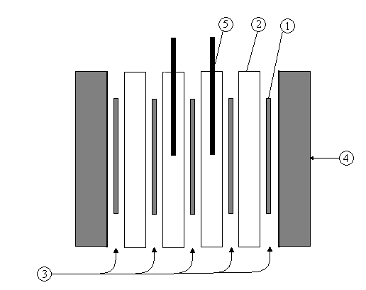
Figure 10.3

Fuel rods contain divided uranium. To slow the neutrons a moderator containing light atoms is used to which the neutrons give kinetic energy of collisions. Available moderators contain pure graphite $C$, heavy water $D_{2}O$ or beryllium Be. Fuel rods are heated as a result of fission chain reaction. For this reason coolant is used for cooling fuel rods and transferring heat energy to generator. Active zone of nuclear reactor surrounded by the reflector that reflects neutrons and decreases neutron leakage. Control rods are used to control chain reaction. Bohr B and cadmium Cd being control rod material able to absorb neutrons considerably. The chain reaction is developed when control rods are put out, when control rods are put in the chain reaction stopped.

Nuclear Fusion

A nuclear reaction between light atomic nuclei in which a heavier nucleus is formed with the release of energy is called nuclear fusion.
See synthesis of helium nucleus from hydrogen nuclei
${}_{1}^{2}{}H+{}_{1}^{2}{}H→{}_{2}^{3}{}\text{He}+{}_{0}^{1}{}n+3,3\text{MeV}$.
Fusion reactions would occur at very high temperatures ~108 K. These reactions are called thermonuclear reactions. They take place in the depths of stars. Possibly these reactions are the main source of the energy of sun and stars.
At first uncontrollable thermonuclear reaction was received in hydrogen bomb in USSR (1953), in which nuclear fusion reaction was realized
${}_{1}^{2}{}H+{}_{1}^{3}{}H→{}_{2}^{4}{}\text{He}+{}_{0}^{1}{}n+\text{17},6\text{MeV}$.
Since 1950 efforts of researchers have been made to produce a controllable thermonuclear reaction. Using the magnetic field to confine plasma at high temperature is one of the ways to solve this problem.

Elementary Particles

Elementary particles are undivided particles, which have no intrinsic structure.
Now we know about 400 elementary particles. More of them are unstable. They are transformed into other particles. Photon, electron, proton, neutron are the stable particles.
Elementary particles have mass, electric charge, spin and other quantum characteristics. Elementary particles can be turned one into another. Special particles called antiparticles correspond to each elementary particle. A particle and corresponding antiparticle have the same masses, spins and lifetime. But the electric charge and magnetic moment of this pair of particles are opposite in sign.
The process of interaction of particle and antiparticle is called annihilation. The formation of γ-quanta or other particles is the result of annihilation. For example, annihilation of electron and positron is accompanied with the transformation of these particles into two γ-quanta
$e^{+}+e^{−}→2γ$.
There are four types fundamental interactions between elementary particles: a strong interaction, an electromagnetic, a weak and a gravitational ones.
These interactions are characterized by constant of interaction and average life time or characteristic time of transfer. Constant of interaction characterizes the intensity of interaction between elementary particles. It is the undimentional value which determines the probability of interactional processes. Table 10.1 shows the comparative characteristic for four types of fundamental interactions.

Table 10.1
Type of interaction | Constant of interaction | Average  lifetime, s | Radius of  interaction, m
Strong | 10 | 10-23 | 10-15
Electromagnetic | ~10-2 | 10-16 | $$∞$$
Weak | ~10-10 | 10-10…10-13 | 10-18
Gravitational | ~10-40 | - | $$∞$$

Strong interaction exists between nucleons in nucleus. This characterizes the higher constant of interaction k ~ 10. The radius of interaction is r ~ 10-15 m. The strong interaction is the reason for existence of stable elements in nature.
Japanese physicist H. Yukawa supposed in 1935 that the strong interaction between two nucleons is caused by exchange particles being called mesons.
Electromagnetic interaction is weaker than the strong interaction. The constant of interaction equals to $\frac{e^{r}}{ℏc}≈\frac{1}{\text{137}}\text{\sim }{\text{10}}^{−2}$. The radius of interaction is unlimited $r=∞$. The electromagnetic interaction exists between electron and nucleus, between atoms in molecule. The exchange particle of the electromagnetic interaction is a photon.
Weak interaction is responsible for the processes of β - decay of nuclei, decay of particles and interaction of neutrinos with substances.
The constant of interaction is of small value ~10-10, the radius of interaction is of order to r ~ 10-18 m.
Gravitational interaction is weaker interaction. The constant of interaction is of order to ~10-40. Radius of interaction is unlimited $r=∞$.
The gravitational interaction exists between all particles. The relative part of this type of interaction is very small and it is negligible one.
The base of elementary particles characteristic is its mass. There exist four types of elementary particles: photons, leptons, mesons, barions.
The table 10.2 presents types of elementary particles and its basic characteristics.

Table 10.2
Group | Particle | Symbol | Rest mass | Charge | Spin | Average lifetime,s
Photon | Photon | γ | 0 | 0 | 1 | stable
Leptons | Electron | e- | 1 | -1 | 1/2 | stable
Leptons | Positron | e+ | 1 | +1 | 1/2 | stable
Leptons | Neutrino | ν_{e} | 0 | 0 | 1/2 | stable
Leptons | Antineutrino | $${\tilde{ν}}_{e}$$ | 0 | 0 | 1/2 | stable
Leptons | Muon  (μ-meson) | μ+ | 206,8 | +1 | 1/2 | ~10-6
Leptons | Muon  (μ-meson) | μ- | 206,8 | -1 | 1/2 | ~10-6
Mesons | π-meson  (pion) | π⁰ | 264,2 | 0 | 0 | ~10-15
Mesons | π-meson  (pion) | π⁰ | 273,2 | +1 | 0 | ~10-8
Mesons | π-meson  (pion) | π⁰ | 273,2 | -1 | 0 | ~10-8
Mesons | k-meson | k+ | 966,5 | +1 | 0 | ~10-8
Mesons | k-meson | k- | 966,5 | -1 | 0 | ~10-8
Mesons | k-meson | k⁰ | 974,8 | 0 | 0 | ~10-10
Mesons | k-meson | $${\tilde{k}}^{0}$$ | 974,8 | 0 | 0 | ~10-10
Baryons | Proton | p | 1836,1 | +1 | 1/2 | stable
Baryons | Antiproton | $$\tilde{p}$$ | 1836,1 | -1 | 1/2 | stable
Baryons | Neutron | n | 1838,6 | 0 | 1/2 | ~103
Baryons | Antineutron | $$\tilde{n}$$ | 1838,6 | 0 | 1/2 | ~103
Baryons | Lambda hyperon | λ⁰ | 2182 | 0 | 1/2 | ~10-10
Baryons | Sigma  hyperon |  | 2324 | 0 | 1/2 | ~10-10
Baryons | Sigma  hyperon |  | 2327 | +1 | 1/2 | ~10-10
Baryons | Sigma  hyperon |  | 2341 | -1 | 1/2 | ~10-10

Besides of these types of elementary particles the short-living particles with the strong interaction exist, which are called resonances. These particles correspond to the resonance states being formed as a result of interaction of several particles. The average lifetime of resonances is of order to ~10⁻²³ ÷ 10⁻²² s. The nature of resonances is unknown today.

SI UNITS, CONVERSION FACTORS AND PHYSICAL CONSTANTS

1. THE SI SYSTEM
Base units and symbols
Table 1. SI base units
Quantity | Name | Symbol
Length | metre | m
Mass | kilogram | kg
Time | second | s
Electric current | ampere | A
Thermodynamic temperature | keivin | K
Luminous intensity | candela | cd
Amount of substance | mole | mol

Derived units
Derived units are expressed algebraically in terms of base units (Table 2). Many have special names (Table 3) and symbols which may themselves be used to express other derived units (Table 4).

Table 2 Examples of SI derived units expressed in terms of base units

Quantity | SI unit
Quantity | Name | Symbol
Area | square metre | m²
Volume | cubic metre | m³
Speed, velocity | metre per second | m/s
Acceleration | metre per sec squared | m/s²
Wave number | 1 per metre | m⁻¹
Density, mass density | kilogram per cubic metre | kg/m³
Concentration (of amount of substance) | mole per cubic metre | mol/m³
Activity (radioactive) | 1 per second | s⁻¹
Specific volume | cubic metre per kilogram | m³/kg
Luminance | candela per square metre | cd/m²

Table 3. SI derived units with special names

Quantity |  |  | SI unit
Quantity | Name | Symbol | Expression  in terms  of other  units | Expression  in terms  of SI base  units
Frequency | Hertz | Hz |  | s⁻¹
Force | Newton | N |  | m kg s⁻²
Pressure, stress | Pascal | Pa | N/m² | m⁻¹ kg s⁻²
Energy, work,  quality of heat | Joule | J | N m | m² kg s⁻²
Power, radiant flux | watt | W | J/s | m² kg s⁻³
Quantity of  electricity  electric charge | Coulomb | C | A s | s A
Potential difference  electromotive force | Volt | V | W/A | m² kg s⁻³ A⁻¹
Capacitance | Farad | F | C/V | m⁻²kg⁻¹s⁴A²
Electric resistance | Ohm | Ω | V/A | m² kg s⁻³ A⁻²
Conductance | Siemens | S | A/V | m⁻² kg⁻¹ s³ A²
Magnetic flux | Weber | Wb | V s | m² kg s⁻² A⁻¹
Magnetic flux  density | Tesla | T | Wb/m² | kg s⁻² A⁻¹
Inductance | Henry | H | Wb/A | m² kg s⁻² A⁻²
Luminous flux | lumen | lm
Illuminance | lux | lx |  | m⁻² cd sr

Table 4. Examples of SI derived units expressed in terms of other derived units

Quantity | SI unit
Quantity | Name | Symbol | Expression in terms  of SI base units
Surface tension | Newton per  meter | N/m | kg s⁻²
Heat flux density,  irradiance | watt per  square meter | W/m² | kg s⁻³
Heat capacity  entropy | joule per  Kelvin | J/K | m² kg s⁻² K⁻¹
Specific heat  capacity  specific  entropy | joule per  kilogram  Kelvin | J/(kg K) | m² s⁻² K⁻¹
Specific energy | joule per  kilogram | J/kg | m² s⁻²
Thermal  conductivity | watt per meter  Kelvin | W/(m K) | m kg s⁻³ K⁻¹
Energy density | joule per cubic  meter | J/m³ | m⁻¹ kg s⁻²
Molar energy | joule per mole | J/mol | m² kg s⁻² mol⁻¹
Molar entropy,  molar heat  capacity | joule per mole  Kelvin | J/(mol K) | m² kg s⁻² K⁻¹ mol⁻¹

Supplementary units
These may be regarded either as base units or as derived units.

Table 5. SI supplementary units

Quantity | SI unit
Quantity | Name | Symbol
Plane angle  Solid angle | radian  steradian | rad  sr
Dimensionless quantities

The values of dimensionless quantities (such as the coefficient of friction, the refractive index, the relative permeability or the relative permittivity) are expressed by pure numbers. The corresponding SI unit is the ratio of the same two SI units and may be expressed by the number 1.
The writing of units
(a) The product of two or more units should be indicated by a dot, although it may be omitted when there is najisk of confusion with another unit, for example: N-m or Nm but not mN.
(b) A solidus (oblique stroke, /), a horizontal line, or negative powers may be used to express a derived unit formed from two others by division, for example: m/s, $\frac{m}{s}$ or ms⁻¹.
(c) The. solidus must not be repeated on the same line unless ambiguity is avoided by parentheses. In complicated cases negative powers or parentheses should be used, for example: m/s² or m.s⁻² but not m/s/s; m kg/(s³A) or m kg s⁻³ A⁻¹ but not m kg/s³/A.
Multiples and sub-multiples of SI units

Table 6. SI prefixes

Factor | Prefix | Symbol | Factor | Prefix | Symbol
10¹² | tera | T | 10⁻¹ | deci | d
10⁹ | giga | G | 10⁻² | centi | c
10⁶ | mega | M | 10⁻³ | milli | m
10³ | kilo | k | 10⁻⁶ | micro | μ
10² | hecto | h | 10⁻⁹ | nano | n
10¹ | deka | da | 10⁻¹² | pico | p
 |  |  | 10⁻¹⁵ | fermi | f
 |  |  | 10⁻¹⁸ | atto | a

Recommendations, (a) Prefix symbols are printed in roman (upright) type without spacing between the prefix symbol and the unit symbol.
(b) An exponent affixed to a symbol containing a prefix indicates that the multiple or sub-multiple of the unit is raised to the power expressed by the exponent, for example: 1 cm³ – 10⁻⁶ m³ , 1 cm = 10⁻² m.
(c) Do not use compound prefixes, for example: 1 nm but not 1 mμm.

2. OTHER UNITS, PERMITTED AND FORBIDDEN
Permitted units
Certain others are retained because of their particular convenience in specialized fields of science; and others, because their values expressed in SI units must be obtained by experiment, and are therefore not known exactly (Tables 8 and 9).

Table 8. Units used with the international system in specialized fields

Name | Symbol
electronvolt | eV
unified atomic mass unit | u
astronomical unit | AU
parsec | pc

Forbidden units
Do not mix SI with CGS units with special names (Table 10).

Table 10. CGS units with special names

Name | Symbol | Value in SI units
erg | erg | 1 erg = 10"⁷J
dyne | dyn | 1 dyn = 10~⁵N
poise | P | 1 P = 1 dyn-s/cm² = 0.1 Pa-s
stokes | St | 1 St = lcm7s = Kr⁴m²/s
gauss | Gs,G | 1 Gs corresponds to 10" ⁴T
oersted | Oe | 1 Oe corresponds to A/m
maxwell | Mx | 1 Mx corresponds to 10"⁸ Wb
stilb | sb | 1 stib = 1 cd/cm² = 10⁴cd/m²
phot | ph | 1 ph m 10* lx

3. CONVERSION OF UNITS
The conversion tables are used as follows: to convert the units in the row into the units in the column, multiply by the factor shown at their intersection. Example: to convert a stress in psi into a stress in bars, multiply by 6.90 ∙10⁻².

Table 12.
Angle | 1 rad | = 57.2958
Current | 1 A | = 1 Cs⁻¹
Density | 1 g/cm⁻³ | = 10³ kg m⁻³
Diffusion coefficient | 1 cm²/s | = 10⁻⁴ m²/s
Force | 1 dyn | = 10⁻⁵ N
 | 1 pound force | = 4.448 N
Length | 1 ft | = 0.3048 m
 | 1 in | = 0.0254 m
 | 1 Å | = 10⁻¹⁰ m
Mass | 1 gr | = 10⁻³ kg
 | 1 pound mass | = 0.453 kg
Surface energy | 1 erg/cm² | = 10⁻³ J m⁻²
Temperature | 1 ⁰F | = 0.556 ⁰K
Viscosity | 1 P | = 0.1 N S m⁻²
Volume | 1 gal | = 3.78 10⁻³ m³

Table 13. Conversion table for stress and pressure
 | MNm⁻² | dyn cm⁻² | psi | kgf cm⁻² | kgf mm² | bar | ton in⁻²
MN m⁻² | 1 | 10⁷ | 145 | 10.2 | 0.102 | 10 | 6.35 10⁻²
dyn cm⁻² | 10⁻⁷ | 1 | 1.4 10⁻⁵ | 1.02 10⁻⁶ | 1.02 10⁻⁸ | 10⁻⁶ | 6.35 10⁻⁹
psi | 6.90 10⁻³ | 6.90 10⁴ | 1 | 7.03 10⁻² | 7.03 10⁻⁴ | 6.90 10⁻² | 4.46 10⁻⁴
kgf cm⁻² | 9.80 10⁻² | 9.0 10⁵ | 14.2 | 1 | 10⁻² | 0.980 | 6.23 10⁻³
kgf mm⁻² | 9.80 | 9.80 10⁷ | 1.42 10³ | 100 | 1 | 98.0 | 6.23 10⁻¹
bar | 0.10 | 10⁶ | 14.50 | 1.02 | 0.0102 | 1 | 6.35 10⁻³
ton in⁻² | 15.75 | 1.57 10⁸ | 2.24 10³ | 1.61 10² | 1.61 | 1.57 10² | 1

Table 14. Conversion table for energy
 | J | erg | cal | eV | BThU | ftlbf
J | 1 | 10⁷ | 0.239 | 6.24 10¹⁸ | 9.47 10⁻⁴ | 0.737
erg | 10⁻⁷ | 1 | 2.39 10⁻⁸ | 6.24 10¹¹ | 9.47 10⁻¹¹ | 7.37 10⁻⁸
cal | 4.18 | 4.18 10⁷ | 1 | 2.61 10¹⁹ | 3.96 10-³ | 3.08
eV | 1.60 10⁻¹⁹ | 1.6 10⁻¹² | 3.83 10⁻¹⁷ | 1 | 1.52 10⁻²² | 1.81 10⁻¹⁹
BThU | 1.06 10³ | 1.06 10⁻¹⁰ | 2.52 10² | 6.59 10²¹ | 1 | 7.78 10²
ft lb_{f} | 1.36 | 1.36 10⁷ | 3.24 10⁻¹ | 8.47 10¹⁸ | 1.28 10⁻³ | 1

Table 15. Conversion table for specific energy

 | J/mol | cal/mol | erg/atom | eV/atom
J/mol | 1 | 0.239 | 1.66 10⁻¹⁷ | 1.04 10⁻⁵
cal/mol | 4.18 | 1 | 6.94 10⁻¹⁷ | 4.34 10⁻⁵
erg/atom | 6.02 10¹⁶ | 1.44 10¹⁴ | 1 | 6.25 10¹¹
eV/atom | 9.63 10⁴ | 2.305 10⁴ | 1.6 10⁻¹² | 1

4. PHYSICAL CONSTANTS IN SI UNITS

Acceleration due to gravity, g | 9.80 m s⁻²
Angstrom, Å | 10⁻¹⁰ m
Atomic mass unit, amu | 1.661 10⁻²⁷ kg
Avogadro's number, N | 6.022 10²³ mol⁻¹
Base of natural logarithms, e | 2.718
Boltzmann's constant, k | 1.38 10⁻²³ J ⁰K⁻¹
Capacitivity (vacuum), ε | 8.85 10⁻¹² C V⁻¹ m⁻¹
Electron charge | 1.60 10⁻¹⁹ C
Electron mass | 9.11 10⁻³¹ kg
Electron moment | 9.27 10⁻²⁴ A m⁻²
Faraday constant, F | 9.65 10⁴ C
Gas constant, R | 8.31 J mol⁻¹ °K⁻¹
Gas volume (STP), V_{o} | 2.24 10⁻² m³ mol⁻¹
Neutron rest mass, m_{n} | 1.675 10⁻²⁷ kg
Plancks constant, h | 6.62 10⁻³⁴ J s
Proton rest mass, m_{p} | 1.672 10⁻²⁷ kg
Velocity of light, c | 3.00 10⁸ m s⁻¹

