MINISTRY OF Education and science of ukraine
Zaporozhye National Technical University

S.V. Loskutov, S.P. Lushchin

Short course of lectures of general physics

For students studying physics on English,
and foreign students also
Semester II
Part 1

2009

Short course of lectures of general physics. For students studying physics on English, and foreign students also. Semester II, Part I / S.V. Loskutov, S.P. Lushchin. – Zaporozhye: ZNTU, 2009.- 88 p.

Compilers:
S.V. Loskutov, professor, doctor of sciences (physics and mathematics);
S.P. Lushchin, docent, candidate of sciences (physics and mathematics).

Reviewer:
G.V. Kornich, professor, doctor of sciences (physics and mathematics).

Language editing: A.N. Kostenko, candidate of sciences (philology).

Approved
by physics department,
protocol № 6
dated 30.03.2009
by ETF
protocol № 8
dated 21.04.2009

It is recommended for publishing by scholastic methodical division as synopsis of lecture of general physics at meeting of Chair of Theory and Practice of Translation, protocol № 10 dated 15.06.2009.

The authors shall be grateful to the readers who point out errors and omissions which, inspite of all care, might have been there.

Contents
Part I
Lecture 1. Electrostatics ………………………………………………….. 5
Electric charge ….………………...………………………………….…... 5
The charge conservation law ………………………………………..……. 6
Electrostatic charging …………………….………………………………. 7
Coulomb’s Law ………………………………………………………..… 8
Electric Charge Density ….……………………………………………... 11
Electric Field Intensity…. ……………………………………………….. 11
The electric field Lines of Force ………..……………….………...…..… 13
Electric field around a charged conductor ……….………..…………….. 15
Lecture 2. Electric Field in vacuum ……………………………………... 16
Electric flux ……………………………………………………………... 16
Implications of Gauss' Law ….….………………………………….…… 18
Work by electrostatic forces. Electric potential ………………..…..….… 22
Connection Between Intensity Vector and Potential ……………..……... 24
Lecture 3. Electric Field in Dielectrics ……….……………………..….. 25
The Dielectrics Polarization ……………………………………...……... 27
Conductors in Electric Field …………………………………….……… 29
The Electric Capacitance …………………………………………….….. 30
The Capacitance of a Plane Capacitor ………………………….…..…… 32
The Electric Field Energy ……….……………………………………..... 33
Piezoelectric effect ……………………………………………………… 34
Lecture 4. Electricity theory of conductivity ………………….……….. 35
The Direct Electric Current …………….……………………………….. 35
The Current Intensity ..……………….……...…………………………... 36
Ohm’s Law for an Uniform Conductor ………….……………………… 41
Ohm’s Law in the Differential Form ……………………………………. 42
Current and electrical resistance ………………………………………… 42
Multi-loop Circuits and Kirchoff's laws …………………………….….. 42
Ohm’s Law for Heterogeneous Circuit …………………………………. 45
Difference of Potentials. Electromotive Force ……………………...….. 45
Lecture 5. Magnetic Fields ……………..……………….………………..46
Force Lines of the Magnetic Field …………...……………………...…. 49
Magnetic fields created by permanent magnets ….………...………...…. 50
The magnetic field produced by currents in wires …………………..….. 50
Force acting on a charged particle in a magnetic field …………...……... 52
Lecture 6. The Magnetic Field Intensity …………..……………………. 56
Vector of the Magnetic Induction and Vector of the Magnetic
Field Intensity …….. ………….………………………………...………. 57
The Biot - Savart Law …………………………………………….…….. 59
Lines of Force and flux field intensity of magnetic field ……..………… 62
Ampere Force …………………………………………………..……….. 63

Lecture 7. Electromagnetic Fields. Maxwell’s Equations ……………… 65
Interaction of currents and magnets……………………….…………….. 65
Magnetic Flux …………………………………………………………… 67
Electromagnetic induction ……………………………………….……… 67
Source of Alternating Current ………………………………………… 73
Self-Induction …………………………………………………………… 74
Eddy Electric Field ……………………………………………………… 75
Mutual Inductance. Transformer ………………………………………... 76
Magnetic Field Energy …………………………………………………. 79
Lecture 8. Finite bodies in a magnetic field ……………………………. 80
Relationship between permeability and susceptibility …………………. 82
Physical Fundamentals of Magnetic Properties of Solids ……………… 83
The Forms of Substances Magnetism …………………………………… 83
Diamagnetism …………………………………………….…………… 84
Paramgnetics …………………………………………………………… 84
Ferromagnetics. Magnetic hysteresis …………………………………... 85

Lecture 1. Electrostatics

Electrostatics studies electric fields of motionless electric charges. Electric fields are created by electric charges in space. Thus, every charged body is surrounded by its electric field, which theoretically extends out to infinity. Electric field has got energy and the mass.

Electric charge

In this part of the course we shall examine physical phenomena in which electric charges take part. Bodies which have the same kind of charge repel each other, while bodies with different charges attract one another. There are two kinds of charge, positive and negative. Like charge repel, unlike charges attract, fig 1.1.
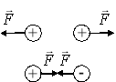
Figure 1.1

Positive charge comes from having more protons than electrons; negative charge comes from having more electrons than protons.
Charge is quantized, it means that the charge comes in integer multiples of the elementary charge e. What does it mean for the charge to be quantized? Charge comes in multiples of an indivisible unit of charge, represented by the letter e. In other words, the charge comes in multiples of the charge on the electron or the proton. These things have the charge with the same size, but the sign is different. A proton has a charge of +e, while an electron has a charge of -e.
The unit of the electric charge is the Coulomb, and is defined from the unit of current called the ampere,
Coulomb = Ampere × second.
Not only electrons and protons carry charge. Other particles (positrons, for example) also carry charge in multiples of the electronic charge. Putting "charge is quantized" in terms of an equation, we say:
$q=n⋅e$, (1.1)
q is the symbol used to represent charge, while n is a positive or negative integer, and e is the electronic charge, e =1.60·10⁻¹⁹ Coulombs.
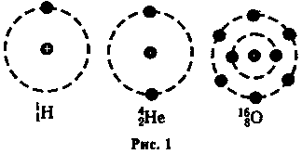
Figure 1.2

The electric Charge Conservation Law

Placing the pair of closely spaced in a field, and then carefully rotating them, the positive charge may be accumulated on the one plate and negative charge on the other. Moreover, the quantity of induced electricity may be measured by an electrometer. It has been found out that both positive and negative charged bodies are made up of a whole number of elementary electric charges.
The electric charge conservation law states that the net charge of an isolated system remains constant. If a system starts out with an equal number of positive and negative charges, there are nothing we can do to create an excess of one kind of charge in that system unless we bring in charge from outside the system (or remove some charge from the system). Likewise, if something starts out with a certain net charge, say +100 e, it will always have +100 e unless it is allowed to interact with something external to it. The charge can be created and destroyed, but only in positive - negative pairs. The table of elementary particle masses and charges:
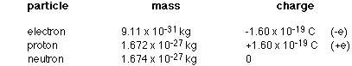
The electric charge conservation law is observed to stay true in any phenomena that involves the electrically charged bodies: “The algebraic sum of the positive and negative charges in a closed system does not alter, whatever process is occurring in the system”.
$\underset{i}{Σ}q_{i}=\text{const}$. (1.2)

Electrostatic charging

Forces between two electrically-charged objects can be extremely high. Most things are electrically neutral, they have equal amounts of positive and negative charge. If this was the case, the world we live in would be a much stranger place. We also have a lot of control over how things get charged. This is because we can choose the appropriate material to use in a given situation. Metals are good conductors of the electric charge, while plastics, wood, and rubber are not. They called insulators. The charge does not flow nearly as easily through insulators as it does through conductors, that is why the wires that you plug into a wall socket are covered with a protective rubber coating. The charge flows along the wire, but not through the coating to you. If the structure of a body is such that the free displacement of charged particles is forbidden or extremely difficult, then the body is called a dielectric. The semiconductors are the crystals whose electric properties depend very greatly on their composition, manufacture and state.
Materials are divided into three categories, depending on how easily they will allow the charge (i.e., electrons) to flow along them. These are: conductors – metals, for example; semiconductors – silicon is a good example; insulators – rubber, wood, plastic for example.
Most materials are either conductors or insulators. The difference between them is that in conductors, the outermost electrons in the atoms are so loosely bound to their atoms that they free to travel around. In insulators, on the other hand, the electrons are much more tightly bound to the atoms, and are not free to flow. The semiconductors is a very useful intermediate class, not as conductive as metals but considerably more conductive than insulators. By adding certain impurities to semiconductors in the appropriate concentrations the conductivity can be well-controlled.
There are three ways that objects can be given a net charge.
- Charging by friction – this is useful for charging insulators. If you rub one material with another (say, a plastic ruler with a piece of paper towel), electrons have a tendency to be transferred from one material to the other. For example, rubbing glass with silk or saran wrap generally leaves the glass with a positive charge; rubbing rod with fur generally gives the rod a negative charge.
- Charging by conduction – useful for charging metals and other conductors. If a charged object touches a conductor, some charge will be transferred between the object and the conductor, charging the conductor with the same sign as the charge on the object.
- Charging by induction – also useful for charging metals and other conductors. Again, a charged object is used, but this time it is only brought close to the conductor, and does not touch it. If the conductor is connected to ground (ground is basically anything neutral that can give up electrons to, or take electrons from, an object), electrons will either flow on to it or away from it. When the ground connection is removed, the conductor will have a charge opposite in sign to that of the charged object.
An example of induction using a negatively charged object and an initially-uncharged conductor (for example, a metal ball on a plastic handle).
1. Bring the negatively-charged object close to, but not touching, the conductor. Electrons on the conductor will be repelled from the area nearest the charged object.
2. Connect the conductor to ground. The electrons at the conductor tend to get as far away from the negatively-charged object as possible, so some of them flow to ground.
3. Remove the ground connection. This leaves the conductor with a deficit of electrons.
Remove the charged object. The conductor is now positively charged.
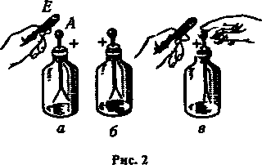
Figure 1.3

Coulomb’s Law

The French engineer Charles Coulomb investigated the quantitative relation of forces between charged objects during the 1780's. Using a torsion balance device, created by Coulomb, he could determine how the electric force varies as a function of the magnitude of the charges and the distance between them.
Coulomb used little spheres with different charges whose exact value he did not know, but the experiment allowed him to test the relation between the charges. Coulomb realized that if a charged sphere touches another identical not charged sphere, the charge will be shared in equal parts symmetrically. Thus, he had the way to generate charges equal to ½, ¼, etc., from the original charge. Keeping the distance constant between the charges he noticed that if the charge of one of the spheres was duplicated, the force was also duplicated; and if the charge in both spheres was duplicated, the force was increased to four times its original value. When he varied the distance between the charges, he found out that the force decreased against the square of the distance; that is, if the distance was duplicated, the force decreased to the fourth part of the original value.
When Coulomb was doing his original experiments he decided to use a torsion balance to measure the forces between charges. You already learned about a torsion balance when you discussed Henry Cavendish’s experiment to measure the value of “γ”, the universal gravitational constant.
Coulomb was actually doing his experiments about 10 years before Cavendish. He set up his apparatus as shown below with all spheres charged the same way. He charged one of the free moving spheres. He then touched it to the other free moving sphere (charging it by conduction). Each of the free moving spheres was then touched to one of the spheres on the rod. Although he didn't know the actual charge on any particular sphere, Coulomb did know that each was equal. In that way Coulomb demonstrated that the electric force between two stationary charged particles is:
- Inversely proportional to the square of the distance r between the particles and is directed along the line that joins them. Proportional to the product of the charges q₁ and q₂. Attracted if the charges have opposite electrical sign and repulsed if the charges have equal sign.
A charged body, whose dimensions can be neglected in comparison with the distance to other bodies, is called the point of charge. The Coulomb’s law considers the point charges and describes the interaction between them: in vacuum a force of interaction of two point charges q₁ and q₂ is directly proportional to the product of these charges and is inversely proportional to the squared distance r between them.

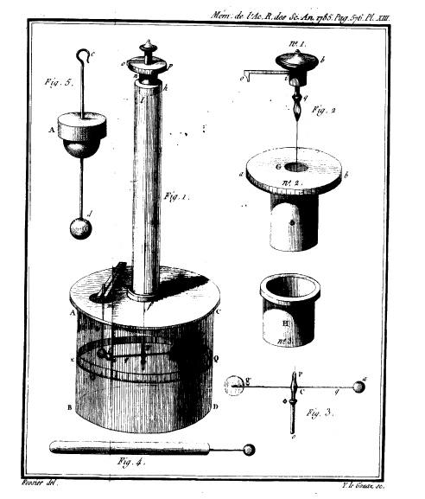
Figure 1.4 - The Torsion Balance

The force is directed along the line, connecting two charges:

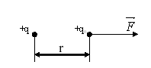
Figure 1.5

$\vec{F}=\frac{1}{4{\text{πε}}_{0}}\frac{q_{1}q_{2}}{r^{2}}\vec{i}$, (1.3)
where $\vec{i}=\frac{\vec{r}}{r}$ the unit vector, $ε_{0}$ is the electric constant. This quantity ($ε_{0}$) has no any physical sense. It is introduced in this law to agree the units. The numerical value of this quantity is $ε_{0}=8,\text{85}⋅{\text{10}}^{−\text{12}}F/m$.
Remember that the force is a vector, so when more than one charge exerts a force on another charge, the net force on that charge is the vector sum of the individual forces. Remember, also, that the charges of the same sign exert repulsive forces on one another, while the charges of opposite sign attract fig. 1.6.
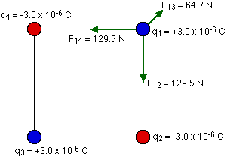
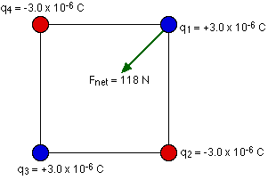
Figure 1.6

The Electric Charge Density

We should distinguish three types of the charge density.
1. The ratio of the charge value to volume is called the volume charge density:
$ρ=\frac{\text{dq}}{\text{dV}},\left[ρ\right]=\frac{C}{m^{3}}$. (1.4)
2. The ratio of the charge value to area, over which it is distributed, is called the surface charge density:
$σ=\frac{\text{dq}}{\text{dS},}\left[σ\right]=\frac{C}{m^{2}}$. (1.5)
3. The ratio of the charge value to line, along which it is distributed, is called the line charge density:
$λ=\frac{\text{dq}}{\text{dl}},\left[λ\right]=\frac{C}{m}$. (1.6)

The Electric Field Intensity

To help visualize how a charge, or a collection of charges, influences the region around it, the concept of the electric field is used.
The electric field E is analogous to g, which we called the acceleration due to gravity but which is really the gravitational field, fig.1.7.
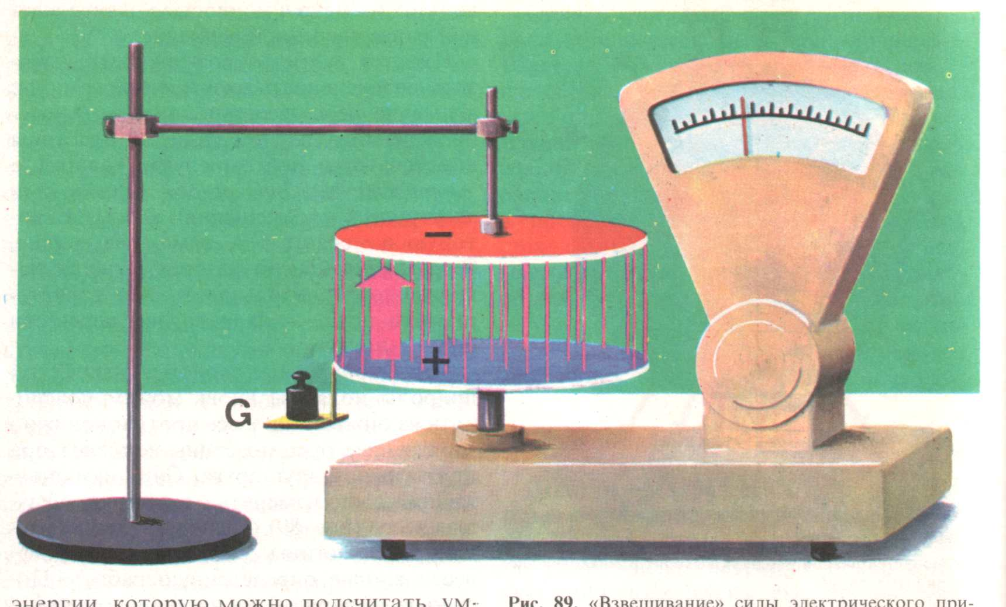
Figure 1.7

Everything we learned about gravity, and how masses respond to gravitational forces, can help us to understand how the electric charges respond to electric forces. The one big difference between gravity and electricity is that m, the mass, is always positive, while q, the charge, can be positive, zero or negative, fig.1.8.
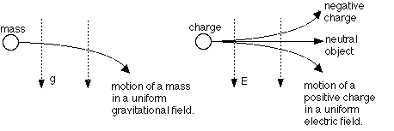
Figure 1.8

The electric field intensity is its force characteristic, which depends on coordinates. The electric field intensity at a given point is equal to the force, acting on a unit positive charge, placed at this point
$\vec{E}=\frac{\vec{F}}{q_{0}},$ (1.7)
where q₀ = +1 C. The direction of $\vec{E}$vector coincides with that of the force acting on the positive charge in the electric field. The unit of electric field intensity in SI system is
$\left[E\right]=\frac{N}{C}=\frac{V}{m}\text{.}$ (1.8)
Hence, it is possible to describe an electric field by its intensity E, which is defined as follows
$\vec{E}=\frac{q}{4{\text{πε}}_{o}{εr}^{2}}⋅\frac{\vec{r}}{\left|\vec{r}\right|}$ . (1.9)
The electric field from a positive charge points away from the charge; the electric field from a negative charge points toward the charge. Like the electric force, the electric field E is a vector. If the electric field at a particular point is known, the force a charge q experiences when it is placed at that point is given by
$\vec{F}=q⋅\vec{E}$ . (1.10)
If q is positive, the force is in the same direction as the field; if q is negative, the force is in the opposite direction as the field.
The electric field of fixed charges is called the electrostatic field. We should distinguish the homogeneous and heterogeneous fields. At any point of homogeneous field the vector $\vec{E}$ is the same. On the contrary, at any point of heterogeneous field there are different $\vec{E}$-vectors. The superposition principle takes place: the vector $\vec{E}$ at a given point for electric field of any system of charges may be found by summing the vectors for the individual charges
$\vec{E}=\sum_{i=1}^{n}{{\vec{E}}_{i}}$, (1.11)
where n is the number of charges, fig 1.9.
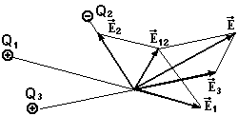
Figure 1.9

The electric field Lines of Force

An electric field can be visualized on paper by drawing lines of force, which give an indication of both the size and the strength of the field. Lines of force are also called field lines. Field lines start on positive charges and terminate on negative charges, and the direction of the field line at a point tells you what direction the force experienced by a charge will be if the charge is placed at that point. If the charge is positive, it will experience a force in the same direction as the field; if it is negative the force will be opposite to the field. The fields from isolated, individual charges look like this, fig.1.10.
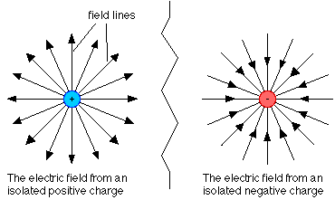
Figure 1.10

When there is more than one charge in a region, the electric field lines will not be straight lines; they will curve in response to the different charges. In every case, though, the field is highest where the field lines are close together, and decreases as the lines get further apart. A view of the lines of force depends upon arrangements of charges. The electric lines of force have got two properties:
1. They can be initiated and terminated at electric charges or at the infinity only;
2. They cannot cross with each other.
Examples of some electric fields are shown in the next figure 1.11.

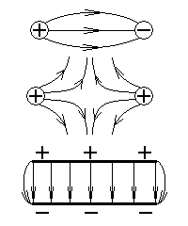
Figure 1.11

The Electric field around a charged conductor

A conductor is in the electrostatic equilibrium when the charge distribution (the way the charge is distributed over the conductor) is fixed. Basically, when you charge a conductor the charge spreads itself out. At equilibrium, the charge and electric field follow these guidelines:
- the excess charge lies only at the surface of the conductor;
- the electric field is zero inside of the conductor;
- the electric field at the surface of the conductor is perpendicular to the surface;
- charge accumulates, and the field is strongest, on pointy parts of the conductor.
Let's see if we can explain these things. Consider a negatively-charged conductor, in other words, a conductor with an excess of electrons. The excess electrons repel each other, so they want to get away from each other as far as possible. To do this they move to the conductor’s surface. They also distribute themselves so the electric field inside the conductor is zero. If the field wasn't zero, any electrons that are free to move would. There are plenty of free electrons inside the conductor (they're the ones that are canceling out the positive charge from all the protons) and they don't move, so the field must be zero.
A similar argument explains why the field at the surface of the conductor is perpendicular to the surface. If it wasn't, there would be a component of the field along the surface. A charge experiencing that field would move along the surface in response to that field, which is inconsistent with the conductor being in equilibrium.
Why does the charge pile up at the pointy ends of the conductor? Consider two conductors, one in the shape of a circle and one in the shape of a line, fig 1.12. Charges are distributed uniformly along both conductors. With the circular shape, each charge has no net force on it, because there is the same amount of charge on either side of it and it is uniformly distributed. The circular conductor is in equilibrium, as far as its charge distribution is concerned.

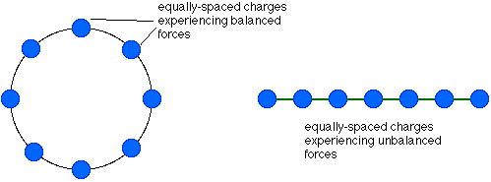
Figure 1.12

With the line, on the other hand, a uniform distribution does not correspond to equilibrium. If you look at the second charge from the left on the line, for example, there is just one charge to its left and several on the right. This charge would experience a force to the left, pushing it down towards the end. For charge distributed along a line, the equilibrium distribution would look more like this, fig. 1.13.

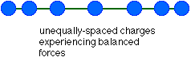
Figure 1.13

The charge accumulates at the pointy ends because that balances the forces on each charge.

Lecture 2. Electric Field in VACUUM

Electric flux

A clever way to calculate the electric field from a charged conductor is to use Gauss' Law. Gauss' Law can be tricky to apply, though, so we won't get into that. What we will do is to look at some implications of Gauss' Law. It's also a good time to introduce the concept of flux. Electric flux is a measure of the number of electric field lines passing through an area. To calculate the flux through a particular surface, multiply the surface area by the component of the electric field perpendicular to the surface. If the electric field is parallel to the surface, no field lines pass through the surface and the flux will be zero. The maximum flux occurs when the field is perpendicular to the surface.
Let's consider a E_{n} projection of the intensity vector $\vec{E}$ on the perpendicular to an elementary dS area. See fig.2.1:
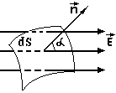
Figure 2.1

The product of E_{n} by dS is called the flux of the intensity vector $\vec{E}$ through this area:
$dΦ=E_{n}\text{dS}=\text{EdS}\text{cos}α=(\vec{E},d\vec{S})$, (2.1)
where $d\vec{S}=\text{dS}×\vec{n}$. A flux of $\vec{E}$ through a closed area is
$Φ=\oint_{s}{E_{n}\text{dS}}$. (2.2)
The theorem of Gauss deals with the determination of intensities of various electric fields. This theorem is deduced proceeding from consideration of a shape of charged bodies. In fact it follows from Coulomb's law. Let's consider the electric field near the q as a point charge.
We have got the force, acting on the test charge q₀:
$F=\frac{1}{4{\text{πε}}_{0}}⋅\frac{{\text{qq}}_{0}}{r^{2}}$. (2.3)
By definition

. (2.4)
A closed surface is called the surface of Gauss. In general form the theorem of Gauss for electrostatic field in vacuum reads as following: the flux of the intensity vector in vacuum through an arbitrary closed surface is equal to the sum charges, which are surrounded by this surface, divided by electric constant ε₀:
$Φ=\frac{1}{ε_{0}}⋅\sum_{i}{qi}$. (2.5)
Or more rigorous equation is:
$\oint_{s}{E_{n}\text{dS}}=\frac{1}{ε_{0}}⋅\sum_{i}{qi}$ (2.6)

Implications of Gauss' Law

Gauss' Law is a powerful method of electric fields calculating. If you have a solid conducting sphere (e.g., a metal ball) that has a net charge Q on it, you know all the excess charge lies on the outside of the sphere. Gauss' law tells us that the electric field inside the sphere is zero, and the electric field outside the sphere is the same as the field from a point charge with a net charge of Q. That's a pretty neat result.

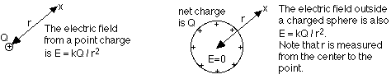

Figure 2.2

The result for the sphere applies whether it's solid or hollow. Let's look at the hollow sphere, and make it more interesting by adding a point charge at the center.
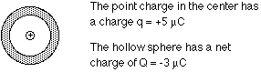

Figure 2.3

What does the electric field look like around this charge inside the hollow sphere? How is the negative charge distributed on the hollow sphere? To find the answers, keep these things in mind:
- The electric field must be zero inside the sphere;
- Outside the sphere, you can find the net electric field by adding, as vectors, the electric field from the point charge alone and from the sphere alone
We know that the electric field from the point charge is given by kq/ r². Because the charge is positive, the field points away from the charge. If we took the point charge out of the sphere, the field from the negative charge on the sphere would be zero inside the sphere, and given by kq/r² outside the sphere.
The net electric field with the point charge and the charged sphere, then, is the sum of the fields from the point charge alone and from the sphere alone (except inside the solid part of the sphere, where the field must be zero). This is shown in the figure:
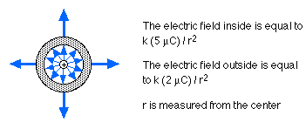
Figure 2.4

How is the charge distributed on the sphere? The electrons must distribute themselves so the field is zero in the solid part. This means there must be -5 microcoulombs of charge on the inner surface, to stop all the field lines from the +5 microcoulomb point charge. There must then be +2 microcoulombs of charge on the outer surface of the sphere, to give a net charge of -5 + 2 = -3 microcoulombs.
1. The electric field intensity, created by a point charge q is a charge, which forms an electric field, r is a distance to a chosen point M. Our aim is to determine the intensity of an electric field at this point. It is reasonable to draw a sphere of Gauss through a given point M. Now we've got:$Φ=\frac{q}{ε_{0}}$, because only the charge q is located inside this sphere. Further
$$\begin{aligned}Φ=\text{ES}=E⋅4{πr}^{2}=\frac{q}{ε_{0}}; \\ E=\frac{1}{4{\text{πε}}_{0}}⋅\frac{q}{r^{2}}\text{.}\end{aligned}$$

In figure 2.5 the value of E is plotted versus r:
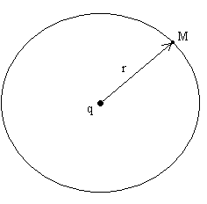
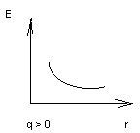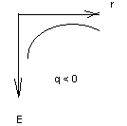

Figure 2.5

2. The electric field intensity, created by a hollow sphere. Let us consider that there is a hollow charged sphere of R₀ radius. We should determine its electric field. We mean to find a vector E at any point of space. R₀ is a radius of a real charged sphere; r is the radius of an imagined sphere of Gauss. If r > R₀ the theorem of Ostrogradsky is

$E⋅4{πR}_{0^{2}}=\frac{q}{ε_{0}};E=\frac{1}{4{\text{πε}}_{0}}⋅\frac{q}{R_{0^{2}}}$.
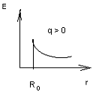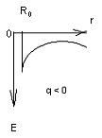

Figure 2.6

If r < R₀, q=0 inside the sphere and E=0.
3. The electric field intensity, created by an infinite charged plane. Let us consider an infinite charged plane. The surface charge density is equal to δ. It is reasonable to use a cylinder as a surface of Gauss. The flux of vector intensity through a side surface is equal to zero. As for butt-end surface it is:
$$2\text{ES}=\frac{σS}{ε_{0}};q=σS⇒E=\frac{σ}{2ε_{0}};$$
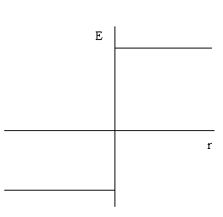

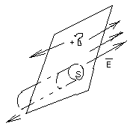

Figure 2.7

Intensity vector E doesn’t depend upon r.
4. The electric field of two charged parallel infinite planes. A plane capacitor consists of two planes, which are charged by electricity of the opposite sign (fig.2.6). The surface charge density is $δ=\frac{\text{dq}}{\text{dS}}\text{.}$ The distance between planes is d (fig.2.7).
$E=E_{+}+E_{−}=2⋅\frac{σ}{2ε_{0}}=\frac{σ}{ε_{0}}$.
5. The electric field of an infinite uniformly charged wire. In this case the surface of Gauss is a cylinder. The theorem of Ostrogradsky and Gauss is:
$$E⋅2π\text{rl}=\frac{λl}{ε_{0}};q=λl⇒E=\frac{1}{2{\text{πε}}_{0}}⋅\frac{λ}{r}\text{.}$$
Work by electrostatic forces. Electric potential

Let us move a test positive unit charge q₀ from the first point to the second one along line L and calculate the work.
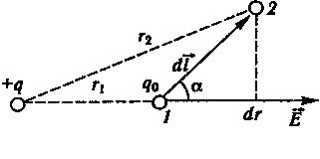
Figure 2.8

The elementary part of length dl is so small, that the electric field intensity $\vec{E}$ may be taken as a constant in magnitude and direction within the limits of dl. The total work, done in this small interval is
$\text{dA}=\text{Fdl}\text{cos}α=\frac{1}{4{\text{πε}}_{0}}⋅\frac{{\text{qq}}_{0}}{r^{2}}\text{dl}\text{cos}α$ , (2.7)
as $\text{dl}\text{cos}α=\text{dr}$,
$\text{dA}=\frac{1}{4{\text{πε}}_{0}}⋅\frac{{\text{qq}}_{0}}{r^{2}}\text{dr}$. (2.8)
The total work is
$A=\int_{r_{1}}^{r_{2}}{\text{dA}}=\frac{{\text{qq}}_{0}}{4{\text{πε}}_{0}}\int_{r_{1}}^{r_{2}}{\frac{\text{dr}}{r^{2}}=}\frac{1}{4{\text{πε}}_{0}}\left(\frac{{\text{qq}}_{0}}{r_{1}}−\frac{{\text{qq}}_{0}}{r_{2}}\right)\text{.}$ (2.9)
From this equation we can see that a work done doesn't relate to the shape and length of the path L. A work is defined only by the position of the points 1 and 2. Consequently, the electric field of a unit charge is potential and electrostatic force is conservative. The work, done by this electrostatic forces around any closed contour is always zero:$(\oint{\text{dA}=0})$. That is
$\oint{q_{0}\text{Edl}=0}$. (2.10)
And for unit charge $q_{0}=1:$
$\oint{\text{Edl}=0\text{.}}$ (2.11)
This integral is called the intensity vector $\vec{E}$circulation. Consequently, the circulation of the vector intensity of electrostatic field around any closed contour is always equal to zero. The field, that has this property, is called potential.
Potential is the energetic characteristic of the electric field. It is denoted as $ϕ$. The potential at a given point is the potential energy of a unit positive charge, placed at this point:
$ϕ=\frac{W}{q_{0}}\text{.}$ (2.12)
It is a scalar function of coordinates:
$ϕ=ϕ(z,y,z)=ϕ(r)\text{.}$ (2.13)
The unit of potential is called Volt. $\left[ϕ\right]=\frac{J}{C}\text{.}$
The work which electric field performs, removing unit positive charge $q_{0}$ from point 1 to point 2 is:
$A=\frac{1}{4{\text{πε}}_{0}}\left(\frac{1}{r_{1}}−\frac{1}{r_{2}}\right)=W_{1}−W_{2}\text{.}$ (2.14)
The work is equal to the difference of potential energies of charge $q_{0}$ at the point 1 and 2:
$\begin{aligned}ϕ=\frac{W}{q_{0}}=\frac{1}{4{\text{πε}}_{0}}⋅\frac{q}{r}; \\ A=q_{0}(ϕ_{1}−ϕ_{2})\text{.}\end{aligned}$ (2.15)
If unite positive charge removes from given point to infinity, which $ϕ$=0, the work
$$A_{∞}=q_{0}ϕ;$$
and $ϕ=\frac{A_{∞}}{q_{0}}$. (2.16)
This is the following definition of potential: the work, electric field performs, removing unit positive charge from given point to infinity is called the potential of an electric field at a given point. At the given point the potential of a set of point charges is the algebraic sum of the potentials, created at the given point by each charge separately:
$ϕ=\sum_{i}{ϕ_{i}}$. (2.17)
Potential plays the same role for the charge that the pressure does for the fluids. If there is a pressure difference between two ends of a pipe filled with the fluid, the fluid will flow from the high pressure end towards the lower pressure end. Charges respond to differences in potential in a similar way.
Electric potential is a measure of the potential energy per unit charge. If you know the potential at the point, and then you place a charge at that point, the potential energy associated with that charge in that potential is simply the charge multiplied by the potential. Electric potential, like potential energy, is a scalar, not a vector. Equipotential lines are connected lines of the same potential. These often appear on field line diagrams. Equipotential lines are always perpendicular to field lines, and therefore perpendicular to the force experienced by a charge in the field. If a charge moves along an equipotential line, no work is done; if a charge moves between equipotential lines, work is done.
Field lines and equipotential lines for a point charge, and for a constant field between two charged plates, are shown below:
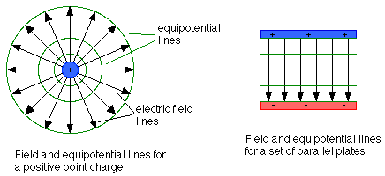
Figure 2.9

Connection Between Intensity Vector and Potential

The relationship between work and force in dynamics is:
$\text{dA}=\left(\vec{F},d\vec{r}\right)$. (2.18)
Let us divide this equation by the value of the test charge q₀ :
$\frac{\text{dA}}{q_{0}}=\left(\frac{\vec{F}}{q_{0}};d\vec{r}\right)⇒ϕ_{1}−ϕ_{2}=\int_{1}^{2}{\vec{E}d\vec{r}}$, (2.19)
$ϕ_{2}−ϕ_{1}=−\int_{1}^{2}{\vec{E}d\vec{r}}$. (2.20)
Dividing the last equation by the value, we obtain:
$E=−\frac{dϕ}{\text{dr}}\text{.}$ (2.21)
Thus
$\vec{E}=−\text{grad}ϕ$. (2.22)
At given point of electric field the intensity equals to minus gradient of potential at this point.

Table 2.1 – The intensity and the potential

The intensity | The potential
Vector, $\vec{E}$ | Scalar, φ
$\vec{E}=\frac{\vec{F}}{q_{0}}$,(force characteristic) | $ϕ=\frac{W}{q_{0}}$,(energetic characteristic)
$$\left[E\right]=\frac{N}{\text{Cl}}=\frac{V}{m}$$ | $$\left[ϕ\right]=V=\frac{j}{C}$$
$$\vec{E}=−\text{grad}ϕ$$ | $$ϕ_{1}−ϕ_{2}=\int_{r_{1}}^{r_{2}}{\left(\vec{E}d\vec{r}\right)}$$
For a point charge
$$E=\frac{1}{4{\text{πε}}_{0}}⋅\frac{q}{r^{2}}$$ | $$ϕ=\frac{1}{4{\text{πε}}_{0}}⋅\frac{q}{r}$$
Lecture 3. Electric Field in Dielectrics

All substances can be divided into three groups: conductors, dielectrics (insulators) and semiconductors. Conductors have got so called free charges (electrons). They can move within the entire sample. Dielectrics have not got free charges. They’ve got only fixed charges. It means that in dielectrics charges can move only within molecules. Every electric charge is fixed by its molecule. Let’s consider two metallic bodies, which are put in dielectric. In dielectrics fixed charges arise under the effect of the outside field. The molecules of the dielectrics are situated as it is shown in fig.3.1:

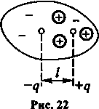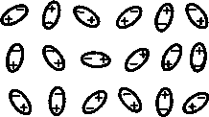

Figure 3.1

The field of dielectrics is in the opposite direction regarding to the field of conductor. Thus, a field of dielectrics reduces an initial field. The force of interaction of two bodies is less in dielectrics, than in vacuum. This idea may be expressed as:
$F_{{\text{12}}_{\text{diel}}}$ =$\frac{F_{{\text{12}\text{in}}_{\text{vac}}}}{ε}$, (3.1)
where ε is called the dielectric constant. It is dimensionless value.
The number of free ions and electrons in unit volume of a dielectric placed in an electric field is so small that the redistribution of these charges does not produce an appreciable effect. The dipole is under the action of a moment of a couple
$M=\text{Fl}\text{sin}α=\text{qlE}\text{sin}α$ . (3.2)
If we take the vector l directed from the negative sign to the positive sign, then the electric moment will be
$p=q⋅l$ . (3.3)
Let us assume that a dielectric consist of molecules, which behave like dipoles in the presence of an external electric field i.e. they possess a fixed electric moment p, when no external field acts the thermal motion of the dipoles is a random and
$\vec{P}=Σ\vec{p_{i}}=0$. (3.4)
As soon as the external field begins to act, a turning force rotates the dipoles into the line of intensity vector. Obviously, the vector P depends on the intensity of the external field and the temperature of the dielectric. This formulation of an electric moment in the unit volume of the dielectric is called the polarization of the dielectric and the electric moment per unit volume P is the polarization vector.

The Dielectrics Polarization

The sum of dipole moments of molecules per unite of volume is called the polarization vector. By definition,
$\vec{P}=\frac{\sum_{i}{{\vec{p}}_{i}}}{V}\text{.}$ (3.5)
The more is the intensity of an outside electric field, the more is the polarization.
$\vec{p}\text{\sim }\vec{E}$ . (3.6)
$\vec{p}=ε_{0}χ\vec{E}$ , (3.7)
where χ is the electric susceptibility.
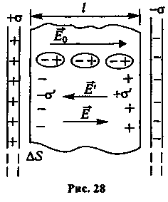
Figure 3.1

Experiments show that the plates may always be so oriented that no electricity is induced on the plate faces. This enables us to introduce still another vector to describe an electric field, namely, the electric displacement D, which is defined by the following conditions: the vector D is normal to the plates when the orientation of the plates is optimal with respect to induction.
$\vec{E}{\text{εε}}_{0}=\frac{q}{4{πr}^{2}}⋅\frac{\vec{r}}{|\vec{r}|}=\vec{D}$ (3.8)

So as
$E_{a}=\frac{σ}{ε_{0}} \text{and}E_{b}=\frac{σ_{2}}{ε_{0}ε}$ (3.9)
We have
σ₂= εσ₁ (3.10)
the charges, which appear on the surface of the dielectric create a field E, opposite in direction to the field E₀ of the free charges on the condenser plates, so
$E_{b}=E_{a}−E^{1}=\frac{σ^{1}}{ε_{0}}$ (3.11)
Hence the density of the surface charge which appears on dielectric is
$σ^{1}=σ_{2}(1−\frac{1}{ε})=σ_{1}(ε−1)$ (3.12)
the electric moment per unit volume of the polarized dielectric is equal to
$P=\frac{N_{e}l}{lΔS}=\frac{q^{1}}{ΔS}=σ$ (3.13)
where σ is the density of the conditional charges on the surface.
The intensity vector $\vec{E}$ is the sum of two vectors:
$ε_{0}\vec{E}=\vec{D}−\vec{P}$, (3.14)
where $\vec{D}$ is the vector of electric induction (displacement). That is on by due to free charges; $\vec{P}$ is the vector of polarization. It is due to only fixed charges.
$\vec{D}=ε_{0}\vec{E}+\vec{P}=ε_{0}\vec{E}+ε_{0}χ\vec{E}=ε_{0}\vec{E}(1+χ)={\text{εε}}_{0}\vec{E}$ , (3.15)
$\vec{D}={\text{εε}}_{0}\vec{E}$ , (3.16)
where $ε=1+χ$.
The surface charges create an electric field of intensity E, which acts inside the dielectric in the opposite direction to the external field E_{0.} A surface charge and an internal field E, appears on a dielectric which is placed between the two plates of a charged condenser.
When the dielectric is absent, the charges on the plates are distributed everywhere in same density
$D=σ$ . (3.17)
If the dielectric occupies a part of the space between the plates, then the free charges on these plates are attracted to the bound charges which appear on the surface of the dielectric which destroy the symmetrical distribution of the charges on the plates.
D_{a}=σ₁; D_{b}=σ₂ . (3.18)
However the field intensity will be equal at these two points, because the condenser plates, are equipotential surfaces and thus
$E_{A}=E_{B}=\frac{V_{1}−V_{2}}{l}$ . (3.19)

Conductors in Electric Field

Conductors contain the so-called free charges. There are free valence electrons and free ions in electrolytes. Two features of conductors are responsible for electric properties. The first one is a very big mobility of these charges. The second feature is their interaction according to Coulomb’s law. When a conductor is placed in an electric field, the forces act upon free charges and move them. Let’s enumerate the conclusions of special features of conductors put in an electric field:
- in an electric field the conductor charges are situated on the surface only;
- there is no electric field inside a conductor;
- the intensity vectors are perpendicular to the surface of a conductor.
All points of a conductor surface have got the same value of potential. The redistribution of free charges in a conductor, being acted on by an external electric field is called electrostatic induction.
The fig.3 shows distortion of a homogenous field when a conductor of irregular form is placed in it. Intensity of an electric field inside the conductor equals to zero.

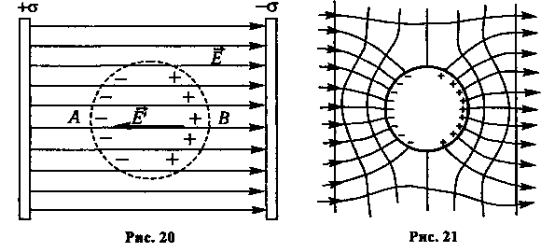
Figure 3.2
When a conductor is placed in an electric field, then forces act on the free charges and tend to make them move in opposite directions depending on their respective charges. The forces tend to redistribute the charges within the confines of the material
In the process of this division of positive and negative charges, an intrinsic field E is created in the conductor, which acts in the opposite direction to the external field intensity E₀. As soon as
${\vec{E}}_{0}+\vec{E}=0$ (3.20)
becomes equal to zero, the displacement of charges stops.
The redistribution of free charges in a conductor, when it is acted on by an external electric field is called electrostatic induction. The division of the positive and negative charges in a conductor creates an additional field, which combines with the external field and “distorts” it. Figure shows the distortion of a homogeneous field when an uncharged metal sphere is placed in it. In equilibrium the combined field intensity is always perpendicular to the surface of the sphere, as free charges would otherwise circulate on the sphere’s surface. Thus the surface of the sphere, like the whole sphere, is at the same potential.
Near the surface of a conductor the displacement and intensity of the field are proportional to the surface density of charge. Let us apply the Gauss-Ostrogradsky theorem to an elementary cylinder of base ΔS, the axis of which is directed along the vector D (Fig. 3.21).
There is no field inside the cylinder, so the flux of the displacement vector D, will only come from the outer surface of the cylinder, so from formula
We obtain $\begin{aligned}D⋅ΔS=\sum{q_{i}=σ⋅ΔS} \\ D=σ;E=\frac{σ}{ε_{0}ε}\end{aligned}$. (3.21)

Electric Capacitance

A capacitor is a device for storing charge. It is usually made up of two plates separated by a thin insulating material known as the dielectric. One plate of the capacitor is positively charged, while the other has negative charge. The electric capacitance is a property of any conductor. This property provides an ability to accumulate the electric charges. By definition the ratio
$C=\frac{q}{ϕ}$ (3.22)
is called the electric capacitance of an isolated conductor. Isolated conductor is located sufficiently far from other bodies. The charge of a body under consideration is q, its potential is φ. As we know for a point charge:
$ϕ=\frac{1}{4{\text{πεε}}_{0}}⋅\frac{q}{r}$. (3.23)

Thus, $ϕ\text{\sim }q;$ (3.24)
and $ϕ=\frac{1}{C}q$, (3.25)
where C is the coefficient of proportionality. Value of C is an electric capacitance. The SI unit of capacitance is:
$\left[F\right]=\frac{C}{V}$.
The capacitance of a charged sphere can be calculated as:
$ϕ=\frac{1}{4{\text{πεε}}_{0}}⋅\frac{q}{R}$,
where R is the radius of the sphere. By definition:
$C=\frac{q}{ϕ}$ (3.26)
and from the last equation we obtain
$C=4{\text{πεε}}_{0}R$. (3.27)
For example, the capacitance of Earth is C ≈ 0.7 mF.
Dielectrics, insulating materials placed between the plates of a capacitor, cause the electric field inside the capacitor to be reduced for the same amount of charge on the plates. This is because the molecules of the dielectric material get polarized in the field, and they align themselves in a way that sets up another field inside the dielectric opposite to the field from the capacitor plates. The dielectric constant is the ratio of the electric field without the dielectric to the field with the dielectric:
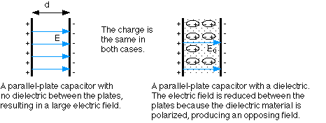
Figure 3.4

Note that for a set of parallel plates, the electric field E between the plates is related to the potential difference by the equation:
$E=Ud$, $\vec{E}=−\text{gradU}$ . (3.28)

Capacitance of a Plane Capacitor

By definition:
$C=\frac{q}{Δϕ};$
$Δϕ=\text{Ed}=\frac{σ}{{\text{εε}}_{0}},$ (3.29)
σ is the surface charge density.
$σ=\frac{q}{S}$ (3.30)
We have got:
$C=\frac{{\text{εε}}_{0}S}{d}$. (3.31)
S is the area of each plane, d is the distance between them; ε is the dielectric constant of a medium inside the capacitor.

Electric Field Energy

The energy of an electric field is conserved inside the plane capacitor. Let’s assume that we charge a plane capacitor by transferring a charge element dq from the negative plane to the positive one.
We perform work and this work is transformed in a potential energy (φ₁> φ₂). This work is specified by:
$\text{dA}=\left(ϕ_{2}−ϕ_{1}\right)\text{dq}$ (3.32)
It is a negative value because φ1> φ2 and a work is done over the field.
$C=\frac{q}{ϕ_{1}−ϕ_{2}},⇒ϕ_{2}−ϕ_{1}=−\frac{q}{C}$. (3.33)
Substituting (3.32), (3.31) , we obtain:
$\text{dA}=\frac{−\text{qdq}}{C}$ . (3.34)
Potential energy is:
dW = - dA.
Then:
$W=\int_{0}^{q}{\frac{q}{C}}\text{dq}=\frac{1}{C}\int_{0}^{q}{\text{qdq}=\frac{q^{2}}{2C}}$. (3.35)
Thus:
$W=\frac{q^{2}}{2C}=\frac{1}{2}{CΔϕ}^{2}$. (3.36)
Now we should express the energy in terms of the electric intensity:
$C=\frac{{\text{εε}}_{0}S}{d},Δϕ=\text{Ed}\text{.}$ (3.37)
Substituting (3.36) and (3.37):
$W=\frac{1}{2}{\text{εε}}_{0}E^{2}\text{Sd}$ . (3.38)
However Sd=V (volume of the capacitor). Dividing the last equation by V, we obtain,
$ω=\frac{W}{V}=\frac{{\text{εε}}_{0}E^{2}}{2}\text{.}$ (3.39)
Value of ω is called the volume density of electric field energy.
Unit of $ω:$ $\left[ω\right]=\frac{J}{m^{3}}$.
Let’s take grounded conductor. The process of discharging the condenser, which is charged to a potential difference φ by a quantity of electricity q, may be viewed as the successive outflow to ground of elementary charges dq under the action of electric field forces. The total work preformed by the field during condenser discharge is
$\int_{0}^{q}{\frac{q}{c}\text{dq}=\frac{q^{2}}{2C}}$ . (3.40)
Using the relationship between potential and charge, we obtain for the energy:
$W_{\text{el}}=\frac{q^{2}}{2C}=\frac{ϕq}{2}=\frac{{Cϕ}^{2}}{2}$ . (3.41)
In the case of a parallel-plate condenser of infinite extent, the energy formula may be written in the form
$W_{\text{el}}=\frac{ε_{0}{\text{εϕ}}^{2}}{2d}$. (3.42)

Piezoelectric effect

A phenomenon called the piezoelectric effect is observed in many crystal substance (quartz, Rochelle salt, tourmaline, sugar); if the crystal is divided up into lamina, whose is perpendicular to its electrical axis, then, under compression, opposite charges change if the lamina in extended. The inverse effect is also observed, i.e., if charge of opposite signs is placed on the surface of the crystal, it either compresses or expands. The surface density of the charges σ and the mechanical pressure p are related by
$σ=δp$ (3.43)
where δ is the piezoelectric constant.
The piezoelectric effect has found wide applications in industry, in particular, to excite ultrasonic vibration. This is done by applying an electric field, which varies with ultrasonic frequency with respect to time, to the surface of the surrounding medium with ultrasonic waves. The inverse effect is used to study and measure large or rapidly varying pressures, in particular, ultrasonic vibrations; the electric voltage which appear on the sides of the deformed crystal is amplified and then supplied to some measure apparatus.
The polarization of many gases, liquid or solids disappear and disappear depending on whether an external electric field is present or not, and the polarization vector P is directly proportional to the intensity of the polarization field E:
$P={\text{χε}}_{0}E;χ=ε−1$ . (3.44)
However, in some crystal, which are called ferroelectric, the polarization coefficient χ is not a constant but varies and depends quit strongly on the field intensity E; and this dependence is strongly affected by the temperature of substance. Such materials include Rochelle salt, barium titanate, and so on. When the temperature of the substance is above a certain critical value θ, the polarization coefficient χ does not depend on the intensity of the external field E, but depends on the temperature
$χ(T−θ)=\text{const}$ (3.45)
or
$χ=\frac{\text{const}}{T−θ}$ . (3.46)
A considerable dependence of χ on E is observed for T<θ. Fig. show the dependence of P on E for temperatures larges and smaller than θ.

Lecture 4. Electricity theory of conductivity
The Direct Electric Current

The electric current, which is a charge’s flow, occurs when there is a potential difference. For a current to flow also requires a complete circuit, which means the flowing charge has to be able to get back to where it starts. Current I is measured in amperes A, and is the amount of charge flowing per second:
$I=\frac{\text{dQ}}{\text{dt}}$. (4.1)
When current flows through wires in a circuit, the moving charges are electrons. For historical reasons, however, when analyzing circuits the direction of the current is taken to be the direction of the flow of positive charge, opposite to the direction the electrons go. We can blame Benjamin Franklin for this. It amounts to the same thing, because the flow of positive charge in one direction is equivalent to the flow of negative charge in the opposite direction.
The electric charges in various substances are always subject to a random thermal motion. To obtain a uniform motion of the charges in certain direction one must apply a force; in particular, if the body which contains the charges is placed in electric field, it acts on the positive charges in the direction of field intensity E and on the negative charges in the opposite direction.
The ordered motion of electric charges is called the electric current. In direct current the same quantities of charges pass through a cross-section of a conductor in any equal intervals of time. The electric current is produced by a difference of potentials between two points (φ₁- φ₂, φ₁> φ₂).
The uniform movement of electrons in a metallic conductor may also be produced without an electric field, by mechanical action, if one rapidly breaches a moving of a metallic body; the free electrons continue to move in the direction of rotation for a short due to their own inertia, and so create a short lived electric current.
An electric current may be formed also from a uniform ion movement which takes place in solid substance, for example in ionic crystals of type NaCl.
When a battery or power supply sets up a difference in potential between two parts of a wire, an electric field is created and the electrons respond to that field. In a current-carrying conductor, however, the electrons do not all flow in the same direction. In fact, even when there is no potential difference (and therefore no field), the electrons are moving around randomly. This random motion continues when there is a field, but the field superimposes onto this random motion a small net velocity, the drift velocity. Because electrons are negative charges, the direction of the drift velocity is opposite to the electric field.
In a typical case, the drift velocity of electrons is about 1 mm/s. The electric field, on the other hand, propagates much faster than this, more like 10⁸ m/s.

Intensity of the current

The current density is a vector, which is directed along the motion of positive charges. The module is:
$j=\frac{I}{S}$. (4.2)
Unit of j is:
$\left[j\right]=\frac{A}{m^{2}}$.
Let us assume that only charges of one sign cross the small area S. Let use n to denote the number of elementary charged particles per unit volume of the conductor, and v to denote the average velocity of their ordered motion in the direction.
If the charge on one particle is equal to e, then a total charge
$Δq=\text{enSv}Δt$, (4.3)
crosses the area S in the time t. The intensity of the current is therefore
or $\begin{aligned}I=\frac{Δq}{Δt}=\text{nevS} \\ I=\text{nevS}\end{aligned}$ . (4.4)
Consider the electric current in a metal conductor, in which there exists an electric field with intensity E. This field acts on the free electrons by a force

F = eE.
Which imparts to their acceleration?
. (4.5)
Let us assume that upon each collision electron loses all the energy it has received from the force F = eE during the time τ. The free path electron reaches a velocity
(4.6)
The time of free path of the electron is determined from the electron velocity u and the average length of movement or the mean free path λ
, (4.7)
then the density of the current in a metal conductor is equal to
. (4.8)
The quantity
$σ=\frac{1}{2}\frac{{\text{ne}}^{2}}{m}\frac{λ}{u}$ (4.9)
is a characteristic of the conductor and is called its specific conductivity.
We may also calculate the energy given to one electron during the time t under the action of the force F=eE, if we multiply by the number of the free paths during the time t, i.e., t/r
$W_{t}=\frac{{\text{mv}}^{2}}{2}\frac{t}{τ}=\frac{m}{2}{\left(\frac{\text{cE}}{m}τ\right)}^{2}\frac{t}{τ}=\frac{e^{2}}{2m}{τE}^{2}t$. (4.10)
Let us calculate the energy, which is given to a unit volume, containing n free electrons per unit time
$W_{n}=\frac{\text{nWt}}{t}=\frac{1}{2}\frac{{\text{ne}}^{2}}{m}{τE}^{2}={σE}^{2}$ (4.11)
or, using the fact that $σ$ is the current density, Ohm’s Law in differential form.
Experiments have shown that the ratio of the thermal conductivity X to the electric conductivity G is almost the same for all metals and is proportional to the absolute temperature
(Wiedemann-Franz Law). (4.12)
Many concepts of physics are based on the electron theory of metals. The electron theory of metals presumes the electron gas to be in thermal equilibrium with the crystal lattice. The electrons move in the crystal at random. In conditions of thermal equilibrium the temperature of the electron gas should be equal to the temperature of the lattice ions. Since the mean displacement of the electrons taking part in random (thermal) motion is zero such random motion cannot result in an electric current which describes the transport of a charge across some cross section. To establish a current as a directional motion of the electrons is needed. This may be initiated by various factors: electric field, temperature gradient, etc.
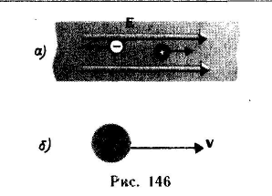
Figure 4.1
If an electric field of intensity E is established in a metal the electrons will be accelerated by this field. The acceleration of the electron in this field is
. (4.13)
After time t the electron attains the velocity
$\vec{v}=\vec{a}t=\frac{\text{et}}{m}\overline{E}$, (4.14)
directed against the field. If the initial velocity of the electron is υ_{t}, its velocity at the moment t will be equal to
$\vec{a}t=\vec{v_{t}}=\frac{\text{et}}{m}\vec{E}+\vec{v_{t}}$. (4.15)
As we see from here, the electron velocity component in the direction of the field decreases, and that against the field increases. As a result the electron ensemble attains an appropriate directional velocity. The electron moving at random at the same time takes part in the motion against the field. The directional motion of the electron ensemble in an electric field is termed drift, and the velocity of directional motion is termed drift velocity and designate by υ_{d}. Acted upon by the field E the electron in time t will be displaced to a distance
. (4.16)
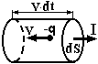
Figure 4.2

Between two collisions the electron moves as a particle free from the action of a field of latter and other electrons. To describe the motion of the electrons the concept of mean free transit time τ and of mean free part l are introduced
$\vec{l}={\vec{v}}_{t}τ$. (4.17)
Let us determine the mean electron drift velocity in directional motion on the electron is zero, at t = τ it will be equal to
$\vec{a}τ=\frac{\text{er}}{m}\vec{E}$. (4.18)
The drift velocity will be equal to the mean velocity of directional motion
${\vec{v}}_{d}=\frac{0+\vec{a}τ}{2}=\frac{eτ}{2m}\vec{E}$ . (4.19)
It follows from here that the mean velocity of directional motion is proportional to the electric field intensity E, the coefficient in the relation between the drift velocity and field intensity is termed electron mobility and is denoted by the letter
$μ=\frac{\text{er}}{2m};\vec{v_{d}}=μ\vec{E}$. (4.20)
Numerically, electron mobility is equal to electron drift velocity in an electric field of unit intensity. If electron concentration is n, then per unit time a charge will pass through a unit cross-section which is contained in a parallelepiped of unit base and height equal to υ_{d}. The charge passing through unit cross-section per unit time is termed the current density j, and we may write
$\vec{j}=\text{en}\vec{v_{d}}=\text{en}μ\vec{E}=σ\vec{E}$. (4.21)
This equality is the expression of Ohm’s law in differential form.
$σ=\text{en}μ$ (4.22)
and
$σ=\frac{e^{2}nτ}{2m}$ . (4.23)
This expression was obtained by Drude. The SI unit for electrical conductance is siemens (S) and that for special conductance S/m. The dimensions of mobility SI may be obtained from
$\begin{aligned}μ=\frac{eτ}{2m} \\ [μ]=\frac{A⋅s^{2}}{\text{kg}}\end{aligned}$ . (4.24)

Ohm’s Law for an Uniform Conductor

A uniform conductor doesn’t contain any current sources. Ohm’s law reads as follows: the current through a uniform conductor is directly proportional to the difference of potentials at its ends and is inversely proportional to an electric resistance:
$I=\frac{ϕ_{1}−ϕ_{2}}{R}=\frac{Δϕ}{R}$, (4.25)
R is the resistance of a conductor.
Unit of R is [R]= Ω.
For conductor of a constant cross-section of S and length l:
$R=ρ\frac{l}{S}$, (4.26)
where ρ is the specific resistivity. Unit of ρ is: [ρ]= Ω·m.
The inverse value of ρ is called the conductivity:
$γ=\frac{1}{ρ}$. (4. 27)
The unit of γ is $\left[γ\right]=\frac{S}{m}$

Ohm’s Law in the Differential Form

Ohm’s law in differential form is related to any point of a conductor.
$I=\frac{ϕ_{1}−ϕ_{2}}{R}=\frac{ϕ_{1}−ϕ_{2}}{ρ\frac{\text{dl}}{\text{dS}}}=\frac{\text{Edl}}{ρ\frac{\text{dl}}{\text{dS}}}=\frac{\text{EdS}}{ρ}$. (4.28)
Dividing the last equation by dS, we obtain:
$$\frac{I}{\text{dS}}=\frac{E}{ρ},$$
Thus (4.29)

Current and electrical resistance

The voltage can be thought of as the pressure pushing charges along the conductor, while the electrical resistance of a conductor is a measure of how difficult it is to push the charges along. Using the flow analogy, electrical resistance is similar to friction. For water flowing through a pipe, a long narrow pipe provides more resistance to the flow than does a short fat pipe. The same applies for flowing currents: long thin wires provide more resistance than do short thick wires.
The resistance R of a material depends on its length l, cross-sectional area S, and the specific resistivity, that depends on the material:
(4.30)
The resistivity and conductivity are inversely related. Good conductors have low resistivity, while poor conductors (insulators) have resistivities that can be 20 orders of magnitude larger.
Resistance also depends on temperature, usually increasing as the temperature increases. For reasonably small changes in temperature, the change in resistivity, and therefore the change in resistance, is proportional to the temperature change. This is reflected in the equation:
. (4.31)
At low temperatures some materials, known as superconductors, have no resistance at all. Resistance in wires produces a loss of energy (usually in the form of heat), so materials with no resistance produce no energy loss when currents pass through them.

Multi-loop Circuits and Kirchoff's laws

It was Qustav Robert Kirchhoff who published the first systematic formulation of the principles governing the behavior of electric circuits. Kirchhoff’s theory includes two laws. The first law deals with the so-called junction point (node). By definition, a point of electric circuit, where three or more conductors are connected together is called the junction point.
1. The first Kirchhoff’s law states, that the sum of the currents entering or leaving the junction point at any instant of time is equal to zero. In other words, the algebraic sum of the currents at any junction point equals to zero.
$\sum_{i}{I_{i}=0\text{.}}$ (4.32)
The current, which enters junction point, is considered to be positive. The current, which leaves junction point, is considered to be negative.
For example:
. (4.33)
This law follows from the law of charge conservation. If a charge comes to node must go away.
2. The second Kirchhoff’s Law deals with closed loops in a branched circuit. According to general form of Ohm’s law:

$\begin{aligned}\begin{aligned}\left\{I_{1}\left(R_{1}+r_{1}\right)=ϕ_{1}−ϕ_{2}+ε_{1} | \right.\left\{I_{2}\left(R_{2}+r_{2}\right)=ϕ_{2}−ϕ_{3}+ε_{2} | \right.\end{aligned} \\ \end{aligned}$ (4.34)

This law states, that for any closed loop, taken in a branched circuit, the algebraic sum of the products of the currents and the respective resistances is equal to the algebraic sum of all the electromotive forces in the loop. The currents, direction of which coincides with the direction of round of loop, are assumed to be positive. E.m.f. are assumed to be positive if they increase the potential in the direction of round (fig. 4.4). Consequently:
$\sum_{i}{I_{i}}\left(R_{i}+r_{i}\right)=\sum_{k}{ε_{k}}$. (4.35)
Before talking about what a multi-loop circuit is, it is helpful to define two terms, junction and branch.
A junction is a point where at least three circuit paths meet.
A branch is a path connecting two junctions.
In the circuit below, there are two junctions, labeled a and b. There are three branches: these are the three paths from a to b.
In a circuit involving one battery and a number of resistors in series and/or parallel, the resistors can generally be reduced to a single equivalent resistor. With more than one battery, the situation is trickier. If all the batteries are part of one branch they can be combined into a single equivalent battery. Generally, the batteries will be part of different branches, and another method has to be used to analyze the circuit to find the current in each branch. Circuits like this are known as multi-loop circuits.
Finding the current in all branches of a multi-loop circuit (or the e.m.f. of a battery or the value of a resistor) is done by following guidelines known as Kirchoff's rules. These guidelines also apply to very simple circuits.
Kirchoff's first rule: the junction rule. The sum of the currents coming in to a junction is equal to the sum leaving the junction. (Basically this is conservation of charge)
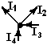
Figure 4.3

Kirchoff's second rule: the loop rule. The sum of all the potential differences around a complete loop is equals zero (energy conservation).
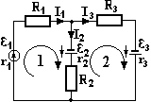
Figure 4.4

There are two different methods for analyzing circuits. The standard method in physics, which is the one followed by the textbook, is the branch current method. There is another method, the loop current method, but we won't worry about that one.
Ohm’s Law for Heterogeneous Circuit

Heterogeneous circuit contains the so-called current sources. In order to obtain a current in a conductor a difference of potentials must be maintained on its ends. Devices, enabling to maintain a potential difference are called current sources. Such sources are not of physical nature. They are usually electrochemistry sources. They can increase the potential. Any current source has got two characteristics: the internal resistance r, the electromotive force of a source $ε$(e.m.f.) Unit of $ε$ is: [$ε$]= V .
In an external circuit current flows from plus to minus. However in the current source the current flows visa versa: from minus to plus as it is shown on the Fig. You can see that a drop of potential is observed in external circuit. However the increase of potential occurs inside a source. Ohm’s law is given by the next formula:
$I=\frac{ϕ_{1}−ϕ_{2}+ε}{R+r},$ (4.36)
$I\left(R+r\right)=ϕ_{1}−ϕ_{2}+ε$. (4.37)
The last equation is the general form of Ohm’s law.

Difference of Potentials. Electromotive Force

The work of transfer of the test charge (q₀=+1C) in an electric field is called the difference of potentials. It doesn’t depend on the path of transfer.
$ϕ_{1}−ϕ_{2}=\frac{A_{\text{12}}}{q_{0}}$. (4.38)
The electromotive force is the work of the test charge which is transfered inside the current source. It depends up on the way. The electromotive force is equal to work, done against the electrostatic forces.
The voltage is the sum of works of field and external forces. It depends upon the path of transfer. Thus:
$I\left(R+r\right)=ϕ_{1}−ϕ_{2}+ε$. (4.39)
IR is called the drop in voltage in the external part of circuit. Ir is called the drop in voltage inside the source.
A closed circuit consists of some current sources and some resistances. As it can be seen on figure, in this case φ₁= φ₂ and consequently from the Ohm’s law in general form we obtain:
$I=\frac{ε}{\left(R+r\right)},$ (4.40)
$ε=\text{IR}+\text{Ir}$. (4.41)

Lecture 5. magnetic field

There is a strong connection between electricity and magnetism. With electricity, there are positive and negative charges. With magnetism, there are north and south poles. Similar to charges, like magnetic poles repel each other, while unlike poles attract.
An important difference between electricity and magnetism is that in electricity it is possible to have individual positive and negative charges. In magnetism, north and south poles are always found in pairs. Single magnetic poles, known as magnetic monopoles, have been proposed theoretically, but a magnetic monopole has never been observed.
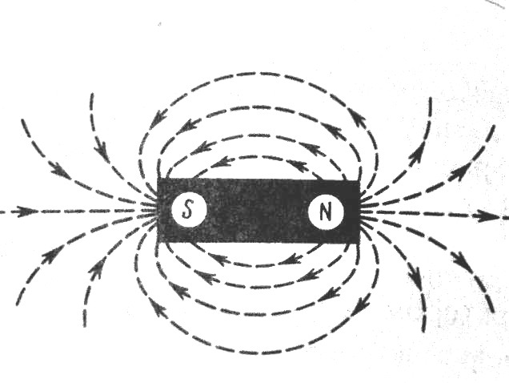
Figure 5.1

In the same way that electric charges create electric fields around them, north and south poles will set up magnetic fields around them. Again, there is a difference. While electric field lines begin on positive charges and end on negative charges, magnetic field lines are closed loops, extending from the south pole to the north pole and back again (or, equivalently, from the north pole to the south pole and back again). With a typical bar magnet, for example, the field goes from the north pole to the south pole outside the magnet, and back from south to north inside the magnet.
Electric fields come from charges. So do magnetic fields, but from moving charges, or currents, which are simply a whole bunch of moving charges. In a permanent magnet, the magnetic field comes from the motion of the electrons inside the material, or, more precisely, from something called the electron spin. The electron spin is a bit like the Earth spinning on its axis.
The magnetic field is a vector, the same way the electric field is. The electric field at a particular point is in the direction of the force a positive charge would experience if it were placed at that point. The magnetic field at a point is in the direction of the force a north pole of a magnet would experience if it were placed there. In other words, the north pole of a compass points in the direction of the magnetic field.
One implication of this is that the magnetic south pole of the Earth is located near to the geographic North Pole. This hasn't always been the case: every once in a while (a long while) something changes inside the Earth's core, and the earth's field flips direction. Even at the present time, while the Earth's magnetic field is relatively stable, the location of the magnetic poles is slowly shifting. The symbol for magnetic field is the letter B. The unit is the tesla (T).
The science of magnetism grew from the observation that certain “stones” (magnetite) worlds attract bits of iron. The word magnetism comes from the district of Magnesia in Asia Minor, which is one of the places at which the stones were found. “Natural magnet” is the earth itself, whose orienting on a magnetic compass needle has been known since ancient times.
We define the space around a magnet or a current –carrying conductor as the site of a magnetic field. Electric change at rest with respect to a chosen reference system has only electric fields around them. When these charge move, they also have a magnetic field around them. A current is an assembly of moving charges. To investigate magnetic they fields it is essential to use the effect they have on different bodies, for example:
1) a torque acts on a magnetic compass needle and its maximum value at given place is determined from the orientation of the compass needle;
2) a torque also acts on a coil of wire and its magnitude depends on the size of the coil, and the current in it. It reaches a maximum in a given place when the orientation of the place of the coil is at certain angle;
3) a section of a long thin conductor, in which a current is flowing, is subject to a force proportional to the length of the conductor, to the current flowing, and to the orientation of the conductor in the magnetic field.
In all cases one must have a “test body”, which measures the effect of magnetic field in a certain place, and some device which registers this effect.
Magnetic field is one of the forms of matter. It is created by moving electric charges or permanent magnets. No magnetic field appears around electric charges at rest. There is no difference, where electric charges move. Magnetic field can be created, when electric charges move: in space; in a conductor; in a molecule or in atom.
Thus, magnetism is typical only for moving electric charges. It can be detected due to its action on magnetic needles, moving charges or conductors with current. If magnetic needle is in magnetic field, a momentum of force (torque) acts on it. In this case the orientation of magnetic needle coincides with the direction of magnetic field at this point (from the south pole to the north pole). The magnitude of magnetic field is proportional to the maximum value of the momentum of force, acting on the needle. A moment of force acts on a coil of wire in the magnetic field. The orientation of the normal vector, being perpendicular to the coil, coincides with the direction of magnetic field. Magnitude of the moment of force depends upon the size of the coil and the current in it.
A magnetic field exists near all the planets. The investigation of the magnetic field of the Earth is a very important problem. But the nature of this phenomenon is unknown today.
Magnetic field acts on currents, moving changed bodies or particles and magnetized bodies. The most convenient way of characterizing the properties of such a field is to describe its mechanical action on a current circuit. At each point of the field, a circuit that is free to rotate assumes a definition equilibrium position. the position of stable equilibrium is described not only by the orientation of the circuit axis in space, but by the orientation of a definite side of the circuit, the side for which the current will appear to be flowing counter-clockwise as viewed by an observer on that side positive or north and agree to draw the normal to the circuit so as to form a right-hand screw system with current direction. A torque will act on a test circuit that deviates from the equilibrium position. For a particular angel α, the torque is proportional to the product of the circuit area S and the current I flowing in the circuit. This can be expressed by means of a single vector quantity – the so-called magnetic moment of the ring current. The magnetic moment is generally designated by the vector
$\vec{M}=I⋅S⋅\vec{n}$ , (5.1)
where n is the unit normal vector. Experiments with a test circuit show that torque is
$N=B⋅M⋅\text{sin}α$, (5.2)
where B is a constant of proportionality. The value of B varies from field to field and for different point in space of particular field. This formula show that B is equal to the maximum torque acting on a unit test circuit (M=1). We call this coefficient B, which characterizes the magnetic field, the magnetic induction. The vector quantity whose direction is that of the magnetic field and which is numerically equal to B is known as the magnetic induction vector.
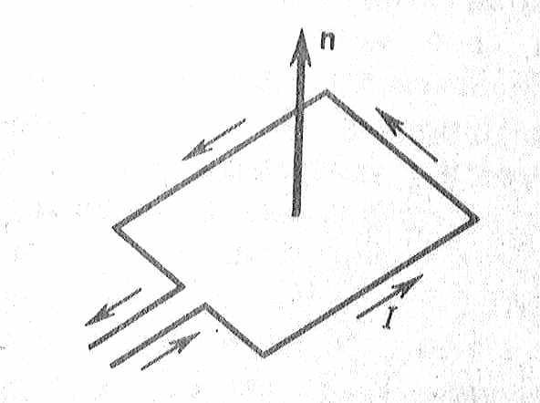
Figure 5.2

The formula for the torque may be written in vector form as follows
$\vec{N}=\left[\vec{M}⋅\vec{B}\right]$ (5.3)
A body possessing a magnetic moment requires the expenditure of work to turn it from its equilibrium position. In the case of a body turned through a small angle α, the work of rotation may be expressed in the form
$\text{Nd}α=B⋅M⋅\text{sin}α⋅dα=−d\left(B⋅M⋅\text{cos}α\right)$ . (5.4)
The deviation of a body from the equilibrium position is associated with the accumulation of a “potential” energy
$U=−M⋅B⋅\text{cos}α$ . (5.5)

Force Lines of the Magnetic Field

The force lines of the magnetic field are imagined lines, tangents of which coincide with the direction of the magnetic induction at the given point. The magnetic force lines are not continuous at any space point. They are closed. Such fields are called vortex. The force lines of a conductor with current are concentric circles in a plane perpendicular to the conductor. The direction of the force lines of magnetic field is determined by the right-hand screw rule: if a screw is turned in forward direction of the current, the direction of the rotation will coincide with that of the force lines.
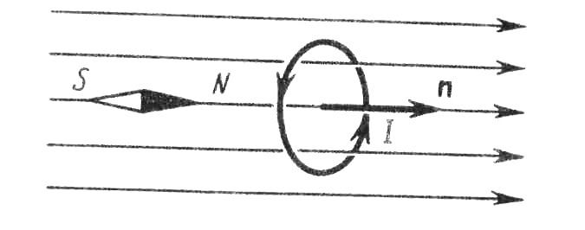
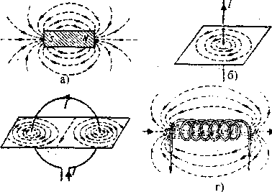
Figure 5.3

Magnetic fields created by permanent magnets

Every permanent magnet has two poles. The flux lines are directed outwardly at the North Pole and inwardly at the South Pole. Imagine a surface constructed so that in encloses the North Pole. We can then determine the total number of lines passing outwardly thought this surface. By analogy with the corresponding electric quantity, this number is called the magnetic flux (Φ). The flux through an elemental area perpendicular to the flux lines is equal to
$dΦ=\text{BdS}$. (5.6)
Through the closed surface
$Φ=\oint{B\text{cos}α\text{dS}}$, (5.7)
where α is the angle formed with the flux lines by the normal to the area.

Magnetic field produced by currents in wires

The simplest current we can come up with is a current flowing in a straight line, such as along a long straight wire. The magnetic field from a such current-carrying wire actually wraps around the wire in circular loops, decreasing in magnitude with increasing distance from the wire. To find the direction of the field, you can use your right hand. If you curl your fingers, and point your thumb in the direction of the current, your fingers will point in the direction of the field. The magnitude of the field at a distance r from a wire carrying a current I is given by:
, (5.8)
were μ₀ is a constant, the permeability of free space
.
Currents running through wires of different shapes produce different magnetic fields. Consider a circular loop with a current traveling in a counter-clockwise direction around it (as viewed from the top). By pointing your thumb in the direction of the current, you should be able to tell that the magnetic field comes up through the loop, and then wraps around on the outside, going back down. The field at the center of a circular loop of radius r carrying a current I is given by:
. (5.9)
For N loops put together to form a flat coil, the field is just multiplied by N:
. (5.10)
If a number of current-carrying loops are stacked on top of each other to form a cylinder, or, equivalently, a single wire is wound into a tight spiral, the result is known as a solenoid. The field along the axis of the solenoid has a magnitude of:
, (5.11)
where n = N/L is the number of turns per unit length (or, in other words, the total number of turns over the total length).
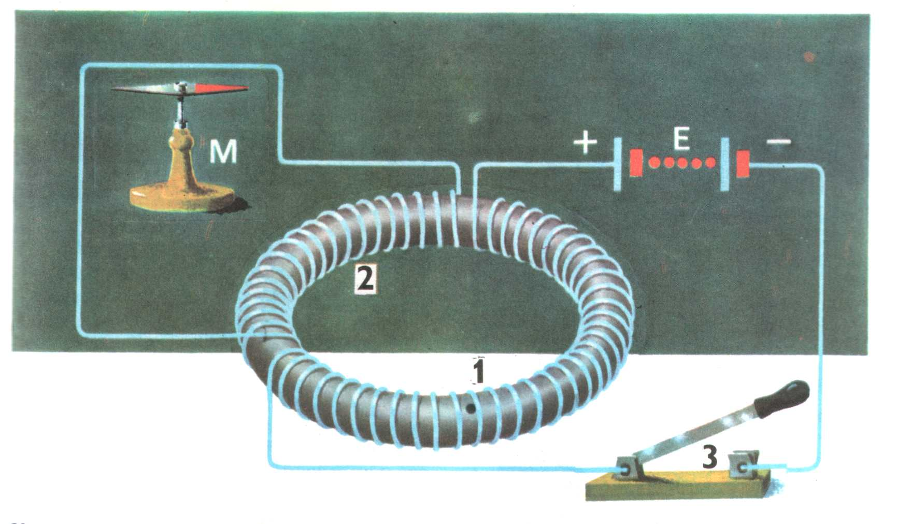
Figure 5.3

Force acting on a charged particle in a magnetic field

Magnetic field doesn’t effect an immobile electric charge. If a charge is moving with the velocity , the force of Lorentz arises. It is given in the following formula:
. (5.12)
The direction of the Lorent’z force is determined by the rule of the left hand. Lorentz force is directed perpendicularly to as well as to (fig.5.4). Module of Lorent’z force is:
$F_{L}=\text{qB}υ\text{sin}α$,
where α is the angle between $\vec{υ}$ and $\vec{B}$.
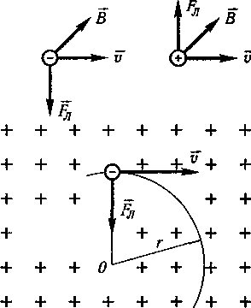
Figure 5.4

Lorent’z force is usually used in engineering in order to accelerate the charged particles, like electrons and protons. We consider motion of an electron in the uniform magnetic field. We assume that the electron with the velocity flies into the magnetic field of induction$\vec{B}$. In this case v is perpendicular to$\vec{B}$. Consequently, an electron being under consideration must deviate from y-axis as is shown in figure 5.4.
The direction of the deviation is perpendicular to $\vec{B}$ as well as to$\vec{υ}$. Further, force of Lorentz continues to act and the deviation arises again. It is easy to see, that the Lorentz force acts as centripetal force. Thus electron moves along the circumference. The equation of motion is given by:
$\text{qB}υ=\frac{{mυ}^{2}}{r}⇒r=\frac{m}{q}⋅\frac{υ}{B}$. (5.13)
If is not perpendicular to Ox, electron moves along a spiral. H is step of a spiral, r is radius of a spiral.
$\begin{aligned}υ_{\coprod{}=υ\text{cos}α,}υ_{}=υ\text{sin}α, \\ T=\frac{2πr}{υ}=\frac{2π}{B}⋅\frac{m}{q}, \\ h=υ_{\coprod{}⋅T=υT\text{cos}α=\frac{2π}{B}\frac{mυ\text{cos}α}{q}\text{.}}\end{aligned}$ (5.14)
If $\vec{B}$ increases, then r and h decrease. This case is used for focusing the charged particle beam.
Electric current is simply a flow of electric changes. If e is particle charge, υ the particle velocity and n the particle concentration, then the expression for the current intensity may be expressed in the form
. (5.15)
Substituting this expression in the formula for Amperes law, we obtain
. (5.16)
But n ּS ּ d l is the number of particles in the conductor volume under consideration. Thus the force acting on one particle is the Lorents force
. (5.17)
The unit of B follows from this equation. This is given the special name Veber/meter² or Tesla.
1 Veber/meter² =1nt/coul(meter/sec)=1 nt/Amp-m;
1 Veber/meter² =10⁴ Gauses.
The resultant force if a charged particle moves thorough a region in which both an electric field and a magnetic field are present; is
. (5.18)
An electric field E exerts a force on a charge q. A magnetic field B will also exert a force on a charge q, but only if the charge is moving (and not moving in a direction parallel to the field). The direction of the force exerted by a magnetic field on a moving charge is perpendicular to the field, and perpendicular to the velocity (i.e., perpendicular to the direction the charge is moving).
The equation that gives the force on a charge moving at a velocity v in a magnetic field B is:
, (5.19)
were θ is the angle between the magnetic field and the velocity of the charge.
This is a vector equation: F is a vector, v is a vector, and B is a vector. The only thing that is not a vector is q.
Note that when v and B are parallel (or at 180°) to each other, the force is zero. The maximum force, F = qvB, occurs when v and B are perpendicular to each other.
The direction of the force, which is perpendicular to both v and B, can be found using your right hand, applying something known as the right-hand rule. One way to do the right-hand rule is to do this: point all four fingers on your right hand in the direction of v. Then curl your fingers so the tips point in the direction of B. If you hold out your thumb as if you're hitch-hiking, your thumb will point in the direction of the force.
At least, your thumb points in the direction of the force as long as the charge is positive. A negative charge introduces a negative sign, which flips the direction of the force. So, for a negative charge your right hand lies to you, and the force on the negative charge will be opposite to the direction indicated by your right hand.
In a uniform field, a charge initially moving parallel to the field would experience no force, so it would keep traveling in straight-line motion, parallel to the field. Consider, however, a charged particle that is initially moving perpendicular to the field. This particle would experience a force perpendicular to its velocity. A force perpendicular to the velocity can only change the direction of the particle, and it can't affect the speed. In this case, the force will send the particle into uniform circular motion. The particle will travel in a circular path, with the plane of the circle being perpendicular to the direction of the field.
In this case, the force applied by the magnetic field (F = qvB) is the only force acting on the charged particle. Using Newton's second law gives:
. (5.20)
The particle is undergoing uniform circular motion, so the acceleration is the centripetal acceleration:
,
so,
.
A factor of v cancels out on both sides. The radius of the circular path is then:
. (5.21)
A particle that is initially moving at some angle between parallel and perpendicular to the field would follow a motion which is a combination of circular motion and straight-line motion...it would follow a spiral path. The axis of the spiral would be parallel to the field.
The field does not affect v-parallel in any way; this is where the straight line motion comes from. On the other hand, the field and v-perpendicular combine to produce circular motion. Superimpose the two motions and you get a spiral path.
With the force, velocity, and field all perpendicular to each other, we have to work in three dimensions. It can be hard to draw in 3-D on a 2-D surface such as a piece of paper or a chalk board, so to represent something pointing in the third dimension, perpendicular to the page or board, we usually draw the direction as either a circle with a dot in the middle or a circle with an X in the middle.
Think of an arrow with a tip at one end and feathers at the other. If you look at an arrow coming toward you, you see the tip; if you look at an arrow going away from you, you see the X of the feathers. A circle with a dot, then, represents something coming out of the page or board at you; a circle with an X represents something going into the page or board.
The following diagram shows the path followed by two charges, one positive and one negative, in a magnetic field those points into the Fig.
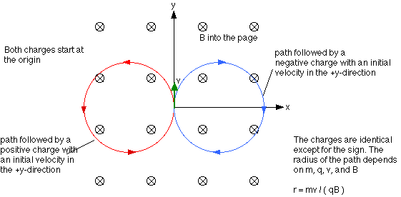
Figure 5.5

LECTURE 6. Magnetic Field Intensity

Let us assume that a current I flows in an infinitely long straight conductor of very small cross-section. Draw two planes I and II through the conductor. The magnetic field around the conductor is cylindrically symmetric so that $\frac{dα}{2π}$ is the fraction of the total magnetic field enclosed by the planes. We may assume that the whole magnetic field around the conductor is proportional to the total current intensity, so that a measure of the magnetic field between the two planes is

$\text{dM}=I\frac{dα}{2π}$. (6.1)
Draw a circle of radius $α$ in the plane perpendicular to the conductor so that
$$dα=\frac{\text{dl}}{a} \text{from} \frac{dα}{2π}=\frac{\text{dl}}{2\text{πα}}$$
and
$$\text{dM}=I\frac{dα}{2π}=\frac{I}{2\text{πα}}\text{dl}\text{.}$$
The quantity
$H=\frac{I}{2\text{πα}}$ , $\left[H\right]=\left[\frac{A}{m}\right]$ (6.2)
may be considered as a characteristic of the magnetic field at distance a from an infinitely long straight conductor carrying a current I.
We shall call it the magnetic field intensity at the given point. It is known that a magnetic compass needless when placed in the neighborhoods of a current carrying wire. We will connect the magnetic field to this by stating that the magnetic field intensity vector lies in a plane perpendicular to the conductor and in the direction determined be the “corkscrew rule: if a corkscrew is turned round the direction of motion of the current, then $\vec{H}$ coincide with the direction of movement of a point situated on the handle of the corkscrew.

Vector of Magnetic Induction and Vector of Magnetic Field Intensity

The moments of the forces, acting on a plane current loop, placed in magnetic field, is:
$\vec{M}=[{\vec{p}}_{m},\vec{B}]$, (6.3)
where${\vec{p}}_{m}$ is the magnetic moment of the loop, $\vec{B}$ is the magnetic induction. And
${\vec{p}}_{m}=\text{IS \{}\vec{n}$, (6.4)
where I is the current, S – the area of the loop, n is the unit normal vector.

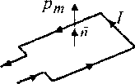
Figure 6.1

The direction of the magnetic moment is determined according to the right-hand screw rule: if the head of the screw is rotated in the direction of the current loop, the forward motion of the screw will coincide with the direction of pm . I.e. the magnetic induction may be determined as:
$\vec{B}=\frac{M_{\text{max}}}{p_{m}}$, (6.5)
where M_{max} is the maximum moment of force, acting on the loop by current. The value of the magnetic induction for loops with different magnetic moments is the same. Units of vector of magnetic induction $\vec{B}$ is tesla (T). Vector $\vec{H}$ is called the magnetic field intensity; characterizes the magnetic field in the vacuum. $\vec{H}$ is created only by macrocurrents. It isn’t related to the medium properties. $\vec{B}$ is related to the medium properties. Both vectors are connected with each other by formula:
$\vec{B}={\text{μμ}}_{0}\vec{H}$, (6.6)
where μ is the magnetic permeability of substance, μ₀ is the magnetic constant.
$μ_{0}=1\text{.}\text{26}⋅{\text{10}}^{−6}\frac{H}{m}$.
The direction of $\vec{H}$coincides with the direction of vector$\vec{B}$. Units of vector $\vec{H}$are.
Let us consider the interaction of an isolated magnetic pole and a current element. The magnetic pole a field B at the location of the electric current. In accordance with Amperes law the force acting on the current element is
dF=I [d l B]. (6.7)
The magnetic flux through an elemental area perpendicular to the flux lines is equal to
dΦ=BdS . (6.8)
Through the closed surface
Φ=$\oint{B\text{cos}α\text{dS}}$ (6.9)
If B=m/4πr²
then in place of magnetic induction, we can substitute the expression for a point pole. Since the field is directed along the radius, we obtain the following expression for the interaction force
dF=m/4πr² I [d l, r/ r] (6.10)
or
dF=mI/4πr² dl sin dl, r
The force exerted by a current element on a magnetic pole may be written in the form
$\text{dF}=\frac{m}{{\text{4πr }}^{2}}I[\text{dl},\frac{r}{r}]$ ּ
The force acting on a unit magnetic pole is called the magnetic field intensity
$\text{dH}=\frac{\text{dF}}{m}$ ּ (6.11)
The magnetic field intensity created by a current element is given by the formula
$\text{dH}=\frac{I}{{\text{4πr }}^{2}}[\text{dl},\frac{r}{r}]$ (6.12)
The relationship existing between the magnetic field intensity and the magnetic induction can be determined experimentally. It turns out that in all cases, except in the case, except in the case of anisotropic bodies, the intensity and induction vectors are parallel to each other. Moreover, in all cases, except in the case of ferromagnetic substance, a simple linear relation ship exists between H and B namely
$B=μ_{0}μH$ ּ (6.13)
were $μ_{0}$ is a coefficient characterizing the medium (the relative magnetic permeability of the medium)

The Biot - Savart Law

Using the Biot-Savart law, we can calculate the magnetic field induction at any point of space near the conductor with current near the conductor. In fact, we find the field distributions $\vec{B}$, due to each current element . Further, we calculate$\vec{B}$, integrating the field distributions at that point. The small element of the conductor is under consideration, this element creates the induction $\vec{B}$ at an arbitrary M point. The distance from to the M-point is defined with the help of the radius-vector:
$\begin{aligned}d\vec{B}=\frac{{\text{μμ}}_{0}}{4π}⋅I⋅\frac{\left[d\vec{l},\vec{r}\right]}{r^{3}}, \\ d\vec{B}⊥d\vec{l},d\vec{B}⊥\vec{r}, \\ \vec{B}=\int{d\vec{B}}\text{.}\end{aligned}$ (6.14)
In scalar form:
$\text{dB}=\frac{{\text{μμ}}_{0}}{4π}⋅\frac{\text{Idl}\text{sin}α}{r^{2}}$ ּ (6.15)

Magnetic field of a straight conductor.
Let us assume that a current flows in an infinitely long thin strait conductor. The small element $d\bar{l}$ creates magnetic induction $\vec{B}$in the M point. The distance from the conductor to the M point is R. The direction of magnetic induction $\vec{B}$in the M point is determined by the right-hand screw rule. The direction of the magnetic induction of all elements $d\bar{l}$is the same as $\vec{B}$. Total vector equals to the sum of modules of $\vec{B}$. According to the Biot-Savart-Laplas law, module of magnetic induction is:
$\text{dB}=\frac{{\text{μμ}}_{0}}{4π}⋅\frac{\text{Idl}\text{sin}α}{r^{2}}$ , (6.16)
where I is the current, α is an angle between and , is a radius-vector. Actually:
$r=\frac{R}{\text{sin}α},\text{dl}=\frac{\text{rdl}}{\text{sin}α}$.
By substituting these parameters to the last formula we obtain:
$\text{dB}=\frac{{\text{μμ}}_{0}}{4π}\text{Idl}\text{sin}αdα$.
As angle α varies from o to π, then the total vector $\vec{B}$is:
$B=\int{\text{dB}=}\frac{{\text{μμ}}_{0}}{4π}I\int_{0}^{π}{\text{sin}α}\text{dl}=\frac{{\text{μμ}}_{0}}{4π}⋅\frac{2I}{R}$. (6.17)
Finally, the induction of magnetic field of a straight conductor may be expressed as:
$B=\frac{{\text{μμ}}_{0}}{4π}⋅\frac{2I}{R}$. (6.18)
The magnetic induction at the center of a circumference conductor
At the center of a circumference conductor($\text{sin}α=\text{sin}\text{90}\text{°=}1$):
$\text{dB}=\frac{{\text{μμ}}_{0}}{4π}I\frac{1}{r^{2}}\oint{\text{dl}}=\frac{{\text{μμ}}_{0}}{4π}I\frac{1}{r^{2}}⋅2πr=\frac{{\text{μμ}}_{0}}{2r}⋅I$.
The solenoid
As it may be seen magnetic fields of over spiral inside the coil should be added. On the contrary, magnetic fields between the spirals are annihilated. The magnetic induction of a coil (solenoid) is given by:
$B={\text{μμ}}_{0}\text{nI}$, (6.19)
where $\frac{n}{l}=N$is the number of spirals per unit of length.
In the general case the shape of the conductor may be complicated. It is essential to find a method of calculating the intensity of the magnetic field which is always applicable. For a body of arbitrary shape we could carry out the summation over the elementary vector $d\vec{H}$ and calculate the total intensity
$$\vec{H}=\sum{d\vec{H}}$$
or
$\vec{H}=\int{d\vec{H}}$ ּ (6.20)

The Biot-Savart Law states that the intensity of the magnetic field at a point due to current element $\text{Idl}$may always be calculated by the formula
$\text{dH}=\frac{\text{Idl}\text{sin}α}{4{πr}^{2}}$ ּ (6.21)
If ${\vec{H}}_{1,},{\vec{H}}_{2}\text{.}\text{.}\text{.}$ are the intensities at a given point from small current elements acting independently, the statement that the total intensity at the point
$$\vec{H}={\vec{H}}_{1}+{\vec{H}}_{2}+\text{.}\text{.}\text{.}$$
or
$\vec{H}=\sum_{i=1}^{n}{{\vec{H}}_{i}}$
is called the principle of superposition of magnetic field intensities.
Let us note one important consequence of the Biot-Savart Law, which is useful in calculating magnetic fields. Suppose that a current I flows in a conductor of arbitrary shape. Then, the magnetic field H at a point A due to this current
$H=\oint{\frac{\text{Idl}\text{sin}α}{4{πr}^{2}}}$ ּ
If there are several currents I₁, I₂… enclosed by the line L, then from the principle of superposition the circulation of the intensity vector around the contour surrounding the currents will be equal to the algebraic sum of the currents.
$\oint{\text{Hdl}\text{cos}β=\oint{\vec{H}}d\vec{l}=\sum_{i=1}^{n}{I_{i}}}$ (6.22)
This statement is called the total current relation.

Lines of Force and flux field intensity of magnetic field

A magnetic field is called homogeneous if the intensity is the same in magnitude and direction at all points; therefore the field around a straight conductor is non-homogeneous. A magnetic field is graphically represented by the lines of force along the tangent to the line.
The direction of the lines of force corresponds to the direction of the field intensities. By convention, the number of force lines passing thought a unit area of perpendicular to these lines is the field intensity H at this spot. The product
${ΔФ}_{н}=HΔS\text{cos}α$ (6.23)
(where α is the angle between the vector $\vec{H}$ and the normal to the area $ΔS$) is called the flux of magnetic field intensity vector through ΔS and is the number of lines of force passing through this area. The magnetic induction and the magnetic field intensity are connected by the relation
, (6.24)
µ₀ is a coefficient which depends on the choice of the units. If we now use pure definition of one ampere and the values for F=2ּ10⁷ Newton’s, I₁=I₂=1A, a=1m, l=1m, then according to Ampere’s Law a force F, acts on a length l of the second parallel conductor
$F=μ_{0}H_{1}I_{2}l=μ_{0}\frac{I_{1}I_{2}}{2πa}l$. (6.25)
The quantity µ₀ is called the magnetic permeability of vacuum. The product µ₀µ is the magnetic permeability of the medium, and the dimensionless quantity µ, which represents how many more times the force on a moving charge in the medium is compared to the force on the charge in vacuum, is called the relative magnetic permeability of the medium. Value of µ is tabulated in books. In vacuum
$μ=1$.
Thus we have introduced two vectors to describe the magnetic field:
$$\bar{H}(x,y,z)$$
and
$\bar{B}(x,y,z)$.
- The vector H is given by the geometrical peculiarities of the magnetic field (its “structure” or topology). The value of the vector H(x,y,z) is defined by the trajectories of the moving charges which create the field; vector H(x,y,z) may be calculated if we know all the information about the moving charges.
- The vector B is defined by the action of the magnetic field on the moving charge (this includes current carrying conductors and molecular currents in magnetic materials).

Ampere Force

If a conductor with the current is placed into a magnetic field, the Ampere’s force effects on it. This force is given by the following formula:
(6.26)
where is an element length of current.
One can see, that the direction of ${\bar{F}}_{A}$is perpendicular to, as well as to and is determined by the left-hand rule. If an open palm of a hand is oriented so that the vector of magnetic induction enter the palm, while the extended forefingers point in the direction of the current, then the extended thumb points in the direction of Ampere’s force. The module of Ampere’s force is:
, (6.27)
where $α$ is the angle between vectors and .
The torque acting on a current – carrying circuit is clearly the resultant of the forces exerted on every part of the conductor in which current flows. We can experimentally establish the relation for the force acting on a current element. Utilization the tension of a spring to counterbalance the displacement, or measure the magnetic force.
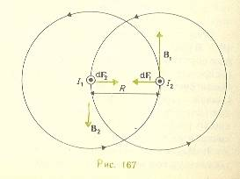

Figure 6.2

Ampere first established the relation for the force acting on a current element of small length. This relation has the following form
dF=I/c [d l B] i.e.
The vector notation here is suggestive of the familiar left – hand rule. The force acting on an element of wire length is always perpendicular to the plane passing through the current and the magnetic induction vector at this location. In the form used in the SI system the formula for the Ampere force is
dF = I [d l B] . (6.28)
In the simple case of a rectilinear piece of wire of length l, located in a uniform magnetic field B, Amperes law may be directly applied in the form
F=I l B sin lB , (6.29)

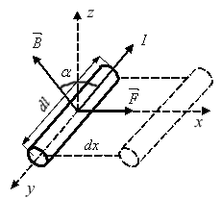

$\begin{aligned}\text{dA}=\text{Fdx}=\text{BIdl}\text{sin}α\text{dx}= \\ =\left|B\text{sin}α=B_{n}\right|=B_{n}\text{Idldx}= \\ {\text{IB}}_{n}\text{dS}=\left|B_{n}\text{dS}=dΦ\right|=\text{Id}Φ\end{aligned}$ (6.30)
$$A=\int_{1}^{2}{\text{Id}Φ}$$

Lecture 7. Electromagnetic Fields. Maxwell’s Equations
Interaction of currents and magnets

We have at our disposal formulas for the forces and torques acting on device by a magnetic field of any origin:

Table 7.1
Action on a current |  | Action on  a magnet
CGS | SI | Action on  a magnet
$$F=\frac{I}{c}[\text{dl},B]$$  $$N=[μB]$$  where $μ=\frac{1}{c}\text{IS}$ | $$F=I[\text{dl},B]$$  $$N=[μB]$$  where $μ=\text{IS}$ | $$F=\text{mH}$$  $$N=[μH]$$  where $μ=\text{ml}$

Formula relating fields to their sources:

Table 7.2
Field due to current |  | Field due to magnet
CGS  $$\text{dH}=\frac{I}{{\text{cr}}^{2}}[\text{dl},\frac{r}{r}]$$  $$B=μH$$ | SI  $$\text{dH}=\frac{I}{4{πr}^{2}}[\text{dl},\frac{r}{r}]$$  $$B=μ_{0}μH$$ |  | CGS SI  $B=\frac{m}{r^{2}}$ $B=\frac{m}{4{πr}^{2}}$ $B=\frac{2μ}{r}$$B=\frac{μ}{2{πr}^{3}}$

Magnetic interaction, i.e. the action of one magnet on another. Two poles separated by a distance r interact in accordance with Coulomb’s law:
$F=\frac{m_{1}m_{2}}{4{\text{πμ}}_{0}{μr}^{2}}$ (7.1)
The interaction force is inversely proportional to the magnet permeability.
Electromagnet action, i.e. the action of a current on a magnet. A current element exerts a torque on a magnet. For simplicity, we assume that µ ┴ H. Then
$\text{dN}=\frac{μI}{4{πr}^{2}}\text{dl}\text{sin}\text{dl},r$ . (7.2)
The interaction does not depend on the magnet magnetic permeability, i.e., on the properties of the medium.
Magnetoelectric action, i.e. the action of a magnet on a current. Consider a current – carrying circuit located along the extension of the bar magnet axis at a distance from the magnet.
The torque acting on the circuit is
$N=\frac{μ_{\text{cur}}μ_{\text{mag}}}{2{πr}^{3}}\text{sin}α$. (7.3)
Electrodynamics’ action, i.e., the action of one current on another current. Two parallel currents are attracted with a force
$\text{dF}=\frac{I_{1}}{C}{\text{dl}}_{1}B$,
$\text{dF}=μ_{0}μ\frac{I_{1}I_{2}{\text{dl}}_{1}{\text{dl}}_{2}}{4{πr}^{2}}$ . (7.4)

Magnetic Flux

Let us consider a magnetic loop at S-area. The loop may have any shape. It is made of a conductor material. By definition the magnetic flux through the loop is set by:
$Ф_{B}=B_{n}S,$ (7.5)
where B_{n}- projection of $\bar{B}$onto $\bar{n}$.
Thus Ф=BScosα,
where α is the angle between $\bar{B}$ and $\bar{n}$. If the field is heterogeneous, then the element of magnetic flux is:
$\begin{aligned}\text{dФ}=B_{n}\text{dS} \\ Ф=\oint_{S}{B_{n}\text{dS}}\end{aligned}$ (7.6)
The unit of magnetic flux is Weber (Wb)

Electromagnetic induction

Let us consider two experiments made by Faraday in 1831(Fig.). One can see that any motion of nature magnet inside the coil resulting in the current flowing through a circuit. It is important that the current arises, only if the magnet is moving. The galvanometer doesn’t show anything if the magnet is at rest.
In the second experiment galvanometer shows the current only if the switch is closing or the switch is opened. Pay attention to a fact that the circuits are disconnected. If the switch is closed, no effect is observed. These are only two of thousands experiments of Faraday. The electromagnetic induction phenomenon is illustrated by these experiments.
Any change of the magnetic flux through the conduct loop results in generation of an induced electromotive force at this loop. This phenomenon is called the electromagnetic induction and the electromotive force is called the induced electromotive force. Its magnitude can be calculated with formula:
$ε_{i}=−\frac{\text{dФ}}{\text{dt}}$. (7.7)
This is the Faraday’s law. The induced e.m.f. is equal to the minus rate of a change of the magnetic flux through area confined by a loop. The minus sign is included in this law to give the direction of the induced e.m.f. according to Lorent’z law: an induced e.m.f. in loop gives rise to a current, whose magnetic field is opposite to the change of magnetic flux that produces it. That is, an induced current has such a direction that its magnetic field prevents the change in the external magnetic field. If the conductor loop is closed an induced current arises. Its value is given by:
$I=\frac{ε_{i}}{R}=−\frac{1}{R}⋅\frac{dΦ}{\text{dt}},$ (7.8)
where R is the resistance of the circuit.
So far we've dealt with electricity and magnetism as separate topics. From now we'll investigate the inter-connection between the two, starting with the concept of induced e.m.f.. This involves generating a voltage by changing the magnetic field that passes through a coil of wire.
We'll come back and investigate this quantitatively, but for now we can just play with magnets, magnetic fields, and coils of wire. You'll be doing some more playing like this in one of the labs. There are also some coils and magnets available in the undergraduate resource room - please feel free to use them.
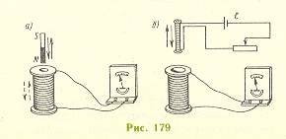
Figure 7.1

First, connect a coil of wire to a galvanometer, which is just a very sensitive device we can use to measure current in the coil. There is no battery or power supply, so no current should flow. Now bring a magnet close to the coil. You should notice two things:
- If the magnet is held stationary near, or even inside, the coil, no current will flow through the coil.
- If the magnet is moved, the galvanometer needle will deflect, showing that current is flowing through the coil. When the magnet is moved one way (say, into the coil), the needle deflects one way; when the magnet is moved the other way (say, out of the coil), the needle deflects the other way. Not only can a moving magnet cause a current to flow in the coil, the direction of the current depends on how the magnet is moved.
How can this be explained? It seems like a constant magnetic field does nothing to the coil, while a changing field causes a current to flow.
To confirm this, the magnet can be replaced with a second coil, and a current can be set up in this coil by connecting it to a battery. The second coil acts just like a bar magnet. When this coil is placed next to the first one, which is still connected to the galvanometer, nothing happens when a steady current passes through the second coil. When the current in the second coil is switched on or off, or changed in any way, however, the galvanometer responds, indicating that a current is flowing in the first coil.
You also notice one more thing. If you squeeze the first coil, changing its area, while it's sitting near a stationary magnet, the galvanometer needle moves, indicating that current is flowing through the coil.
What you can conclude from all these observations is that a changing magnetic field will produce a voltage in a coil, causing a current to flow. To be completely accurate, if the magnetic flux through a coil is changed, a voltage will be produced. This voltage is known as the induced e.m.f.
The magnetic flux is a measure of the number of magnetic field lines passing through an area. If a loop of wire with an area S is in a magnetic field B, the magnetic flux is given by:
,
where φ is an angel between the magnetic field B and the vector S, which is perpendicular to the plane of the loop.
If the flux changes, an e.m.f. will be induced. There are therefore three ways an e.m.f. can be induced in a loop:
- Change the magnetic field.
- Change the area of the loop.
- Change the angle between the field and the loop.
We'll move from the qualitative investigation of induced e.m.f. to the quantitative picture. As we have learned, an e.m.f. can be induced in a coil if the magnetic flux through the coil is changed. It also makes a difference how fast the change is; a quick change induces more e.m.f. than a gradual change. This is summarized in Faraday's law of induction. The induced e.m.f. in a coil of N loops produced by a change in flux in a certain time interval is given by faraday’s law of induction:
$$ε={−NΔФ}/{Δt}$$
Recalling that the flux through a loop of area S is given by
Faraday's law can be written:
$ε=−NΔ(B⋅A⋅\text{cos}ϕ)/{Δt}$ (7.9)
The negative sign in Faraday's law comes from the fact that the e.m.f. induced in the coil acts to oppose any change in the magnetic flux. This is summarized in Lenz's law.
Lenz's law: The induced e.m.f. generates a current that sets up a magnetic field which acts to oppose the change in magnetic flux.
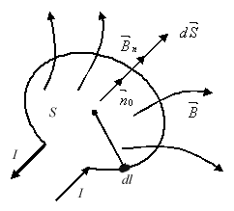
Figure 7.2

Another way of stating Lenz's law is to say that coils and loops like to maintain the status quo (i.e., they don't like change). If a coil has zero magnetic flux, when a magnet is brought close then, while the flux is changing, the coil will set up its own magnetic field that points opposite to the field from the magnet. On the other hand, a coil with a particular flux from an external magnetic field will set up its own magnetic field in an attempt to maintain the flux at a constant level if the external field (and therefore flux) is changed.
The phenomenon of electromagnetic induction discovered by Faraday may be described as follows:
An electric current the value of the magnetic flux passing the loop changes. Moreover, the inducted e.m.f. is proportional to the rate of change of the magnetic flux.
where
$Φ=\int{B\text{cos}α\text{dS}}$ . (7.10)
We shall show that the law of electromagnetic induction is closely related to the existence of a Lorenz force.
There are free charges in the displaced conductor. These charges are subjected to the action of a Lorenz force.
$f=\text{evB};$ (7.11)
When the conductor moves with a velocity υ, thus, the force is directed along the wire. The changes are impaled to move and an induced current is thereby created. The electromotive force is equal to the work of moving a unit charge around a closed circuit. It has the form
$$ε^{\text{ind}}=\text{vBl}$$
or
$ε^{\text{ind}}=−\frac{dΦ}{\text{dt}}$ (7.12)
The induced current depends only on the relative displacement of the conductor with respect to the magnetic field. Thus, it may asserted with equal validity that a Lorenz force is produce when is “at rest” and the magnetic field moves. This follow form the principle of relativity.
Consider a system of coordinates relative to which a magnetic field moves. Such a coordinate system may be fixed, for example, relative to a laboratory bench a long which the pole of a permanent magnet moves. Then, a Lorenz force will act on charges at rest relative to this bench. Let us assume nothing is known about the moving permanent magnet. Having established that a force acts on the stationary electric charges, we are perfectly justified in concluding that an electric field exits in this system whose intensity is equal to the Lorenz force divided by the magnitude of the charge. Thus the electric field intensity in the “stationary” coordinate system, relative to which the source of constant magnetic field moves with velocity v, is expressed by the formula
(7.13)
The electromotive force
$$V=\oint{\text{Edl}}$$
Along a closed curve is equal to the derivative with respect to the time of the magnet flux passing through this circuit:
$V=\frac{dΦ}{\text{dt}}$ (7.14)
This is the generalized law of induction. Equating the expression for electromotive force and magnetic flux, the law can be written as follows
$\oint{\text{Edl}=−\frac{d}{\text{dl}}\int{B\text{cos}α\text{dS}}}$ (7.15)
Lenz’s law: as the magnet approaches the circuit, a current of such direction is induced in the latter that the field produce tends to oppose the action which caused it.
One of Maxwell’s most important new ideas was that symmetry must exist in the interdependence between magnetic and electric fields.
According to the hypothesis, if a change in electric flux occurs in some region of space, a rotational magnetic field is created. Moreover, the magneto-motive force V taken along a closed curve is equal to the change in electric flux passing through this closed curve
$V=\frac{\text{dN}}{\text{dt}}$, (7.16)
where
$V=\oint{\text{Hdl}}$, (7.17)
and the electric flux
$N=\int{D\text{cos}α\text{dS}}$. (7.18)
As is known, when currents are present the magneto-motive force along a closed curve is equal to
$V=I$.
Maxwell assumed that the magnetomotive force are additive. Thus, the general formula has the form
$\oint{\text{Hdl}=I+\frac{\text{dN}}{\text{dt}}}$. (7.19)
The expression dN/dt has the dimensionality of electric current.
$\oint{\text{Hdl}=I+I_{\text{displ}}}$. (7.20)
Maxwell’s equations are:
$\oint{\text{Edl}=−\frac{dΦ}{\text{dt}}}$ are $\oint{\text{Hdl}=I+\frac{\text{dN}}{\text{dt}}}$. (7.21)
Let us consider the physical essence of electromagnetic phenomena as given by Maxwell’s equations. It may be summarized in the electromagnetic manner.
The division of an electromagnetic field into electric and magnetic fields has only relative meaning. If from the viewpoint of an inertial system of coordinates only a magnetic field exists, then from the viewpoint of another system moving relative to this system there exists an electric field in addition to a magnet field. The converse is also true, namely, if an observer in one system of coordinates finds only an electric field present, then an observer in another inertial system will find that an electric field and magnetic field exist.
Let us now consider an electromagnetic field from the viewpoint of an inertial frame of reference, in region of space in which free electric charges and hence conduction currents are absent. In this case
$\oint{\text{Edl}=−\frac{dΦ}{\text{dt}}}$ and $\oint{\text{Hdl}=\frac{\text{dN}}{\text{dt}}}$. (7.22)

The electromagnetic field may be depicted as a chain of rings, where close magnetic lines of force are alternately linked with close electric lines of force.
If the region of space under consideration contains charges and currents, than in addition to rotational field with linked lines of force there exits a rotational magnetic field whose closed field closed flux lines encircle currents and a potential electric field whose flux lines begin on positive charges and terminated on negative charges.

Source of Alternating Current

It is the electromagnetic induction phenomenon that enables engineering to produce the alternative current. Let us consider a rectangular loop, which is located in the homogeneous magnetic field. The loop can rotate around the axis OO`. The magnetic flux through this loop can be calculated with the formula:
Ф=BScosα, (B and S = const).
However α is changing:
α= ωt.
Consequently,
Ф=BScosωt.
Thus, taking the derivative, we obtain:
$\begin{aligned}ε_{i}=−\frac{\text{dФ}}{\text{dt}}=ω\text{BS}\text{sin}ωt, \\ ε_{i\text{max}}=ω\text{Bs}\text{,sin}ωt=1, \\ ν=\frac{ω}{2π}=\text{50}\text{Hz}\text{.}\end{aligned}$
Consequently, e.m.f. of induction is generated during the rotation of the conducted loop in the magnetic field. This e.m.f. is related to time as sinus law.
It is of great interest, that Lorent’z force is the real reason of this phenomenon. Look at the upper branch of the loop. A conductor contains free charges. A positive charge moves downstairs in magnetic field. Thus a force of Lorent’z arises. This force compels the charge to move along the branch as it is shown in figure.
The direction of the motion of charges in the lower branch is opposite. Then branches change with each other.

Self-Induction

Let us assume that in an electric circuit the changing current is flowing. In this case I ≠ const. This current generates changing magnetic field. In its turn this magnetic field results in e.m.f. of induction. This phenomenon is called self-induction. Thus, the origin of an e.m.f. in the same circuit, in which the changing current flows, is called the phenomenon of self-induction.
The current of self-induction increases when closing and opening any electric circuit. It is directed opposite to the initial direction. An example of current of self-induction is shown on the figure:
E.m.f. of self-induction is directly proportional to the rate of current changing:
$ε_{\text{si}}=−L\frac{\text{dI}}{\text{dt}}$, (7.23)
where L is called the self-inductance. The unit of L is Henry. [ L ] = H.
The flux increment through the loop is given by:
dФ=LdI.
Inductance of a conducted loop or a circuit depends on its material, shape and dimensions and magnetic permittivity of the environment. The formula for a solenoid is important. Let N- the number of turns, n=N/l – turns per unit of length.
By definition of flux:
Ф=BSN,
$\begin{aligned}B={\text{μμ}}_{0}\text{nI}, \\ L=\frac{Ф}{I}=\frac{\text{BSN}}{I}=\frac{{\text{μμ}}_{0}\text{ISN}}{I}={\text{μμ}}_{0}n^{2}V, \\ \left(V=\text{Sl},N=\text{nl}\right)\text{.}\end{aligned}$ (7.24)
Induction current increases in massive conductors, placed in the varying magnetic fields or in moving massive conductors in magnetic field. This induction currence is called eddy currence of Foucault currents.
Induction currence causes the intensive heating of conductors. This phenomenon is used in inductance furnace for melting metals.
Existence of induction currents in electric machines and transformers causes the considerable looses of energy. That is why the cores of transformers and magnetic circuits aren’t unbroken.
Induction currents may be used for damping the moving parts of devices. If a metal needle vibrates near the poles of electromagnet, the induction current arises in it according to the Lorent’z law and damps the motion of a needle.

Eddy Electric Field

The induced e.m.f. arises in the motionless coil in the variable magnetic field. Lorent’z force doesn’t act on the motionless charges in this coil and appearing of the e.m.f. of electromagnetic induction in motionless coil cannot be explained by the arising Lorent’z force. The appearance of induced current is caused by the eddy electric field$E_{B}$. The circulation of the eddy electric field intensity along the closed contour L equals to the e.m.f. of electromagnetic induction:
$\oint_{L}{E_{B}\text{dl}=ε_{i}}$. (7.25)
That is, the variable magnetic field gives rise to the eddy electric field and is a reason of appearance of the e.m.f. of electromagnetic induction.

Mutual Inductance. Transformer

Let us consider two loops with current I₁ and I₂. The variable current I₁ in the first loop creates the variable magnetic field in the position of the second coil.
Magnetic flux Ф₂ through the second loop is:
$Ф_{2}=L_{\text{12}}I_{1}$, (7.26)
where L₁₂ is the coefficient of the mutual inductance.
According to the Faraday’s law of electromagnetic induction, the e.m.f. of a mutual inductance is:
$ε_{\text{12}}=−\frac{dФ}{\text{dt}}=−L_{\text{12}}\frac{{\text{dI}}_{1}}{\text{dt}}$. (7.27)
If R₂ is the resistance of the second loop, then the current intensity in this loop is:
$I_{2}=\frac{ε_{\text{12}}}{R_{2}}=−\frac{{\text{dI}}_{1}}{\text{dt}}⋅\frac{L_{\text{12}}}{R_{2}}$. (7.28)
The variable current sets up its own varying magnetic field that creates an induced e.m.f. in the first loop. Thus, the magnetic flux Ф₁ through the first loop is:
$Ф_{1}=L_{\text{21}}I_{2}$.
The e.m.f. of the mutual inductance in the first loop is:
$ε_{i1}=−\frac{{dФ}_{1}}{\text{dt}}=−L_{\text{21}}\frac{{\text{dI}}_{2}}{\text{dt}}$, (7.29)
where L₂₁ is the coefficient of mutual inductance.
So, the loops 1 and 2 are connected and the appearance of the e.m.f. of inductance in the loop, when the current varying in the other one is called the phenomenon of mutual inductance. The coefficients of mutual inductance L₁₂ and L₂₁ depend on the size, shape and relative positions of loops and also on the magnetic properties of the surrounding medium. They are in proportionality to coefficients between the magnetic flux and the current intensity. They should be measured in the same units, as the self-inductance – in Henries.
Let us consider mutual inductance of two coils with n₁ and n₂ turns mounted on a common toroidal core of magnetic permeability μ. The magnetic induction of the first coil is:
$B={\text{μμ}}_{0}\frac{n_{1}I_{1}}{l}$, (7.30)
where I₁ is the current in the first coil, l is the length of the coil.
The magnetic flux through the second coil is:
$Ф_{2}={\text{Bsn}}_{2}={\text{μμ}}_{0}\frac{n_{1}n_{2}}{l}S$, (7.31)
where S is the cross-section of coils.
The coefficient of mutual inductance is:
$L_{\text{21}}=\frac{Ф_{2}}{I_{1}}={\text{μμ}}_{0}\frac{n_{1}n_{2}}{l}S$. (7.32)
The coefficient is the same for the first coil. Thus:
$L_{\text{12}}=L_{\text{21}}={\text{μμ}}_{0}\frac{n_{1}n_{2}}{l}S$. (7.33)
The phenomenon of mutual inductance is used in transformers either to rise or to lower the voltage of the varying electric current.
Let us assume that two coils with n₁ and n₂ turns are wound on a closed core or ferromagnetic material. The principle circuit is shown in figure.
The varying magnetic field in the first coil creates the magnetic flux through the second coil. According to the Faraday’s law, the e.m.f. of the mutual inductance appears in the second coil and the e.m.f. of self-inductance appears in the first one. The current I₁ in the first coil according to the Ohm’s law is denoted as:
$ε_{1}−\frac{d\left(n_{1}Ф\right)}{\text{dt}}=I_{1}R_{1}$, (7.34)
where R₁ is the resistance of the first coil.
The drop in voltage in the first coil is small. That is I₁R₁≈0.
$ε_{1}≃n_{1}\frac{dФ}{\text{dt}}$. (7.35)
e.m.f. of the mutual inductance in the second coil is:
$ε_{2}=−\frac{d\left(n_{2}Ф\right)}{\text{dt}}=−n_{2}\frac{dФ}{\text{dt}}\text{.}$ (7.36)
From the comparison of these two equations we obtain:
$\frac{ε_{1}}{ε_{2}}=−\frac{n_{1}}{n_{2}}⇒ε_{2}=−\frac{n_{2}}{n_{1}}ε_{1}$. (7.37)
Sign “minus” says, that e.m.f. in the first and second coils are in opposite phases. The ratio of the number of turns in the coils is called the coefficient of transformation:
$$k=\frac{n_{1}}{n_{2}}\text{.}$$
If k > 1, the transformer works for increase; if k < 1, the transformer is step-down.
If we neglected the loses of energy in the coils of transformer (≈2%), the power of current in both coils would be the same:
$$ε_{1}I_{1}≈ε_{2}I_{2};$$
and we obtain: $\frac{ε_{2}}{ε_{1}}=\frac{I_{1}}{I_{2}}=\frac{n_{2}}{n_{1}}$. (7.38)
That is, the ratio of currents in the coils is opposite proportional to the ratio of number of turns in the coil. The step-up transformers are used to transfer electric energy for long distances, because in this case the loses of energy on Joule heating decreases. The step-down transformers are used for electric welding. In this case we deal with big currents and small voltages.

Magnetic Field Energy

The electric field has got the energy per unit volume, been given by the formula:
$ω_{E}=\frac{ε_{0}{εE}^{2}}{2}$. (7.39)
Energy can also be stored in the magnetic field. An analogical formula for the magnetic field energy may be expressed as:
$ω_{B}=\frac{B^{2}}{2{\text{μμ}}_{0}}=\frac{\text{BH}}{2}=\frac{{\text{μμ}}_{0}H^{2}}{2}$. (7.40)
Lets try to derive this formula. Let’s consider an experiment. The conductor with current is located inside the magnetic field. The length of it is l. It can move parallel to itself. The Ampere’s force grows:
$\begin{aligned}F_{A}=\text{BIl}\text{sin}α, \\ \left(α=\text{90}°\text{,sin}α=1\right)\text{.} \\ \text{dA}=−\text{dW}\text{.} \\ F_{A}=F_{A}\text{dr}=\text{BIldr}=\text{IBds}=\text{IdФ},\end{aligned}$ 7.41)
$\begin{aligned}\text{dФ}=\text{LdI}, \\ \text{dA}=\text{LIdI},W=\int_{0}^{L}{\text{LIdI}=\frac{{\text{LI}}^{2}}{2}\text{.}}\end{aligned}$ (7.42)
On the other hand:
$L={\text{μμ}}_{0}n^{2}V$, (7.43)
$B={\text{μμ}}_{0}\text{nI},W=\frac{B^{2}}{2{\text{μμ}}_{0}}V;(V=\text{sl})$. (7.44)
Dividing this formula by V, we obtain:
$ω_{B}=\frac{B^{2}}{2{\text{μμ}}_{0}}$. (7.45)
The volume density of the magnetic field is its energy that contains in the unit volume:
$ω_{B}=\frac{\text{dW}}{\text{dV}}\text{.}$ (7.46)
Table 7.3 – Comparison of Electric and Magnetic Fields
Electric field | Magnetic field
1)It is created by immobile electric charges | 1)It is created by moving electric  charges
2)Can be discovered by the force acting on charge being tested. | 2) Can be discovered by the force, on a conductor with current or magnetic needle
3)It is described by the intensity vector | 3)Is described by the magnetic induction
 | B=M_{max/pm}
4)The lines of force start and end at charges or at infinity. | 4)The lines of force are closed
5)Capacity of a source (divirgention)is directly proportional to the charge density: | 5)There are no magnetic field sources I in nature.  Div B=0
6) Electric field is potential.  $$\oint_{L}{\text{Edl}}=0$$ | 6)The magnetic field is vortex  $$\oint_{L}{\text{Bdl}}≠0$$

LECTURE 8. Finite bodies in a magnetic field

To one degree or another all bodies possess magnetic properties. In accordance with the value of µ, bodies may be divided into distinct classes:
Ferromagnetic substances – including iron, nickel, and cobalt – whose relative permeability’s are much greater than unit;
Paramagnetic substances; whose permeability’s are somewhat greater than unit;
Diamagnetic substances, whose permeability’s are slightly less than unit.
When a diamagnetic or paramagnetic body is placed in a magnetic field, the distortion of the field is negligible, but for ferromagnetic body there is considerable distortion. Let us consider magnet forces. A body that does not possess magnetic properties becomes magnetic when placed in a field. As we know, a system possessing a magnetic moment may be detected in two ways. In a uniform field, the body tends to become oriented in such a manner that the direction of the moment is parallel to the external field. Moreover, in a nonuniform field the body will experience a force tending to move it along the lines of force. In the case of ferromagnetic bodies, the torque may be detected without difficulty.
$N=[μH]$. (8.1)
The vector directed along the magnetic moment and numerically to the magnitude of the magnetic moment and numerically equal to the magnitude of the magnetic moment per unit volume is called the magnetization vector I.
Let us consider a small volume of a magnetic substance located in a nonuniform field. For simplicity, assume that the field varies along one axis and that the gradient is equal to dH/dx. Since a small volume of magnetic substance behaves like a magnetic dipole, the potential energy of a unit volume may be written in the form
$U=−\text{IH}$. (8.2)
If the moment acts along the field, the force exerted on a unit volume of the magnetic substance is equal to the derivative of the potential energy with respect to the coordinate
$\int{=−I\frac{\text{dH}}{\text{dx}}}$.
Experiments show that for diamagnetic and paramagnetic bodies the following simple relationship exists between the magnetization vector and magnetic field intensity
$I=μ_{0}χH$. (8.3)
where χ is the magnetic susceptibility. For diamagnetic bodies χ is negative, while it is positive for paramagnetic bodies. A paramagnetic body is attracted toward the region of strong field, while a diamagnetic body is repelled from such a region. In a uniform field, a paramagnetic needle tends to become oriented with its axis along the flux lines, while a diamagnetic needle tends to become oriented perpendicular to the flux lines.

Relationship between permeability and susceptibility

The permeability is determined from the formula
$μ=\frac{B}{H}$.
The susceptibility is determined from the forces exerted on a magnetic substance. Let us return to the experiment for determining the magnetic permeability of a body to the form of a wid. The primary winding creates a field of intensity
$H=\frac{\text{nI}}{L}$. (8.4)
Which is independent of the substance of the wide? First, it should be noted that the magnetic induction of a ring solenoid without an iron core has the significance of magnetic moment per unit volume. The magnetic moment of one turn is equal to IS, for the total magnetic moment of the system we obtain nIS, and the magnetic moment in unit volume
$\frac{\text{nIs}}{\text{LS}}$
is simply equal to the field intensity. If I is magnetic moment per unit volume due to the additional dipoles, the magnetic induction increases by this amount and becomes
$B=μ_{0}H+I$.
Such an increase in B also occurs when the solenoid is filled with a magnetic substance. Since
$I=μ_{0}χH,$ (8.5)
then
$B=μ_{0}(χ+1)H$. (8.6)
Hence, the susceptibility and permeability are related by the equation
$μ=1+χ$. (8.7)

Physical Fundamentals of Magnetic Properties of Solids

All materials have magnetic properties. If any substance is put in magnetic field, it becomes magnetized. This phenomenon is called magnetization. A magnetic moment is one of the important characteristics of magnetism. This quantity is analogical to electric dipole moment(Fig.). However, a single magnetic pole cannot exist. That is why m is a fictitious magnetic charge. In fact, a magnetic moment is created by a current loop. By definition magnetization vector is magnetic dipole moment per unit volume.
, (8.8)

where – magnetic moment of atom (molecule). Vector of magnetization is associated with V - volume currence only. Vector is directly proportional to intensity of external magnetic field.
, (8.9)

The $χ$ coefficient is called the magnetic susceptibility of the magnetic field. On the other hand magnetic induction is the sum
(8.10)
where $μ=1+χ$ is magnetic permeability of a substance.

The Forms of Substances Magnetism

All materials have some magnetic properties, caused by the motion of their electrons. Magnetism of substances has some forms: diamagnetism, paramagnetism, ferromagnetism.
Diamagnetism is a weak effect common to all substances and results from the orbital motion of electrons. In certain substances this effect is masked by a stronger effect due to electron spin paramagnetism. Some paramagnetic materials, such as iron also possess ferromagnetism.

Diamagnetism

Materials, whose atoms or molecules in the absence of an external magnetic field have no magnetic moment, are called diamagnetics. For diamagnetics, the magnetic susceptibility$χ<0$, and it is relatively small value.
$(\left|χ\right|\text{\sim }{\text{10}}^{−6}÷{\text{10}}^{−5})\text{.}$ (8.11)
Diamagnetics are repelled by the non-uniform magnetic field. i.e., they are moved in the direction of decreasing magnetic field intensity. In the uniform magnetic field the orientation of diamagnetic rod is perpendicular to the lines of magnetic induction. It is caused by the motion of electrons in atoms around the nuclear. If an external magnetic field is applied, the electrons change their orbits an d velocities so as to produce a magnetic field that is opposite to the magnetic field of the applied one in accordance with Lenz law. Thus, the permeability of diamgnetics is less than that of a vacuum and lies between 0 and 1. Diamagnetism is present in all substances. A magnetization curve is shown in the fig:
Examples of purely diamagnetic properties are Ag, Au, Cu, C, Si, Ge, H₂O, Hg, Pb, Bi organic compounds and others.

Paramagnetics

Materials, whose atoms or molecules in the absence of the external magnetic field have some magnetic moments, are called paramagnetics. They have positive magnetic susceptibility$χ>0$. Its value is:
$\left|χ\right|\text{\sim }{\text{10}}^{−5}÷{\text{10}}^{−3}\text{.}$ (8.12)
Paramagnetism is caused by the spins of electrons. Paramagnetic substances having atoms or molecules, in which there are unpaired electrons and thus a resulting magnetic dipole moment. There is also a contribution to the magnetic properties from the orbital motion of the electrons. Paramagnetics are such materials as Pt, Pd, Mb, Al, Mg, Ca, Cr, Mn, O2 and others. Certain metals, such as Na and K, exhibit some of paramagnetism, resulting from the magnetic moment of free or nearly free electrons in their conduction bands. The permeability $μ$ of paramagnetics is thus greater than that of a vacuum. It is slightly greater than 1. Thermal motion makes the orientation of the magnetic moment completely random, so that the total magnetic moment p_{m} is zero in the absence of a magnetic field. In this case material is not magnetized.
If paramagnetic is placed in the magnetic field, the elementary dipoles tend to line up with the field. The magnetization of the substance takes place, so all paramagnetics have magnetic field and its orientation has the same direction as the external magnetic field. In a non-uniform field paramagnetics tend to form the weaker to the stronger part of the field. In uniform magnetic field, the orientation of paramagnetic rod is parallel to lines of magnetic induction. A magnetization curve is expressed on the next fig:
If temperature increases thermal motion makes the orientation of the magnetic moment random in the external magnetic field. Thus, the magnetic susceptibility of paramagnetics is inversely proportional to its temperature (Curie’s law).
$χ=\frac{C}{T},C=\frac{{nμ}_{0}p^{2_{\text{ma}}}}{3χ}\text{.}$ (8.13)
where C - Curie’s constant, n – the number of atoms per unit volume (concentration), pma – magnetic moment of an atom, k – Boltsman’s constant:

Ferromagnetics. Magnetic hysteresis

Ferromagnetic bodies differ from the others mainly in that magnetic state of such a body is not linearly dependent, and moreover is not uniquely dependent, on the magnetic field intensity.
Let us consider the magnetization of an iron body as a function of the field intensity. We reiterate:
The magnetization curve gives the magnetic susceptibility, while the slope magnetic permeability. From the figure, it is seen that the permeability curve has a maximum. For weak fields the permeability is low. As the field intensity is increased, µ increases to a maximum, than begins to drop, and after reading saturation remains unchanged. When the value of the permeability is given without specifying the external conditions, the maximum permeability is usually meat.
Let us assume that after the iron has been brought to a state of magnetic saturation the magnetic field intensity is decreased. It turns out that the induction decreases along a different curve. The field intensity may be decreased to zero, but magnetization remains. The corresponding value of magnetization and induction at this point are referred to as the residual value.
Demagnetization occurs when the field intensity attains a value H_{c}, the value of the so-called. As the current is increased further in the same in the reverse direction. The magnetic flux until initial process. Having attained a negative induction maximum, we may then proceed in the other direction. In this manner, the hysteresis loop show in figure is obtained. the nature of a histeresis loop depends to a great extent on the material. A body is said to be magnetically soft if the coercive force is small.
Ferromagnetics is magnetics that have magnetization in the absence of external magnetic field. Its permeability is a large value and depends upon an external magnetic field. For ferromagnetics susceptibility $χ$ can achieve values up to: $χ={\text{10}}^{4}÷{\text{10}}^{5}\text{.}$ The magnetization vector of ferromagnetics is a function of the intensity of external magnetic field. The relationship is shown in the next figure.
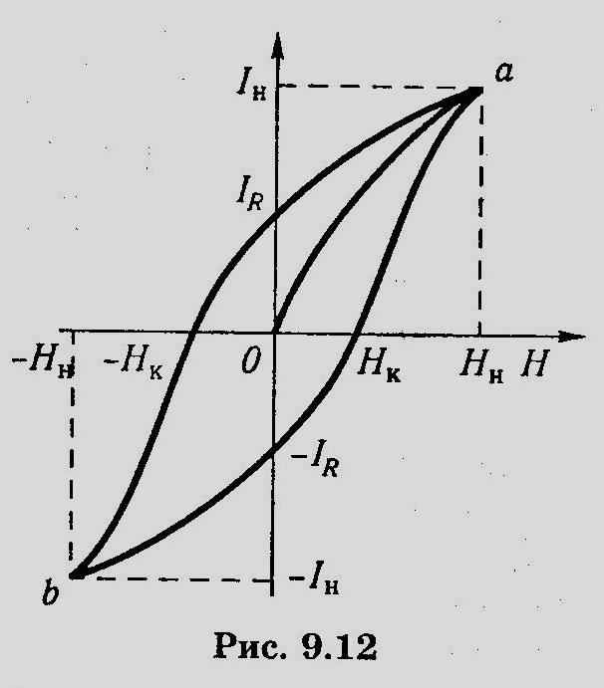
Figure 8.1

Ferromagnetics are magnetized to saturation in weak fields
since:
, (8.14)
and versus curve is called magnetization curve (Stoletov curve).
Magnetization of ferromagnetics was investigated in 1878 by A.G. Stoletov(1839-1896). The magnetic permeability $μ$ depends on the intensity of the external magnetic field.
This permeability curve passes through a maximum, then μ rapidly falls as soon as the magnetic saturation is attained.
The magnetic properties of ferromagnetics depend upon temperature. If temperature is raised above certain critical value T_{c}, called the Curie temperature, a ferromagnetic transforms into a paramagnetic. For every paramagnetic there exist its own Curie temperature. For example, T_{c} for iron is 768˚ C, for cobalt 1120˚ C, for nickel - 358º C.
Ferromagnetic materials retain their magnetization, when they are removed from the magnetization field. For its magnetization curve for its does not retrace themselves as we increase and then decrease the external magnetic field. The lack of retraceability is shown in Fig:
In this figure B versus H curve has the form of the loop and is called the hysteresis loop. The segment 0 – 1 is the magnetization curve of the demagnetized ferromagnetic at the initial state (B=0). This curve is called the initial magnetization curve. If the magnetic field $\bar{H}$is reduced from a certain value (point 1) to 0, the magnetic induction $\bar{B}$falls to a value B_{r.} This magnetic induction is called residual. Ferromagnetics in this state are called permanent magnets. To demagnetize completely the ferromagnetics it is necessary to apply the reverse field He. This magnetic field intensity He is called the coercive force of ferromagnetics. Further increasing of magnetic field intensity in the reverse direction leads to demagnetization of ferromagnetic (3 – 4). Point 4 corresponds to the saturation magnetization. Segments (4-5-6) correspond to demagnetization and (6-1) corresponds to further demagnetization to saturation magnetization in the point 1. Thus the closed curve is the hysteresis loop. The area of which denotes the work done by the external field during one magnetization cycle of a body (ferromagnetic).
The main characteristics of ferromagnetics are residual induction Br, coercive force Hc, maximum permeability μmax and Curie temperature T_{c}. These characteristics are different for ferromagnetic materials in a wide range. All ferromagnetics can be presented as two groups:
1. Soft magnetic materials, which have small coercive force
$H_{C}\text{\sim }(0,8÷8)\frac{A}{m}$,
a high permeability, narrow hysteresis loop and very small loses of energy at demagnetization.
2. Hard magnetic materials, which have big coercive force
$H_{C}\text{\sim }({\text{10}}^{4}÷{\text{10}}^{5})\frac{A}{m}$,
a relatively low permeability, wide hysteresis loop and big loses of energy of demagnetization.
They are difficult to magnetized and demagnetized. Typical soft magnetic materials are silicon steel Fe-Si and soft iron. These materials are mainly used in electro engineering as cores of transformers.
Typical hard magnetic materials are cobalt, steels and various alloys of Ni, Al, Co. They are used for making permanent magnets.
Ferromagnetics placed in magnetic field change its size during magnetization and demagnetization. This phenomenon is called magnetostriction. It is used to produce supersonic waves.
The classic theory of ferromagnetism was found by French physicist P.Weiss in 1907. According to this theory ferromagnetic material is split into small regions which in the absence of the external magnetic field are spontaneously magnetized to saturation. These regions are called domains. The total magnetization of the ferromagnetic sample is found to be equal to zero. Consequently the ferromagnetic material is not magnetized in the whole. If a ferromagnetic is placed in an external magnetic field domains, whose magnetization is not oriented in the field direction turns its magnetization direction into the magnetizing field. As the result the growth in domain size occur and ferromagnetic material becomes magnetized.
At first Einstein and Haas (1915) experimentally proved that ferromagnetism is caused by orientation of its own magnetic moment of electrons, i.e. by the electron spins. The ferromagnetism is observed in crystal materials, which atoms have unfilled inner electron shells with uncompensated spins.
The modern interpretation of ferromagnetism by quantum theory of Frenkel and Heisenberg (1928) is to assume the existence of strong interatomic forces. These forces are known as exchange forces and have quantum nature. By means of exchange forces the spin magnetic moments of electron are oriented parallel to each ot her, that causes the existence of spontaneous magnetizing regions – domains in the absence of the external magnetic field. Under the influence of the external magnetic field atoms of neighboring domains tend to be aligned in the direction of the field.

