MINISTRY OF Education and science of ukraine
Zaporozhye National Technical University

S.V. Loskutov, S.P. Lushchin

Short course of lectures of general physics

For students studying physics on English, and foreign students also
Semester I
Part 1

2006

Short course of lectures of general physics. For students studying physics on English, and foreign students also. Semester I, Part I / S.V. Loskutov, S.P. Lushchin. – Zaporozhye: ZNTU, 2006.- 66 p.

Compilers:S.V.Loskutov, professor, doctor of sciences (physics and mathematics);
S.P.Lushchin, docent, candidate of sciences (physics and mathematics).

Reviewer: G.V. Kornich, professor, doctor of sciences (physics and mathematics).

Language editing: A.N. Kostenko, candidate of sciences (philology).

Approved

by physics department,
protocol № 7
dated 30.05.2006

It is recommended for publishing by scholastic methodical division as synopsis of lecture of general physics at meeting of English department, protocol № 5 dated 4.06.2006.

The authors shall be grateful to the readers who point out errors and omissions which, inspite of all care, might have been there.

Contents
Part I
Lecture 1. Introductory Lecture …………………………………………..5
The fields and uses of physics …………….……………………….…….. 5
Measurement …………………………….………………………… …….6
Vectors and scalars …………………….………………………………… 7
Lecture 2. Kinematics ……………………………………………. …….11
Velocity ,,,,,,,,,,,,,,,,,……………. …..…………….……………….…….. 13
Acceleration …….…………………………………………………. ……14
Ultimate velocity ………………………….……..……………….. .….…15
Tangential and normal accelerations ………….…………….…….….….16
Lecture 3. Constant Acceleration ………………………………….……..17
Galileo’s Experiment ……………………………………………….…… 19
Projectile Motion ………………………………………………….…….. 20
Circular Motion of a Particle ………………………………... ………… 23
Principles of relativity by Galileo …………………………….…….…… 26
Lecture 4. Particle dynamics ……………..……………………….….…. 27
Classification of forces ………………………….…………………….… 29
Frictional forces ……………….…………………….………………...… 29
Centripetal forces ……………..…………..…………….…………….…. 32
Gravitational force ……………………………………………….….…... 32
The fundamental law of mechanics …….……………………………….. 33
Motion in circle is accelerated motion ……………….. ………….….…. 35
Lecture 5. Law of conservation of impulse …………. …………….…… 38
Mechanical Energy ……… …………………………………………...…. 39
Kinetic Energy and the Work-Energy Theorem …………….………..…. 40
Mass and Energy ……………….……………………………….….….. 45
Lecture 6. Momentum ………………………………………….…….…. 46

Rotation of Rigid Body ………………………..……………………...…. 48
Fundamental equation of motion for a rotating body ……………….…… 51
Lecture 7. Forces of Inertia ………….…………………………………... 52
Centrifugal force ……………………………………………. ………..... 54
Corioli’s force ……………………………..……….. ……………….….. 55
Lecture 8. Vibrations ………………………………….…………….……55
Small deviations from equilibrium ………………………….………. … 55
Velocity, Acceleration, Energy of Oscillations…………………….…… 57
Forced vibrations ………………………………………….……….….... 62
Addition of mutually perpendicular vibrations …………….…………… 63
Additional of parallel vibrations ………………………………...…...….. 64
Part 2
Lecture 9. The Damped Mechanical Oscillations ……….. ………….….. 69
The Spring Pendulum …………………….………………….……….… 71
Physical pendulum …………………………………………………….. 73
The Mathematical Pendulum ………………….……………………….. 73
Lecture 10. Wave Motion. Principles of Acoustics …………………….. 75
Wave Equation …………………………………………………………... 76
Standing Waves …………………………………………………..……... 77
Sound Vibrations and Waves …………………..…………………..……. 79
Lecture 11. Electromagnetic Oscillations and Waves ………….….…..….81
Forced Oscillations. Electrical Resonance ……………………..……...… 84
Electromagnetic Waves …………………………………………………. 85
Lecture 12. Liquids and Their Properties. ……………………..…. …..… 88
Molecular Pressure and Surface Tension …………….………..…..…..… 88
Capillary Phenomena …………………………………..………….……. 91
Microscopic and Macroscopic Parameters ………………..………....…. 93
Lecture 13. Ideal gas ………………….…………………………..…...... 94
The Equation of State …………………………………………………… 94
The Equation of the Gas State …………………………….…..…..……. 95
Lecture 14. The Equations of State of Real Gases …….………….……. 96
Kinetic Theory of Gasses …………………………………. ………..… 97
Gas Pressure ……………………………………………………..……... 98
Absolute Temperature ………….……….…………………………….. 102

Lecture 15. Processes in the ideal gases ………………………………. 102

Distribution of Gas Molecules by Velocities ……………………........... 103
Transfer Phenomena ……………………………………………………106
Diffusion ……………………………………………..….. ……………. 106
Heat Conductivity …………………………………………………….. 108
Internal Friction………….. ……………….. ………………………….. 109
Lecture 16. Internal Energy of a Gas …………………………………... 109

Work, performed by Gas …………………………….……………….. 110
Temperature and Heat …………………………….…………………. 111
The first law of thermodynamics …………………..……………….… 112
Thermodynamic Process …………………………….……………….... 113
Specific heat ………………………………………………………....... 113
Application of the first law of thermodynamics to gas processes…….… 115
Lecture 17. Cycles ………………………….. ……………………….… 119

The principle of operation of heat engine …… ……… ………….…..120

Carnot’s Engine. Cycle of Carnot ………………………………..…..…. 121

Work and efficiency of Carnot’s Cycle ………………….…….……..… 121
Entropy ……………….. …………………………………………….… 125

Lecture 18. The second law of thermodynamics ………………. …..…. 127
Processes involving a change of gas state ……………….…….……..….129
Lecture 1. Introductory Lecture
The fields and uses of physics

The story of mans civilization is the story of his study of nature and the application of his knowledge in his life. The use of tools, first of stone and later of metals, the domestication of animals, the development of writing and counting, all progressed slowly since rapid advance was not possible until man began to gather data and check theories. Till that time most of mans knowledge was based on the speculation of the Greeks.
Non until a little over three centuries ago did man adopt the scientific method of studying his environment. After this the development of civilization has become increasingly more rapid. The advance of all the natural sciences has been almost simultaneous: in fact, many of the prominent scientists were working in more than one field of knowledge.
Probably more conditions under which man lives, physics deals not with man himself, but with the things he sees and feels and hears. This science deals with the laws of mechanics, heat, sound, electricity, light, in order to build our machinery age. Modern physics also deals with electronics, atomic phenomena, photo-electricity, X-rays, radioactivity, the transmutation of matter and energy and the phenomena associated with electron tubes and the electric waves of modern radio.
The practical application of the achievement of the physics continues to develop at an ever-increasing rate. “Practical physics” plays, therefore, no small role, for the laws of physics are applied in every movement we make, in every attempt of communication, in the warmth and light we receive from the sun, in every machine. Practical application of physics is not all made by physicists, for the majority of those who apply the principles of physics are called “engineers”.
In fact, most of the branches of engineering are closely related with one more sections of physics: civil engineering applies the principles of mechanics and heat; electrical engineering is based on fundamentals of electricity, etc. The relation between engineering and physics is so close that a thorough knowledge and understanding of physical principles is important for progress of engineering. One of the tools common to physics and engineering is mathematics. If we want to make effective the use of the principles and measurements of physical science, we must have a workable knowledge of mathematics. Physics and mathematics are thus the basic “foundations of engineering”.
Measurement

When you can measure what you are speaking about, and express it in numbers, you know something about it; but when you cannot express it in numbers, your knowledge is of a meager and unsatisfactory kind; it may be the beginning of knowledge, but you have scarcely, in your thoughts, advanced to the stage of Science, whatever the matter may be. Often in the history of science small but significant discrepancies between the theory and accurate measurements have led to the development of new and more general theories. Such advances in our understanding would not have occurred if scientists had been satisfied with only a qualitative explanation of the phenomena of nature.
The building blocks of physics are the physical quantities in terms of which the laws of physics are expressed. Among these are force, time, velocity, density, temperature, charge, magnetic susceptibility, and numerous others. When these terms are used, their meanings may be vague or may differ from their scientific meanings.
For the purposes of physics the basic quantities must be defined clearly and precisely. Physical quantities are often divided into fundamental quantities and derived quantities. Derived quantities are whose defining operations are based on other physical quantities. For example:
$V=S/t$. (1.1)
Fundamental quantities are not defined in terms of other physical quantities. Their operational definitions involve two steps: first, the choice of a standard, and second, the establishment of procedures for comparing the standard to the quantity to be measured so that a number and a unit are determined as the measure of that quantity.
In general, the measured value of a physical quantity depends on the reference frame of the observer making the measurement. Consider reference frames moving with uniform velocity with respect to each other and with respect to the fixed stars. Such reference frames are called inertial frame of reference. Experiment shows that all inertial reference frames are equivalent for the measurement of physical phenomena. Observers in different frames may obtain different numerical values for measured physical quantities, but the relationships between the measured quantities, that is, the laws of physics, will be the same for all observers.
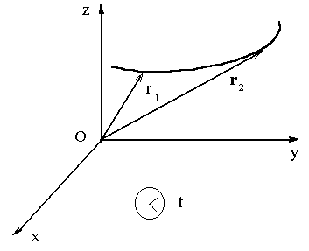
Figure 1.1

Three different systems of units are most commonly used in science and engineering. They are the meter-kilogram-second or MKS system, the Gaussian system, in which the fundamental mechanical units are the centimeter, the gram, and the second – CGS system, and the British engineering system (a foot-pound-second).

Vectors and scalars

A change of position of a particle is called a displacement. A displacement is characterized by a length and a direction. We can represent a subsequent displacement from A to B and C, fig.1.2. The net effect of the two displacements will be the same as a displacement from A to C. We speak then of AC as the sum or resultant of the displacements AB and BC. Notice that this sum is not an algebraic sum and that a number alone cannot uniquely specify it. Quantities that behave like displacements are called vectors. Vectors, than, are quantities that have both magnitude and direction and combine according to certain rules of addition.
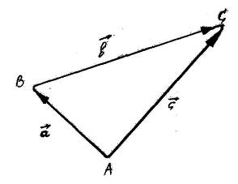
Figure 1.2

Quantities that can be completely specified by a number and unit and that therefore have magnitude only are called scalars.
To represent a vector on a diagram we draw an arrow. The relation among vectors $\vec{a}, \vec{b}, \vec{r}$can be written as
$\vec{a}+\vec{b}=\vec{r}$. (1.2)
Another way of adding vectors is the analytical method, involving the resolution of a vector into component with respect to a particular coordinate system. Fig.1.2. shows a vector $\vec{a}$ whose tail has been placed at the origin of a rectangular coordinate system. If we drop perpendicular lines from the head of $\vec{a}$ to the axis the quantities $a_{x}$and $a_{y}$so formed are called the components of the vector $\vec{a}$.
The process is called resolving $\vec{a}$ vector into its components. The components $a_{x}$and $a_{y}$are found readily from
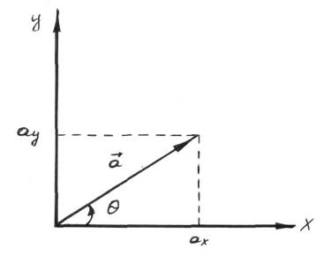
Figure 1.3

$a_{x}=a\text{cos}θ \text{and} a_{y}=a\text{sin}θ$ (1.3)
where $θ$ is the angle that the vector $\vec{a}$ makes with the positive x-axis, measured counter-clockwise from this axis. To obtain $\left|\vec{a}\right|$ and $θ$ from $a_{x}$and $a_{y}$
$a=\sqrt{a_{x}^{2}+a_{y}^{2}}$ and $\text{tan} θ={a_{y}}/{a_{x}}$ . (1.4)
When we multiply a vector quantity by another vector quantity by another vector quantity, we must distinguish between the scalar product and the vector product. The scalar product of two vectors $\vec{a}$and$\vec{b}$, written as $\vec{a}⋅\vec{b}$, is defined to be
$\vec{a}⋅\vec{b}=\left|\vec{a}\right|⋅\left|\vec{b}\right|\text{cos}Ψ=a⋅b\text{cos}Ψ=a⋅b\text{cos \{}\vec{a}\vec{b}$, (1.5)
where $a$ is the magnitude of vector $\vec{a}$, $b$is the magnitude of vector $\vec{b}$, and $\text{cos}Ψ$is the cosine of the angle $Ψ$between the two vectors.
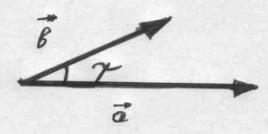
Figure 1.4

The notation $\vec{a}⋅\vec{b}$ is also called the dot product of $\vec{a}$ and $\vec{b}$and is spoken as “$\vec{a} \text{dot} \vec{b}$”. The vector product of two vectors $\vec{a}$ and $\vec{b}$is written as $\vec{a}×\vec{b}$ and is vector $\vec{c}$, where
$\vec{c}=\vec{a}×\vec{b}$. (1.6)
The magnitude of $\vec{с}$ is defined by
$\left|\vec{с}\right|=\left|\vec{a}\right|⋅\left|\vec{b}\right|\text{sin}Ψ$, (1.7)
where $Ψ$is the angle between $\vec{a}$ and $\vec{b}$.
The direction of $\vec{c}$, the vector product of $\vec{a}$ and $\vec{b}$, is defined to be perpendicular to the plane formed by $\vec{a}$ and $\vec{b}$.
Imagine rotating a right – handed screw whose axis is perpendicular to the plane formed by $\vec{a}$ and $\vec{b}$so as to turn it from $\vec{a}$ to $\vec{b}$ through the angle $Ψ$between them. Another convenient way to obtain the direction of a vector product is the following. Imagine an axis perpendicular to the plane of $\vec{a}$ and $\vec{b}$through their origin. Now wrap the fingers of the right hand around this axis and push the vector $\vec{a}$ into the vector $\vec{b}$ through the smaller angle between them with the fingertips, keeping the thumb erect;
The notation, $\vec{a}×\vec{b}$ is also called the cross product of $\vec{a}$ and $\vec{b}$and spoken as “$\vec{a}$ cross $\vec{b}$”.
$\vec{a}×\vec{b}=−\vec{b}×\vec{a}$ . (1.8)
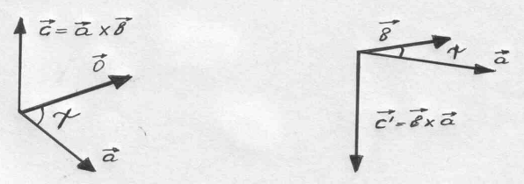
Figure 1.5

We are starting the study of physics today. Until the beginning of the seventeenth century mankind had little understanding of the structure of the material world. Man believed that stones were stones, fire was fire, and water was simply water. Now we know that all kinds of substances consist of very small invisible particles - atoms. They make up all the elements and compounds that exist in the world. Their interactions provide the energy that man uses.
In the nineteenth century the scientists first established experimentally the atomic theory of the structure of a matter. They found that the simple forms of a matter were chemical elements which consisted of atoms – indivisible particles of very small size.
At the end of the nineteenth century scientists achieved a great quantity of information on the atomic structure of a matter and the general nature of the atom, which, they found, was further divisible. They discovered most of the chemical elements and found that atoms of each element were different in chemical and physical properties from properties of other elements. A further discovery showed that the atoms combine in small numbers and form units of matter or molecules and that in all substances the atoms and molecules are in a state of rapid motion.
When we think of the substance which we call water, we commonly think of it as a definite liquid. It does not mean, however, that it is the only possible state in which water can exist. The liquid state is the normal state for the substance which we call water, but water can exist also as a gas and as a solid; in the gaseous state it changes to steam or water vapour, and in the solid state it becomes ice. Many substance can and do at various times exist in more than one of these three possible states. The molecules move differently in the three states.
In gases we find that the gas molecules are free to move and they are quite far apart. A body of gas no definite volume or shape, but takes the volume and shape of the vessel. A solid has both volume and shape. The molecules of a solid are also in motion, but they can move only a small amount because the atoms are very close together. The closer the molecules are together, the less free they are to move. The liquid state is between the gaseous and solid states. The molecules of a liquid are less free of move than the gas molecules, but are freer to move than the molecules of a solid.
The molecules of a solid are very close together and have a great attraction for each other. The closer they are together, the heavier is the solid; however, the molecules are in a state of continual vibration. In this state their attraction for each other is very great, and that is why it is very difficult to change the shape of a solid.
It we heat the solid, the molecules begin to vibrate more and more and three fore there is less attraction for each other. Thus, a solid expands when we heat it. When the molecules are quite far apart from each other, the solid changes into a liquid.
The story of mans civilization is the story of his study of nature. The scientific method of studying of nature. Those, who apply the principles of physics are called “engineers”. Physics and mathematics are the basic “foundations of engineering”. When you can measure what you are speaking about, and express it in numbers, you know something about it.

Lecture 2. Kinematics

Mechanics study the motion of objects and the forces that affect their motion. When a body changes its position relative to other bodies. It is said to be in mechanical motion.
The classic mechanics was founded in sixteenth and seventeenth centuries due to the work of Galileo Galilei and Isaac Newton. Mechanics is divided into three branches: kinematics, dynamics and static’s. Kinematics deals with motion without considering its cause. Dynamics considers laws of motion and the factors, which cause this motion. Static deals with laws of equilibrium of body. We shall begin our studies with the motion of a particle.
Kinematics studies the motion of a material point or bodies without regard to the courses of this motion. The basic concepts of kinematics are following: the material point; the frame of reference; the radius-vector; the trajectory; the path length; the displacement; the velocity; the acceleration.
If the dimensions and the shape of a body are not considered in a particular phenomenon, we can conceive a body as being represented by a point. A material point is a body dimensions of which may be neglected within a given problem.
In order to describe the motion of a particle, one must indicate which points in space the particle has passed and the points in time during which it was located in one or another point of the path. The location of the point in a coordinate system is determined by three coordinates x, y, z, or by radius vector $\vec{r}$, drawn from the origin of the coordinate system to the given point. The radius vector $\vec{r}$ is given by the magnitude
$\left|\vec{r}\right|=r=\sqrt{x^{2}+y^{2}+z^{2}}$, (2.1)
and the angles it forms with the coordinate axes
$\text{cos}α=\frac{x}{r}; \text{cos}β=\frac{y}{r}; \text{cos}γ=\frac{z}{r}\text{.}$ (2.2)
Frame of reference is a body reference, system of axes closely connected with it and clock. Body of reference is any body referring to which positions of other objects are determined. In order to describe the motion of a body we must first select a frame of reference, i.e., we choose one or several bodies considered to be fixed, and construct a coordinate system, say, a rectangular one (fig. 2.1).
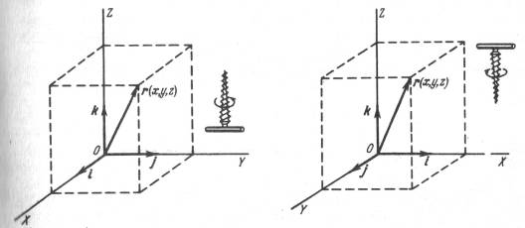
Figure 2.1

A change in position respectively to a frame of reference is called motion of a body. Mechanics, the oldest of the physical sciences, is the study of the motion of objects. When we describe motion we deal with the part of mechanics called kinematics. Thus, the motion in space can be described in the form of a continuous function

$\vec{r}=f(t)$
$\begin{aligned}\left\{r_{x}=r_{x}(t) | \right.\left\{r_{y}=r_{y}(t) | \right.\end{aligned}$ . (2.3)

Its vector equation is called the equation of motion. Let us consider AB, a portion of the path. Assume that at the instant of time t the moving particle was at A, and at the instant of time $t+Δt \text{at} B$.
Let us introduce the radius vectors ${\vec{r}}_{A}$ and ${\vec{r}}_{B}$. We know that during the interval of time $Δt$, the particle moved from A to B. It is therefore natural to call the vector AB the particle displacement vector.
The curvilinear motion is determined by the displacement vector $Δ\vec{r}$ for time$Δt$, where the smaller $Δ\vec{r}$ is the greater is the accuracy. The motion of a body may be:
- translational, if any straight line that passes through the body remains continually parallel to itself, and
- rotational, if the points of a body create concentric circles.

Velocity

To characterize the rapidity of motion used the term of velocity. The average speed for the path AB is given by the relation
$v_{\text{av}}=\frac{\text{AB}}{Δt}$. (2.4)
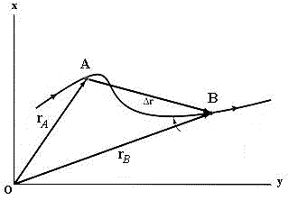
Figure 2.2

The velocity of a particle is the rate at which its position changes with time.
${\vec{v}}_{\text{av}}=\frac{Δ\vec{r}}{Δt}$. (2.5)
As $Δt$ decreases, the ratio $\frac{\text{AB}}{Δt}$ approaches a limit. The vector $v_{\text{inst}}$ having the direction of the tangent to the curve at the given moment limit of the ratio $\frac{\text{AB}}{Δt}$ as$Δt→0$, is called the instantaneous particle velocity
$\vec{v}=\underset{Δt→0}{\text{lim}}\frac{Δ\vec{r}}{Δt}=\frac{d\vec{r}}{\text{dt}}$. (2.6)
Let us now consider the curvilinear path AB, (fig.2.2) vectors $v_{A } \text{and} v_{B}$ differ in magnitude as well as in direction. To determine the increase in magnitude with the velocity, it is necessary, as before, to subtract the magnitude of the vector ${\vec{v}}_{A}$ from the magnitude of the vector${\vec{v}}_{B}$:
$Δ\left|\vec{v}\right|=\left|{\vec{v}}_{B}\right|−\left|{\vec{v}}_{A}\right|$. (2.7)
Vector v is directed along the tangent to the trajectory in the direction of motion. The unit of velocity is m/s. Vector v can be resolved in to the axis:
$\vec{v}=v_{x}\vec{i}+v_{y}\vec{j}+v_{z}\vec{k}$. (2.8)
Modulus of vector $\vec{υ}$ can be expressed as:
$\left|\vec{v}\right|=\sqrt{v_{x}^{2}+v_{y}^{2}+v_{z}^{2}}$; (2.9)
where $v_{x}=\frac{{\text{dr}}_{x}}{\text{dt}}$; $v_{y}=\frac{{\text{dr}}_{y}}{\text{dt}}$; $v_{z}=\frac{{\text{dr}}_{z}}{\text{dt}}$.

Acceleration

The velocity varies with time in the general case. We distinguish between uniform and non-uniform motion. Uniform motion is the motion if $\vec{υ}$equals constant, $\vec{v}$= const. And non-uniform motion, $\vec{v}$ when is not equals constant, $\vec{υ}≠$const. The vector $Δ\vec{v}$ is called the velocity increment
$Δ\vec{v}={\vec{v}}_{B}−{\vec{v}}_{A}$. (2.10)
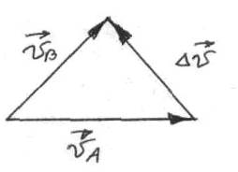
Figure 2.3

The ratio of the velocity increment to the interval of time during which this increment takes place is called the average acceleration:
$a_{\text{av}}=\frac{Δv}{Δt}$. (2.10)
The acceleration of a particle is the rate of change of its velocity with time. The vector
${\vec{a}}_{\text{inst}}=\underset{Δt→0}{\text{lim}}\frac{Δ\vec{v}}{Δt}=\frac{d\vec{v}}{\text{dt}}$ (2.11)
is called instantaneous acceleration of a body at a given moment of motion. Or vector $\vec{a}$ is the first derivative of $\vec{υ}$ with respect to t. Vector $\vec{a}$ may be expressed as:
$\vec{a}=\frac{d(\frac{d\vec{r}}{\text{dt}})}{\text{dt}}=\frac{d^{2}\vec{r}}{{\text{dt}}^{2}}$. (2.12)
The unit of acceleration is [a] = m/s².

Ultimate velocity

If body begins motion from condition of rest and moves with acceleration, its velocity in time t will be:
$v=a⋅t$. (2.13)
Consequently, for any different from zero value of acceleration "a" during long enough time "t" it is possible to obtain any great value of the velocity. However, this does not occur. According to the theory of relativity
$v=\frac{a⋅t}{\sqrt{1+{\left(atc\right)}^{2}}}$. (2.14)
If ${\left(\frac{\text{at}}{c}\right)}^{2}\text{>>}1$, then
$v≈\frac{\text{at}}{\sqrt{({\text{at}}/c)^{2}}}=\frac{\text{at}}{{\text{at}}/c}=c$. (2.15)
Velocity of the light in seconds is an ultimate physical velocity c = 3 ·10⁸ м/с.

Tangential and normal accelerations

It is customary to resolve the acceleration vector into two components
$\vec{a}={\vec{a}}_{t}+{\vec{a}}_{n}; a=\sqrt{a_{t}^{2}+a_{n}^{2}}=\sqrt{{\left(\frac{\text{dv}}{\text{dt}}\right)}^{2}+{\left(\frac{v^{2}}{R}\right)}^{2}}$ (2.16)
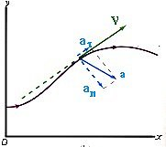
Figure 2.4

The vector ${\vec{a}}_{t}$, directed along the curve, represents the change in the magnitude of the velocity and is called the tangential acceleration.

$\begin{aligned}\left\{\text{Time} \text{derivative} | \right\}\end{aligned}\left\{\right\} {\vec{a}}_{t}=\underset{Δt→0}{\text{lim}}\frac{Δ\vec{v}}{Δt}=\frac{d\vec{v}}{\text{dt}} \begin{aligned}\left\{\text{direvative} \text{of} \vec{v} \text{with} | \right\}\end{aligned}\left\{\right\}$.(2.17)

The vector ${\vec{a}}_{n}$, directed normal to the curve, represents the change in the direction of the velocity and is called the normal acceleration.
${\vec{a}}_{n}=\frac{v^{2}}{R}$, (2.18)
where R is the radius of curvature at the given point.
The normal acceleration ${\vec{a}}_{n}$ is often also called the centripetal acceleration. There are following simple relations between the period T, the frequency ν and the angular velocity ω:
$ν=\frac{2πR}{T}, v=ωR, ν=\frac{1}{T}, ω=\frac{2π}{T}$ (2.19)
The motion, being the function of tangential and normal components of acceleration, is classified as follows:
1) $a_{t}=0; a_{n}=0$ - uniform and rectilinear motion;
2) $a_{t}=±j; a_{n}=0$ - uniformly accelerated (+j) or uniformly retarded (-j) rectilinear motion;
3) $a_{t}=f(t); a_{n}=0$ - rectilinear variably accelerated motion;
4) $a_{t}=0; a_{n}=j_{n}$ - circular uniform motion, the radius of the circle is determined by the velocity of motion and the magnitude$a_{n}$, as given in formula $a_{n}=\frac{v^{2}}{R}$;
5) $a_{t}=0; a_{n}=f(t)$ - curvilinear uniform motion;
6) $a_{t}=±j; a_{n}≠0$ - curvilinear uniformly accelerated (retarded) motion;
7) $a_{t}=f(t); a_{n}≠0$ - curvilinear variably accelerated motion.

Lecture 3. Constant Acceleration

Let $t_{1}=0$and let $t_{2}$ be any arbitrary time t. Let $v_{x0}$ be the value of $v_{x}$at t=0 and let $v_{x}$ be its value at the arbitrary time t. With this notation we find $a_{x}$ from
$a_{x}=\frac{Δv}{Δt}=\frac{v_{x}−v_{x0}}{t−0}$ (3.1)
or
$v_{x}=v_{x0}+a_{x}t$.
The equation states that the velocity $v_{x}$ at time t is the sum of its value $v_{x0}$ at time t=0 plus the change in velocity during time t, which is $a_{x}t$.
When the velocity $v_{x}$ changes uniformly with time, its average value over any time interval equals one-half the sum of the values of $v_{x}$ at the beginning and the end of the interval.
That is the average velocity $v_{x}$ between t₁ = 0 and t₂ = t is
$v_{x}=\frac{1}{2}(v_{x0}+v_{x})$. (3.2)
If the position of a particle at t=0 is x₀ , the position x at time t can be found from
$x=x_{0}+v_{x}t$. (3.3)
If $t_{0}=0,$ then
$a=\frac{Δv}{Δt}=\frac{v−v_{0}}{t}⇒v=v_{0}+\text{at}$. (3.4)
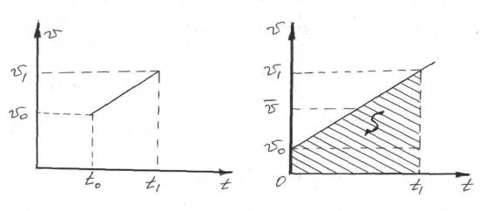
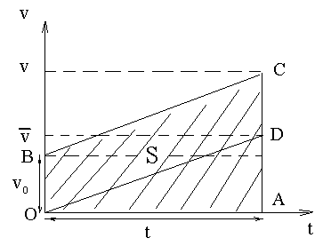
Figure 3.1

For the path we have $x=\vec{v}t$ and $x=S$(fig. 3.1), then
$v_{\text{av}}=\frac{S}{t}=\frac{v_{0}t+\frac{1}{2}(v−v_{0})t}{t}=\frac{\left(\frac{v_{0}}{2}+\frac{v}{2}\right)t}{2}=\frac{1}{2}(v_{0}+v)$
or $v_{\text{av}}=\frac{v_{0}+v}{2}$. (3.5)
In result we have
$x=\frac{1}{2}(v_{0}+v)t=\frac{1}{2}v_{0}t+\frac{1}{2}\text{vt}=\frac{1}{2}v_{0}t+\frac{1}{2}(v_{0}\text{at})t=v_{0}t+\frac{1}{2}{\text{at}}^{2}$. (3.6)

Galileo’s Experiment

Galileo Galilei (1564-1642), an Italian scientist of the Renaissance has showed that the character of the motion of a ball rolling downwards on inclined surface was the same as that of a ball in free fall. The inclined surface merely served to reduce the effective acceleration of gravity and to slow the motion thereby. Time intervals measured by the volume of water discharged from a tank could then be used to test the speed and acceleration of this motion. Galileo showed that if the acceleration along the incline is constant, the acceleration along the incline is simply a component of the vertical acceleration of gravity, and along an incline if constant slope the ratio of two acceleration remains fixed.
He found from his experiments that the disproportion covered in consecutive time intervals were proportional to the odd numbers 1, 3, 5, 7…etc. Total distances for consecutive intervals thus were proportional to 1+3, 1+3+5, 1+3+5+7, etc., that is to the squares of the integers 1, 2, 3, 4, etc.
But if the distance covered is proportional to the square of the elapsed time, velocity acquired is proportional to the elapsed time, a result which is true only if motion is uniformly accelerated, He found that the same results were shown regardless of the mass of the ball used.
We shall select a reference frame rigidly attached to the earth. The y-axis will be taken as positive vertically upward. Then the acceleration due to gravity $\vec{g}$ will be a vector pointing vertically down in the negative y-direction. (This choice is arbitrary). Then we have
$\begin{aligned}v_{y}=v_{y0}+a_{y}t \\ y=\frac{1}{2}(v_{y0}+v_{y})t \\ y=v_{y0}t+\frac{1}{2}a_{y}t^{2} \\ v_{y}^{2}=v_{y0}^{2}+2a_{y}y\end{aligned}$, (3.7)
were $a_{y}=−g$.

Projectile Motion

An example of curved motion with the constant acceleration is the projectile motion. This is the two-dimensional motion of a particle thrown obliquely into the air. If we choose a reference frame with the positive y-axis vertically upward, we may put
$a_{y}=−g \text{and} a_{x}=0$. (3.8)
Let us further choose the origin of our reference frame to be the point at which the projectile begins its flight
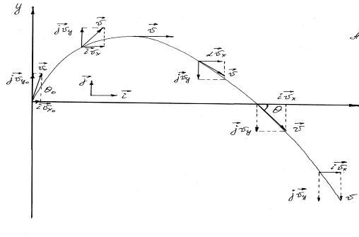
Figure 3.2

The velocity at t = 0, the instant the projectile begins its flight, is ${\vec{v}}_{0}$, which makes an angle $θ$₀ with the positive x-direction. The x – and y-components of ${\vec{v}}_{0}$ are then
$\begin{aligned}v_{x0}=v_{0}\text{cos}θ_{0} \\ v_{y0}=v_{0}\text{sin}θ_{0}\end{aligned}$. (3.9)
The horizontal velocity component retains its initial value throughout the flight, so that
$v_{x}=v_{x0}=v_{0}\text{cos}θ_{0}$. (3.10)
The vertical component of the velocity will change with the same in accordance with vertical motion with the constant downward acceleration
$a_{y}=−g \text{and} v_{y0}=v_{0}\text{sin}θ_{0}$ (3.11)
so that
$v_{y}=v_{0}\text{sin}θ_{0}−\text{gt}$. (3.12)
The magnitude of the resultant velocity vector at any instant is
$v=\sqrt{v_{x}^{2}+v_{y}^{2}}$. (3.13)
The angle $θ$ that the velocity vector makes with the horizon at that instant is given by
$\text{tan}θ=\frac{v_{y}}{v_{x}}$ (3.14)
The x-coordinate of the particle’s position at any time is
$x=(v_{0}\text{cos}θ_{0})t$. (3.15)
The y-coordinate is
$y=(v_{0}\text{sin}θ_{0})t−\frac{1}{2}{\text{gt}}^{2}$ (3.16)
$t=\frac{x}{v_{0}\text{cos}θ_{0}}$ (3.17)
$y=(\text{tan}θ_{0})x−\frac{g}{2(v_{0}\text{cos}θ_{0})^{2}}x^{2}$ (3.18)
$y=\text{bx}−{\text{cx}}^{2}→\text{the} \text{equation} \text{of} a \text{parabola}$ (3.19)

Let us suppose that we know the change of acceleration with time, i.e., the function
$a=a(t)$, (3.20)
then the velocity of the particle at the instant t may be easily found
$v=v_{0}+a_{1}{Δt}_{1}+a_{2}{Δt}_{2}+\text{.}\text{.}\text{.}=v_{0}+\sum{a_{i}⋅Δt}$. (3.21)
The less ${Δt}_{i}$ is the more accurate will be the calculation, that is why the value of ${Δt}_{i}$ must be taken infinitesimal. In this case the sum $\sum{a_{i}{Δt}_{i}}$ is written as an integral
$v=v_{0}+\int_{0}^{t}{a(t)\text{dt}}$. (3.22)
If the body moves with variable acceleration the path covered by it is defined in the same way.
$S=\int_{0}^{t}{v(t)\text{dt}}$. (3.23)
Fig. 3.3 gives a graphical explanation of this calculation. This path is represented by the area $M_{0}{\text{MNN}}_{0}$

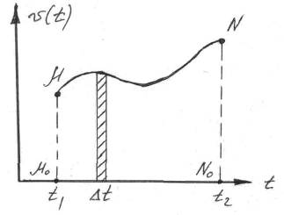

Figure 3.3

Circular Motion of a Particle

A motion, in which all points of a body describe circumferences about a certain axis, is called a rotational motion. We meet some new quantities studying kinematics of rotation. At first let us innumerate them: Δφ - angle of rotation; $ω$- angular velocity; $ε$- angular acceleration; T – period of rotation; ν - frequency of rotation.
Let us suppose that a particle performs its motion in circle with radius R and at the initial t₀ it is located at point A. The displacement of a particle can be expressed by the formula $Δs=ν⋅Δt$, but
$Δs=RΔα$, $\left(\frac{2πR}{\text{360}}=\frac{ΔS}{Δα}\right)$ (3.24)
and we obtain
$\frac{ΔS}{Δt}=R\frac{Δα}{Δt}; v={Rω}_{\text{av}}$ . (3.25)
Where $ω_{\text{av}}=\frac{Δα}{Δt}$ is the ratio between the angle of rotation of the radius-vector and the corresponding time interval? This relation is termed the average angular velocity of rotation. When $Δt$ tends to zero we have:
$\underset{Δt→0}{\text{lim}}\frac{Δα}{Δt}=ω$, (3.26)
i.e. obtain the angular velocity of rotation at the time instant t.

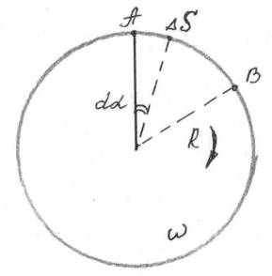
Figure 3.4

For the average angular acceleration
$ε_{\text{av}}=\frac{Δω}{Δt}$, (3.27)
and instantaneous acceleration
$ε=\underset{Δt→0}{\text{lim}}\frac{Δω}{Δt}$. (3.28)
We may obtain
$\begin{aligned}S=Rα, v=Rω \\ a_{t}=\frac{\text{dv}}{\text{dt}}=R\frac{dω}{\text{dt}}=Rε\end{aligned}$ . (3.29)
For uniformly accelerated rotary motion we obtain

$\begin{aligned}ω=ω_{0}+εt \\ α=ω_{0}t+\frac{{εt}^{2}}{2}\end{aligned}$ . (3.30)
The normal acceleration of a particle moving along a circle with the radius R can be expressed as a function of the angular velocity of rotation
$a_{n}=\frac{v^{2}}{R}=ω^{2}R$ . (3.31)
The angular velocity of rotation is a vector $\vec{ω}$ directed along the axis rotation. The direction $\vec{ω}$ is defined by applying the so–called right-hand rule, i.e. in the direction of translational motion of the screw having the same rotation.
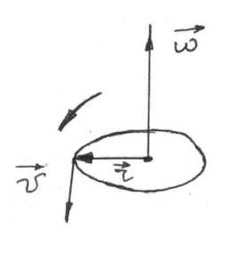
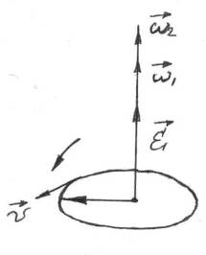

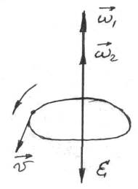
Figure 3.5

The angular acceleration $\vec{ε}$
$\begin{aligned}\vec{ε}=\frac{{\vec{ω}}_{2}−{\vec{ω}}_{1}}{Δt} \vec{v}=\left[\vec{ω}\vec{R}\right] \\ \vec{ε}=\frac{d\vec{ω}}{\text{dt}}\end{aligned}$. (3.32)
The period of rotation T is the time of one complete revolution. In this case Δϕ= 2π
$ω=\frac{2π}{T}⇒T=\frac{2π}{ω}\text{.}$ (3.33)

Principles of relativity by Galileo

Let us consider two references systems, moving relatively to each other with constant velocity. Lets find the relationship between x, y, z and x₁, y₁, z₁ of point P. If the count of time is started from the moment, when origin of coordinates of both reference systems is coincided, then
$x=x^{'}$. (3.34)
Transformation of Galiley
$\begin{aligned}y=y^{'}+v_{0}t \\ z=z^{'} \\ t=t^{'}\end{aligned}$ . (3.35)
(time in both system flows equally) Applicable if
$v_{0}\text{<<}c$. (3.36)
Lets find the relationship between velocities
$\begin{aligned}\overset{˙}{x}={\overset{˙}{x}}^{'}→v_{x}=v_{x}^{'} \\ \overset{˙}{y}={\overset{˙}{y}}^{'}+v_{0}→v_{y}=v_{y}^{'}+v_{0} \\ \overset{˙}{z}={\overset{˙}{z}}^{'}→v_{z}=v_{z}^{'}\end{aligned}$ (3.37)

Or in vector form
$\vec{v}={\vec{v}}^{'}+{\vec{v}}_{0}$. (3.38)
The rule of adding velocities under free choice of the mutual directions of the coordinate axes$K и K^{'}$. Any reference system moving relatively to some inert system with constant velocity will also be inert. Equation of motion does not change when transferring between inert references systems

$\vec{a}={\vec{a}}^{'}$ . (3.39)

Lecture 4. Particle dynamics

In this lecture and the next we discuss the causes of motion, an aspect of mechanics called dynamics. The motion of a given particle is determined by the nature and the arrangement of the other bodies that form its environment.
Dynamics deals with the motion of bodies under the effect of forces. The basic concepts of dynamics are mass, impulse and force.
The mass is a property of any body. The body property to resist of the acceleration under the effect of force is called mass [m]=[kg].
Density is the mass per unit of volume:
$ρ=\frac{m}{V}$. (4.1)
Impulse (linear momentum) is the product of mass by velocity. It is a vector quantity
$\vec{p}=m\vec{v}$ (4.2)
Force – the physical quantity resulting on the interaction of bodies. The unit of force is a Newton: [F]=N.
In what follows, we limit ourselves to the very important special case of gross object moving at speeds that are small compared to c, the speed light; this is the realm of classical mechanics:$v$<< c, c = 10⁸ m/s.
The central problem of classical particle mechanics is this:
- we are given a particle whose characteristics we know;
- we place this particle, with a known initial velocity, in an environment of which we have a complete description: v₀, g =9,8 m/c², x₀ , y₀.
Problem: what is the subsequent motion of the particle? x = f(t); y = f(t).
This problem was solved by Isaac Newton (1642-1727) when he put forward his laws of motion and formulated his law of universal gravitation.
We introduce the concept of force and define it in terms of the acceleration and experienced by a particular standard body:
$F$~$\vec{a}$ (4.3)
We develop a procedure for assigning a mass m to a body so that we may understand the fact that different particles of the some kind experience different acceleration in the same environment. Finally, we try to find the ways of calculating the forces that act on particles from the properties of the particle and its environment; that is, we look for force laws.
Galileo asserted that some external force was necessary to change the velocity of a body but that no external force was necessary to maintain the velocity of a body. For example, exerts a force on the block when it sets in motion. The rough plane exerts a force on it when it slows it down. Both of these forces produce a change in the velocity, that is, they produce acceleration.
This principle of Galileo was adopted by Newton as the first law of motion: “Every body persists in its state of rest or of uniform motion in a straight line unless it is compelled to change that state by forces impressed on it.”
The first law tells us that, if there are no nearby object then it is possible to find a family of reference frames in which a particle has no acceleration. Newton’s first law is often called the law of inertia and the reference frames to which it applies are therefore called inertial frames. When several forces act on a body, each produces its own acceleration independently. The resulting acceleration is the vector sum of the several independent accelerations.
${\vec{a}}_{\text{res}}={\vec{a}}_{1}+{\vec{a}}_{2}+\text{.}\text{.}\text{.}+{\vec{a}}_{n}=\sum_{i=1}^{n}{{\vec{a}}_{i}}$ (4.4)
What effect will the same force have on different object? The same force will produce different accelerations on different bodies. We define the ratio of the masses of the two bodies to be the inverse ratio of the accelerations given to these bodies by the same force, or
$\frac{m_{1}}{m_{0}}=\frac{a_{0}}{a_{1}}$ (same force $\vec{F}$acting) (4.5)
We can now summaries all the experiments and definitions described above in one equation, the fundamental equation of classical mechanics:
$\vec{F}=m\vec{a} \left[\vec{F}\right]=\frac{1\text{кг}⋅1м}{1с^{2}}=1N$ (4.6)
Newton’s second law:
$\vec{a}=\frac{\vec{F}}{m}$ (4.7)
The acceleration of the body is directly proportional to the resultant force acting on it and parallel in direction to this force and that the acceleration, for a given force, is inversely proportional to the mass of the body.
Classification of forces

We consider three kinds of the forces in dynamics:
1) Gravity force - according to the law of universal gravitation the force between two point masses $m_{1}$ and $m_{2}$ is equal to:
$F=γ\frac{m_{1}m_{2}}{R^{2}}$. (4.8)
Weight of gravity: $\vec{P}=m\vec{g}$ , (4.9)
g - is the acceleration in a force form.
2) Force of friction. When two contacting solid bodies are in motion relative to each other force arises which hinders their motion. This force is called the force of friction.
However, the forces of friction can exist when bodies are at rest. The force of friction is caused by the irregularities of the contacting surfaces. The friction force is given by:
${\vec{F}}_{\text{fr}}=−k\vec{N}$. (4.10)
The friction is observed in liquids and gases too, in this case
${\vec{F}}_{\text{fr}}=−r\vec{v}$, (4.11)
where r is the coefficient of the medium resistance. One may see that friction force is directly proportional to the velocity.
3) When a body is subjected to decoration, the elastic force arises. The magnitude of elastic force is directly proportional to the strain. According to the Hook’s Law
$σ=Eε$, (4.12)
where σ (sigma) – is the stress, $σ=\frac{F}{S}$; $ε=\frac{l−l_{0}}{l_{0}}$ - strain; E - Young’s modulus. The last value is a material constant. Units of this values: [σ]=$\frac{N}{m^{2}}$=[Pa].

Frictional forces

If we project a block of mass m with initial velocity v₀ along a long horizontal table, it eventually comes to rest. This means that, while it is moving, it experiences an average acceleration <a> that points in the direction opposite to its motion. In this case we declare that the table exerts a force of friction, F whose average value is m<a> on the sliding block. The frictional force on each body is in a direction opposite to its motion relative to the other body.
The frictional forces acting between surfaces at rest with respect to each other are called forces of static friction. The maximum force of static friction will be the same as the smallest force necessary to start motion.
The forces acting between surfaces in relative motion are called forces of kinetic friction.
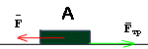
Figure 4.1

The maximum force of static friction between any pair of dry unduplicated surfaces follows these two empirical laws:
- It is approximately independent of the area of contact, over wide limits.
- It is proportional to the normal force.
The ratio of the magnitude of the maximum force of static friction to the magnitude of the normal force is called the coefficient of static friction for the surfaces involved. We can write
f_{s} $μ$_{s}N . (4.13)

The force of kinetic friction f_{k} between dry unlubricated surfaces follows two laws:

- it is approximately independent of the area of contact over wide limits;
- it is proportional to the normal force:
f_{k} $=μ$_{k}N, (4.14)
$μ$_{k} is the coefficient of kinetic friction.

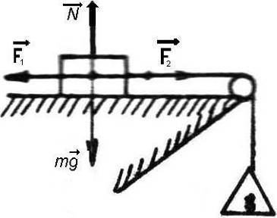

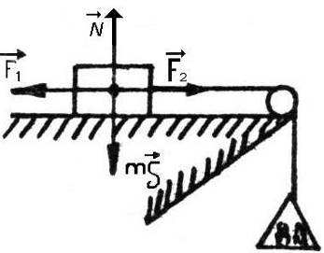

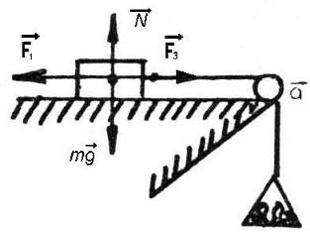

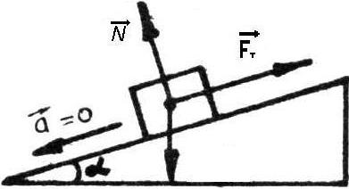

Figure 4.2

Centripetal forces

Forces responsible for uniform circular motion are called centripetal forces because they are directed toward the center of the circular motion. A centripetal force is not a new kind of force but simply a way of describing the behavior with time of forces that are attributable to specific bodies in the environment. Thus a force can be centripetal and elastic, centripetal and gravitational, or centripetal and electrostatic.
Nevertheless we can, if we find it convenient, apply classical mechanics from the point of view of an observer in noninertial frame. Such a frame might be one that is rotating with respect to the fixed stars. We can apply classical mechanics in noninerteal frames if we introduce forces called pseudo - forces.
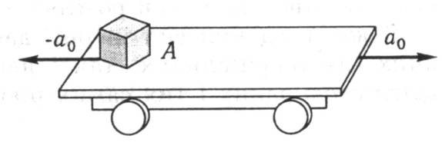

Figure 4.3

Gravitational force

Every particle of matter in universe attracts every other particle with is proportional to the product of their inert masses m₁ and m₂ and inversely proportional to the square of a distance r between them
$F=γ\frac{m_{1}m_{2}}{r^{2}}$, (4.14)
where $γ$is a constant of gravity, $γ$=6,670·10⁻¹¹H·m²/кг².
Sometimes we come across a term gravitational mass relating to properties the bodies to act on other bodies in space. It is quite obvious, that all bodies are connected with space (which possesses definite physical properties) and this connection manifests itself as a gravitational field surrounding each body. The action of the gravitational field of a given body on other is expressed in the appearance of forces of gravity, whose numerical values vary for different bodies.
If we choose a standard body as a unit mass, we can compute the gravitational mass of any other body by using this equation and measuring the distance and the force of gravity between them. In result we have
$\frac{m_{1}}{m_{2}}=\frac{μ_{1}}{μ_{2}}=\frac{F_{1}}{F_{2}}$. (4.15)

The fundamental law of mechanics

Second law. This law is basic of classical mechanics. The acceleration of a body is directly proportional to the vector sum of forces acting upon it and is inversely proportional to the mass of the body. The direction of acceleration coinsides with direction of the force sum.
$\vec{F}=m\vec{a}$ (4.16)
$$\vec{a}=\frac{\sum_{i}{{\vec{F}}_{i}}}{m}$$
$F=m\frac{d\vec{v}}{\text{dt}}=\frac{d(m\vec{v})}{\text{dt}}=\frac{d\vec{p}}{\text{dt}}$ (4.17)
The derivative of impulse with respect to time equals to the vector sum of forces, acted upon the body. If the forces ${\vec{f}}_{1}, {\vec{f}}_{2}, {\vec{f}}_{3},$$\text{etc}$, whose sum total is
$\vec{F}=\sum{\vec{f}}$ (4.18)
act on a body, the acceleration acquired by the bodies equals to the quotient by dividing the resultant force by the

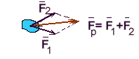
Figure 4.4

The law of inertia follows directly from the fundamental law. If there are no forces acting on the body, the acceleration is equal to zero and the motion of the body is rectilinear and uniform.
First law. Everybody retains its state of rest or straight line uniform motion unless its compelled to change that state by the external forces. Possibility of body to be in a state of rest or of uniform rectilinear (straight line) motion is called inertia and so 1st Newton’s Law is the law of inertia.
In applying Newton’s fundamental law to a particular body, we focus our attention on this body and consider the forces acting on it. It should not be forgotten, however, that force is a measure of the interaction between bodies and that one-sided interaction does not exist. If one body acts on another, the latter also acts on the former. The measurement of force is equivalent to the measurement of interaction. Thus, the very method of measuring force assumes that the force of one body acting on another and the force exerted by the latter on the former are equivalent in magnitude. Since we are usually interested in one particular body, we focus our attention on the force acting on it; the other force is called the force of counteraction of the force of reaction. The forces of action and reaction are equal in magnitude but are oppositely directed. This proposition has become known as Newton’s third law of motion.
Third law of motion: “To every action there is always opposed an equal reaction: or, the mutual actions of two bodies upon each other are always equal, and directed to contrary parts”
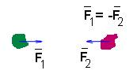
Figure 4.5

The forces with which two bodies act upon each other are equal in magnitude and opposite in direction.
${\vec{F}}_{\text{12}}=−{\vec{F}}_{\text{21}}$ (4.19)
Newton’s laws are correct only if:
1) a = 0. The coordinate system does not accelerate. This coordinate system are called inertial.(frame of reference).
2) Body dimension are much more than atomic ones.
3) The body velocity is much less than the velocity of light v << c .
The system for which Newton’s laws are valid must, without fail, satisfy the following conditions: a body on which no forces are acting must move rectilinearly and uniformly or must be at rest. Such a system is called an inertial system.
The principle of the relativity of motion: an infinite number of inertial system exist and, in such systems, the law of inertia and the $\vec{F}=m\vec{a}$ law are satisfied. In this respect, none of these systems has any special advantage over the other systems. All inertial systems are equally suitable for the description of physical phenomena.

Motion in circle is accelerated motion

If a body moves in a circle with constant angular velocity the magnitude of its acceleration is equal to
$a_{n}=ω^{2}R; v=ωR; E=\frac{dω}{\text{dt}}=\frac{d}{\text{dt}}\left(\frac{v}{R}\right)$. (4.20)
And its resultant is inward along the radius. The resultant force acting on the uniformly rotating body is called the centripetal force.
$F_{\text{centrip}}=\frac{{\text{mv}}^{2}}{R}={mω}^{2}R$. (4.21)
The force of the accelerated body on the constraint has been called the inertial resistance. Such of force also exists, of course for circular motion – it is called the centrifugal force. Centrifugal force and centripetal force are equal in magnitude but oppositely directed. The centrifugal force is applied to the constraints of a body executing circular motion.
Let us consider the action of force F. Suppose that at time interval Δt the force F may be considered with the satisfactory accuracy as constant, then
$\vec{F}⋅Δt=mΔ\vec{v}$ (4.22)

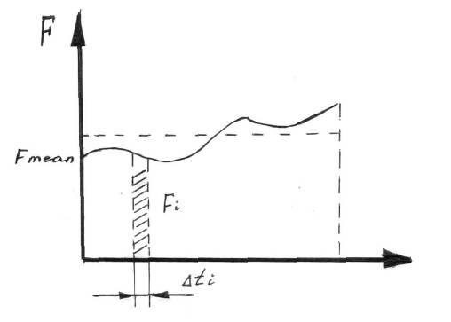
Figure 4.6

Diving the time of action t of a variable force into some intervals of time Δt, we may find the following resultant action of this force.
$\sum{F_{i}}⋅{Δt}_{i}=\sum{m}⋅{Δv}_{i}=m\sum{{Δv}_{i}}$. (4.23)
Since the total change in velocity of motion Δv_{i}, is equal to the difference between the initial and finite velocities of the body v₂ - v₁ then
F_{i}Δ t = mv₂ - mv₁ (4.24)
For constant force
Ft = mv₂ - mv₁ (4.25)
The product of force and the time of its action is called impulse, and the product of the mass of a body and its velocity is termed the momentum of this body.
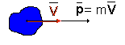
Figure 4.7
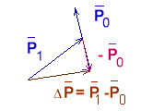
Figure 4.8

The impulse of a force is equal to the change of momentum of the body to which this force is applied. The action of variable forces is sometimes defined by the force termed mean force $\vec{F}$:
$\vec{F}=\frac{1}{t}\sum{F_{i}⋅{Δt}_{i}}$. (4.26)
There are different units for measuring mass and force. The International System of Units given the following definition of the fundamental physical units.
Meter – a length equal to 165063.73 wave-length of the orange-red spectrum line of the atom of krypton having a mass number 86. This definition of a meter gives more precise measurement (10⁻⁹) than the distance taken between two lines engraved on the surface of a platinum–iridium bar. The mentioned spectrum is an orange-red line of krypton with atomic weight 86 and the symbols ₂p¹⁰ and ₅d⁵ arbitrarily denote two stationary conditions of this atom and the conversion from one condition into another is accompanied by this spectrum radiation.
Second – 1/31556925.9747 fraction of the length of the tropical year for 1900, January, at 12 o’clock of ephemeral time. The tropical year is the interval of time between two successive passages in the same direction of the Sun through the Earth’s equatorial plane. The tropical year does not undergo irregular changes but it reduces by 0.5 sec per century. Ephemeral time is a time of uniform duration and is used for astronomic calculations and it does not depend on irregularities of rotation of the Earth.
Kilogram – a unit of mass corresponding to the mass of the international standard kilogram
Newton is that force which will produce an acceleration of 1 m/sec² in a mass 1 kg.
$$N=\frac{\text{kg}⋅m}{{\text{sec}}^{2}}$$
According to the Absolute System of Units CGS (centimeter – gram - second) the unit of force is a dyne – 1 dyne =10⁻⁵ Newton. Note that the force with which a body having a mass of 1 kg is attracted to the Earth (it is termed kilogram – force (kg f) equals):
1 kg f =1 kg g m/sec² = g ·Newton;
1 kg f = 9.8 N = 9.8·10⁵ dyne.
The units of pressure are N/m² and d/cm²:
1 N/m² = 10 d/cm²;
1 atmosphere = 1 kg f/cm² = 9.8·10⁴ N/m²;
1 mm of mercury column = 133.5 N/m².

Lecture 5.Law of conservation
of impulse

This laws is a consequence of the second and the third Newton’s Laws. Consider the interaction between some bodies. Let us assume that there are only internal Forces. This is so called closed system. The Second Law for each body is given by:
$\begin{aligned}\left\{\frac{d(m_{1}{\vec{v}}_{1})}{\text{dt}}={\vec{F}}_{\text{21}}+{\vec{F}}_{\text{31}}+\text{.}\text{.}\text{.}+{\vec{F}}_{n1} | \right.\end{aligned}$, (5.1)
where ${\vec{F}}_{\text{21}}=−{\vec{F}}_{\text{12}};\text{.}\text{.}\text{.}{\vec{F}}_{(m−1)n}=−{\vec{F}}_{n(n−1)}$
Thus we obtain the sum of these forces equals zero.
$\sum_{i=1}^{n}{\frac{d(m_{i}{\vec{v}}_{i})}{\text{dt}}}=0$. (5.2)
From this equation we obtain:
$\sum_{i=1}^{n}{m_{i}v_{i}}=\text{const}$, (5.3)
for both physical systems. The vector sum of linear momentums impulses of bodies in a closed system is a constant quantity.

Mechanical Energy

Let a body be acted upon by a number of forces whose vector sum is equal to zero. The body moves uniformly and rectilinearly. All the forces may than be resolved into four components.

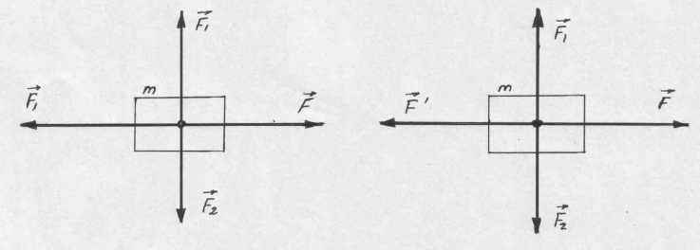
Figure 5.1

$ΔA=\vec{F}⋅Δ\vec{s}$ (5.4)

Forces ${\vec{F}}_{1}$ and ${\vec{F}}_{{}_{2}}$ in accordance with the adopted definition, perform no work. Force $\vec{F}$performs work equal to $F⋅ΔS,$ where $ΔS$ is the traversed distance. The work of force ${\vec{F}}^{'}$ is equal to $−F^{'}⋅ΔS$, where the minus sing indicates that work is performed against the force ${\vec{F}}^{'}$.
Let us now consider the motion of a body with acceleration (curvilinear and non uniform motion). Now, $\vec{F}$ is not equal to ${\vec{F}}^{'}$, and ${\vec{F}}_{1}$ is not equal to ${\vec{F}}_{{}_{2}}$. The work of force ${\vec{F}}^{'}$ is again negative, i.e., the work is performed against the force ${\vec{F}}^{'}$ and equal ${\vec{F}}^{'}$$ΔS$
The inequality between the forces ${\vec{F}}_{1}$ and ${\vec{F}}_{{}_{2}}$shows that the motion is curvilinear. Their difference $F_{2}−F_{1}$ corresponds to the normal component of the acceleration. Let us consider an extreme case – uniform motion in a circle. The resultant force for such motion is directed, as we know, along the radius of the circle, i.e., perpendicular to the direction of motion. Therefore, the centripetal force performs no work. $F−F^{'}={\text{ma}}_{t}$ is the tangential component of the resultant force $F_{t}^{\text{res}}$, and
$FΔS−F^{'}ΔS={\text{ma}}_{t}ΔS$ (5.5)
The work expended in accelerating a body is equal to the product of the mass of the body, the traversed distance, and the tangential acceleration. The work performed by the force of resistance and the work expended in accelerating the body
$FΔS=F^{'}ΔS+{\text{ma}}_{t}ΔS$ (5.6)
For $a_{t}$, we obtain
$a_{t}=\frac{Δv}{Δt}$; (5.7)
where v is the average velocity, which is equal
$v=\frac{1}{2}\left(v_{1}+v_{2}\right)$ (5.8)
Since $Δv=v_{2}−v_{1}, \text{then} \text{dA}=m\frac{\text{dv}}{\text{dt}}\text{dS}=m\frac{\text{dS}}{\text{dt}}\text{dv}$ or $\text{dA}=\text{mvdv}$. In result $A=\int_{v_{1}}^{v_{2}}{\text{mvdv}=\frac{{\text{mv}}_{2}^{2}}{2}−\frac{{\text{mv}}_{1}^{2}}{2}}$. (5.9)

Kinetic Energy and the Work-Energy Theorem

Let us suppose now that the resultant force acting on an object is zero, so that the object is accelerated. Let us choose that x-axis to be in the common direction of $\vec{F}$. What is the work done by this force on the particle in causing a displacement x? We have
$a=\frac{v−v_{0}}{t}$ and $x=\frac{v+v_{0}}{2}t$ (5.10)
If t=0, then v=v₀. Then the work done is
$W=F⋅x=\text{max}−m\left(\frac{v−v_{0}}{t}\right)⋅\left(\frac{v+v_{0}}{2}\right)⋅t=\frac{1}{2}{\text{mv}}^{2}−\frac{1}{2}{\text{mv}}_{0}^{2}\text{.}$ (5.11)
We call one-half the product of the mass of a body and the square of its speed the kinetic energy of the body.
$K=\frac{1}{2}{\text{mv}}^{2}$ (5.12)
The work done by the resultant force acting on a particle is equal to the change in the kinetic energy of the particle.
$W=K=K_{0}=ΔKalignl\begin{aligned}\left\{\text{work}−\text{energy} | \right\}\end{aligned}\left\{\right\}$ (5.13)
Kinetic energy is a function of the state of motion. If the kinetic energy changes from K₁ to K₂, then the work performed there by is equal to K₂ - K₁, independent from the nature of the motion.
Let us consider several phenomena in witch the performed work is not accompanied by a change in the velocity of the body. We shall concern with two deformations of a body, while the second deals with events occurring during the motion of a body in a gravitational or electric field.
The function of state or the function of the body’s properties and degree of deformation is called the potential energy of elasticity. The work expended in stretching the body from length $l+S_{1}$ to length $l+S_{2}$ where l is the length of the outstretched spring, is
$A=F(S_{2}−S_{1})$ (5.14)
Hook’s law:
$\frac{F}{S}=E\frac{S}{l}$ (5.15)
where E is the modulus of elasticity and S is the cross-section of the stretched body. Thus, the stiffness has the value
$K=\frac{\text{ES}}{l}; \text{Fdx}=−\text{dUdA}$ (5.16)
$\text{dA}=\text{Fdx}=\text{kxdx}; F_{\text{el}}=\text{ks}; A=F_{\text{cp}}ΔS; A=\frac{F}{2}(S_{2}−S_{1})$ (5.17)
In the expression for work, we must use the average value of the force F. We then obtain
$A=\frac{{\text{kS}}_{2}^{2}}{2}−\frac{{\text{kS}}_{1}^{2}}{2}=Δ\left(\frac{{\text{kS}}^{2}}{2}\right); F\text{==}\text{gradU}=−\frac{d}{\text{dx}}U$ (5.18)
The work against the elastic force is expended in increasing the quantity$\frac{{\text{kS}}^{2}}{2}$. The quantity
$U_{\text{el}}=\frac{{\text{kS}}^{2}}{2}$ (5.19)
will be called elastic potential energy.
Gravitational force possesses the same feature as elastic force. The body is located close to the Earth’s surface. From point L, the body is moved to the higher point 2 along some curvilinear path. Let us divide this path into small segments, replacing the curved line by a broken line. The work expended in moving a body along one of these linear segments of length dl then
$\text{dA}=\text{mgdl}\text{sin}α \text{or} \text{dA}=\text{mgdh}$ (5.20)
where dh is the increase in height. For work expended along the entire path
$A=\text{mg}(h_{2}−h_{1})$ (5.21)
where h₁ and h₂ are the height of points 1 and 2 respectively. Furthermore
$A=({\text{mgh}}_{1})−({\text{mgh}}_{2})=Δ(\text{mgh})$ (5.22)
It is quite evident that
$U=\text{mgh}$ (5.23)
gravitational potential energy.
Let us assume that two attracting bodies draw together along the line of action of the forces over an infinitely small segment – dr of the path.
Thus
$\text{dA}=−γ\frac{m_{1}m_{2}}{r^{2}}\text{dr}$ (5.24)
But $\frac{\text{dr}}{r^{2}}=d\left(1\frac{1}{r}\right)\text{.}$ Therefore
$\text{dA}=−d\left(−γ\frac{m_{1}m_{2}}{r}\right)$. (5.25)
Work takes place at the expense of a decrease in the value of $U=−\frac{m_{1}m_{2}}{r}$, which is a measure of the gravitational energy in the general case.
$\begin{aligned}\text{dA}=−\text{dU} \\ ΔA=−ΔU \\ A_{1}−A_{2}=−\left(U_{2}−U_{1}\right)\end{aligned}$ (5.26)
The ratio of the amount of work A done in moving any particle of mass m from a given point to infinity and the mass of this particle is called the potential of the gravitational field in the given point. At the distance r from the center of the Earth the potential of the gravitational field $ϕ$ equals
$A=−\int_{r}^{∞}{γ\frac{\text{mM}}{r^{2}}\text{dr}=−γ\frac{\text{mM}}{r}; ϕ=\frac{A}{m}=−γ\frac{M}{r}}$. (5.27)
The work and the potential are negative since the force of gravity becomes an obstacle to this displacement. The work done in moving the particle from one point in the gravitational field “1” to another “2” equals
$A=m(ϕ_{1}−ϕ_{2})$ (5.28)
The gravitational field is potential. The law of universal gravitation served as a basis for computing the masses of the Earth, Sun, Moon and planets. The mass of the Earth is $\text{mg}=γ\frac{\text{mM}}{R^{2}}$.
$$M_{\text{Earth}}=\frac{{\text{gR}}^{2}}{γ}=5\text{.}\text{98}⋅{\text{10}}^{\text{24}}\text{kg}$$
The mass of the Sun M_{Sun} may be determined from the period of rotation T of planets. Along the orbit of each planet the force of attraction is centripetal, therefore
$\begin{aligned}γ\frac{{\text{MM}}_{\text{Sun}}}{r^{2}}=\frac{{\text{Mv}}^{2}}{r}; v=\frac{2πr}{T}; \\ M_{\text{Sun}}=\frac{4π^{2}r^{3}}{{γT}^{2}}\end{aligned}$ (5.29)
And thus, for two planets we obtain
$\frac{r_{1}^{3}}{r_{2}^{3}}=\frac{T_{1}^{2}}{T_{2}^{2}}$ (5.30)
in other words, the squares of the times taken to describe their orbits by two planets are proportional to the cubes of the major semiaxes of the orbits (Kepler’s Law).
Irrespective of the type of forces involved in the motion; the work of the resultant force is always equal to the increment of the body’s kinetic energy
$FΔS=Δ\left(\frac{{\text{mv}}^{2}}{2}\right)$ (5.31)
or in another form
$F_{\text{pot}}⋅ΔS+fΔS=Δ\left(\frac{{\text{mv}}^{2}}{2}\right)$ (5.32)
Here F_{pot} is potential forces; f is non potential forces. The work for f forces is equal to the change in the internal energy of a body or the medium in which the body moves. Substituting in place of the work of the potential forces the increment of potential energy with reversed sing, we can write
$fΔx=Δ\left(\frac{{\text{mv}}^{2}}{2}+U\right)$ (5.33)
The sum of a body’s potential and kinetic energy is called total mechanical energy.
$fΔS=ΔE$ (5.34)
The change in a body’s total energy is equal to the work of no potential forces. For a system consisting of many bodies the total energy will be equal
$E=\frac{m_{1}v_{1}^{2}}{2}+\frac{m_{2}v_{2}^{2}}{2}+\text{.}\text{.}\text{.}+U$ (5.35)
If all the interacting bodies are taken into account (close system), from of the law remains the same as for a single body. If the work of the no potential forces is negligible, the total mechanical energy of a closed system of bodies remains unchanged or is conserved. It is the law of conservation of mechanical energy.
According to the International System of Units the work and energy are measured in Joules. Joule is the amount of work done in applying one Newton through one meter of a distance traversed by the point of application of this force in the direction of the force:

Joule = Newton x meter.
According to CGS system – ergs:

Erg – 1 dyne x 1 centimeter
1 Joule = 10⁷ ergs
The unit of power is a watt. Watt is the amount of energy or work which uniformly produces 1 Joule of work per second.
1 watt = Joule/sec; 1 watt = 10⁷ erg/sec.

Mass and Energy

One of the great conservation laws of science has been the law of conservation of matter. The Roman poet Lucretus wrote: “Things cannot be born from nothing, cannot when begotten be brought back to nothing”.
Albert Einstein suggested that, if certain physical laws were to be retained, the mass of a particle had to be redefined as

m=$\frac{m_{0}}{\sqrt{1−{v^{2}}/{c^{2}}}}$ or m =m₀ (1-$β$²)^{-1/2} $β$=v/c (5.36)

Here m₀ is the mass of the particle which is at rest with respect to the observer, called the rest mass of the particle measured as it moves at a speed v relative to the observer, and c is the speed of light, heaving a constant value of approximately 300·10³ kmeters/sec.
To find the kinetic energy of a body, we compute the work done by the resultant force in setting the body in motion. We obtained
$K=\int_{0}^{v}{\vec{F}d\vec{r}=\frac{1}{2}m_{0}v^{2}}$ (5.37)
for kinetic energy, when we assumed a constant mass m₀.
Suppose now instead we take into account the variation of mass with speed and use
$m=m_{0}(1−β^{2})^{−\frac{1}{2}}$ (5.38)
in our previous equation. We find that the kinematics energy is no longer given by $\frac{1}{2}m_{0}v^{2}$ but instead is
$K={\text{mc}}^{2}−m_{0}c^{2}=(m−m_{0})c^{2}=Δ{\text{mc}}^{2}$. (5.39)
The basic idea that energy is equivalent to mass can be extended to include energies other than kinetic. When we compress a spring and give it elastic potential energy U, its mass increases from m₀ to
$m_{0}+\frac{U}{c^{2}}$ (5.40)
When we add heat in amount Q to an object, its mass increases by an amount $Δm$, where
$Δm \text{is} \frac{Q}{c^{2}}$. (5.41)
We arrive at a principle of equivalence of mass and energy. For every unit of energy E of any kind supplied to a material object increases by an amount
$Δm=\frac{E}{c}$ (5.42)
This is the famous Einstein formula
$E=Δ{\text{mc}}^{2}$. (5.43)

Lecture 6. Momentum

The product of the mass of a body and its velocity is known as the body’s momentum or quantity of motion.
$\vec{P}=m\vec{v}$ (6.1) In a system of bodies
$\vec{P}={\vec{p}}_{1}+{\vec{p}}_{2}+\text{.}\text{.}\text{.}$ (6.2)
Low of conservation of momentum: in a closed system the vector $\vec{P}$ does not change. These laws follow directly from Newton’s laws:
$\begin{aligned}\frac{d}{\text{dt}}(m\vec{v})=\vec{F} \\ \sum_{i=1}^{n}{\frac{d{\vec{P}}_{i}}{\text{dt}}}=\sum_{i=1}^{n}{{\vec{F}}_{i}} , \text{but} \sum_{i=1}^{n}{{\vec{F}}_{i}=0} \\ \sum{{\vec{p}}_{i}}=\text{const}\end{aligned}$ (6.3)
If a body is fixed at its center of gravity, it is in a state of neutral equilibrium. Using the rule for adding parallel forces, we obtain the following expression for the position of the center of gravity when the particles are considered to be distributed along a straight line, say the x-axis.
$\begin{aligned}Χ=\frac{m_{1}x_{1}+m_{2}x_{2}+m_{3}x_{3}+\text{.}\text{.}\text{.}}{m_{1}+m_{2}+m_{3}+\text{.}\text{.}\text{.}} \\ \frac{d\vec{R}}{\text{dt}}\sum{m_{i}=\sum{m_{i}\frac{d{\vec{r}}_{i}}{\text{dt}}}}\end{aligned}$ (6.4)

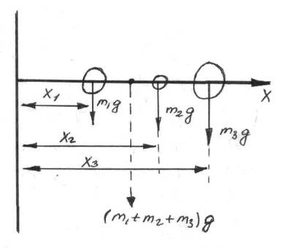
Figure 6.1

In common case
$\begin{aligned}\vec{R}=\frac{m_{1}{\vec{r}}_{1}+m_{2}{\vec{r}}_{2}+\text{.}\text{.}}{m_{1}+m_{2}\text{.}\text{.}\text{.}} \\ \vec{V}=\frac{d\vec{R}}{\text{dt}} \\ \vec{V}=\frac{m_{1}{\vec{v}}_{1}+m_{2}v_{2}+\text{.}\text{.}\text{.}}{m_{1}+m_{2}+\text{.}\text{.}\text{.}}\end{aligned}$ (6.5)

Rotation of Rigid Body

“Perfectly rigid” bodies means that we may neglect any deformation occurring during the motion of such a body, and assume that the distances between the particles of the body remain unchanged.
Let us consider a rigid body rotating about a fixed axis passing through it. We are interested in the kinetic energy of rotation of the entire rigid body, which is composed of the kinetic energies of the individual particles
$${Δm}_{1},{Δm}_{2},\text{.}\text{.}\text{.}$$
$K_{\text{rot}}=\frac{{Δmv}_{1}^{2}}{2}+\frac{{Δm}_{2}v_{2}^{2}}{2}+\frac{{Δm}_{3}v_{3}^{2}}{2}+\text{.}\text{.}$ (6.6)

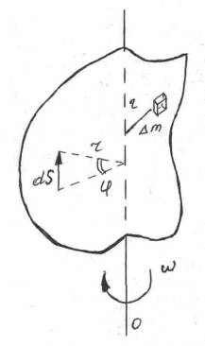
Figure 6.2

Angular velocity is
$ω=\frac{dϕ}{\text{dt}} \begin{aligned}\left\{\text{if} \text{the} \text{body} \text{turns} | \right\}\left\{\text{through} \text{an} \text{angle} dϕ | \right\}\end{aligned}\left\{\right\}$ (6.7)
But $\text{dS}=\text{rd}ϕ \text{and} \frac{\text{ds}}{\text{dt}}=r\frac{dϕ}{\text{dt}}⇒v=rω$,
where v is linear velocity. Thus, the formula K_{rot} may be written in the following form
$K_{\text{rot}}=\frac{ω^{2}}{2}\left(r_{1}^{2}{Δm}_{1}+r_{2}^{2}{Δm}_{2}+\text{.}\text{.}\text{.}\right)$ (6.8)
The quantity in brackets does not depend on the velocity of motion, but is a measure of the inertial properties of a body executing rotational motion.
$I=r_{1}^{2}{Δm}_{1}+r_{2}^{2}{Δm}_{2}+\text{.}\text{.}\text{.}$ is called the moment of inertia of the body.
$I=\int{r^{2}\text{dm}}$ (6.9)
The formula for a body’s kinetic energy of rotation acquires form
$K_{\text{rot}}=\frac{{Iω}^{2}}{2}$ (6.10)
If we carefully examine the formula for moment of inertia, we see that the value of I depends on the nature of the distribution if the mass with respect to the axis of rotation.
Let us calculate the moment of inertia of a flat disk, of radius r, relative to the axis perpendicular to the plane of the disk and passing through its center. The mass of an annular element of radius x is
$\text{dm}=ρ2π\text{xdx}$, (6.11)
where $ρ$ is the density of the disk’s material. This ring has a moment of inertia
${\text{dI}}_{1}={\text{dmx}}^{2}$ (6.12)
and the moment of inertia of the entire disk is
$I_{1}=\int_{0}^{2}{{\text{dI}}_{1}=\int_{0}^{r}{ρ2{πx}^{2}\text{dx}=2\text{πρ}\frac{r^{4}}{4}=\frac{\text{mr}}{2}}}; m=\text{ρπ}r^{2}$ (6.13)
The moment of inertia depends on the orientation of the axis and the location of the point through which is passes. If the axis of rotation is displaced relative to the center of mass by the amount a, I, the new moment of inertia, will differ from I₀, the moment of inertia with respect to the parallel axis passing through the center of mass.
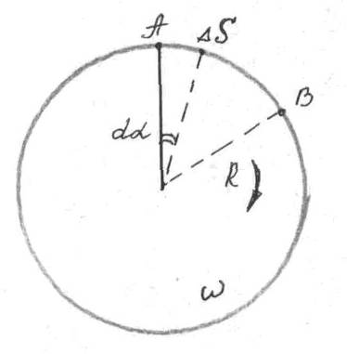

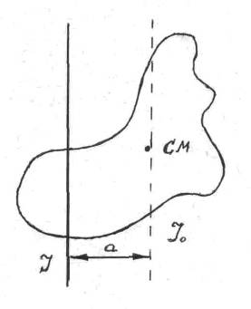
Figure 6.3. We can express the kinetic energy of a body rotating about the displaced axis at the sum

$K=\frac{{\text{Mv}}^{2}}{2}+I_{0}\frac{ω^{2}}{2}$ (6.14)
where v is the velocity of motion of the center of mass and is equal to aω. Thus,
$K=\frac{{\text{Ma}}^{2}ω^{2}}{2}+\frac{I_{0}ω}{2}=\frac{ω^{2}}{2}(I_{0}+{\text{Ma}}^{2})$ (6.15)
Hence, the moment of inertia I with respect to a parallel axis, displaced by a distance a from the center of mass, can be expressed as follows
$I=I_{0}+{\text{Ma}}^{2}$. (6.16)
Moment of inertia in common case may be calculated from the relation
$I=\int{r^{2}\text{dm}}$. (6.17)

Fundamental equation of motion for a rotating body

The force $\vec{F}$is applied at a point located at a distance r from the axis of rotation. The angle between the direction of the force and the radius vector is designated by $θ$. Since the body is perfectly rigid, the work of this force is equal to the work expended in rotating the entire body. In rotating the body through an angle $dϕ$, the point of application traverses the path $\text{rd}ϕ$ and the work dA, equal to the product of the projected force along the direction of displacement and the magnitude of the displacement, is then
$\text{dA}=\text{Fr}\text{sin}θ⋅dϕ$ (6.18)
$\text{Fr}\text{sin}θ$ is the moment of force or torque.
$\begin{aligned}M=\text{Fr}\text{sin}θ; r\text{sin}θ=d \\ \text{or} \\ M=\text{Fd}; \vec{M}=\left[\vec{r}\vec{F}\right]\end{aligned}$
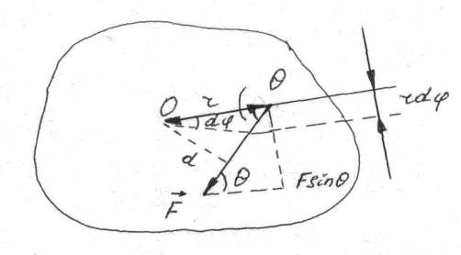
Figure 6.5

The torque is equal to the product of the force and the lever arm. The formula for work that we have sought is
$\text{dA}=M⋅dϕ$ (6.19)
The work of rotating a body is equal to the product of effective torque and the angle of rotation. The work of rotation goes to increase the kinetic energy of rotation. Hence, the following equation must hold
$M⋅dκ=d\left(\frac{{Iω}^{2}}{2}\right)$ (6.20)
If the moment of inertia is constant for the time of motion, then
$\begin{aligned}\text{Md}ϕ=Iωdω \\ \frac{\text{Md}ϕ}{\text{dt}}=Mω=Iω\frac{dω}{\text{dt}} \\ M=I\frac{dω}{\text{dt}} \text{or} M=I\end{aligned}$ (6.21)
This is the fundamental equation of motion for a rotating body. The torque on a body is equal to the product of the moment of inertia and the angular acceleration. The quantity analogous to $\vec{P}$ is the moment of momentum or angular momentum.
$N=Iω$ (6.22)
It can be rigorously proved that angular momentum satisfies the law of conservation in a closed system – the total angular momentum of the bodies belonging to this system does not change.
$I_{1}ω_{1}+I_{2}ω_{2}+I_{3}ω_{3}+\text{.}\text{.}\text{.}=\text{const}$ (6.23)

Lecture 7. Forces of Inertia

Newton’s Laws are correct only if the coordinate system does not accelerate. The coordinate systems that are at rest or are moving rectilinearly and uniformly are called inertial systems. The inertial systems are connected with so-called “fixed” far stars. The coordinate systems which are moving with acceleration are called noninertial. In an inertial system ${\vec{v}}_{0}=0$ or ${\vec{v}}_{0}=\text{const}$ and ${\vec{a}}_{0}=0$.
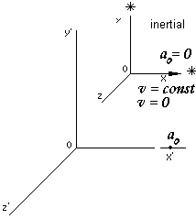

Figure 7.1

For a body
$\vec{a}={\vec{F}}/m$. ($\vec{F}=\sum{{\vec{F}}_{i}}$) (7.1)
Strictly speaking the coordinate that is connected with the Earth is not inertial. In a noninertial system we should add acceleration of body and acceleration of the coordinate system:
$\vec{a}+{\vec{a}}_{0}=\frac{\vec{F}}{m}$ => $m\vec{a}+m{\vec{a}}_{0}=\vec{F}$
$m\vec{a}=\vec{F}−m{\vec{a}}_{0}$ => $\begin{aligned}\vec{F}−m{\vec{a}}_{0}=m\vec{a} \\ \vec{F}+{\vec{F}}_{0}=m\vec{a}\end{aligned}$ ; $m\vec{a}=\vec{F}+{\vec{F}}_{0}$ (7.2)
The product - ${\text{ma}}_{0}$ is called force of inertia:
$F_{\text{in}}=−{\text{ma}}_{0}$ $F_{0}=−\text{ma}$ (7.3)
The force caused by an acceleration of the coordinate system is called the force of inertia. Its magnitude is equal to a product of the body’s mass by the coordinate system acceleration.
Force of inertia is directed in the opposite direction to acceleration. The force $F_{0}=−{\text{ma}}_{0}$ can be also called the inertial resistance. The force of inertia has got the following peculiarities and differences:
- There are no interactions of bodies.
- It changes as a result of a transition to other coordinate system.
- It doesn’t obey the Third Newton’s Law.
- The forces of inertia exist only from the point of view of an observer which is located in the noninertial system.
Let us consider an example. A body lies on a cart. Cart starts the motion and moves with acceleration${\vec{a}}_{0}$. An observer existing in the noninertial coordinate system $x^{|}y^{|}z^{|}$ says: ”The cart started motion and it resulted in acting force is directed oppositely to the cart acceleration.” But other observer in motionless system$\text{xyz}$ says: ”Nothing of that kind! The card went away and the body simply stayed at its place”. Who is right?
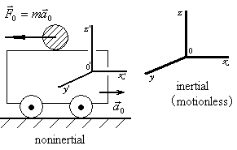
Figure 7.2

Centrifugal force

Arises in systems, which are rotated.
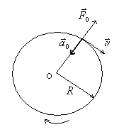
Figure 7.3
${\vec{a}}_{0}=a_{\text{cp}}=\frac{υ^{2}}{R}=\frac{(ωR)^{2}}{R}=ω^{2}R$ (7.4)
$$F_{0}={\vec{F}}_{\text{cf}}=−m{\vec{a}}_{\text{cp}}$$
$$F_{\text{cf}}=−\text{ma}$$
The force is directed along the center.

Corioli’s force
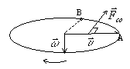
Figure 7.5
${\vec{F}}_{\text{co}}$-Corioli’s force. Corioli’s force acts upon a body in the rotating system
${\vec{F}}_{\text{co}}=2m[\vec{υ},\vec{ω}]$. (7.5)
${\vec{F}}_{\text{co}}$ is directed perpendicular to vectors $\vec{υ}$ and $\vec{ω}$.

Lecture 8. Vibrations
Small deviations from equilibrium

Harmonic oscillation is the periodic variation of a quantity, which can be expressed as a sine or cosine function. The following classifications are used. On the basis of proceeding from the nature of oscillations: mechanical and electromagnetic. On the basis of proceeding from external forces: free and forced oscillation. On the basis of proceeding of the energy changing: undamped and damped oscillations. On the basis of proceeding from the form of equations: harmonic and unharmonic oscillations.
Characteristics of harmonic oscillations:
- the period T is the time of one full oscillation;
- the frequency ν is the number of oscillations per unit of time: $ν=\frac{1}{T}$, [ν]=Hz. - the cyclic frequency:
$ω_{0}=\frac{2π}{T}=2\text{πν}$, [ω₀] = $\frac{\text{rad}}{S}$. (8.1)

Any harmonic oscillation can be illustrated by the graph or by the vector diagram. Fig.8.1 represents graph of function
$x=2\text{sin}(\frac{π}{6}t+\frac{π}{2})$. (8.2)

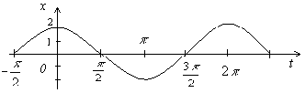
Figure 8.1

For vector diagrams complex numbers are used. Any complex number contains $i=\sqrt{−1}\text{.}$ Value i is called imaginary unit. Now let’s construct the vector diagram of equation
$x=2e^{i(\frac{π}{6}t+\frac{π}{4})}$; (8.3)
$ω_{0}=\frac{π}{6}$ $\frac{\text{rad}}{s}$; $ϕ_{0}=\frac{π}{4}$ $\text{rad}$.
The vector is of 2 m length and is situated under the initial angle$ϕ_{0}$. The vector is rotation of the watch hand with angle velocity $\frac{π}{6}$$\frac{\text{rad}}{s}$.
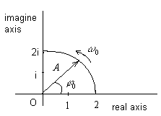
Figure 8.2

Velocity, Acceleration, Energy of Harmonic Oscillations

Corresponding formulas can easily be deduced. These equations may be derived from
$x=A\text{sin}(ω_{0}t+ϕ_{0})$. (8.3)
The velocity of harmonic oscillation:
$υ=\frac{\text{dx}}{\text{dt}}=ω_{0}A\text{cos}(ω_{0}t+ϕ_{0})\text{.}$ (8.4)
The acceleration of harmonic oscillation:
$a=\frac{d^{2}x}{{\text{dt}}^{2}}=−ω_{0}A\text{sin}(ω_{0}t+ϕ_{0})\text{.}$ (8.5)
The kinetic and potential energy of harmonic oscillation:
$E_{\text{kin}}=\frac{{mυ}^{2}}{2}=\frac{{mω}_{0}^{2}A^{2}{\text{cos}}^{2}(ω_{0}t+ϕ_{0})}{2}=\frac{{mω}_{0^{2}}A^{2}}{4}\left[1+\text{cos}2(ω_{0}t+ϕ_{0})\right]\text{.}$
$E_{\text{pot}}=\frac{{\text{kx}}^{2}}{2}=\frac{{\text{kA}}^{2}A{\text{sin}}^{2}(ω_{0}t+ϕ_{0})}{2}=\frac{{mω}_{0^{2}}A^{2}}{4}\left[1−\text{cos}2(ω_{0}t+ϕ_{0})\right]$. (8.6)
Consequently total energy:
$E=E_{\text{kin}}+E_{\text{pot}}=\frac{{mω}_{0^{2}}A^{2}}{2}$ (8.7)
and it doesn’t depend upon time. In the process of harmonic oscillations potential energy transforms into the kinetic energy and vise-versa.
Changes in the state of a system when it repeated by returns to the same state after certain time intervals are called periodic processes. A simple illustration of oscillatory motion is the motion of particle m suspended by a string or spring vibrating about position of equilibrium – a point O.
If the body of particle on which forces are acting its in a position of equilibrium, its potential energy is a minimum and the system is in a potential well. When deviation from the equilibrium position is not large, we are concerned with only a small partition of the potential well. A potential curve near the equilibrium position can always be approximated by parabola.
$F=−\text{gradU}=−\frac{\text{dU}}{\text{dx}}$ (8.8)
$U=\frac{1}{2}{\text{kx}}^{2}$, $F=−\text{kx}$ (8.9)
As is well known, making the proper assumptions, any function may be expanded in a Taylor series for small values of x. The exponent of x increases consecutively from term to term
$U=\sum_{k}{\frac{U^{(k)}(0)}{k!}x^{k}}$; $U=\text{ax}+\frac{1}{2}{\text{kx}}^{2}+{\text{bx}}^{3}+{\text{cx}}^{4}+\text{.}\text{.}\text{.}$ (8.10)
However, for small x, the terms of higher power may be neglected and, if the potential well is symmetrical, the first term vanishes, for the potential energies at equal distances to the left and right of equilibrium are equal. Newton law for the restoring force
$\text{ma}=−\text{kx}$, $m\overset{¨}{x}=−\text{kx}$ (8.11)
$m\overset{¨}{x}+\text{kx}=0$; $\overset{¨}{x}+\frac{k}{m}x=0$ (8.12)
$ω_{0}^{2}=\frac{k}{m}$; $\overset{¨}{x}+ω_{0}^{2}x=0$ (8.13)
$m\frac{d^{2}x}{{\text{dt}}^{2}}=−\text{kx}−b\frac{\text{dx}}{\text{dt}}$; $\frac{b}{m}=2β$ (8.14)
$\overset{¨}{x}+2βx+ω_{0}^{2}x=0$ (8.15)
The equation of motion
$x=A(t)\text{cos}(ωt+ϕ)$ (8.16)
For time dt the lose of energy is
$\text{dE}=F_{f}\text{dx}=−\text{bvvdt}=−{\text{bv}}^{2}\text{dt}$ (8.17)
$\frac{\text{dE}}{\text{dt}}=−{\text{bv}}^{2}|^{x\frac{2m}{2m}}=−\frac{2b}{m}⋅\frac{{\text{mv}}^{2}}{2}$ (8.18)
So as the average kinetic energy is equal half energy for the vibration motion, then
$\frac{{\text{mv}}^{2}}{2}=k=\frac{E}{2}$ (8.19)
$\left\langle K\right\rangle =\frac{K_{\text{min}}+K_{\text{min}}}{2}=\frac{E}{2}$ (8.20)
$\frac{\text{dE}}{\text{dt}}=−\frac{b}{m}E=−2βE$, $(2β=\text{bm})$ (8.21)
$\int{\frac{\text{dE}}{E}=\int{−2β\text{dt}}}$ (8.22)
$E=E_{0}e^{−2βt}$, $E=\frac{{\text{kA}}^{2}}{2}$; $E_{0}=\frac{K}{2}A_{0}^{2}$ (8.23)
$A(t)=A_{0}e^{−βt}$ (8.24)
$x=A_{0}e^{−βt}\text{cos}(ωt+ϕ_{0})$ (8.25)
This equation is satisfied if the point undergoes harmonic vibration about the equilibrium position
$x=A\text{cos}\frac{2π}{T}t$ (8.26)
where T is the period of vibration. Let us verify this statement
$v=\frac{\text{dx}}{\text{dt}}=−\frac{2πA}{T}\text{sin}\frac{2π}{T}t$; $v_{\text{max}}=\frac{2πA}{T}$ (8.27)
$a=−\frac{4π^{2}}{T^{2}}A\text{cos}\frac{2π}{T}t$ (8.28)
$−m\frac{4π^{2}}{T^{2}}A\text{cos}\frac{2π}{T}t=−\text{kA}\text{cos}\frac{2π}{T}t$ (8.29)
As can be seen from the last formula, the period of the free vibrations about the equilibrium position is
$T=2π\sqrt{\frac{m}{k}}$ (8.30)
This period is called the natural or characteristics period of the vibrating system. If there is no friction, the total energy ε of a body naturally remains unchanged for vibrations about its equilibrium position. At any instant of motion
$ε=\frac{{\text{mv}}^{2}}{2}+\frac{{\text{kx}}^{2}}{2}$ (8.31)
Friction produces damped vibrations. The equation of motion is written as follows
$\text{ma}=−\text{kx}−\text{dv}$, $f_{f_{2}}=−\text{dv}$ (8.32)
where coefficient α is the resistance constant
$x=A_{0}e^{−\frac{α}{2m}t}\text{cos}ωt$ (8.33)
$β=\frac{α}{2m}$ (8.34)
$A_{0}$is the amplitude at the instant of time t = 0. The expressions for the amplitude after n-1 and n periods, respectively, are
$A_{n−1}=A_{0}e^{−\frac{α}{2m}(n−1)T}$and $A_{n}=A_{0}e^{−\frac{α}{2m}\text{nT}}$ (8.35)
Let us divide the former relation by latter. The ratio
$\frac{A_{n−1}}{A_{n}}=e^{\frac{α}{2m}T}$ (8.36)
does not, in fact, depend on n. The rate of damping is sometimes expressed by the logarithmic decrement
$δ=\text{ln}\frac{A_{n−1}}{A_{n}}=\frac{α}{2m}T$ (8.37)
The same calculation that leads to the formula for the time dependence of the amplitude of the amplitude also yields the following relation for the period
$T=T_{0}\frac{1}{\sqrt{1−\frac{α^{2}}{4\text{mk}}}}$ (8.38)
This means that, for small resistance, T differs little from
$T_{0}=2π\sqrt{\frac{m}{k}}$ (8.39)
Let us examine the system, shown in fig. If we take the vessel away the body m will perform harmonic oscillations whose frequency we denote by $ω_{0}$. $ω_{0}$is defined by the coefficient of elasticity of the spring k and mass of the oscillator body m, thus
$ω_{0}^{2}=\frac{k}{m}$; $k={mω}^{2}$ (8.40)
In the presence of friction the motion retards, owing to this the period of oscillation increases, and the frequency of oscillation increases, and the frequency of oscillations decreases. In this case the oscillating body is under the action of two forces: restoring force on the part of the spring
$F=−\text{kx}=−{mω}_{0}^{2}x$ (8.41)
and the force of friction
$F_{f2}=−\text{rv}$, (8.42)
where r is a coefficient of friction; v is velocity. Applying Newton’s second law we obtain.
$\text{ma}=−\text{kx}−\text{rv}$ (8.43)
Let us consider oscillatory motion described by the formula.
$x=x_{0}e^{−δt}\text{sin}ωt$ (8.44)
The value $δ$, measured in $1\text{sec}$, is called the damping factor. Calculate the velocity and acceleration of motion expressed by the formula
$v=\frac{\text{dx}}{\text{dt}}=x_{0}e^{−δt}(ω\text{cos}ωt−δ\text{sin}ωt)$, (8.45)
$a=\frac{\text{dv}}{\text{dt}}=x_{0}e^{−δt}(−ω^{2}\text{sin}ωt−2\text{δω}\text{cos}ωt+δ^{2}\text{sin}ωt)$ (8.46)
Substituting x, v and a in (8.44 ), we obtain
$(−{mω}^{2}+{mδ}^{2}+k−rδ)\text{sin}ωt+(2m\text{δω}−rω)\text{cos}ωt=0$ (8.47)
This equation holds good at any instant (at any combination of sin$ωt$ and cos$ωt$), which is possible if the coefficients before sine and cosine equal zero. Then
$2mδ=r$; $δ=\frac{r}{2m}$ (8.48)
$m(ω^{2}+δ^{2})=k={mω}_{0}^{2}$; $ω=\sqrt{ω_{0}^{2}−δ^{2}}$ (8.49)
Forced vibrations

If body is displaced from its equilibrium position and then not interfered with, the vibrations occur at the natural frequency of the body, independent of the natural excitation, i.e., the vibrations are determined only by the properties of the system.
At the same time, there exists a number of means of “blocking” the vibrations of a body to an external frequency. Such forced vibrations may take place in two bodies capable of vibrating are coupled. One of the bodies will force the other to vibrate.
Forced vibrations do not set in immediately. A certain amount of time must elapse before the body coupled to the vibrating system begins to vibrate. Eventually, a particular amplitude is reached and the frequency of the vibrations will be exactly equal to $ω$. Fig. shows the dependence of the amplitude of forced vibrations on the amplitude of forced vibrations on the ratio ω/ω₀ for three system having different amounts of friction.
When the external frequency and the natural frequency coincide, the amplitude of the forced vibrations is a maximum. This phenomenon is widely known as resonance. The equation of motion of a body executing forced vibrations, under action of a periodic external force $F_{0}\text{cos}ωt$ has the form
$\text{ma}=−\text{kx}−αv+F_{0}\text{cos}ωt$ (8.50)
By substitution, one can easily show that the displacement of a vibrating point will satisfy the equation
$x=A\text{cos}(ωt+β)$ (8.51)
where the amplitude
$A=\frac{F_{0}}{\sqrt{(ω_{0}^{2}−ω^{2})^{2}+α^{2}ω^{2}}}$ (8.52)
and the phase shift $β$ satisfies the equation
$\text{tan}β=\frac{\text{αω}}{m(ω_{0}^{2}−ω^{2})}$ (8.53)
From the first formula it follows that the amplitude A depends on $ω$ as follows:
when $ω$<$ω_{0}$ the amplitude increases as $ω$ increases;
when $ω=ω_{0}$ the amplitude riches maximum;
when $ω>ω_{0}$ the amplitude decreases as $ω$ increases.
When there is little friction, the resonance disrupts the system, for at $α=0$ the resonance amplitude goes to infinity. A simple experiment will demonstrate the essence of these interesting relationships.
Suspend a weight by a string and allow it to swing freely. When the period of the free vibrations of this pendulum is manifested, stop the pendulum and by periodic motion of the hand bring it into a state of forced vibration. At first move the hand rapidly, so that the period of the forced vibrations; then move it slowly, so that the period of the natural vibrations. It will be seen that in the first case the pendulum and the hand are ${\text{180}}^{0}$ out of phase, while in the second case they are in phase.

Addition of mutually perpendicular vibrations

To analyze a complex vibration consisting of the sum of two mutually perpendicular vibrations, it is best to use an electronic oscilloscope.
Let us assume that the vibration of the beam trace is the vertical direction is represented by relation
$y=b\text{cos}(ωt+δ)$ (8.54)
and in the horizontal direction by the relation
$x=a\text{cos}ωt$ (8.55)
To determine the nature of the resultant path we must eliminate time from the above equations and obtain an equation of the form
$f(x,y)=0$ (8.56)
Writing the expressions for the displacements in the form
$\frac{x}{a}=\text{cos}ωt$, $\frac{y}{b}=\text{cos}(ωt+δ)=\text{cos}ωt\text{cos}δ−\text{sin}ωt\text{sin}δ$ (8.57)
and replacing, in the second equation, $\text{cos}ωt$ by $\frac{x}{a}$
and $\text{sin}ωt$ by $\sqrt{1−(\frac{x}{a})^{2}}$,
we obtain after simple conversion the equation of an ellipse rotated with respect to the coordinates axes:
$\frac{x^{2}}{a^{2}}+\frac{y^{2}}{b^{2}}−\frac{2\text{xy}}{\text{ab}}\text{cos}δ={\text{sin}}^{2}δ$ (8.58)
Let us now vary the parameters of the vibrations and see what happens to the ellips. If we vary the phase difference, the ellipse will change its form and simultaneously rotate.
Let us return to the original equations. Let us assume that the frequency of the vertical vibration $ω_{2}$ is $Δω$ greater than the frequency of the horizantal vibration $ω_{1}$. Then
$ω_{1}t+δ=ω_{2}t+(Δωt+δ)$, (8.59)
where the variable phase difference is within the brackets. If the frequencies differ considerably from each other, before the beam is able to describe the major portion of one ellipse the phase has already changed. As a result, the described curves look less and less like ellipse. Examples of these queer curves are known as Lissajous Figures.
In the intermediate case, the amplitude assumes a value between zero and 2A. Another important case is the additional of vibrations having different frequencies. For simplicity let us assume that $ϕ=0$ and the amplitudes are equal. Them
$x_{1}=A\text{cos}ω_{1}t$, $x_{2}=A\text{cos}ω_{2}t$ (8.60)
and
$x=2A\text{cos}\frac{ω_{1}+ω_{2}}{2}t\text{cos}\frac{ω_{1}−ω_{2}}{2}t$ (8.61)
In the general case, the vibration motion obtained when such vibrations are added does not exhibit a distinct periodicity with respect to the displacement x.

Additional of parallel vibrations

Vector diagrams are very useful for addition of harmonic oscillations. Let us assume that frequencies of oscillations are equal to each other. However amplitudes and initial phases are different.
$\begin{aligned}\left\{x_{1}=A_{1}\text{sin}(ωt+ϕ_{1}) | \right.\end{aligned}$ (8.62)
In complex form:
$\begin{aligned}\left\{x_{1}=A_{1}e^{i(ωt+ϕ_{1})} | \right.\end{aligned}$ (8.63)
The resultant displacement equals to:
$x=x_{1}+x_{2}=A\text{sin}(ωt+ϕ)$, (8.64)
where A – is unknown amplitude of a total oscillation; $ϕ$ – is its phase.
Let’s consider $Δ{\text{OAA}}_{1}$(fig.8.3).

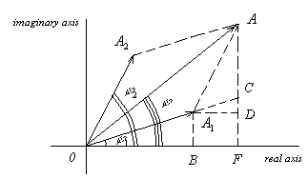
Figure 8.3

According to the theorem of cosines:
$\begin{aligned}A^{2}=A_{1}^{2}+A_{2}^{2}−2A_{1}A_{2}\text{cos}[π−(ϕ_{2}−ϕ_{1})]=A_{1}^{2}+A_{2}^{2}+2A_{1}A_{2}\text{cos}(ϕ_{2}−ϕ_{1})\text{.} \\ \text{tg}ϕ=\frac{\text{AF}}{\text{OF}}=\frac{\text{AD}+\text{DF}}{\text{OB}+\text{BF}}, \\ \text{tg}ϕ=\frac{A_{1}\text{sin}ϕ_{1}+A_{2}\text{sin}ϕ_{2}}{A_{1}\text{cos}ϕ_{1}+A_{2}\text{cos}ϕ_{2}}\text{.}\end{aligned}$ (8.65)

Questions

1. What is dynamics? What is the realm of classical mechanics?
2. The central problem of classical particle mechanics.
3. The program for solving the problem of mechanics.
4. First law of motion or law of inertia.
5. What is inertial frames?
6. Newton's second low.
7. Third law of motion.
8. What is a force of friction?
9. Forces of static friction and of kinetic friction.
10. The coefficient of static (kinetic) friction.
11. Centripetal force is not kind of force.
12. Kinetic Energy and the Work Energy Theorem.
13. Potential energy of elasticity.
14. Gook's law.
15. Gravitational potential energy.
16. Total mechanical energy.
17. What is closed system?
18. The law of conservation of mechanical energy.
19. The law of conservation of matter.
20. The principle of equivalence of mass and energy.
21. Law of conservation of momentum. Quantity of motion.
22. The centre of gravity of a body.
23. "Perfectly rigid" bodies.
24. The momentum of inertia of the body.
25. Steiner's theorem.
26. Moment of force (torque).
27. The work of rotating a body.
28. The fundamental equation of motion for a rotating body.
29. The law of conservation the total angular momentum.

