 | 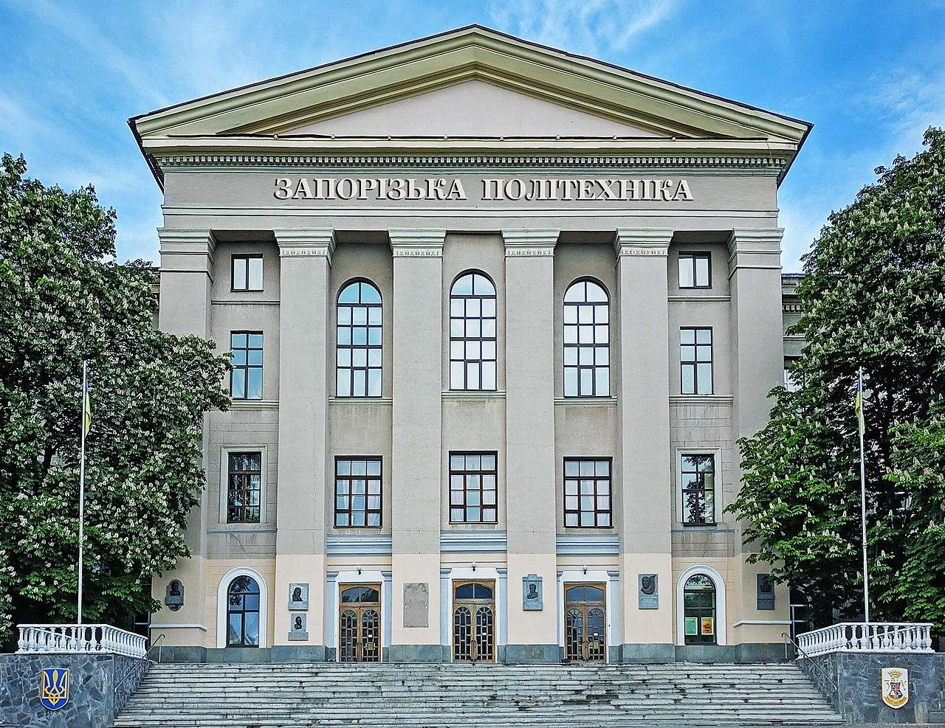

Ministry of Education and Science of Ukraine

National University “Zaporizhzhia Polytechnic”

Faculty of Economics and Management

Ukrainian Association for Management Development and Business Education

Rzeszow University, Institute of Economics and Finance (Poland)

University of Economics in Krakow (Poland)

Zaporizhzhia Chamber of Commerce and Industry

Vytautas Magnus University, Faculty of Economics and Management (Lithuania)

University of Hradec Cralove, Faculty of Economics and Management (Czech Republic)

Economic University of Varna (Bulgaria)

Kuyavian-Pomeranian University (Poland)

International scientific and practical conference

«RECOVERY OF UKRAINE AND ITS REGIONS IN THE CONTEXT OF GLOBAL TRENDS: MANAGEMENT, ADMINISTRATION AND SUPPLY»

INFORMATION SHEET

Dear colleges!

Faculty of Economics and Management of National University “Zaporizhzhia Polytechnic” invites you to take part in International scientific and practical conference “Recovery of Ukraine and its regions in the context of global trends: management, administration and supply”, which will be held on May 25-26, 2023 year.

The purpose of the conference: to unite scientists and a wide range of specialists to discuss the current problems of the recovery of Ukraine and its regions in the context of global trends in wartime conditions and the period of post-war economic recovery of Ukraine, establish contacts between scientists, exchange practical results of scientific research.

PROGRAM COMMITTEE

The Head of Committee:
Victor Greshta, rector of National University “Zaporizhzhia Polytechnic”, Ph.D., professor (Ukraine).

Committee members:

Dmytro Antoniuk, Doctor of Science, vice-president of Zaporizhzhia Chamber of Commerce and Industry (Ukraine);
Oksana Artiuch, Doctor of Science, professor of Accounting and Auditing Department of Odessa National University of Economics (Ukraine);
Svetlana Atamaniuk, Doctor of Science, head of Physical Culture, Olympic and non-Olympic Sports Department of National University “Zaporizhzhia Polytechnic” (Ukraine);
Marina Baldgi, Doctor of Science, professor, the academician of the Academy of Economic Sciences of Ukraine, professor of the Department of Entrepreneurship and Tourism of the Odessa National Maritime University, Odesa (Ukraine);
Vyacheslav Barannik Ph.D., leading researcher of the Eastern Region Research Sector of the Department of Regional Policy and Territorial Communities of the Center for Internal Political Studies of the National Institute of Social Sciences, head of the Southern Region Research Sector (Ukraine);
Evgen Brydun, Ph.D., assistant professor, founder and chairman of the Board of PJSC “Prestige Insurance Company” (Ukraine);
Vitalij Venger, Ph.D., senior researcher, leading researcher of the industry markets sector of the Department of Sectoral Forecasts and Market Conditions of the State University "Institute of Economics and Forecasting of the National Academy of Sciences of Ukraine" (Ukraine);
Jan V. Victor, Doctor of Science, professor, head of Marketing Department of the University of Economics in Krakow (Poland);
Petro Gudz, Doctor of Science, professor of Department of Management of National University “Zaporizhzhia Polytechnic” (Ukraine);
Liubov Zharova, Doctor of Science, vice-rector for projects and international relations of the University of Economics and Humanities (Poland);
Mykola Zos-Kior, Doctor of Science, professor, professor of Management Department name of І.А. Markinoi, Poltava State Agrarian University (Ukraine);
Sergijj Illyashenko, Doctor of Science, professor of Department of Innovative Entrepreneurship Management and International Economic Relations, National Technical University “Kharkiv Polytechnic Institute” (Ukraine);
Veslava Kuzhnyar, Doctor of Science, professor, head of Marketing and Entrepreneurship Department of Rzeszow University, College of Social Sciences, Institute of Economics and Finance (Poland);
Iryna Lilyk, Ph.D., assistant professor, President of Ukrainian Marketing Association (Ukraine);

Hanna Mohelska, professor, Ph.D., deputy Dean of Informatics and Management Faculty, University of Hradec Cralove, (Czech Republic);
Stoyan Marinov, professor, Dean of the Management Faculty of Economic University of Varna (Bulgaria);
Volodymyr Martynuk, Doctor of Science, professor, professor of Administrative and Finance Management Department NU “Lviv Polytechnic” (Ukraine), professor of the University of Economics and Innovations of Lublin (Poland);
Roman Sass, Doctor of Science, head of Institute of Economics, Kuyavian-Pomeranian University (Poland);
Evgen Chlobystov, Doctor of Science, professor of the Ecology Department, Faculty of Natural Sciences, National University «Kyiv-Mohyla Academy» (Ukraine).

ORGANIZATIONAL COMMITTEE

Vadym Shalomeev, vice-rector for scientific work and international activities of National University “Zaporizhzhia Polytechnic”, Doctor of Science, professor;
Vladyslav Korolkov, Dean of Economics and Management Faculty, Ph.D., assistant professor;
Svetlana Sharova, head of Finance, Banking and Insurance Department, Ph.D., assistant professor;
Vladyslava Lyfar, head of Marketing and Logistics Department, Doctor of Science, professor;
Helena Gubar, head of Economy Theory and Entrepreneurship Department, Ph.D., assistant professor;
Tetyana Pulina, head of Management Department, Doctor of Science, professor;
Helena Lyshenko, head of Accounting and Taxation Department, Ph.D., assistant professor;
Svetlana Kokareva, assistant professor of Physical Culture, Olympic and non-Olympic Sports Department, Ph.D;
Natalia Vysotska, head of Patent-information Department.
Secretary of committee:
Natalia Fatjucha, – assistant professor of Finance, Banking and Insurance Department, Ph.D., assistant professor.

CONFERENCE SECTIONS:

Section 1. Financial and economic security in the recovery system of Ukraine and its regions in the context of global trends.
Section 2. Accounting, auditing, and taxation in the context of the recovery of Ukraine in the conditions of economic globalization.
Section 3. Management and administration in the conditions of wartime and the period of post-war recovery of the economy of Ukraine and its regions.
Section 4. Marketing and logistics in the conditions of wartime and post-war economic recovery of Ukraine.
Section 5. Economic theory and entrepreneurship in the recovery system of Ukraine and its regions in the context of global trends.
Section 6. Problems of the development of the spheres of physical culture and sports, fitness, recreation and physical rehabilitation in the context of the recovery of Ukraine and its regions.

TERMS OF PARTICIPATION IN THE CONFERENCE

Domestic and foreign scientists and practitioners, students, graduate students, doctoral students are invited to participate in the conference.
To participate in the conference, we ask you to send theses and applications by May 5, 2023, to the email address of the conference organizing committee kafedra_fbs@zp.edu.ua.
Documentation forms are posted on the conference page on the university website: https://zp.edu.ua/conference-2023-1-1
Participation in the conference is FREE.
Form of participation in the conference: remote.
The electronic collection of theses will be posted on the website of the National University “Zaporizhzhia Polytechnic”. The best reports will be recommended for publication in the professional publication “Management of Change and Innovation”. Professional publication of category B. Information about the professional publication is given at the link http://cmi.politehnica.zp.ua/index.php/journal/index
The organizing committee reserves the right to reject theses if they do not meet the requirements or the theme of the conference.
Working languages of the conference: Ukrainian, Polish, English.

REGULATIONS FOR THE CONFERENCE

May 25, 2023, from 10:00 a.m. to 1:00 p.m. – online plenary meeting in Zoom (the link will be sent to participants by April 25 via e-mail)

May 26, 2023, from 10:00 a.m. to 1:00 p.m. - work of scientific sections for students of higher education in the format of round tables

REQUIREMENTS FOR THESES

Theses are submitted in electronic version in .doc format, completed in a template (located on the conference page).
The authors are responsible for the accuracy of the given terms, surnames, data, quotations, statistical materials and the like.
Abstracts of reports must be correct and not contain materials or ideas that may have signs of scientific plagiarism.

References

1.Verkhovna Rada of Ukraine. (2018). Proekt Zakonu “Pro Stratehiiu staloho rozvytku Ukrainy na period do 2030 roku” (Act №9015, August 2018). Retrieved from https: http://w1.c1.rada.gov.ua/pls/zweb2/webproc4_1?pf3511=64508.

2. Acemoglu D., Robinson J. (2012). Why nations fail: the origins of power, prosperity and poverty. New York Crown Publishing Group, 544 p.

CONTACT INFORMATION UP TO SECTIONS:

National University “Zaporizhzhia Polytechnic”, Zhukovskogo st., 64,

Zaporizhzhia, Ukraine, 69063

Section 1. Financial and economic security in the recovery system of Ukraine and its regions in the context of global trends.
Katerina Zdorova, senior laboratory assistant of Finance, Banking and Insurance Department; mob.tel. +38 095 071 15 94, email: kafedra_fbs@zp.edu.ua.
Section 2. Accounting, auditing, and taxation in the context of the recovery of Ukraine in the conditions of economic globalization.
Tetyana Rogozina, leading specialist of Accounting and Taxation Department; mob. tel. +38 050 68 40 921, email: ttt.ra78@gmail.com.
Section 3. Management and administration in the conditions of wartime and the period of post-war recovery of the economy of Ukraine and its regions.
Alla Pankova, Ph.D., assistant professor of Management Department; mob.tel.
+ 38 066 214 16 94, email: allapankovazp@gmail.com.
Section 4. Marketing and logistics in the conditions of wartime and post-war economic recovery of Ukraine.
Yuliia Sokolova, Ph.D., assistant professor of Marketing and Logistics Department; mob. tel. +38 0506882347, email: sjalex_81@ukr.net.
Section 5. Economic theory and entrepreneurship in the recovery system of Ukraine and its regions in the context of global trends.
Olha Burma, leading specialist of Economy Theory and Entrepreneurship Department, mob. tel. +38 050 557 45 56, email: ogburma@gmail.com.
Section 6. Problems of the development of the spheres of physical culture and sports, fitness, recreation and physical rehabilitation in the context of the recovery of Ukraine and its regions.
Alina Kubatko, Ph.D., assistant professor of Physical Culture, Olympic and non-Olympic Sports Department; mob. tel. +38 066 299 38 35, email: fitness.politechnica@gmail.com.
Conference coordinator: Svetlana Sharova – Ph.D., associate professor, head of the Department of Finance, Banking and Insurance, National University "Zaporizhzhia Polytechnic";
mob tel. +38 (068) 865 0348.

