 | 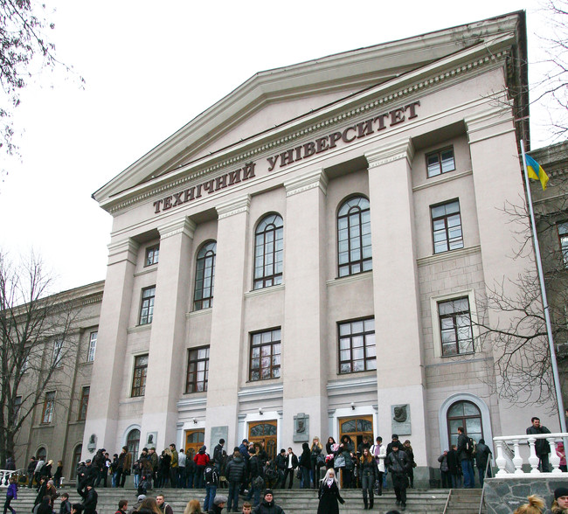

Ministry of Education and Science of Ukraine
Zaporizhzhya National Technical University
Faculty of International Tourism and Human Resources Management
Department of International Tourism
Department of Human Resources Management and Economics of Labor

International Research and Practical Conference
STRATEGIC IMPERATIVES OF DEVELOPMENT OF TOURISM AND ECONOMY UNDER CONDITIONS OF GLOBALIZATION
March 30-31, 2017

Dear colleagues!

Zaporizhzhya National Technical University, Faculty of International Tourism and Human Resources Management invites you to participate in the International Research and Practical Conference “Strategic Imperatives of Development of Tourism and Economy under Conditions of Globalization” on the occasion of 10th anniversary of the Faculty, which will be held on March 30-31, 2017.

Sections description

There are following sections in the program of the Conference:

Section 1. Tourism, Hospitality and Restaurant Business
1. Tourism, Hospitality and Restaurant Business: Strategic Trends of Development.
2. Tourism and Hospitality: Experience based on Modern Technologies.
3. Marketing and Management in Hospitality.
4. Tourism Education and Personnel Provision in the Spheres of Tourism, Hospitality and Restaurant Business .
5. Organization of Leisure and Recreation of Tourists.
6. Development of Tourism in Regions of Ukraine.
7. International Tourism.

Section 2. Economy and Management under Conditions of Globalization
1. Current Problems of Human Resources Management under Conditions of Social Relation Transformation.
2. Strategic Priorities of Management of National and Regional Economy.
3. Management and Marketing: Modern Challenges.
4. Economy of Contemporary Enterprise.
5. Theoretical and Applied Problems of Modeling and Forecasting of Stable Development of Economic Systems.
6. Financial Management on State, Regional and Corporative Levels.

Section 3. Social and Psychological, Organizational and Legal as well as Information and Communicative Aspects of Tourism and Economy Development.

1. Social and Psychological Components of Development Strategies in Tourism and Economy .
2. Organizational and Legal Provision of Tourism Activities and Economic Processes.
3. Innovative Methods of Political Theory and Practice.
4. Modern Mathematical Methods, Models and Information Technologies.
5. Development of Communicative Competencies of Future Specialist.

CONDITIONS OF PARTICIPATION

Domestic and foreign scholars and experts, as well as students, postgraduates and doctoral students are welcome to participate in the conference.
The deadline for the submission of the abstracts and application forms is 01 March 2017 to e-mail of the Organizing Committee: dekanat_mtu@zntu.edu.ua

Form of participation: distant form
The participation is free (in case of electronic PDF version of collection of abstracts).
The participants will be sent the collection of abstracts electronic version to the e-mail address, stated in the author`s application form within four weeks upon the conference completion.
According to the results of the conference the collection of abstracts will be printed. The cost of the printed collection of abstracts (distribution of printed copies by Nova Poshta express delivery (domestic) and Ukrposhta (foreign countries) at the participant’s cost) will be clarified by 15 March, 2017.

Abstract’s presentation guidelines

- abstracts should be submitted by 01 March 2017 in electronic version in the formats.doc or .docx, editor Microsoft Word;
- scope of the abstract: up to 4 pages in А4 format;
- use 14 pt Tіmes New Roman, 1,25 paragraph, 20 mm margins 1,5 interval between lines;
- each drawing, diagram, chart should be provided with inscriptions, tables should be titled;
- formulae should be typed by using Microsoft Equation formulae editor and numbered in round brackets;
- references list should include only the sources which are mentioned in the text; an example the references is as follows: [1, p. 45]. The references to different sources given in brackets should be presented as follows: [1; 2]; the references should be according to the latest requirements (Byuleten' VAK Ukrayiny. – 2009. – No. 5. – P. 26–30).
- file with abstract and application form should include the section number, family name and presented as follows: 1_Andrianov_tezy та 1_Andrianov_zayavka
- Languages of the conference: Ukrainian, Russian, English, Polish
- It is the author’s responsibility to submit a correct abstract
- For students and postgraduate students : the academic advisor’s review is required (scanned review should be attached as separate file).

SAMPLE ABSTRACT:
Andrianov A.V.
Candidate of Economic Sciences, Associate Professor
Zaporizhzhya National Technical University
Zaporizhzhya, Ukraine

INNOVATIVE DEVELOPMENT OF TOURISM UNDER CONDITIONS OF GLOBAL INTEGRATION

Text of your abstract [1, p. 2].

References:
Byuleten' VAK Ukrayiny.– 2009. – No.5. – P. 2-4.

Organizing committee:
Byelikov Sergiy Borysovych – Doctor of Technical Sciences, Professor, Rector of Zaporizhzhya National Technical University
Prushkivsky Volodymyr Gennad’ovych – Doctor of Economic Sciences, Professor, First vice-rector of Zaporizhzhya National Technical University
Vnukov Yuriy Mykolayovych – Doctor of Technical Sciences, Professor, Vice-rector for scientific work of Zaporizhzhya National Technical University
Zaytseva Valentyna Mykolayivna – Honoured Educator of Ukraine, Candidate of Pedagogical Sciences, Professor, Head of Institute of Management and Law, Zaporizhzhya National Technical University
Vasyl'yeva Olena Oleksiyivna – Candidate of Physics and Mathematics Sciences, Associate Professor, Dean of Faculty of International Tourism and Human Resources Management, Institute of Management and Law, Zaporizhzhya National Technical University
Cichorzewska Marzena – Phd Lublin University of Technology, Faculty of Management, Lublin, Rzeczpospolita Polska
Gudz' Maryna Viktorivna – Doctor of Economic Sciences, Professor, Head of Chair of Human Resources Management and Economics of Labor, Zaporizhzhya National Technical University
Gerasymchuk Zoryana Viktorivna – Doctor of Economic Sciences, Professor, Professor of Chair of Management and Marketing, Luzk National Technical University
Matviychuk Lyudmyla Yuriyivna – Doctor of Economic Sciences, Professor, Head of Chair of Tourism and Civil Security, Luzk National Technical University
Vindyuk Andriy Valeriyovych – Doctor of Pedagogical Sciences, Professor, Professor of Chair of International Tourism, Zaporizhzhya National Technical University
Sokolov Andriy Vasyl'ovych – Candidate of Public Administration, Associate Professor, Deputy Head of Chair of Human Resources Management and Economics of Labor , Zaporizhzhya National Technical University
Karpenko Andriy Volodymyrovych – Candidate of Economic Sciences, Associate Professor, Associate Professor of Chair of Human Resources Management and Economics of Labor, Zaporizhzhya National Technical University
Gurova Dar’ya Dmytrivna – Candidate of Geographical Sciences, Associate Professor, Associate Professor of Chair of International Tourism, Zaporizhzhya National Technical University
Brutman Anna Bogdanivna – Candidate of Economic Sciences, Associate Professor, Head of Chair of Foreign Languages for Professional Communication, Zaporizhzhya National Technical University
Morozov Denys Mykolayovych – Candidate of Technical Sciences, Associate Professor, Head of Chair of Information Technologies in Tourism, Zaporizhzhya National Technical University
Vysots’ka Natal’ya Ivanivna – Head of patent and information department, Zaporizhzhya National Technical University

CONTACT INFORMATION:
Zaporizhzhya National Technical University, Zhukovskogo str., 64, Zaporizhzhya, 69063, Ukraine

Section 1. Gurova Dar’ya Dmytrivna:
phone: +380990438303, +380938865887
Section 2. Karpenko Andriy Volodymyrovych:
phone: + 380958106799, +380679936692
Section 3. Brutman Anna Bogdanivna:
phone + 380676100486, +380504940486

