**Registration of the applicant's electronic account in the Unified Interdepartmental Informational System of Ukraine for foreigners and stateless persons**

In order to apply for an electronic invitation for study to an educational institution, a foreign applicant must create his/her own electronic account on the portal <https://apply.studyinukraine.gov.ua/home>.

The main page of the portal looks like this: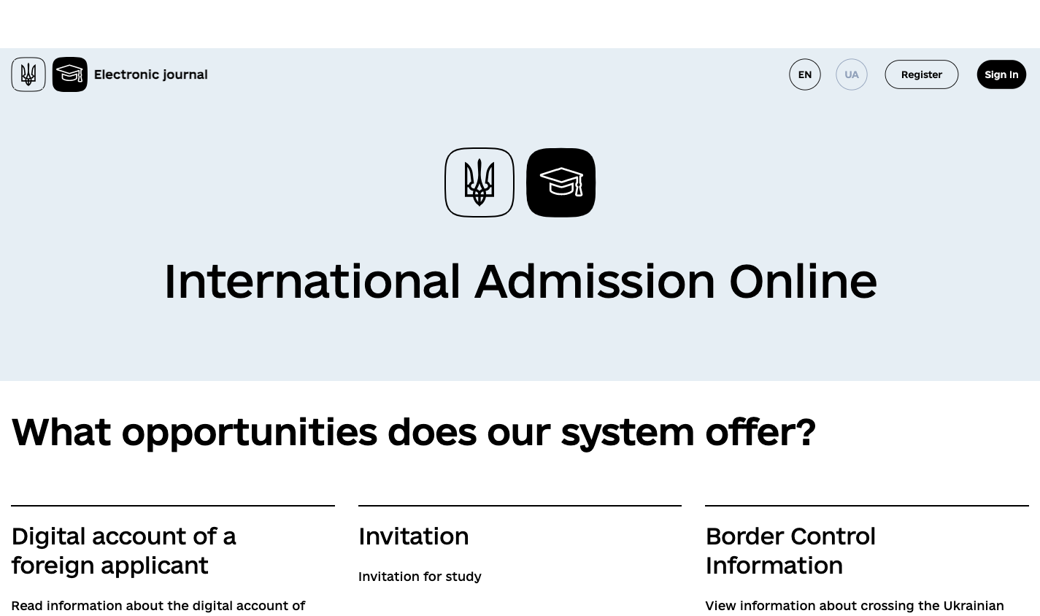

*Picture. 1 - Home page https://apply.studyinukraine.gov.ua.*

**Registration of the applicant's electronic account in the Unified Interdepartmental Informational System of Ukraine for foreigners and stateless persons who wish to study at institutions of professional (vocational and technical), professional pre-university, higher education of Ukraine (hereinafter referred to as the Unified System)**

In order to register in the System, you must:

1) click on the Register button;

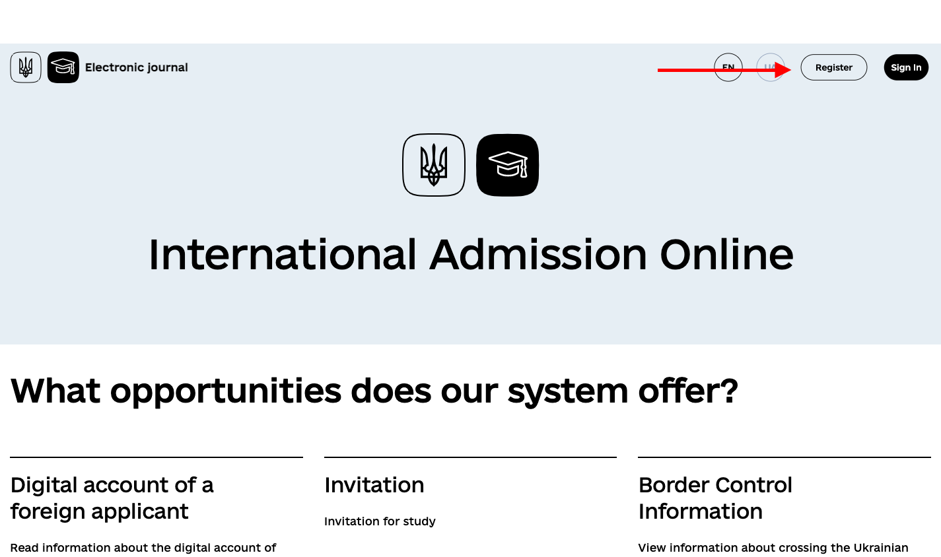

*Picture 2 – location of the Register button.*

2) enter a current email address (**Email** field) and click the **Submit** button;

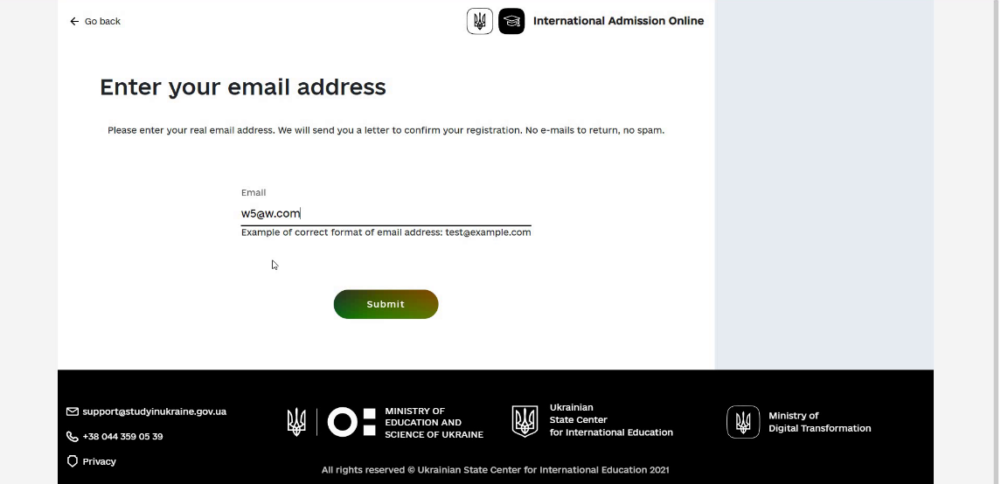

*Picture 3 – Email address entry page for student registration*

3) the system sends a letter to the specified address with a link that must be followed to verify the email address, and informs about this;

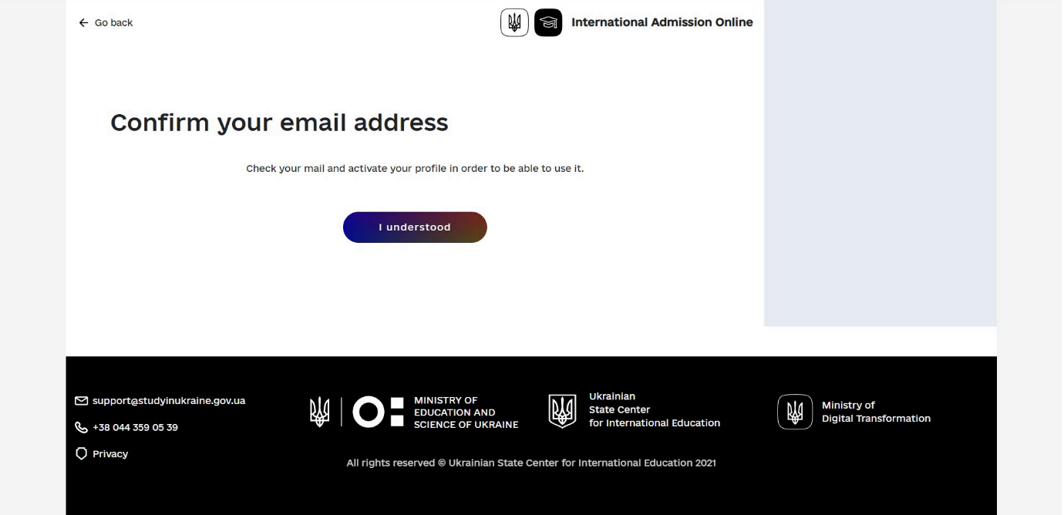

*Picture 4 – A page that informs the entrant of the need to confirm their email address by clicking on the link that was sent by email to the address specified in the previous step.*

4) click on the I understood button, which will redirect you to the main page;

5) when the user clicks on the link in the email, they are redirected to the password setting page;

6) on the password setting page, you must enter the password you will use to log in to the system twice and click Submit.

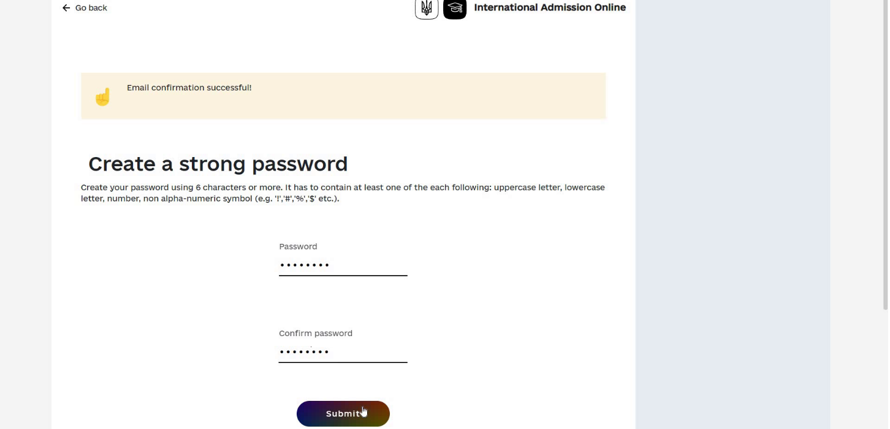

*Picture 5 - The page where the applicant sets a password to log in to their personal account.*

**Entrant login to the system**

To log in to the applicant's electronic cabinet, you must:

1) after the last step of registration or by clicking the **Sign In** button on the main page, the applicant is taken to the authentication page;

2) enter the email address specified during registration (Email field), password (Password field) and click **Submit**.

If the login attempt is unsuccessful, the user will see a message (in red) describing the error and can retry the login.

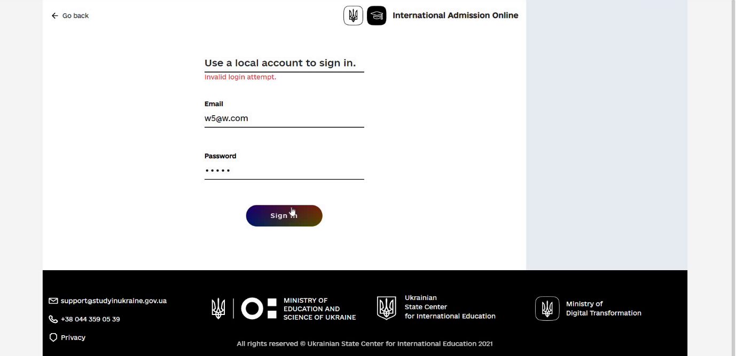

*Рicture 6 – The authentication page to the applicant's account with the entered email address, password, and an error message as a result of an unsuccessful authentication attempt.*

A successful login attempt will result in the opening of the internal page of the Unified System with the **My applications** section.

An electronic account is created free of charge. An applicant must have only one electronic account, where he or she can send up to 20 applications for an invitation for study.

**Creating an application for study**

To create a request for study at a university, you must:

1) in the **My applications** section, where the applicant is taken by after logging in, click on the **+ New Application** button;

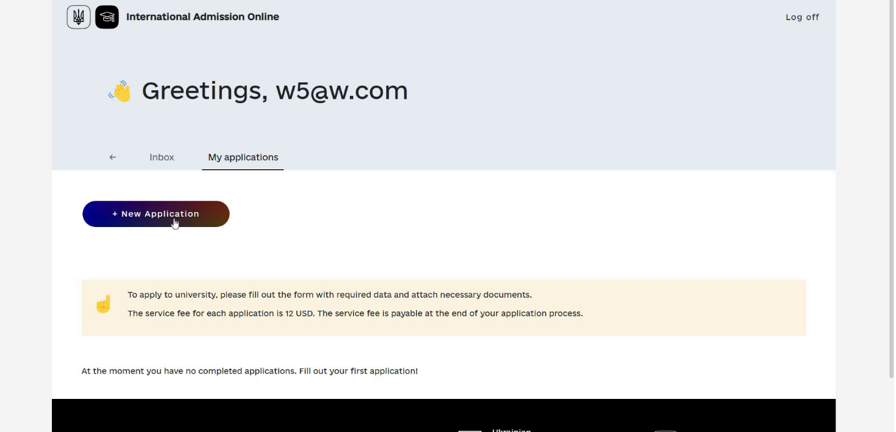

*Picture 7 - The “My applications” section of the applicant's account.*

2) the applicant is taken to the page for entering personal data;

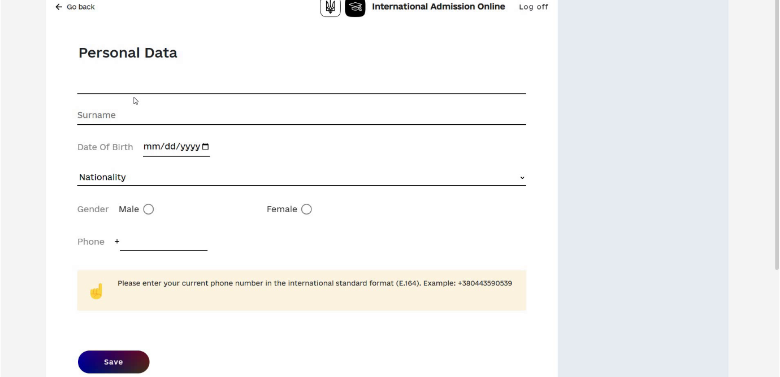

*Рicture 8 - The page for entering personal data of the applicant.*

3) on the page of entering personal data, the applicant must indicate:

● first and last name (**Given names** and **Surname** fields)

● date of birth (**Date Of Birth** field)

● citizenship (**Nationality** field),

● gender (**Gender** field),

● phone number (**Phone** field).

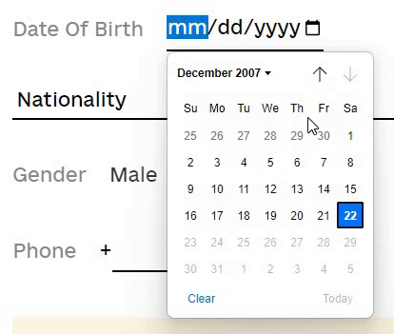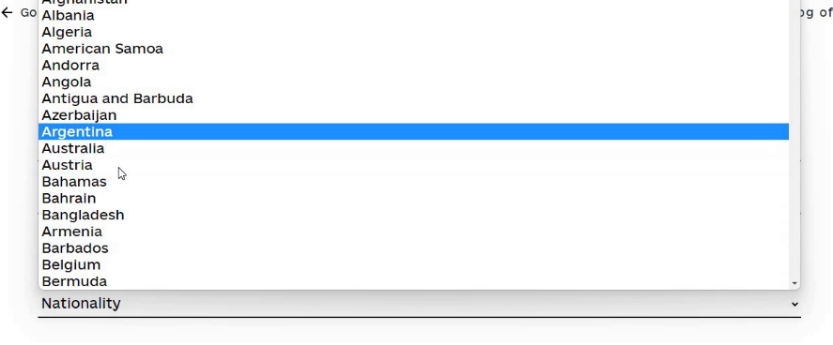

*Рicture 9 - A date entry tool (calendar) and a country selection tool.*

4) after entering the data, click the **Save** button;

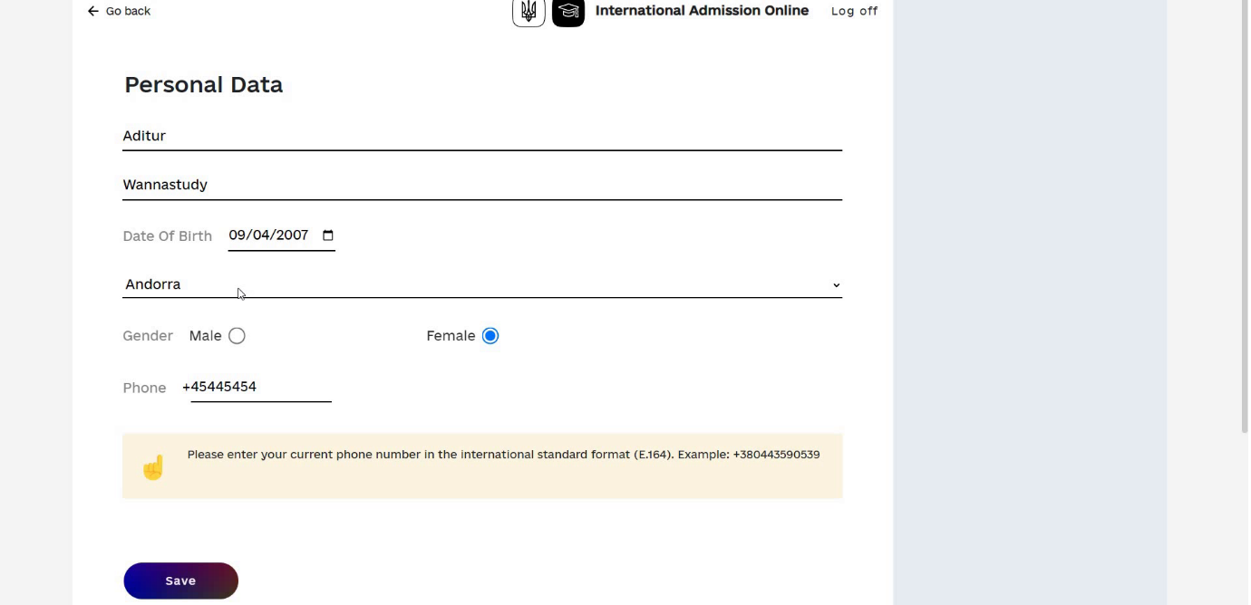

*Рicture 10 - Filled in the personal data page, click* ***Save****.*

5) the applicant is taken to the page for entering data into the application;

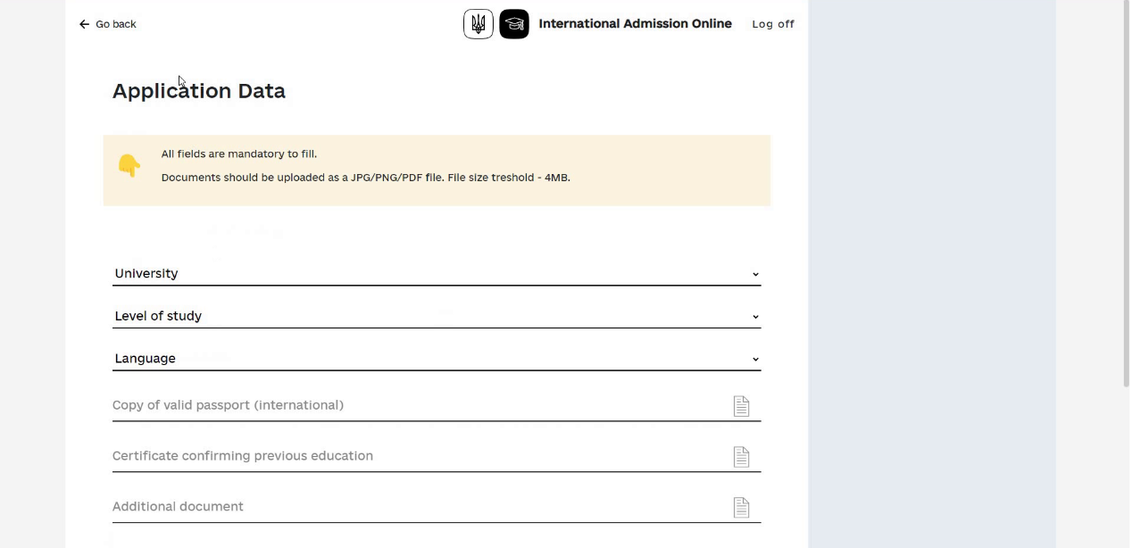

*Picture 11 - The page for entering data to create an application for study.*

6) where the applicant must choose a higher education institution (**University** field);

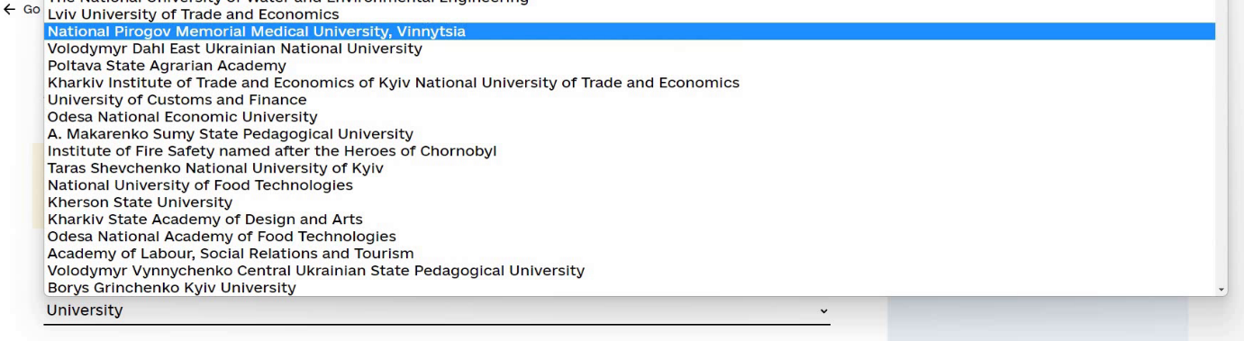

*Picture 12 - A functional element of selecting a higher education institution.*

7) select the level (degree) of study (**Level of study** field);

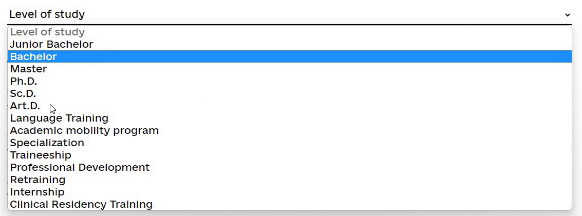

*Picture 13 - A functional element of choosing the level of education.*

8) if a foreign applicant wants to enroll in language training first, he/she selects the **“Language training”** tab;

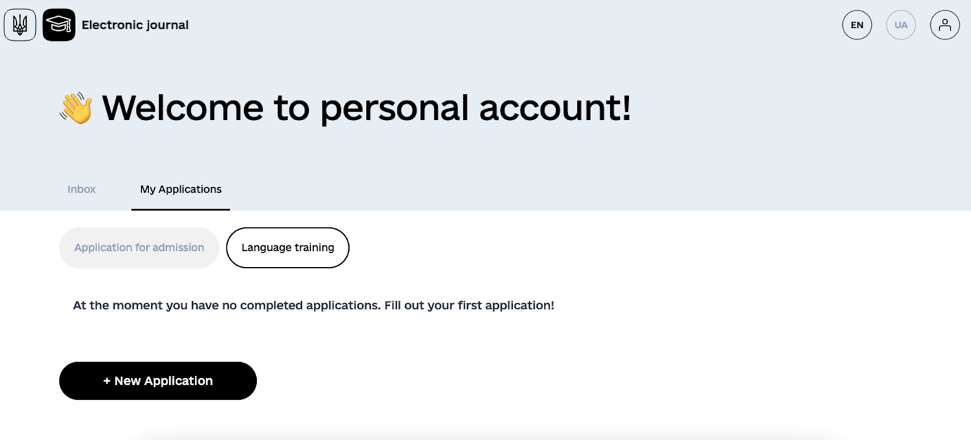

9) and select the language of study (Language field);

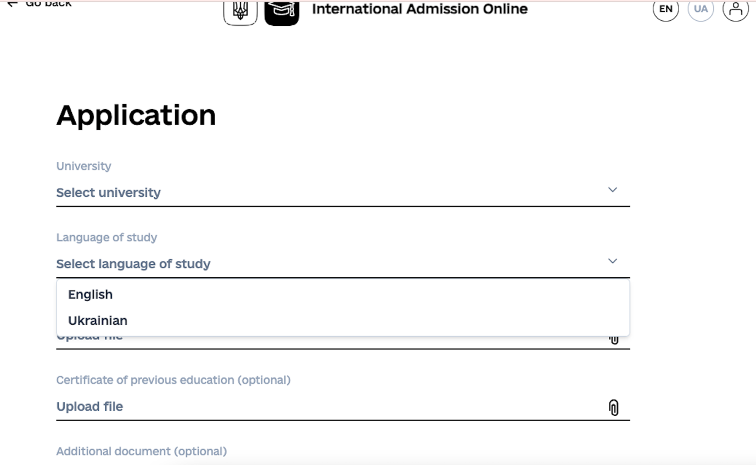

*Picture 14 - A functional element of choosing the language of instruction.*

10) the applicant must attach 2 documents: a scanned copy (or photo) of the passport (**Copy of valid passport (international)** field), a scanned copy (or photo) of the document on previous education (**Certificate confirming previous education** field); if necessary, the applicant can add another scanned copy (or photo) of another document (**Additional document** field);

11) after selecting the field options and adding documents, the applicant must click the **Next** button;

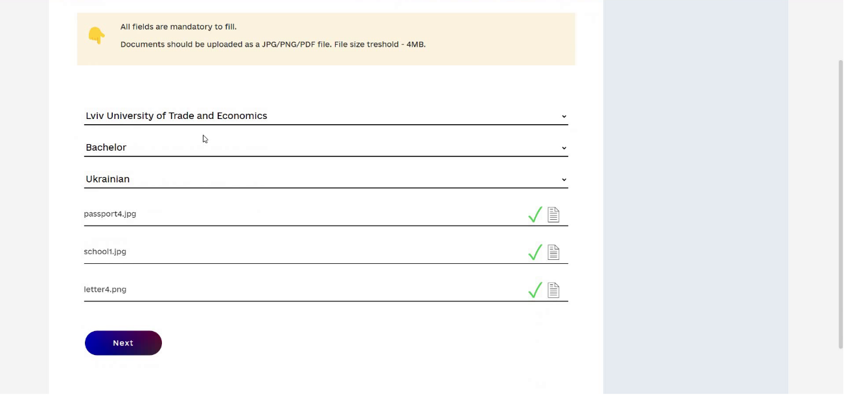

*Picture 15 - The page for entering data to create an application for study is completed, click* ***Next****.*

12) the applicant is directed to a page informing about the need to pay for the application (with the amount of payment);

**Payment for the application**

The cost of creating an application in the electronic cabinet of the Unified System is UAH 3100 per application (approximately USD 74). A foreign applicant can submit up to 20 applications to Ukrainian higher education institutions.

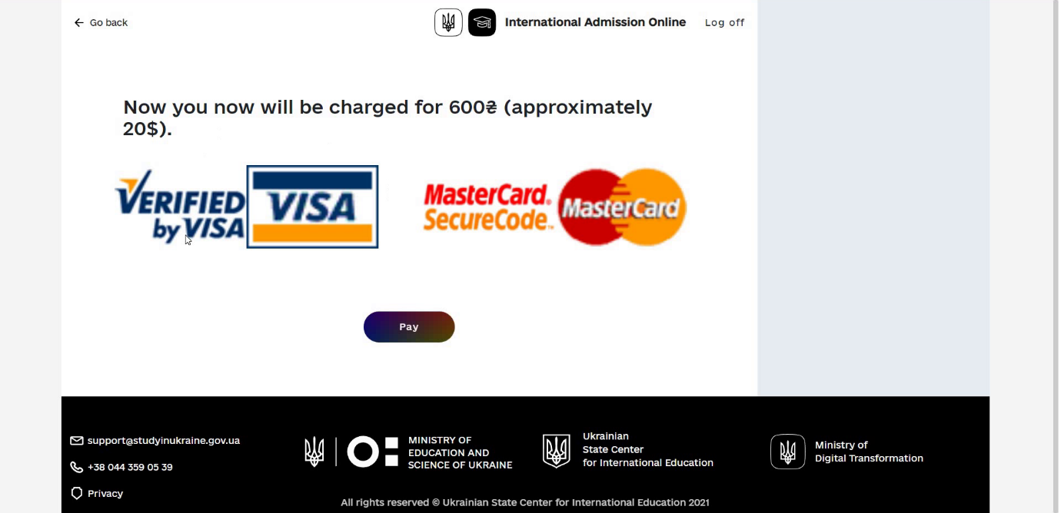

*Picture 16 - Сторінка для перенаправлення на сторінку банку еквайрингу для здійснення оплати.*

1. to start the payment procedure, click the Pay button, which redirects the applicant to the external payment page in the acquirer's bank system;
2. after successful payment, the applicant is redirected to the application page, where he or she can see the application data and a message about the successful submission of the application to the university with the date and time of the application.

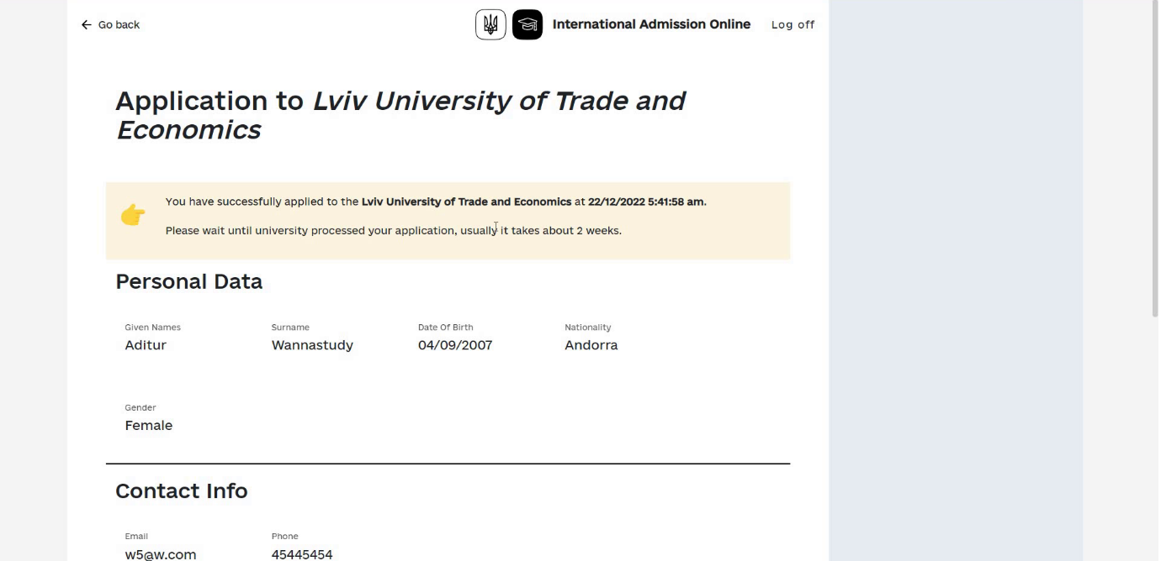

*Picture 17 – The application review page with information about the date and time of submission.*

It may take some time to receive a response to your study application.

**Confirmation or rejection of the educational offer.**

To find out whether the application has been answered, the applicant must:

1) log in to your account, where the application section is immediately displayed;

2) follow the link Go To **Application** → to get to the application review page.

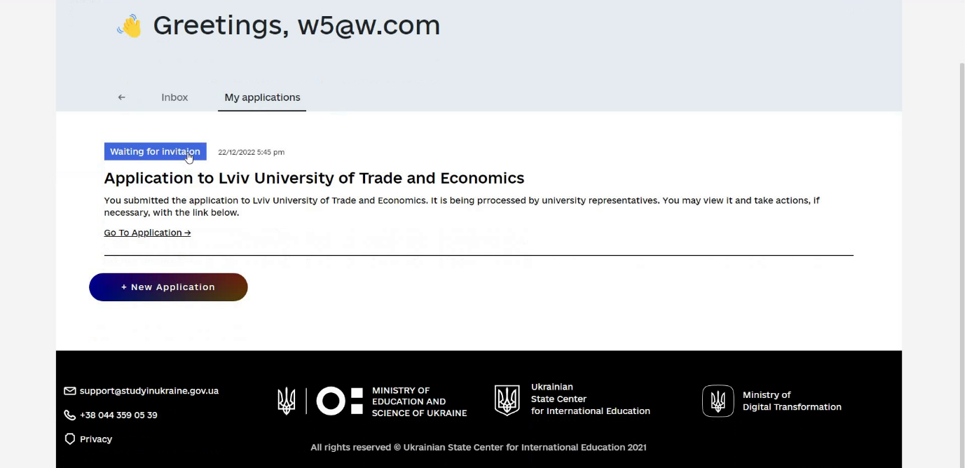

*Picture 18 - A list of applications in the “My applications” section, indicating the status of each application, the link Go To Application → each application.*

If an educational offer has been received, then in order to familiarize themselves with the educational offer, on the application page in the list of educational offers (**Study Proposals** area), the applicant must download the file with the educational offer by clicking on the area with the image of the document.

After reviewing the offer, the applicant can accept it by clicking on the **Accept** button or refuse the offer by additionally indicating the reason for refusal (**Place deny comment** here field) and clicking on the **Reject** button.

In case of refusal, the applicant waits for the next offer.

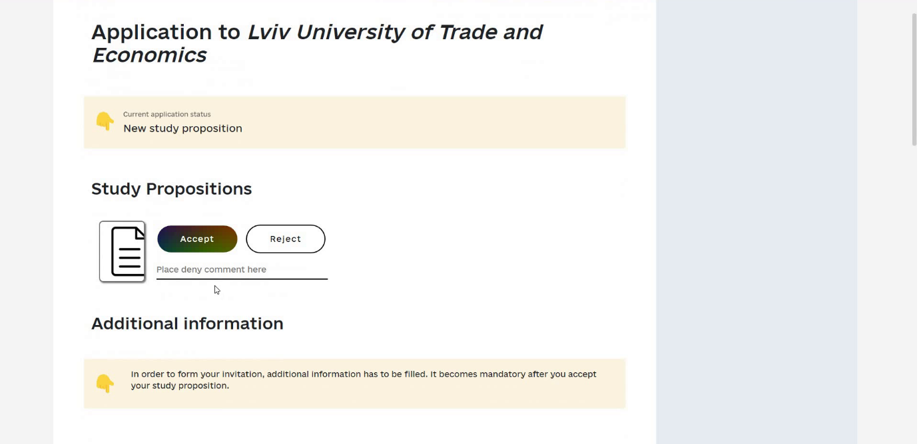

*Picture 19 - The page for viewing the application with the received educational offer, the area with the document image, and the Accept and Reject buttons.*

**Entering additional data to receive an invitation.**

If the offer is accepted, the applicant must provide additional information by following these steps to receive an invitation:

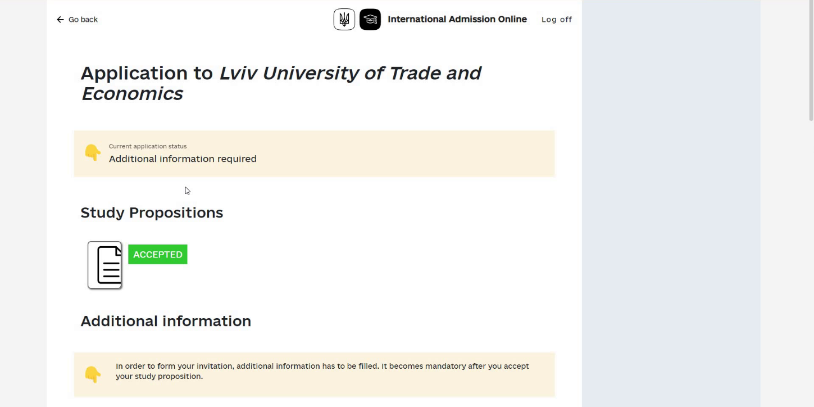

*Picture 20 - The page for viewing the application for study with the accepted educational offer.*

1) add (send) your photo (Photo field, minimum resolution 600x800 px, file size no more than 1 MB);

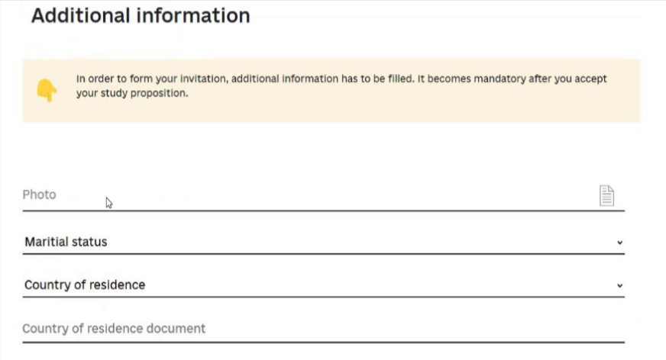

*Picture 21 - The page for viewing the application for study with the accepted educational offer and a block of additional data that the applicant must fill out to receive an invitation for study.*

2) select the country of permanent residence (**Country of residence** field);

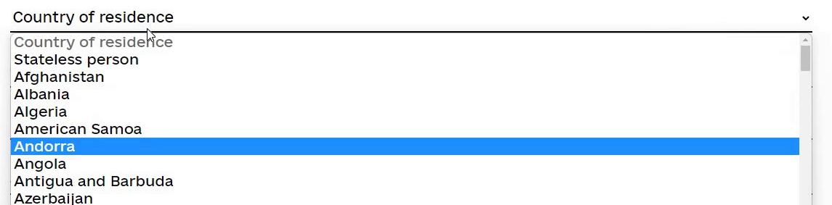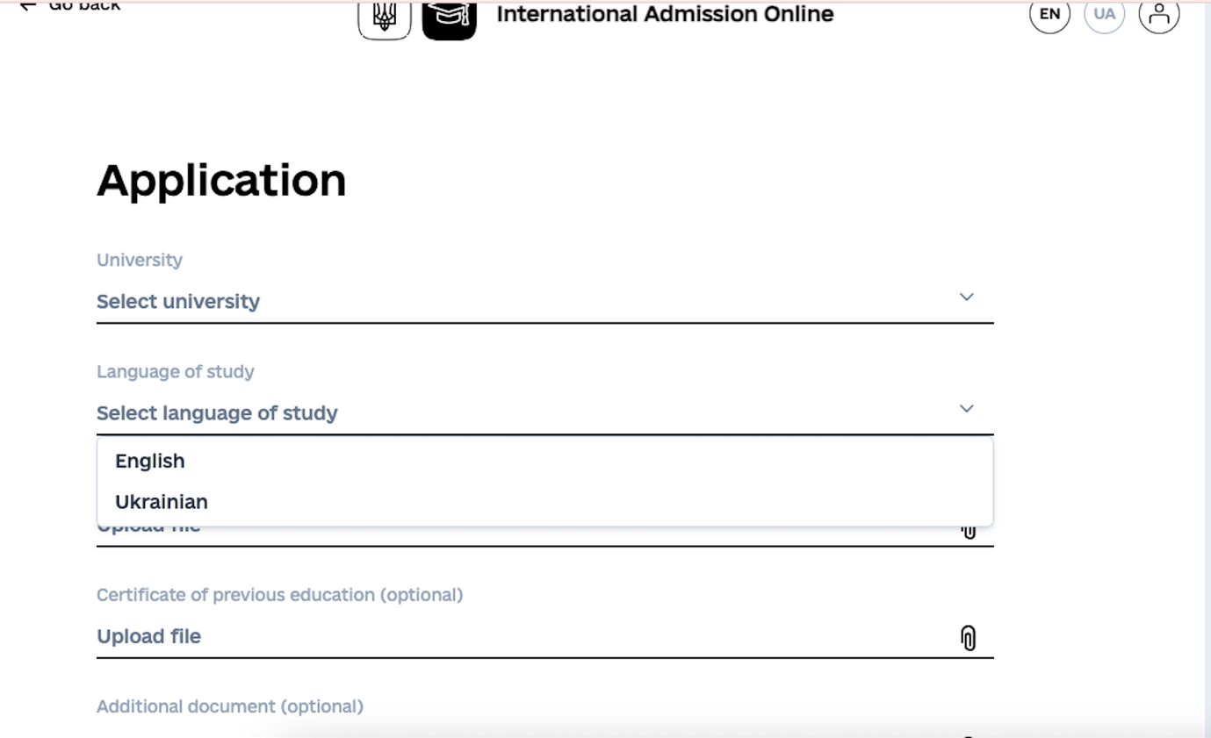

*Picture 22 - A functional element of the choice of the applicant's country of permanent residence.*

3) if the country of permanent residence differs from the citizenship, indicate the number of the document entitling to permanent residence in the specified country (**Country of residence document** field);

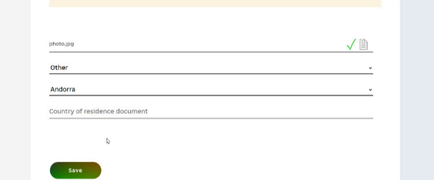

*Picture 23 – The completed application review page with the accepted educational offer and a block of additional data for receiving an invitation for study.*

1. after entering all the data, the applicant clicks the **Save** button;

5) additional data is entered and the applicant sees that the application status has been changed to “**Wait for invitation**”.

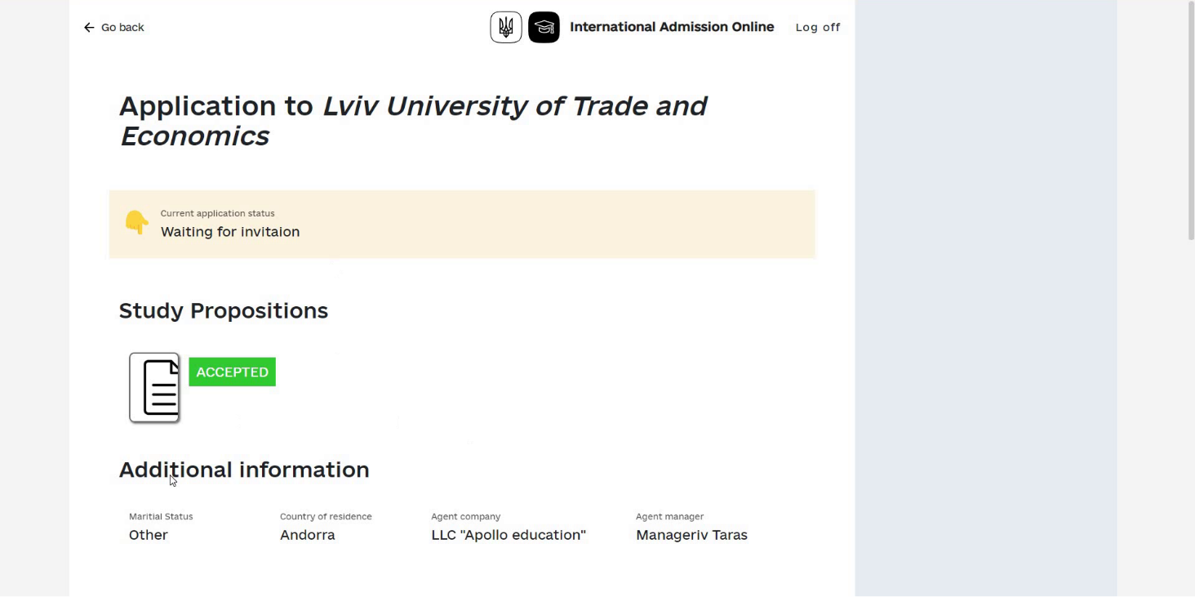

*Picture 24 – Status of the application after entering additional data.*

## 

**Receiving an invitation for study.**

After the invitation is issued, the applicant can download the file with the invitation in the application page by clicking on the area with the image of the document and the inscription INVITATION.

The next step is to apply for a visa.

Currently, it is not possible to apply for a visa through the Unified System, the applicant must apply to a consular office, and will receive a notification in the system with all the necessary links. The operators of the MFA's office have the opportunity to put down the decision, visa number, etc., after which the applicant will receive a notification in the system and by e-mail.

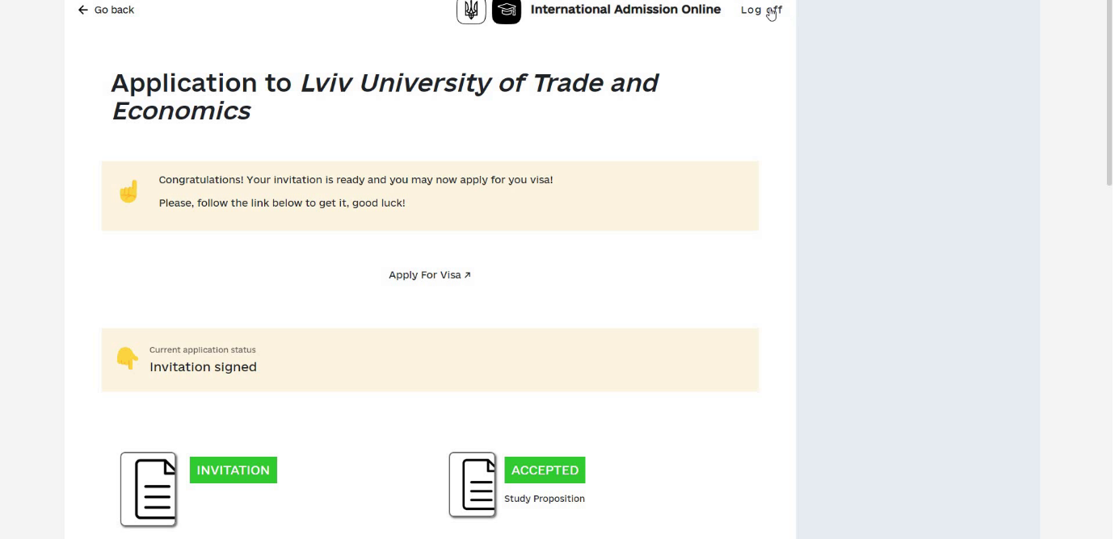

*Picture 25 -* *The page for viewing the application for study with the accepted educational offer, issued invitation and a link to the visa recommendations.*

**Finishing work with the site**

To exit the site and log out of the System, click on the **Log off** link in the upper right part of the application, the System logo, or close the browser tab (window).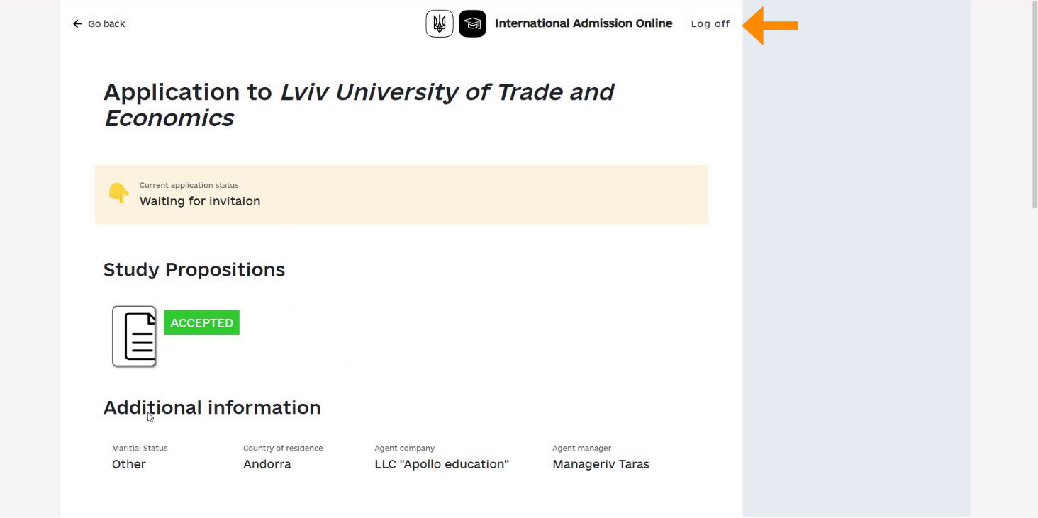

*Picture 26 – Location of the link to log out (end the session) from the site.*

The applicant can also enter information about his/her arrival in Ukraine in his/her electronic cabinet. This information will also be available to the educational institution that issued the invitation for study.